Statue of Liberty
Name of student
Institutional Affiliation
Date of Submission

Statue of Liberty
The statute has a hollow composed colossus of small sheets of copper over a framework of steel that is erupted on an island at the entry to the harbor of New York, in the United States. Frederic and Gustave were the designers of this structure. Its drawing and construction were discovered at the moment as one of the most extensive technical achievements of the 19th century and erupted the bridge between activities and engineering (Ross et al. 2019). This statue of liberty was a combined collaboration of two countries, which is the United States and France, with the intention of the commemoration of the previous friendship of the citizens of these two nations. A French philosopher Auguste_Frederic developed the statute it was designed from hammered copper sheets, and Gustave Eiffel, the person behind the famed tower of the Eiffel, made the designing of these structures from the steel framework. This statute was after that handed to the United States and raised on to the top in an America-shaped pedestal that was located in a small island on the upper side of the New York Bay at the moment called the island of Liberty and offered by president Cleveland Grover at the year of 1886. In the past years, this statute remains standing tall as many of those people from other countries came to see it in America through the island of Ellis. After one century, these statutes underwent renovation in respect of centennial. At the moment, this Statute is still a sign of democracy and freedom the same as one of the essential world features (Coughlin, 2017).
The genesis of Statue of Liberty
From Coughlin (2017), in about the year of 1865, when there was Civil War in America, the historian Edouard de Laboulaye cited that France developed a statute to allow the United States to make the ceremony of the nation's success in developing a functional democracy. Bartholdi, a French sculptor who was known for vast scales sculptures during the time of the centennial of the formation of independence in the year 1876. The work was to be a collaboration of efforts among the two nations-the people from the French had the responsibility of the statute together with the assembly. In contrast, the Americas would construct the walking path on which it could stand and a structure of the friendships in the two people. The ground floor of the statute walking trails has exhibits on a structure history that included the original torch. People who get access to these Liberty's flame this originated after the operation of Germany.
As a result of the demand to generate finances for the statute, work on the sculpture did not commence immediately. Bartholdi's enormous creation named ''Statute of Liberty Enlightening the globe " shows the female human being on hold of touch in her raise right hand and a tablet on the left-hand side. The acceptance date of the declaration of freedom. Bartholdi, the person who was known to be behind, had molded the female face after that of his mother, equipped with vast sheets of copper to make a humanlike structure whereby the animal skin could be made, (Ross et al. 2019).
Statue of Liberty: Assembly and dedication
As the activity progresses in France on the real Statue, contribution struggles went on in the United States for the walking. Developed by the American designer Hunt the statute walking path was expanded inside the courtyard a fortress was constructed used for war in 1812 and was in Bedloe’s Island.
At the statute, it contains a lot of metal plaques on or near this statute of Liberty. This plaque is on the copper only below the feature's feet gave an announcement which was statute in representation of the Liberty, developed by Bartholdi and constructed by the Paris Company of Gadget, the other declaration of the plaque states the law as a gift from the citizens of France that represented the coalition of two countries in obtaining its freedom of America and build their friendship. New York congregation made the plaque that was in remembrance of contributions of funds to construct the walking path.
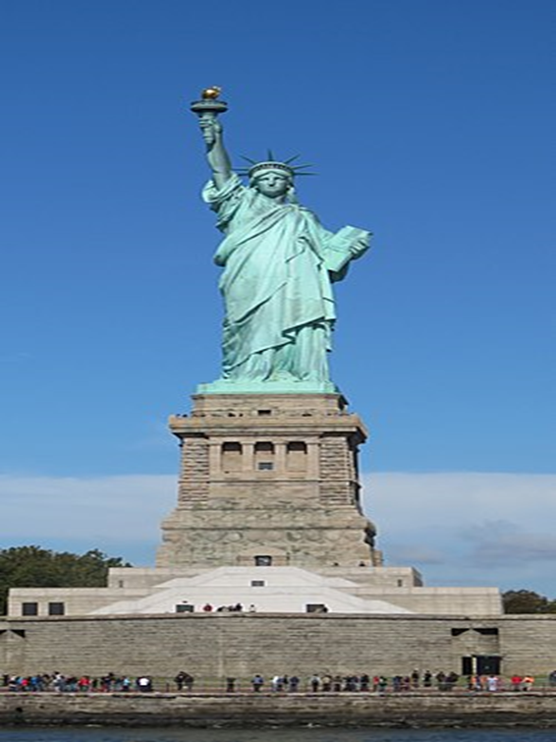
The statue of Liberty in New York, United States

Later in the year, during 1903, a tablet of bronze that contains the word of "The brand Colossus" and was in remembrance of Lazarus Emma that was graced by friends of the play, (Ross et al. 2019). The statutes are on the island, which was located at the western that contains five statues. The people who build the law were honored (Moran, (2016). This statute stood for two Americans; these five statutes were constructed by Sculptor and Maryland. This statute was located in a UNESCO World Heritage Site. This UNESCO world of similarity illustrates the structure as a masterpiece of people's faith that sustains as a highly potent significance, removal of forced labor, freedom, and chance.
According to Burstein (2018), in the boundaries of these buildings are situated in all elements that are important to understand and express the prevailing universal qualities of this Liberty. This building has been protected all over the entire life without any changes. Reconstruction with the relationship to the coated interaction of steel was rectified in an extensive restoration done for the centennial that consists of regenerating the exact torch that not much brighter, which is at the moment preserved in an orphanage. Frequent updates of the inner mechanical and security system are frequently made. This structure occupies a size of 5.95 ha of space, which is considered sufficient to ensure total represented of the monument and activities that describe the structure's significance and does not get affected by the harsh impacts of development. Any official boundary does not encompass this structure; instead, it's the island situated in the city setting that gives equal protection. The structure that is whole Liberty Island offers residence and administrative offices.
This structure is authentic in circumstances of its situation and organized way, and design. The structure's shape and action have been maintained from the period of its construction. The inside iron strapwork helping the metal coating was exchanged in 1986 with a metal that does not get rust that hinders corrosion. All replacement was formed with high fidelity to the original design and construction materials. Timely mechanical rotation and security briefing have not impacted the symbolic numbers of the structure. The identified and severe threads to the authenticity of the building involved pollution, harsh weather, and vast amounts of tourists.
This statute is under the protection and management of the government of the United States of America. The structure was preserved as a public building and is controlled by the national park Service. These rules provide it as the highest vulnerable stage of preservation. The present overall management plan that talks of physical storage and analyzing has been become an alternative in few years of the past by comprehensive research of life measures and instant conservation of the recommendation that has been enacted. Maintenance of the existing universal number of the feature above time will need ongoing monitoring and control of the vulnerable threats that include flat water and vast amounts of tourists (Moran, 2016).
To conclude is that the statute has some symbols that represent various meanings; these symbols are the torch that is representing enlightenment. It gives these structures a symbol of freedom that is indicated by the path of liberty. The name represents the essential symbol of liberty enlightening the globe. This statute stands what America is; it is democrats that are used for remembrance.

References
Coughlin, D. (2017). Standing with the Statue of Liberty.
Coughlin, D. (2017). Twelve Lessons from Six Days in New York City. Effective Executive, 20(3), 71-73.
Moran, E. (2016). The commerce of Nations Rendering Homage to Liberty. American Art, 22.
Ross, B., Roemer, P., Bishop, B., Stauffer, H., & Davis, K. (2019). Statue of Liberty.

