Your Name x

Section 1: Business Insights: Global (formerly Business and Company Resource Center)

- What is the company name and contact information (company URL and e-mail address)?
x

- In what type of business is this company involved?
x

- Identify one of the company’s industry NAICS codes and its name.
x

- What is its ticker symbol?
x

- In what year was this company founded?
x

- How many employees does it have?
x

- What is its annual operating revenue?
x

- From the left-hand side, select either the “Journals” link or the “Recent News” link. Find one article of interest. Using the correct APA format, write a full bibliographic citation. The format you see online is not necessarily the correct APA format so put the correct information in the correct order and format. See assignment instructions for details.
x

- Click on the link to “Company Profiles.” What is the company’s ticker symbol? What is the name of the stock exchange on which the stock is traded?
x

- In the Company Profile, select the Rankings link. Choose a document title. What is the document title? What is the ranking method? What number is your company on this list?
x

- In the Company Profile, identify the company’s primary industry and its NAICS code. Click on the primary industry and provide one interesting piece of information.
x

Section 2: Business Source Complete

- Find an article about your company in this database. To begin, add your company’s name in the first search field (see screen shot below). In the “Select a Field” box, pull down the menu and search by “Company Entity.”

Add a second keyword search term of your own choosing in the search field on line two to narrow your search. Answer the questions below the screen shot.
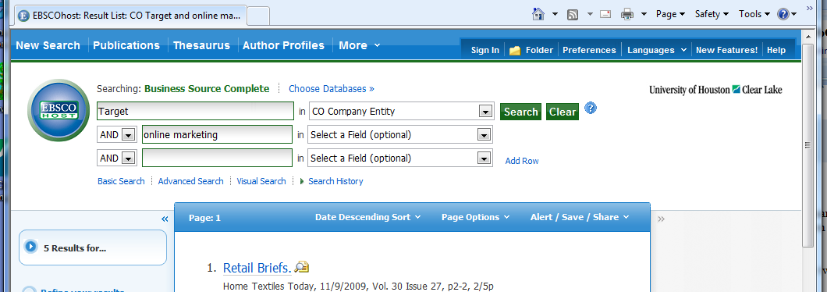

  - What was the keyword you used in the search field on line 2?
x

  - How many entries did this search return?
x

  - Do you think your choice of keyword in line 2 was a good one? Why or why not?
x

  - Provide the bibliographic citation in correct APA or MLA format for one of the sources you retrieved in this search.
x

- Which database—Business Insights Global or Business Source Complete—do you think you will use most often for finding articles about your company? Why?
x

- Using Company Profiles (top of screen, under “More”), open the Datamonitor Report for your company. What is the date of your company’s report?

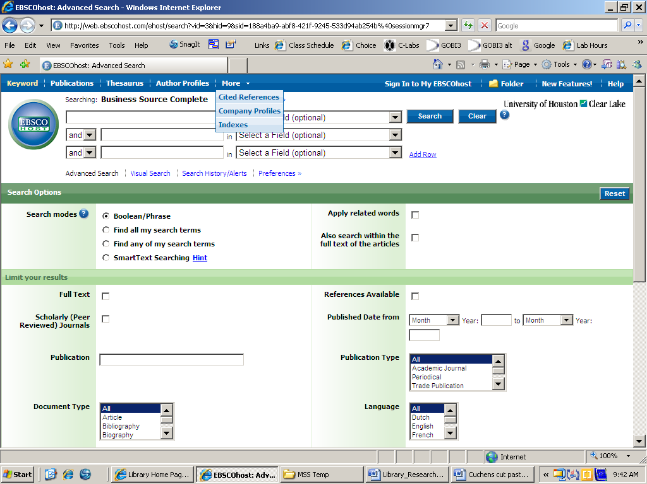

x

- List three items in its Table of Contents.
x

- Find the SWOT analysis and identify the following. If your company does not have a SWOT analysis, do an advanced search using your company name and one of the SWOT terms as a keyword. Find an abstract and provide one significant fact. See screen shots below for an example.

  - A strength
x

  - A weakness
x

  - An opportunity
x

  - A threat
x

If your company does not have a SWOT Analysis, use the search terms to locate information.
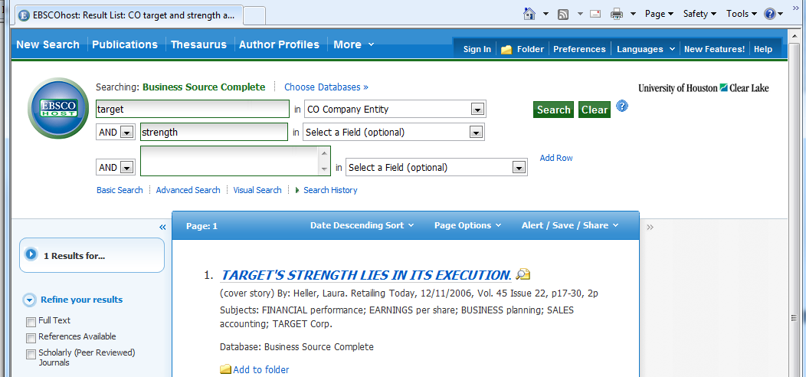

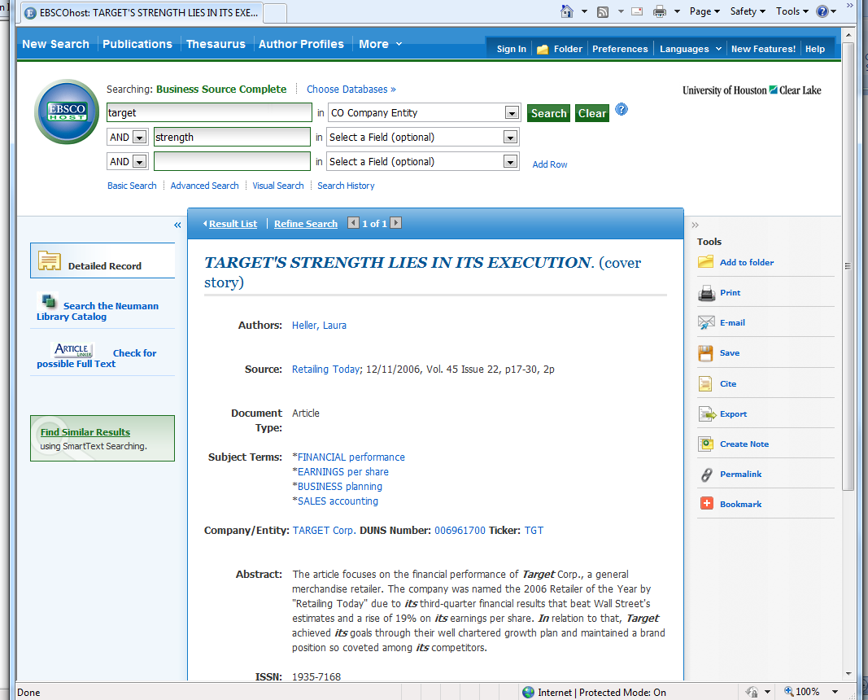

Section 3: Nexis Uni’s Company Dossier

- Go to the “Get Company Info” box and enter your company’s name or ticker. In Company Dossier, “click on your company. In the Snapshot, compare the number of employees to the figure found on Business and Company Resource Center. Is the number the same as #6 above? What does this tell you?
x

- Review the company Snapshot. Who is the chief executive and what is his/her title?
x

- Identify one of the company’s competitors.
x

