Name: Project: Linear Modeling(PQL)
Mat 115:Prof. Rudy Meangru
Project #1: ( / 30 pts) 2- week period

[ Dear student you may consult with other students for help, but under no circumstances take someonelse work and claim it to be yours]

In this activity you will be investigating the rising cost of the MTA transit fare over a period of time in New York City. The goal is to use data to develop a simple mathematical model which can be used to make some reasonable predictions.

You will incorporate the use of algebraic skills such as graphing, rate of change and linear function to complete this activity.

Step 1: Introduction ( 2pts)

Read through this activity and then write a brief introduction of the goals in this activity.

In this project, I will look at the rate of exchange of the value of the MTA transit fare over a duration of time in New York City. To look at the rising cost, I will follow algebraic abilities such as the graphing, price of the trade, and a linear function. Incorporating these algebraic understandings will aid me in creating legitimate information to improve an easy mathematical model. Thus, the mathematical mannequin can be beneficial in making some lifelike predictions about the fee of MTA fare in the future.

Step 2: Scatter Plot ( 5pts)

Use the following data provided in the table below to obtain a scatter plot of time vs. price. Describe the trend of the price in the plot. Do you find the trendshocking?

Time Line | Price(dollars)
1970 | $0.20
1980 | $0.50
2003 | $2.00
2009 | $2.25
2013 | $2.50
2015 | $2.75

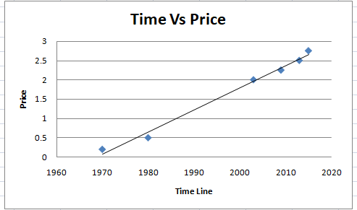

Looking at the scatter plot of how the fee of the MTA fare, y, will increase as the time (year), x, increases, I determined that as the year increases, the MTA fare additionally will increase linearly. Between 2003 and 2015, the fee for the MTA fare will increase by way of a consistent price of $.25. However, evaluating the year 1970 to 2003, the price of the trade is drastic, which startled me due to the fact it immediately modified from $0.20 to $2.00 inside 33 years. Therefore, I discovered the style shocking.

Step 3: Defining your variables.(2 pts)

Identify your independent and dependent variables using appropriate symbols to state them.

Let the independent variable ?? represents the time in years and the dependent variable ?? represents the cost in dollars.

Independent Variable (t): Timeline (Years)
Dependent Variable (P): Price (Dollars)

Step 4: Average rate of Change (4 pts)

Compute the average rate of change per year of the cost over each time period.

Just fill in the result; don’t’ show the calculation.

Time Line | Price(dollars) | Average rate of change
1970 | $0.20 | XXXXXXXXXXXXX
1980 | $0.50
2003 | $2.00
2009 | $2.25
2013 | $2.50
2015 | $2.75

Do these values suggest a linear trend? Explain.
Looking at the domain and range, the costs do no longer advise a linear vogue due to the fact they are no longer elevated via the equal proportion. To clarify, every time the fee of t time in years will increase with the aid of a one-of-a-kind rate and the cost of P additionally will increase via a special rate. This ability slope or charge of alternate is no longer constant. For instance, from 1970 to 1980, the MTA fare price expanded with the aid of a common charge of $0.0, whereas, from 2003 to 1980, the common price of alternate in the MTA fare fee is $0.65. Therefore, this demonstrates the trade-in MTA charge is no longer growing linearly.

Step5: Linear Modeling (6pts)

Assuming that the trend is linear, generate a linear model.
To make the calculation easier, rescale the time values for 2009 through 2015 in the above table.

Let 2009 be the year 0.

t | P(dollars)
0 | 2.25
4 | 2.50
6 | 2.75

Using any two data points from the rescaled table develop a possible linear model of the above data by filling in the blanks in the following calculation.

(0, 2.25) and (4, 2.50)

P= at + b
P= at +2.25
a=$\frac{2.50-2.25}{4-0}$
a=$\frac{0.25}{4}$
The equation that I will use to represent the linear model is
P=$\frac{0.25}{4}t+2.25$

Predict the price in 2020

By using the slope-intercept formula, P=$\frac{0.25}{4}t+2.25$, I will predict the price in 2020
2020-2009= 11
P=$\frac{0.25}{4}t+2.25$
P=$\frac{0.25}{4}(11)+2.25$
P=$2.94$
According to this model, the Price is expected to be about $2.94 in the year 2018.

Step 6: Using EXCEL (6 pts)

- Obtain a scatter plot of the data with the “best-fit”line.

- Generate the linear model through EXCEL.

P=$0.08t+2.23$
- Using this model predict the price in 2018.
2020-2018

P=$0.08*2+2.23=2.39$
- Using this model predict the price in 2018?

P=$0.08*2+2.23=2.39$

Step7: Reflection ( 5pts)

What have you learned from this activity? What challenges did you face and how did you overcome them? What mathematical skills and knowledge did you use to complete this assignment? Did you need to look back at any prior mathematical skills? Did you seek assistance from anyone and was it helpful? Compare the predictions that you get from the two models? Is your computed value a reasonable one to what the fare is currently? What are some of the pitfalls with this linear modeling procedure? Has this activity help you to better appreciate mathematics?
How has this change your feeling about mathematics?

From this activity, I discovered that the value of the MTA fare used to be very low cost in contrast to the MTA fare fee nowadays. Additionally, I realized that inside a certain time span, the value of the MTA fare extensively increased. Between 1970 to 2003, the price of the MTA fare accelerated via $1.80, which is pretty shocking. Nevertheless, from 2009 to 2015, the charge of the MTA multiplied linearly with the aid of a regular price of $0.25. While doing this activity, one of the challenges that I confronted used to be to draw the trend line on Excel due to the fact I am now not acquainted with the features of Excel. I overcame this project by way of analyzing the instructions and following them in consecutive order to draw the trend line and discover the equation. To entire this assignment, some of the mathematical competencies and know-how that I utilized had been finding the slope of the use of two coordinate factors and the usage of the slope-intercept components, which is Y=mx+b to locate the equation of the line. Moreover, after discovering the slope and the y-intercept, I use the substitution approach to find the equation of the linear model. By figuring out the unbiased Variable (t) and the established Variable (P), I used to be capable of substituting the values to predict the price of the MTA fare in the course of the given year. Moreover, after forming the linear equation and drawing the linear graph, I had to analyze what the fashion indicates about the charge (dollars) and the timeline (years). I additionally used rounding numbers to the nearest tenth to exhibit the approximation of the MTA fare cost.

Since I am a specialist at figuring out linear relationships including, slope, scatter-plots, and equations, consequently, I did no longer want to appear returned at any prior mathematical skills. Furthermore, I, for my part, finished this challenge besides looking for any help and utilized my fantastic effort. Comparing the predictions that I bought from the two models, my computed price is highly comparable to the present day MTA fare, which skill the furnished records used to be correct and reasonable.

See addendum for EXCEL instruction.

EXCEL INSTRUCTION

Let’s use the table below as a sample to obtain the desired out from EXCEL.

Day | Expense
1 | 30.80
2 | 25.55
3 | 26.35
4 | 28.30
5 | 30.50
6 | 50.50
7 | 60.80

Step 1: Access Excel spreadsheet.
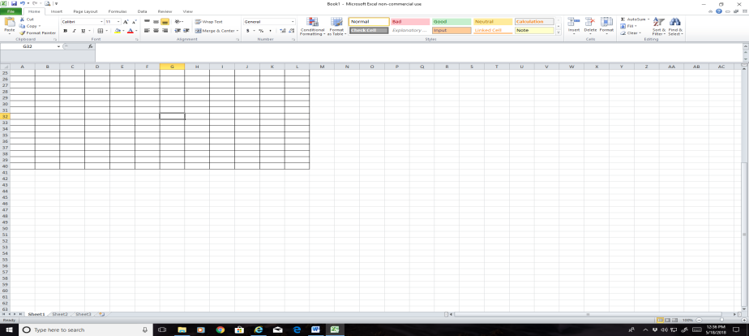

Step 2: Enter the data set either my typing it in EXCEL or copy from the word file and paste it into EXCEL.
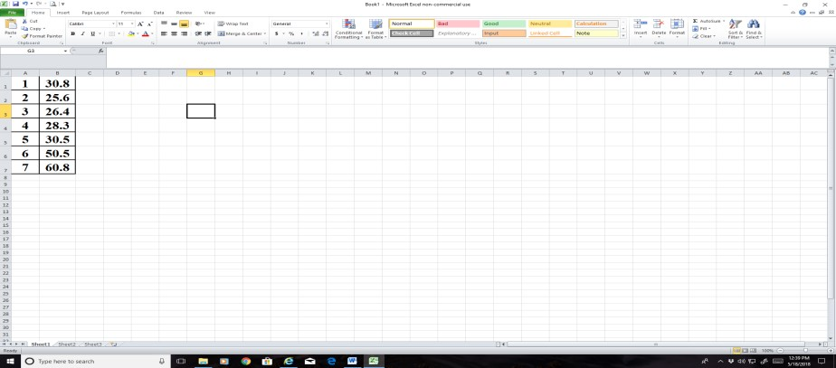

Step 3: To obtain a scatterplot, highlight the data set, select “Insert” on the menu bar and then “Scatter” .

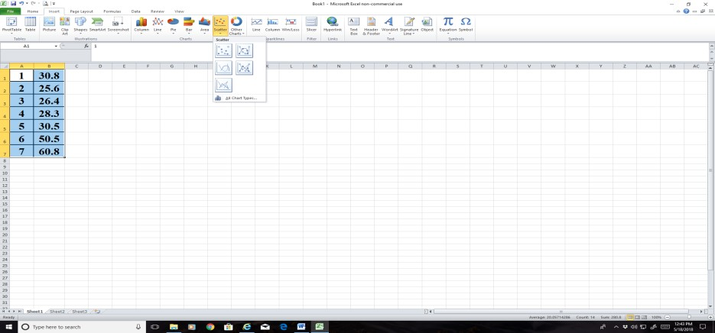

Step 4: Make a choice to obatin the scatter plot.
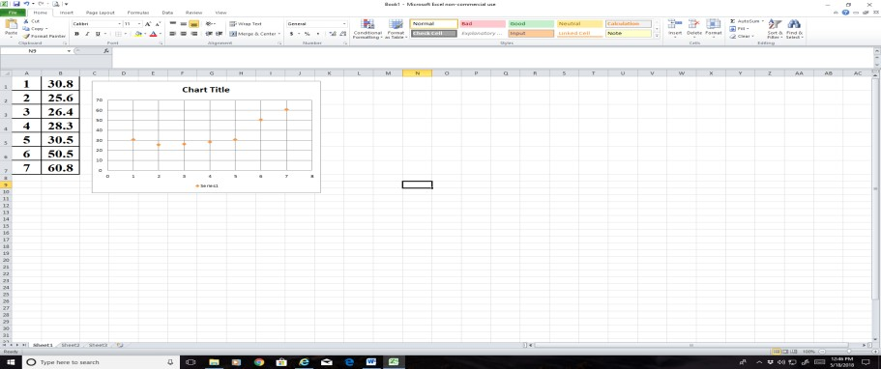

Step 5: To obtain a regression line or curve, place your cursor on any dot and right click. A pull-down menu appears. Select “ AddThreadline” and choose the required model anlong with “ Display Equation on chart”
