Lithium-ion batteries are the most common rechargeable batteries on the market today. From cell phones to automobiles, lithium-ion batteries are everywhere. They have replaced Nickel-Cadmium and Nickel-Metal Hydride as the rechargeable battery of choice. While they are common, they can have issues. Research and find a reported lithium-ion battery incident for a battery that did not operate as planned.
Research and write a minimum 2 page technical paper that answers the following questions:
- Give a brief explanation of what happened in the battery incident.
- What was the end result? The battery failure caused what to happen?
- Was a reason for the battery failure found?
- What was done to fix the problem?
- Is this a common lithium-ion battery failure or a one time event?
Do not just copy what the news websites are saying. I want this paper written in your own words. Look for information at more technical websites. Do NOT just copy the information from websites. The common news websites such as www.cnn.com or www.foxnews.com are going to give you watered down, simplified explanations of the issue. We are engineers. I want you to find more technical information about the problems and the solutions that the manufacturer developed to fix the problem.
A 2 page technical paper needs to contain 2 pages of writing. The paragraphs should be single spaced, with a readable font in the 10-12 point size. For example, this assignment sheet is written in the Calibri font with a font size of 11. If you have pictures, diagrams, etc., they should add to the length of the paper, not fill in to give you 2 pages of text and pictures. If you have written a 2 page paper and your pictures and diagrams take another 2 pages, you now have a 4 page paper. You will not be penalized for going over 2 pages, but your grade will be reduced if you do not have at least 2 pages of text.
This paper will be submitted on Blackboard and checked for plagiarism using SafeAssign. The paper is to be submitted on Blackboard on February 1, 2018 by 4:00pm. I will not accept any papers in class, they must be submitted via Blackboard.
By the way, here is a picture of a battery vent on the Dreamliner.....
1
ENE3150 Technical Paper #1 Spring 2018 Due: February 1, 2018
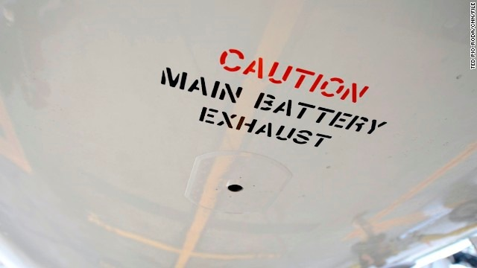
A battery compartment vent on the belly of a United Airlines Dreamliner 787 in May 2013

