Name
Professor
Course
Date

Lowe's Hardware continuous improvement processes and tools

Introduction
Lowe’s Companies, Inc. is a home improvement company that is currently serving more than 10million customers in the United States and over 18 million customers across Mexico and Canada. The company has for the last few years been registering great improvements in its service delivery and also improvements in revenue. In 2017 alone the company registered sales of up to $68.6 billion. Currently, the company is servicing more than 2,390 home improvement and hardware stores. It is also among the biggest companies in the states and has provided employment to more than 310,000 people. This company was founded in 1946 and has been associated with numerous community support programs including community improvement projects (Vandervort & Lowe's, 16). The company is currently focusing on making itself consumer-centric so as to drive sells after it posted disappointing results. The essence of this paper is to discuss the company’s continuous improvement processes and tool.
Processes used to improve its Operations, Products, Services Culture, etc.
Reports indicate that improved macroeconomic conditions are favoring home retailers and this means that the companies that trade in this industry should take advantages of this and strengthen their industry environment. Lowe’s is a very big company and has been in business for long to understand how this industry works, this is the reason why it has remained among the top players which hold a significant market share. The company has been applying different processes so as to improve its operations, services, and culture. Some of these processes include;
I. Acquisitions to expand offerings
Lowe’s crowned its acquisition business by acquiring Maintenance Supply Headquarters in a move that was meant to ensure that it improves its service delivery. Maintenance Supply is one of the leading distributors and understands how well to reach customers. Lowe’s had earlier acquired Central Wholesalers which is a leading distributor in Atlantic. These two acquisitions have been part of the processes that the company is using to improve its service delivery. The main aim for this acquisition as reported by the company’s website is to be able to reach professional consumers who are considered to be more reliable considering that they usually order large and bigger as compared to ordinary customers. The culture of the company is to keep growing and exploiting new markets and so these acquisitions also help the company to continue its legacy (Arani, 48). The company has also come up with a unique strategy of trying to balance outdoor and indoor projects. Much the company’s marketing strategy is focused on indoor categories and it is this move which has triggered increased outdoor sales.
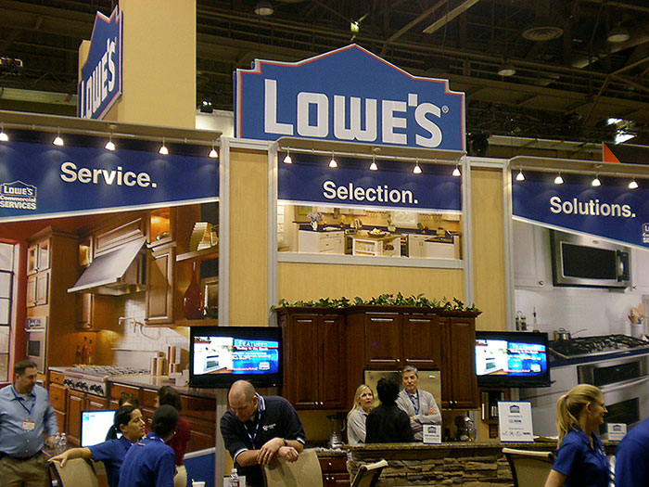

II. Integrated Retail Channels
This is another process that the company is using to improve service delivery to its customers across the United States. This process involves investing in an Omni-channel retail strategy which is tailored to ensure that it is easier for customers to engage with home project specialist for both interior and exterior. It is through this same platform that has enabled customers to engage specialist online, currently, customers are able to get assistance and book appointments when needed. It has also increased some unique tools on its website as a move to improve customer experience. The process of improving the company’s integrated retail channel is one of the tools the company uses as a key growth driver to increase its sales. This is part of improving its service delivery to its customers (Waymer & Vanslette, 63).
III. LGS Sourcing
For decades now, Lowe’s has applied a number of techniques in order to improve its productivity and quality so as to ensure that it retains or increases its market share. First, Lowe’s uses global sourcing and is one of the strictest companies that demand ethical standards from its manufactures. The company has for decades now been bringing different products from different manufacturers across the world through a method called LGS sourcing. This process involves the use of more than 500 vendors from 21 countries which do the supply. The company gives clear guidelines to the manufactures based on market demand and customer specifications. Mainly, Lowe’s is concerned with safety quality and social responsibility among other ethical guidelines. In order to ensure that its vendors are up to the task and that they comply with all set rules, the company has a third party quality assurance teams which do random and regular inspections as a way of keeping the vendors in check. This is one of the processes the company has been using to ensure continuous improvement in the quality of its products. In addition, the company also practices total quality management which is part of its culture based on three principles; employee involvement, continuous improvement, and customer satisfaction.
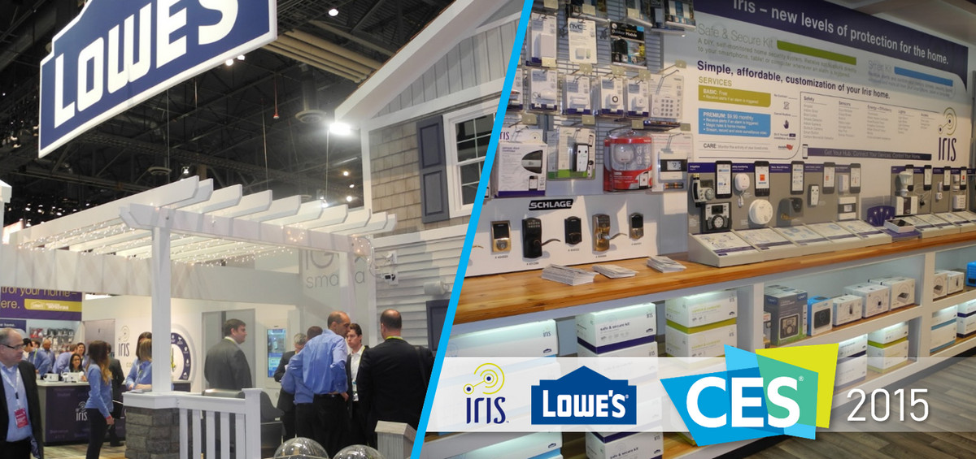

IV. Latest Retail Technologies
Lowe’s marketing strategy is one of the most effective considering its ability to tailor messages to individuals. For the past few years now the company has embarked on heavily investing in different technologies which have significantly led to improved operations and service delivery. For example, the company is able to keep all information related to all their customer including previous purchases, their location, and their interests. Such an improvement has enabled to company to bond with shoppers and long term clients. There are also different technologies that have helped the company to improve its service delivery systems and its operations overall. This has been achieved by transforming its entire infrastructure to accommodate different millennium changes.
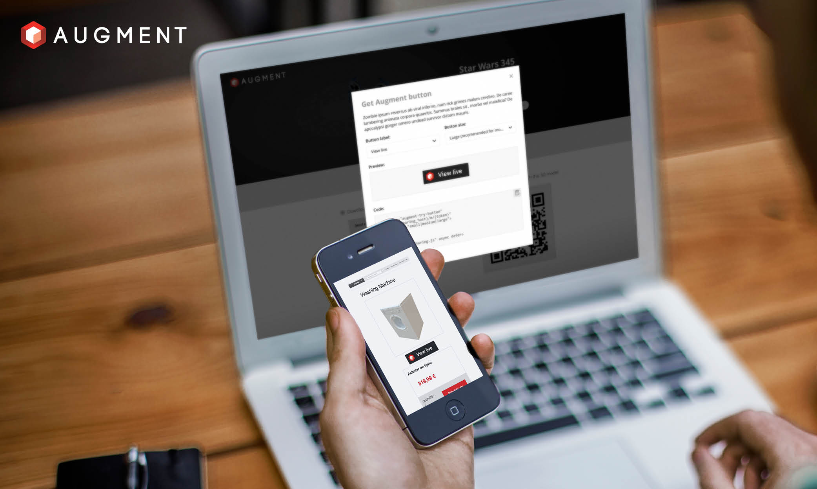
Continuous Improvement and Operations Excellence
Lowe’s has for the last decade being registering continuous improvements and operation excellence which it has transformed to its culture. Specialist and analyst have associated this norm with the company’s policy of total quality management and investments in retail technology. There are only two things that will make a company register such steady continuous growth in such a competitive industry. These include; customer satisfaction and improved marketing strategy. Customer satisfaction is associated with quality of products and services that an organization offers and this is why the company is so strict with quality. Customers come first at Lowe’s and so the company ensure that its customers are satisfied with the services and products that they offer. The company keeps on registering new customers each year who are attracted by the nature of services offered. This has been either through referrals from satisfied customers or just new entrants who would want to try the company’s products (Arani, 71).
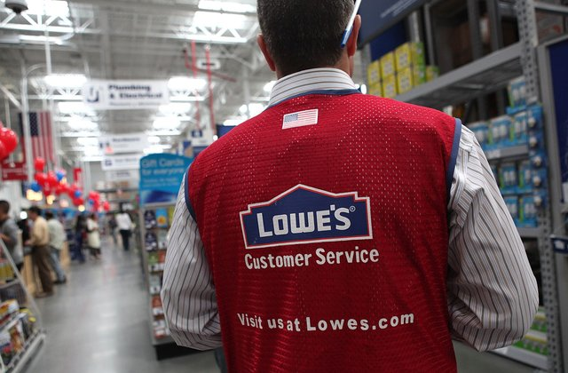
Also, Lowe’s is a strong advocate of continuous improvement and each year the company either introduces new products or services so as to retain its market share and attract new customers. The company has also a very sophisticated business intelligence branch which has played a very crucial role in its dramatic increase in productivity. Each year the company innovates new ways of improving their production processes and also setting new benchmarks which are meant to improve quality and production. In general, the company is a believer of maximizing productivity especially in areas of inventory and project labor and this has ensured continuous improvement is productions. The power of technology is also a driver of continuous development and excellence and it is one of the factors that has enabled the company to thrive in this industry. Technology is one of the critical assets that Lowe’s has and has continued to grow for decades.
Specific tools used by Lowe’s
This is an industry that is dominated with advanced technology and this is why is it has come to be referred to as industry-leading technology. There are several specific tools that Lowe’s use and the most advanced tool is the Data Access and Reporting tool. This is a very important tool that has enabled the company’s employees to access customers’ data, this gives them greater insight into key performance insights. This tool enables employees to run over 15,000 reports in a week and also in managing inventory. This is probably the most advanced too that the company can boast of, it is this tool that enabled the company to undertake market reviews, identify market sales opportunities, and improve margins Lowe's (Companies, Inc. 17). BI is another tool that is used by the company to anticipate which particular product a certain group of customers is likely to buy. It is easy to anticipate which product a certain customer(s) are likely to buy based on the information that you have related to that customer. BI is part of the company’s intelligence unit and has proven to be a very helpful tool in improving merchandise decisions. This tool has also been used to make timely decisions such as stocking and this has led to enhanced employee productivity, timely response to information request, and cost reduction initiatives.

Primary Key Performance Metrics of the business
Lowe’s is one of the advanced companies in the United States and it’s known for its exemplary operations considering its high-efficiency rate. There are several key performance metrics that are notable for viewing the company’s management system. Most of these performance metrics are consumer-focused while others are internally focused. One of the key performance metrics that can be associated with Lowe’s is reliability; this is literally the ability to perform specific tasks as required or expected. In actual sense, reliability has to do with predictability of outcomes. This has been made possible by the reliance of BI which the company relies on to predict different aspects of its operations including production and marketing. Secondly, asset management efficiency is another performance metric that has enabled the company to utilize assets. Mostly, this helps with inventory reducing as well as insourcing as compared to outsourcing. Looking at the LGS sourcing which is a global sourcing network used by Lowe’s, you will realize that the company is utilizing its capacity utilization. Other aspects include cost and responsiveness and these two has enabled the company to achieve continuous improvement and excellence.
In conclusion, Lowe’s is a home improvement company that has proven to be one of the most effective companies in the United States. The company is very effective in one of the most competitive industries in the country and has maintained its market share for decades. For the last few years, the company has been recording continuous improvement in its service delivery, improved quality products, and its culture. This has been made possible by the fact that the company is very innovative and dedicated to ensuring that its customers get the best products ever. Retail technology and acquisitions have been identified as key factors that have necessitated its success. The company is also very strict on quality and uses a third party to oversee the independent verification and inspection of its products. Also, the company has very strict quality related policies that are implemented across all its vendors. As a way of increasing efficiency and improving the quality of produce, the company uses LGS sourcing to acquire its products from over 21 countries.

Work Cited
Arani, O. M; Unique applications of quality improvement tools in sevice and manufacturing industries and in sustainability studies. Publisher: Melbourne, Vic.: DSTO Aeronautical and Maritime Research Laboratory. 2018. Print
Lowe's Companies, Inc. Lowe's home improvement warehouse complete kitchen book. Menlo Park, CA: Sunset Publishing Corporation 2017. Print
Vandervort, D. W., & Lowe's (Firm); Lowe's home improvement warehouse complete bathroom book. Menlo Park, CA: Sunset Pub. Corp 2016. Print.
Waymer, D., & Vanslette, S; Corporate Reputation Management and Issues of Diversity. January 01, 2013. 471-483. Print.

