Name:
Subject:
Institution:

It is essential that Lysistrata should be sacred and should not be manipulated in order to remain strictly faithful to the original intention of the playwright. This will make the design to follow the text to the letter thereby obeying all the indicator’s design in the script. Additionally, this information will make you alert of any creative designer who may need an interpretation from the play. Further play design will be constrained to a limited budget of $8000 which includes space rentals accounting for half of the budget. Finally, the design will be considering the configuration which is roughly thrust and the sides are extremely shallow.
From the director's conversation, the following information will impact the design. First, the design will be impacted by the information regarding the budget constraint which will amount to a limited amount of $8000 inclusive of space rental. Secondly, the theater space information will also impact the design. The theatre is limited to the shallow side since we will convert the church to act as our theater.
The play design is subject to special needs. Such needs include lighting instruments. Our design is only limited to sixteen such lighting instruments. This will ensure that our stage is well illuminated. We need to either incorporate large crucifix in the back wall or build a false wall to conceal it.
For the purposes of the well-casted storyline, we should design a visually compelling design for the purposes of impacting our viewers. This will be achieved by design a neutral design. This means it should not be very shouting nor should it be so dull. Therefore several lighting cues will be used. This includes; key lighting this is the strongest light in the play and is usually first to be set, filling light this light will be used to fill or remove the dark part of the play it is less noticeable and will always be opposite to the key light. (Whitlock, 2018)In order to create a three-dimensional scene we need backlighting, we also need to illuminate the scene from the sides therefore, a side lighting is required.
To have an attractive film we need to have a discussion with another designer to benchmark on color design (MacGillivray, 2014). This will set a tone before any word is uttered by the actor. Since we wish to design a playwright that implicate violence red colour will dominate. In order to symbolize the innocence of the victim, we wish to use pink. For the purpose of isolation, blue will be recommendable. The picture below shows some of the colour that designers recommended.

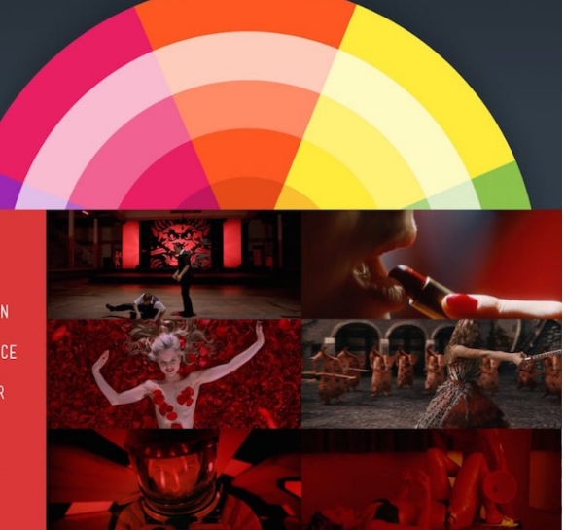

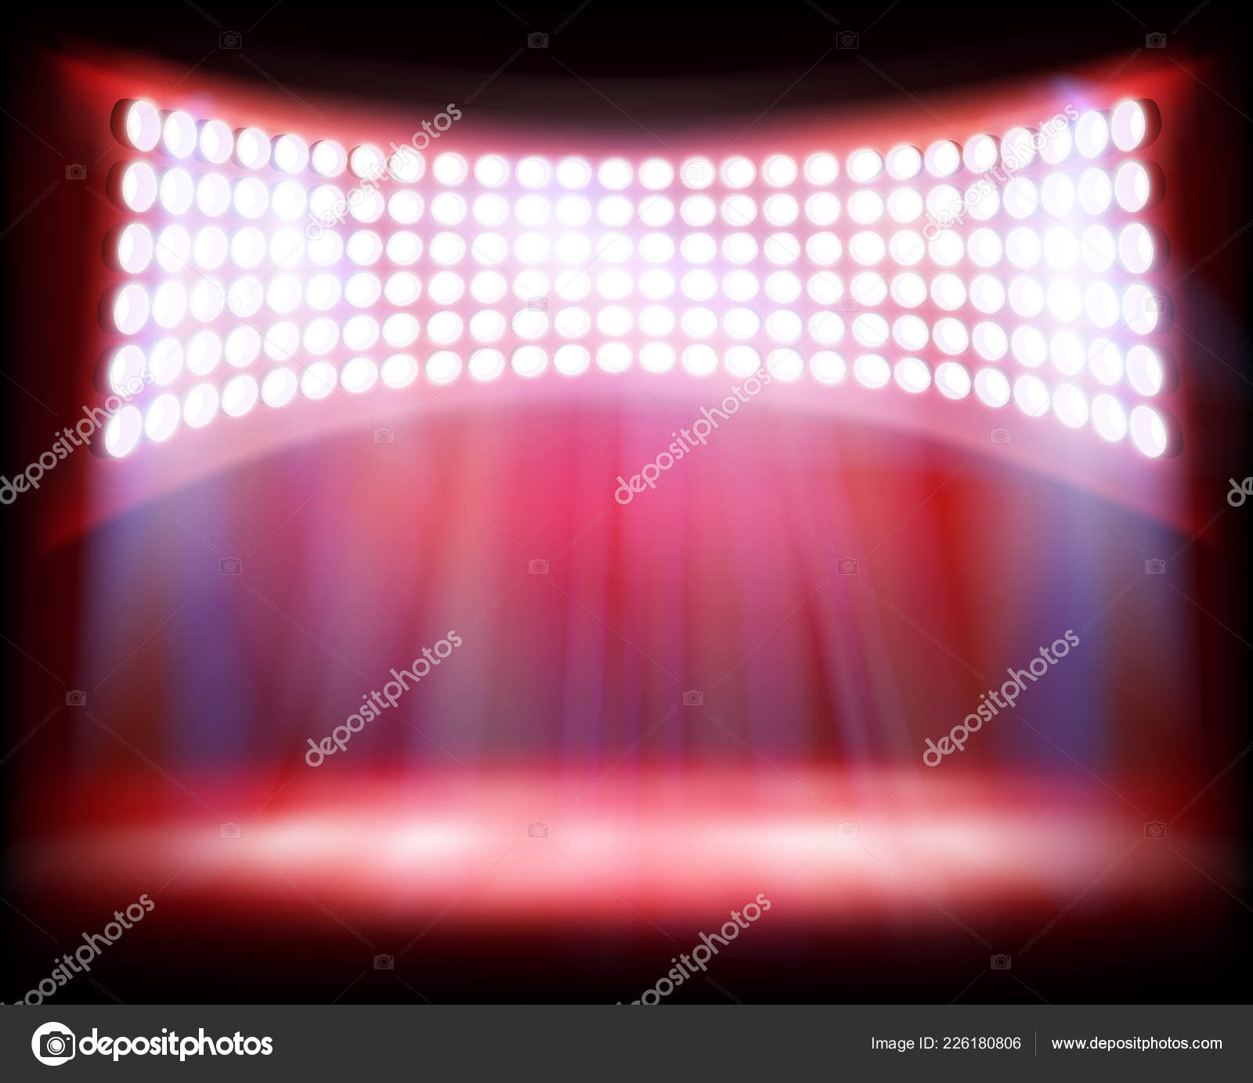

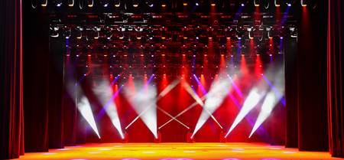

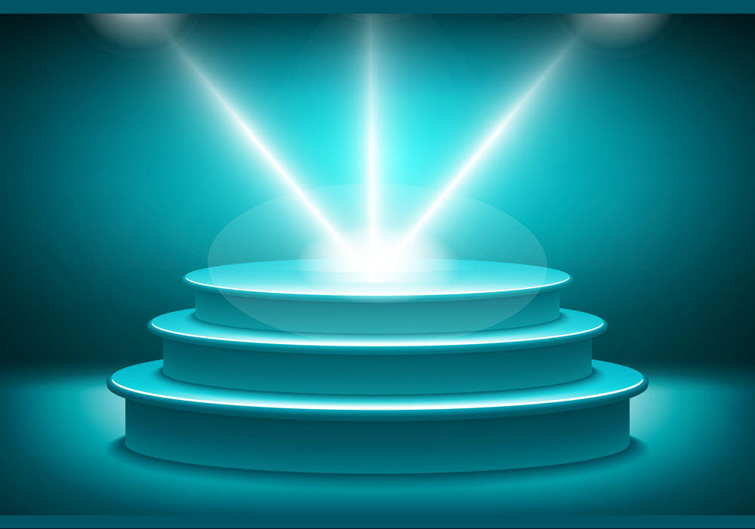

References
MacGillivray, C. (2014, March 18). Explainer: what is production design? Retrieved from theconversation.com: https://theconversation.com/explainer-what-is-production-design-24062
Whitlock, C. (2018, May 10). Top 10 Hollywood Production Design Programs Revealed. Retrieved from www.hollywoodreporter.com: https://www.hollywoodreporter.com/lists/top-10-hollywood-production-design-programs-revealed-1148314

