Coursework submission rules and important notes

Before you start your assignment, it is essential that you familiarise yourself with the Coursework assessment guidelines and instructions available on RevisionMate.
This includes the following information:
- These questions must not be provided to, or discussed with, any other person regardless of whether they are another candidate or not. If you are found to have breached this rule, disciplinary action may be taken against you.
- Important rules relating to referencing all sources including the study text, regulations and citing statute and case law.
- Penalties for contravention of the rules relating to plagiarism and collaboration.
- Coursework marking criteria applied by markers to submitted answers.
- Deadlines for submission of coursework answers.
- The total marks available are 200. You need to obtain 120 marks to pass this assignment.
- Your answer must be submitted on the correct answer template in Arial font, size 11.
- Answers to a coursework assignment should be between 6,000 and 12,000 words in total depending on your writing style.
- Do not include your name or CII PIN anywhere in your answers.
Top tips for answering coursework assignments

- Read the Specimen coursework assignment and answer for this unit, available on RevisionMate.
- Read the Learning Outcome(s) and related study text chapter for each question before answering it.
- Ensure your answer reflects the context of the question. Your answer must be based on the figures and/or information used in the question.
- Ensure you answer all questions.
- Address all the issues raised in each question.
- Do not group question parts together in your answer. If there are parts (a) and (b), answer them separately.
- Where a question requires you to address several items, the marks available for each item are equally weighted. For example, if 4 items are required and the question is worth 12 marks, each item is worth 3 marks.
- Ensure that the length and breadth of each answer matches the maximum marks available. For example, a 30 mark question requires more breadth than a 10 or 20 mark question.

Additional M05 coursework tips

It is recommended that you take the following four-step approach when planning an answer to an M05 question:

- Step One: Identify which area(s) of the law the question is testing and link it back to the correct Learning Outcome(s).
- Step Two: Explain how the relevant area(s) of the law, in outline, may relate to the context set out in the question. Identify relevant statute and case law. When quoting law, focus on the ratio decidendi rather than the general facts of the case.

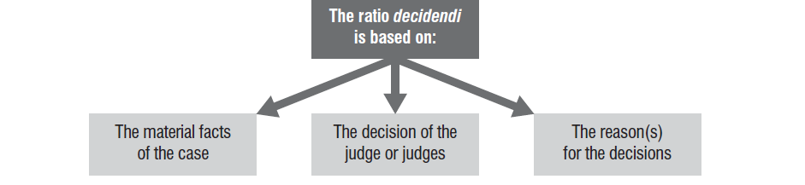

For further information see chapter 1 of the M05 Study text.

- Step Three: Apply the relevant principles of the law, including statute and case law, to the question.
- Step Four: Include in your answer a conclusion which directly links back to the question and relevant area(s) of the law.

The coursework questions link to the Learning Outcomes shown on the M05 syllabus as follows:

Question | Learning Outcome(s) | Chapter(s) in the Study Text | Maximum marks per answer
1 | Learning Outcome 2 | Chapter 2 | 10 marks
2 | Learning Outcome 3 | Chapter 3 | 10 marks
3 | Learning Outcome 4 | Chapter 4 | 10 marks
4 | Learning Outcome 5 | Chapters 3 & 5 & 6 | 30 marks
5 | Learning Outcome 6 | Chapters 3 & 7 | 20 marks
6 | Learning Outcome 7 | Chapter 8 | 20 marks
7 | Learning Outcome 8 | Chapter 9 | 20 marks
8 | Learning Outcome 9 | Chapter 10 | 20 marks
9 | Across more than one Learning Outcome | Across more than one chapter | 30 marks
10 | Across more than one Learning Outcome | Across more than one chapter | 30 marks

To be completed before submission:
Word count:

Start typing your answer here:

Question 1 – Learning Outcome 2 (10 marks)

Question 2 – Learning Outcome 3 (10 marks)

Question 3 – Learning Outcome 4 (10 marks)

Question 4 – Learning Outcome 5 (30 marks)

Question 5 – Learning Outcome 6 (20 marks)

Question 6 – Learning Outcome 7 (20 marks)

Question 7 – Learning Outcome 8 (20 marks)

Question 8 – Learning Outcome 9 (20 marks)

Question 9 – Across more than one Learning Outcome (30 marks)

Question 10 – Across more than one Learning Outcome (30 marks)

Referencing must be completed before submission

All sources must be referenced in the body of your answer as well as in your reference list. See the Specimen coursework assignment and answer for examples of how to reference correctly in text and in your reference list.

References

Glossary of key words

Analyse
Find the relevant facts and examine these in depth. Examine the relationship between various facts and make conclusions or recommendations.

Construct
To build or make something; construct a table.

Describe
Give an account in words (someone or something) including all relevant characteristics, qualities or events.

Devise
To plan or create a method, procedure or system.

Discuss
To consider something in detail; examining the different ideas and opinions about something, for example to weigh up alternative views.

Explain
To make something clear and easy to understand with reasoning and/or justification.

Identify
Recognise and name.

Justify
Support an argument or conclusion. Prove or show grounds for a decision.

Outline
Give a general description briefly showing the essential features.

Recommend with reasons
Provide reasons in favour.

State
Express main points in brief, clear form.

