Performance Management
Name:
Course:
Date:

Coaching Style
Select words, given in the case study, that best describe yourself.
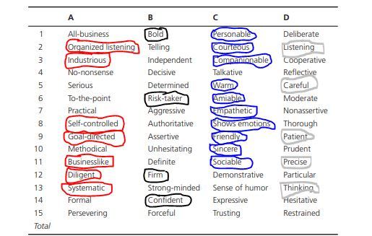
Plot your results on a grid.
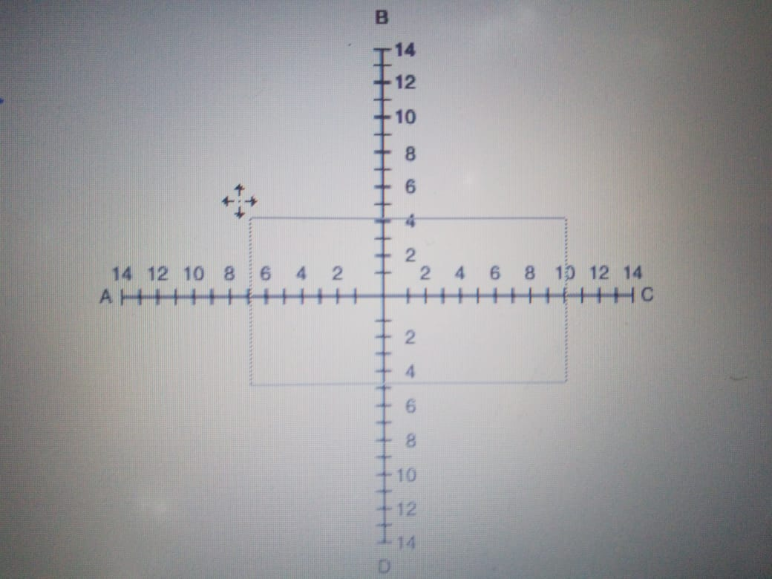
Risky taker
Confident
Goal oriented
Determined
Based on your assessment, respond to the following: What did you learn about yourself? What areas will you change? What steps can be taken to become an adaptive coach?
I have learned that I am a confident coach who is always ready any challenge and win. I am risk taker which means that I can work hard to achieve my goals despite the ups and downs that might be involved. My desire and goal is to achieve my set goals. Areas that I will change will involve changing the way I talk to others and making conversations interesting by adding some sense of humor to improve in my interaction with others. In order to become an adaptive coach I will ensure that I involve others in making my decisions. My coaching style is democratic and I always ensure that other people have their say towards a collective decision making process.

