MAST492 Midterm Exam
October 18, 2021

NAME__________________

Answer the following questions with the knowledge you’ve learned from the class lectures, textbooks, and the case studies students have presented. This exam must represent your own individual effort.
The objective of the exam is to demonstrate your ability to think critically and holistically about a contemporary marine environmental issue, and most importantly, to evolve your understanding from what has been done in the past to ever-changing situations. There is no word limit to each answer, but we recommend you use succinct sentences (or bullet points if needed) to address those questions, which are crucial for efficient communication.
Please submit a word/PDF file to Canvas by 5:00 pm Wednesday, October 20, 2021 (recommended).
- (20%) Figure 1 shows you the seasonally varying riverflow at the Conowingo Dam in the lower Susquehanna River, along with a water quality parameter X at a long-term monitoring station in the upper Chesapeake Bay (1988-2019 climatology, Data from Chesapeake Bay Program Datahub). What water quality parameter do you think X represents, temperature (unit: ºC), salinity (unit: psu), nitrogen (unit: mg/L), chlorophyll (unit: mg/L), or total suspended sediments (mg/L)? Provide at least three convincing arguments to justify your answer (Hint: the absolute value, range of variation, and seasonal phasing with riverflow).
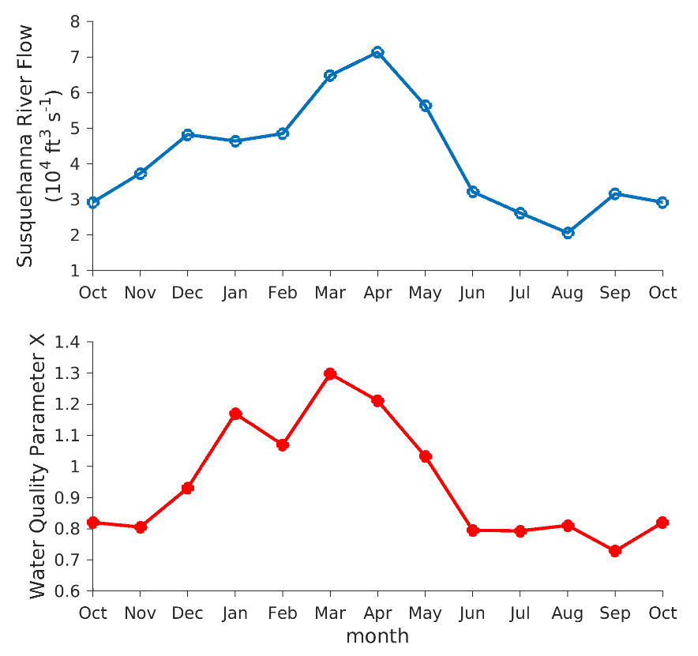

- (20%) What natural factors and human activities predominantly affect the seasonal variations in X concentration at the site? Elaborate your answer.

- Figure 2 shows you the long-term loading of X into the Bay from the Susquehanna River watershed, along with different sources that can affect X input into the Bay (Data from Chesapeake Bay Program Office).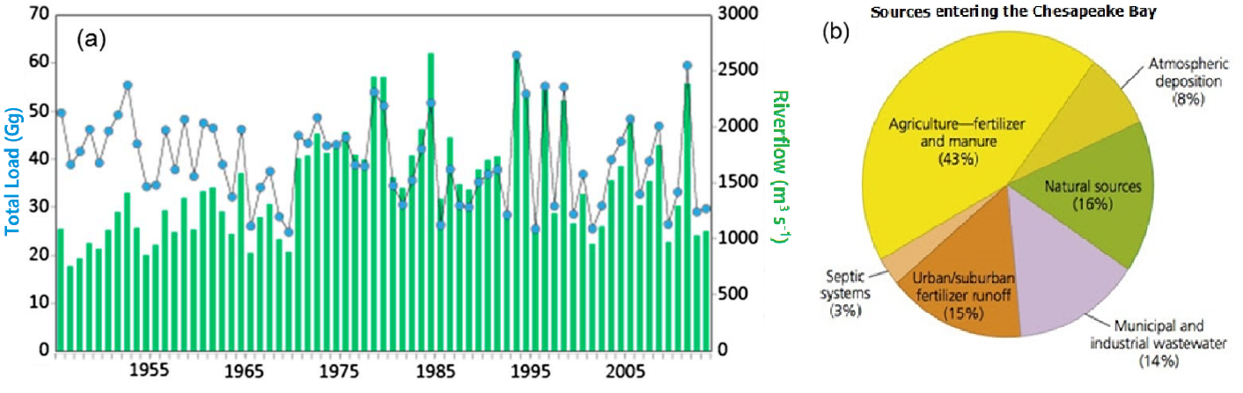
a. (20%) What long-term changes in X load do you observe in Figure 2a (e.g., an abrupt increase, interannual variations, etc.)? What types of human activity are likely to cause these changes?

b. (20%) Based on the pie chart in Figure 2b, what management approaches would likely yield the largest benefits for reducing X inputs into the Chesapeake Bay?

- (20%) Do you observe any human activity changes in your household during the COVID-19 pandemic in comparison to the pre-pandemic routines? With the stay-in-home order in place for a certain time period, if you scale up these changes of human activity from the household level to the community level in the watershed region, what influences do you expect on water quality parameter X?
(Hint: Figure 3 shows you the water quality parameter X in the period of 10/2019-10/2020 in comparison to its long-term mean seasonal cycle. Data from Chesapeake Bay Program Datahub at the same station as Q1).
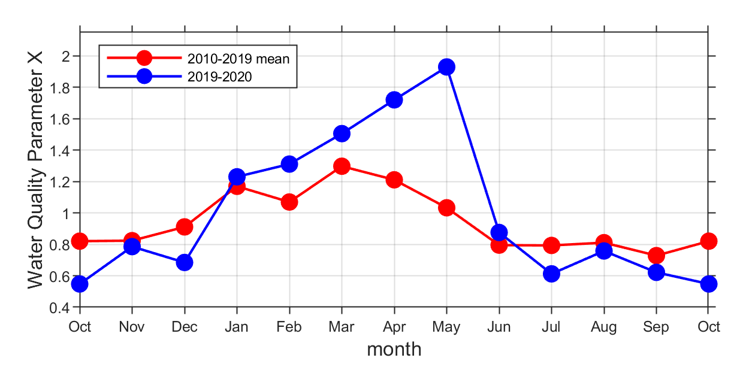

- (Bonus, 25%) We have learned a handful of water quality parameters in the class. Besides the water quality parameter X, can you predict what other water quality parameter(s) may deviate from its seasonal/climatological norms in a near term (e.g., <1 year) due to the human activity changes during the COVID-19 pandemic? Provide at least one justification for your prediction.

