Part I – Statistical Concepts and Interpretation

The corresponding RStudio commands, console output and/or plots have been either included with the question/problem or appended to the end of this assessment.

- [22 points] Lack of sleep costs companies in lost productivity. A major airline recently began encouraging reservation agents to nap during their breaks. In a random sample of 10 of their reservation agents, when comparing the number of complaints about each during the 6 months prior to the policy change to the initial 6 months after, the mean number of complaints received fell by 3.9, with a standard deviation 4.306326.

- [5 points] Create hypotheses appropriate for the following research question: do the data present sufficient evidence to conclude the new napping policy reduced the mean number of complaints about reservation agents?
$$H_{0}: μ_{d}=0$$
$$H_{1}: μ_{d}<0$$

- [6 points] Check the conditions required to complete this test. Given the small sample size, the following boxplot, histogram (with overlaid normal curve) and normal probability plot for the ten observed differences have been provided for reference. Note: see section 1.6.5 on pp. 35-37 and 3.2 on pp. 137-141 for more information on identifying potential outliers and evaluating the normal approximation.

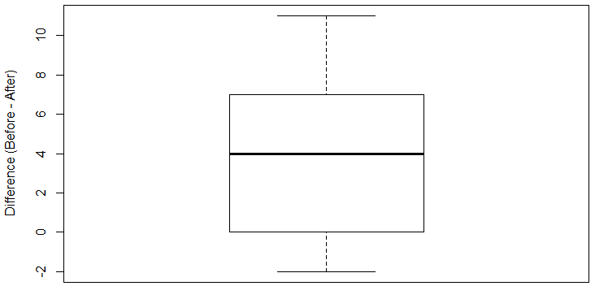
- The population is symmetric and there are no outliers.
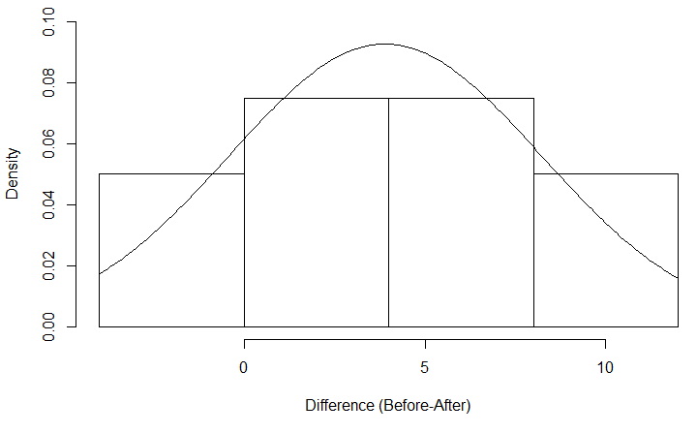
- The distribution of the population is normal.

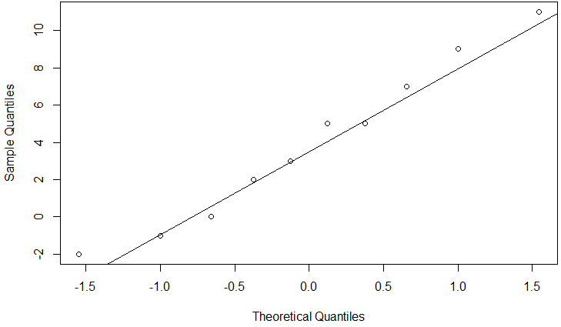
- The population data has a normal distribution since the points fall near the line.

- [6 points] The test statistic and p-value for this test follow in the edited RStudio output below. What do you conclude? State your decision and conclusion in the context of the study. Follow the format of Problem 3, part (d) in Lab 2.

T <- (3.9-0)/(4.306326/sqrt(10)); T

[1] 2.863899

pt(q=T, df=9, lower.tail=F)

[1] 0.00933069

Since the p-value is less than 0.05, reject $H_{0}$. There is enough evidence to conclude that the new napping policy reduced the mean number of complaints about reservation agents.

- [5 points] What type of error might we have made? Explain what the error means in this context.
Type I error. This error means that the null hypothesis might have been rejected when it was actually true.

- [Extra Credit – 10 points] Adopted from Exercise 5.9 on page 258. You are given the following hypotheses: $H_{0}: μ=10$ vs. $H_{A}: μ>10$. We know the sample standard deviation is 6, and the RStudio command qt(0.90,35) returns a critical t-value of 1.306212. Assuming all conditions necessary for inference are satisfied, for what sample mean would the p-value equal the significance level of 0.10? Explain how we could use this sample mean to make a decision for the hypothesis test. Hint: Solve the T-score formula, i.e., test statistic, for $\overline{x}$. The sample size will need to be determined using the appropriate input in the specified qt function. This method for making a decision for a hypothesis test is sometimes referred to as the classical or critical value approach.

$$μ=10$$
$$\overline{x}=?$$
$$n=36$$
$$α=0.1$$
$$s=6$$
$$t-score=1.306212$$
$$t-score=\frac{\overline{x}-μ}{\frac{s}{\sqrt{n}}}$$
$$1.306212=\frac{\overline{x}-10}{\frac{6}{\sqrt{36}}}=\frac{\overline{x}-10}{1}$$
$$1.306212=\overline{x}-10$$
$$\overline{x}=1.303212+10=11.303212$$
If the t-score is greater than the critical value, do not reject Ho. If the t-score is less than the critical value, reject Ho.

- [25 points] Adopted from Exercise 6.54 on page 328. Assisted Reproductive Technology (ART) is a collection of techniques that help facilitate pregnancy (e.g. in vitro fertilization). A 2008 report by the Centers for Disease Control (CDC) and Prevention estimated that ART has been successful in leading to a live birth in 31% of cases. A new fertility clinic claims that their success rate is higher than average. A random sample of 30 of their patients yielded a success rate of 40%. A consumer watchdog group would like to determine if this provides strong evidence to support the company's claim.

- [5 points] Write the hypotheses to test if the success rate for ART at this clinic is significantly higher than the success rate reported by the CDC.

$$H_{0}:p_{0}=0.31$$
$$H_{1}:p_{0}>0.31$$

- [9 points] The normal approximation would be less reliable here, since the success-failure condition on page 275 is not met. Therefore, we could use either (i) a simulation strategy (see section 6.5.2 on pp.303-305) to estimate the p-value or (ii) the binomial cumulative distribution function (see section 6.5.3 on pp. 305-306) to compute the exact p-value.

- [5 points] Below is a histogram showing the distribution of ${\hat{p}}_{sim}$ in 10,000 simulations under the [assumption of the] null hypothesis. Explain how the p-value can be calculated using the simulation results and then determine its value.
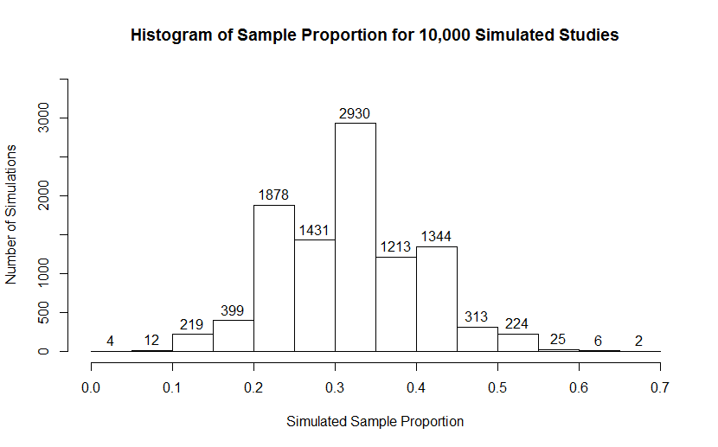
$$p-value=P\left({\hat{p}}_{o}≥40\% \right|Ho is true)$$
The p-value would be the number of simulations above 40% or 0.4 divided by 10000.
The number of simulations equal to or greater than 40%=1344+313+224+25+6+2=1914
$$p-value=\frac{1914}{10000}=0.1914$$

- [4 points] Using the guide below, write the appropriate pbinom command to compute the exact p-value, whose value is $0.1908786$.

pbinom(q, size, prob, lower.tail)

where q is the observed number of successes in the sample, size is the sample size, prob is the hypothesized proportion, $p_{0}$, and lower.tail is set to TRUE for a left-tailed test ($H_{A}:p<p_{0}$) or FALSE for a right-tailed test ($H_{A}:p>p_{0}$). IMPORTANT: if the test is right-tailed and the observed number of successes in the sample is an integer, you will need to decrease its value by 1.

- [6 points] Use the p-value to evaluate the hypotheses. State your decision and conclusion in the context of the study. Follow the format of Problem 3, part (d) in Lab 2.
Reject the null hypothesis. There is enough evidence to conclude that the success rate for ART at this clinic is significantly higher than the success rate reported by the CDC

- [5 points] After performing this analysis, the consumer group releases the following news headline: “Infertility clinic falsely advertises better success rates.” Comment on the appropriateness of this statement. Hint: Given the nature of a hypothesis test, do we really know the truth about the parameter of being tested?
This statement is not appropriate since, from the analysis, the success rate for ART is significantly higher than the success rate reported by the CDC

- [33 points] Adopted from Exercises 6.12 and 6.20 on pp. 315-316.The 2010 General Social Survey asked 1,259 US residents: “Do you think the use of marijuana should be made legal, or not?” 48% of the respondents said it should be made legal.

  - [4 points] Is 48% a sample statistic or a population parameter? Explain.
It is a sample statistic because it represents the general US population.

  - [6 points] A 99% confidence interval for the proportion of US residents who think marijuana should be made legal has been constructed in the edited RStudio console output that follows below. Interpret it in the context of the data. See Example 6.3 on page 276.

p.hat <- 0.48 # observed proportion
n <- 1259 # sample size
C <- 0.99 # confidence level

z <- qnorm(0.5+C/2)
SE <- sqrt(p.hat*(1-p.hat)/n)
m <- z*SE
c(p.hat-m, p.hat+m)

[1] 0.4437318 0.5162682
We are 99% confident that between 44.37% and 51.63% of the US residents think that Marijuana should be made legal.

  - [6 points] A critic points out that this 99% confidence interval is only accurate if the statistic, $\hat{p}$, follows a normal distribution, or if the normal model is a good approximation. Determine if this is true for these data by checking if the required conditions are met. See page 275.
- The sample observations are independent.
- $np=1259*0.48=604.32>10$ and $n\left(1-p\right)=1259\left(1-0.48\right)=654.68>10$.
The conditions are met therefore, the distribution of the statistic is nearly normal.

  - [5 points] A news piece on this survey’s findings states, “Majority of Americans think marijuana should be legalized.” Based on the confidence interval constructed in (b), is this news piece’s statement justified? Explain.
No. US residents’ proportion could be as low as 44.37%.

  - [6 points] If we wanted to limit the margin of error of a 99% confidence interval to 2.5%, use the margin of error, $m$, formula and RStudio console output provided below to determine the minimum number of Americans that would need to be surveyed. See section 6.1.4 on pp. 278-279.

$$z^{*}\sqrt{\frac{p\left(1-p\right)}{n}}<m$$

z <- qnorm(0.995); z

[1] 2.575829

p<-0.48
> me<-0.025
> z<-qnorm(0.995)
> se<-me/z
> n<-(p*(1-p))/se^2
n=2650

  - [6 points] Which two inputs to the margin formula does the researcher have direct control over and how would they change – increase or decrease - one or both values to increase the precision, i.e., reduce the width, of the confidence interval?
- Increase the sample size
- Reducing the confidence interval width

Code

Problem 1, part (b) - FOR REFERENCE ONLY; USED TO GENERATE PLOTS, T, AND P-VALUE

# data: paired differences
before <- c(10,3,16,11,8,2,1,14,5,6)
after <- c(5,0,7,4,6,4,2,3,5,1)
d <- before-after

# boxplot
boxplot(d, ylab="Difference (Before - After)")

# histogram with overlaid normal curve
hist(
x = d,
breaks = seq(-4,12,4),
freq = F,
right = F,
ylim = c(0,0.1),
xlab = "Difference (Before - After)",
main = "Histogram of Differences"
)
lines(x=t<-seq(-4,12,0.1), y=dnorm(t,mean(d),sd(d)))

# normal probability plot
qqnorm(d); qqline(d)

# perform paired t-test
t.test(x=before, y=after, alternative="greater", paired=T)

Problem 3, part (b) – FOR REFERENCE ONLY; USED TO GENERATE HISTOGRAM

n <- 30 # sample size
p.0 <- 0.31 # hypothesized proportion
p.obs <- 0.40 # observed sample proportion
n.sim <- 10000 # number of simulations

# simulate studies using binomial random number generator
p.sim <- rbinom(n.sim, n, p.0)/n

# construct histogram
hist(
x = p.sim,
labels = T,
right = F,
ylim = c(0,3500),
xlab = "Simulated Sample Proportion",
ylab = "Number of Simulations",
main = "Histogram of Sample Proportion for 10,000 Simulated Studies"
)

# compute p-value
sum(p.sim >= p.obs)

Part II – Data Analysis and Application of Inferential Procedures

- [25 points] Adopted from Exercise 6.14 on page 315. A national survey conducted in 2011 among a simple random sample of 1,507 adult Americans found that 844 think the Civil War is still relevant to American politics and political life.

  - Determine if these data provide strong evidence the proportion of all adult Americans think the Civil War is still relevant differs from 0.60 at the 5% significance level.

- [8 points] Write the hypotheses in symbols and words.
Null hypothesis is that the proportion of all adult Americans who think the Civil War is still relevant is equal to 0.6.
Alternative hypothesis is that the proportion of all adult Americans who think the Civil War is still relevant differs from 0.6.
$$H_{0}:p=0.6$$
$$H_{1}:p≠0.6$$

- [6 points] Following the guide provided below, use the prop.test command in RStudio to calculate the test statistic, $Z$, and p-value.

prop.test(x, n, p, conf.level=0.90, correct=F)

Specify the values for x, the number of successes; n, the sample size; and p, the hypothesized proportion, and then copy/paste (or type) the command into the RStudio console (and press enter). Note: The number labeled X-squared is the test statistic, however, you will need to take its square root to get the value of $Z$.
$$x=844, n=1507, p=0.6$$
Test statistic, Z=-3.1654
p-value=0.001548

- [6 points] What is the conclusion of the hypothesis test? State your decision and conclusion in the context of the study. Follow the format of Problem 3, part (d) in Lab 2.
Reject Ho since p-value is less than 0.05. There is sufficient evidence to conclude that the proportion of all adult Americans who think the Civil War is still relevant differs from 0.6.

  - [5 points] Interpret the p-value in this context.
The probability of obtaining a random sample of 1507 Americans where 60% think Civil War is still relevant is approximately 0.001548.

- [15 points] In RStudio, data for a single variable can be entered in the console using the c command. For example x <- c(1,2,3,4,5) stores the first five positive integers in the object x. If we have raw data, i.e., a list of recorded values (or measurements), we can use the t.test command to compute a confidence interval or the test statistic and p-value for a hypothesis test on the mean. Research how to use this command – start with entering ?t.test in the console to get the help file, but also consider the links posted on Blackboard under Course Content > OpenIntro Statistcs, R and RStudio.

  - [5 points] Identify the age at inauguration of the 5th, 10th, 15th, 20th, …, and 45th U.S. presidents.
5th=58
10th=51
15th=65
20th=49
25th=54
30th=51
35th=43
40th=69
45th=70
  - [10 points] Assuming these 9 individuals form a representative sample of all U.S. presidents, use the t.test command to construct and interpret a 90% confidence interval for the mean age at inauguration.
> t.test(x,mu=0,conf.level = 0.9)

- One Sample t-test

- data: x
- t = 17.945, df = 8, p-value = 9.536e-08
- alternative hypothesis: true mean is not equal to 0
- 90 percent confidence interval:
- 50.79443 62.53890
- sample estimates:
- mean of x
- 56.66667

Confidence interval= (50.79443,62.53890)
We are 90% confident that between 50.79% and 62.54% of the US Presidents all under the mean age at inauguration.

