PSY 350: Analysis Plan Worksheet

In this worksheet, you’ll plan the analyses you need to perform for your paper. You’ll need the full paper instructions.
Descriptive Statistics
What descriptive statistics should you calculate and report for each variable? Remember that descriptive statistics are numbers we use to summarize one variable across all of the people in our study. I am asking you here for the name of one or more statistics that are appropriate to describe each of these variables individually (not relationships between variables or hypothesis tests). You started this in your Identifying Variables worksheet – if you got full credit there, keep what you had, or make changes if needed.
Include the demographic variables (only those you actually have). Which R functions do you need to obtain those descriptive statistics? Just list the names of the relevant functions (you don’t need the full script with your dataset name, etc.). (0.5 point per row)
 | Name(s) in Data | Which Statistics Are Appropriate? | R Functions
Example IV: | caff | Proportions in each condition | Prop. Table()
IV #1: | MID | Median trust level index | Mid.table()
IV #2: | AVE | The average trust index | Ave.table()
DV: | DVAR | Variance of answers | Dvar.table()
Covariate: | STEDV | Standard deviation | Stedv.table()
Demographics: | VAR | Variance of trust levels | Var.table ()

Correlations
Which of your variables are measured and continuous? These are the only variables it makes sense to correlate! (1 point)
MID and AVE
What R function(s) do you need to find the correlations among these variables? How do you find correlations among several variables (a subset) all at once? (0.5 point)
DVAR and STDEV
Recruitment Source Differences
As explained in your Introduction & Method, the researchers recruited participants from two different sources to participate in your study. As the Paper Guidelines explain, you need to rule out the possibility that the different recruitment sources led to differences in your DV.
What values should you calculate to assess the shape of any possible difference? (I am asking you to name the appropriate statistic here, not calculate anything). Be specific. (1 point)
Average age of participants
If there is no meaningful difference between recruitment sources, what do you expect these values to look like? Describe this in conceptual terms, I am not looking for you to predict specific numbers. (0.5 point)
An average age factor closer to the median age value
What is the name of the appropriate effect size statistic to calculate for this kind of data? (1 point)
Standardized mean value
If there is no meaningful difference between recruitment sources, what do you expect the effect size statistic to look like? (1 point)
The age of participants did not influence their trust of automated cars
What statistical test is most appropriate for determining whether the difference between these two groups on the DV is statistically significant? Be specific (identify the specific variation of this test that is appropriate for the data you have). (1 point)
Independent sample T test
Why is this test the most appropriate? (1 point)
It compares the difference between the means of two independent variables
If there is no statistically significant difference between recruitment sources, what do you expect to see in the results of your significance test? (1 point)
No divergent means in trust level of the different age groups of the subjects
What R function do you need to perform this test? (0.5 point)
T. test (array1, array 2, tails, type)

Effects of Independent Variables
State your hypotheses about the main effects of your independent variables. Again, if these were correct in the Identifying Variables Worksheet, just repeat them here! If not, make any necessary changes now. (1 point each)
Hypothesis 1: | The age of respondents affected their trust levels automated vehicle
Hypothesis 2: | Past experience with automated systems influenced trust index of the subjects

State your hypothesis about the interaction between your two independent variables here. Make sure that you clearly indicate how you expect the effect of one IV to change based on the level of the other IV! Note that Hypothesis 3 in the Identifying Variables Worksheet was about your covariate. We are changing the order here because it will make much more sense to test these three together! (1 point)
Hypothesis 3: | The probability of people trusting automatic cars is dependent on their age and past experiences with automated machines and systems.

Draw a figure that represents the interaction you expect. You can create your figure using the Chart function in Word or Excel, or you can draw it on paper and attach a photo – the format doesn’t matter but I want to see what you expect the interaction to look like. (1 point)
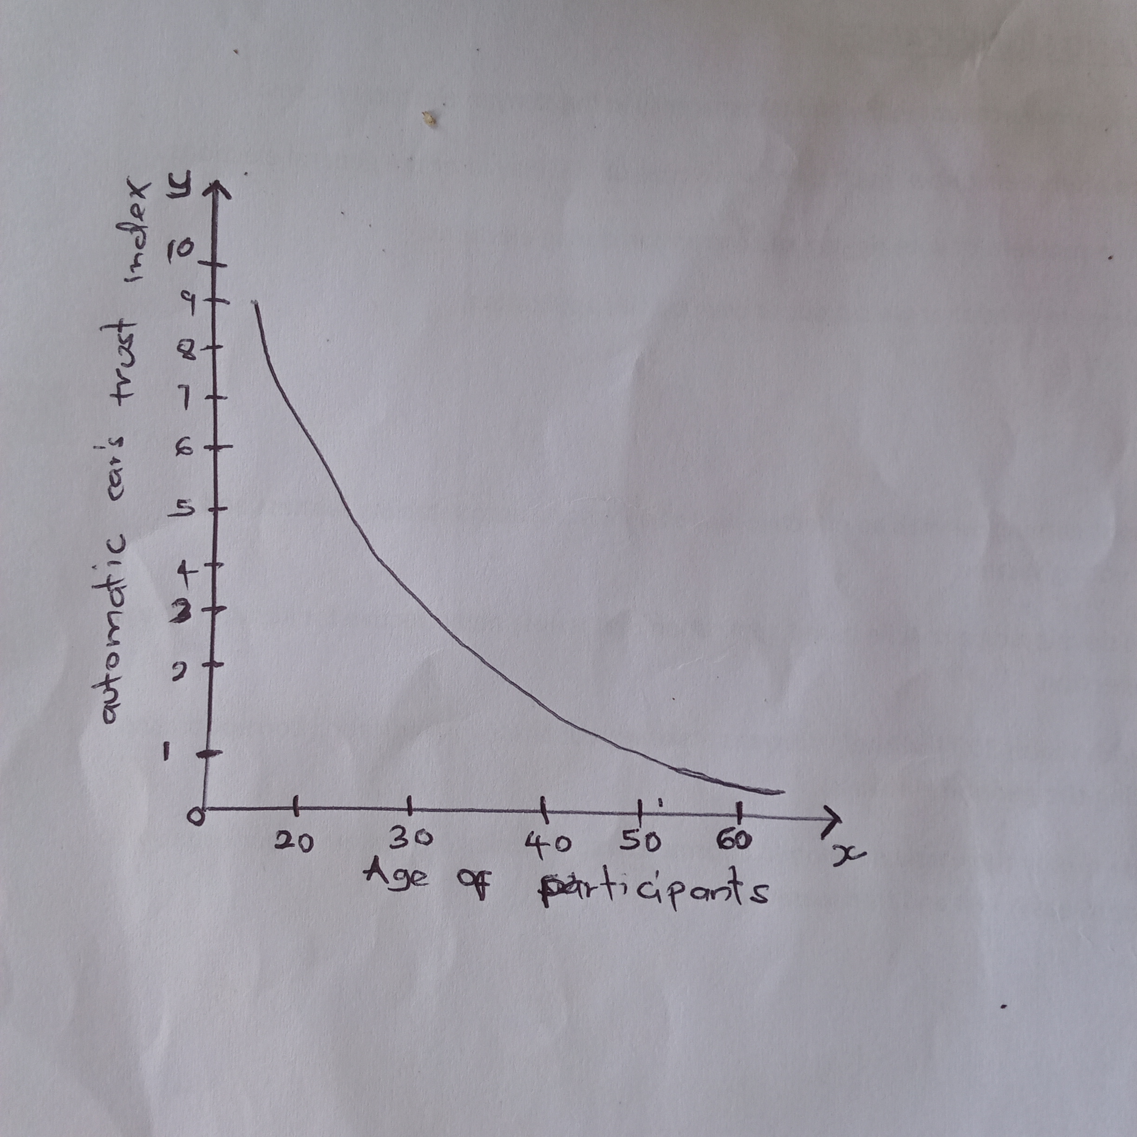

What values should you calculate to assess the shape of your possible effects? (I am asking you to name the appropriate statistic here, not calculate anything). Be specific. (1 point)
Age of participants, extraversion value
If Hypothesis 1 is supported, what do you expect these values to look like? Describe this in conceptual terms, I am not looking for you to predict specific numbers. (0.5 point)
Younger people are likely to have more confidence with automates cars because they are more exposed to technology
If Hypothesis 2 is supported, what do you expect these values to look like? Describe this in conceptual terms, I am not looking for you to predict specific numbers. (0.5 point)
People who have had past experiences with automated machines and systems are more likely to have stronger confidence in automated cars
If Hypothesis 3 is supported, what do you expect these values to look like? Describe this in conceptual terms, I am not looking for you to predict specific numbers. (0.5 point)
Respondents who are younger and have been exposed to automated machines in the past are likely to have more trust in automated vehicles
What statistical test will allow you to assess the significance of your effects for Hypotheses 1-3 all in the same analysis? Be specific. (1 point)
Slope of a regression line
Why is this test the most appropriate option here? (1 point)
The test will effectively test the null hypothesis
How will you know whether there is a statistically significant effect for each hypothesis? What values will you look for in the results of your significance test, and what do you expect those values to look like? (1 point)
If the curve has a sloping gradient as predicted
What R function do you need to perform this test? (0.5 point)
The standard error of the slope coefficient
What post hoc analyses will you need to perform if your omnibus test gives you a significant result? Be specific. (1 point)
The Pearson correlation coefficient
What is the name of the appropriate effect size statistic to calculate for this kind of analysis? (1 point)
Standardized mean difference of groups

Covariate
What statistic should you use to evaluate the internal consistency of your covariate? (1 point)
Average inter-item correlation
What value(s) would allow you to conclude that the internal consistency is acceptable? (0.5 point)
Extraversion trust index data
What R function do you need to calculate internal consistency? (0.5 point)
Cronbach’s alpha test
What kind of variable is your covariate (grouping or continuous)? What is the level of measurement of your covariate? (1 point)
Discrete variables
Hypothesis 4 should deal with the relationship between the covariate and the DV. State your hypothesis here (again, keep it from the Identifying Variables Worksheet if you got full credit there). (1 point)
Hypothesis 4: | The mean item-total correlation is directly linked to the standard deviation value

According to the Paper Guidelines, what kind of analysis do you need to test the relationship between your covariate and your DV? (1 point)
The ANCOVA analysis
Moving Forward
Now that you’ve completed your plan, are you confident in your ability to execute and interpret it? Are there any components of the analysis that you still have questions about? (2 points)
I would like to get clarification on the use of Cronbach’s alpha test to measure the internal consistence of my data.
I would also use some clarification on the use of the ANCOVA analysis in measuring the relationship between the covariate of my data and the standard deviation

