MENU
  - Afternoon Menu
All afternoon teas are served on our handpicked vintage hotel, and is served along with a selection of sweet and savory items

10-Minute White Bean Artichoke Basil Toasts + Early-Grey Tea

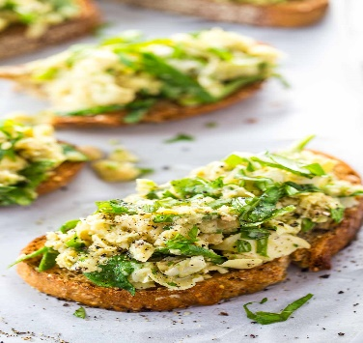
Ingredients

These miniature toasts are stacked high with the most simple, summery, 10-minute artichoke + spinach + chickpea Salad that is chiefly a built-up invitation for any of your fresh summertime herbs. The sour flavor of the artichokes and the lemon plus the smooth, silky, creamy taste of the olive oil and the freshness of the rosemary with some cracked black pepper over the whole thing. It is best with Early-Grey Tea, the famous of all black teas, seasoned with bergamot oil giving it a cologne musk. @ $20.55

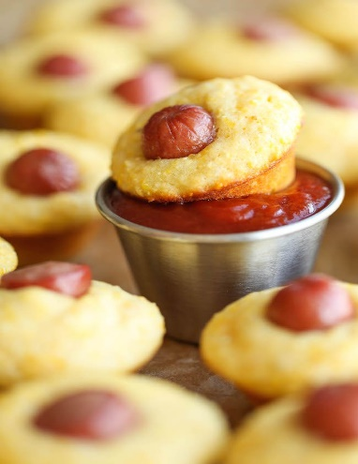
Mini Corn Dog Muffins + Masala Chai Tea
Ingredients
Buttermilk, cornmeal, and unsweetened applesauce.
These mini corn dogs are loaded with aroma! For the lovers of corn dogs, definitely, you're going to adore this formula of min corn dog muffins! What's more, they make an incredible football-watching nibble for those defining moments! It is best served with Masala Chai Tea prepared by adding ginger and cardamom, then served with milk and sugar. @ $25.50

Mexican Shrimp Bites + Green Tea

Ingredients Guacamole smashes of Queso Fresco cheese and hardened shrimp.
This recipe for Mexican shrimp bites is seared shrimp and guacamole layered onto individual potato chips. A super easy appetizer! It is best served with Green Tea a traditional Chinese tea processed which are not oxidized. @ $22.00
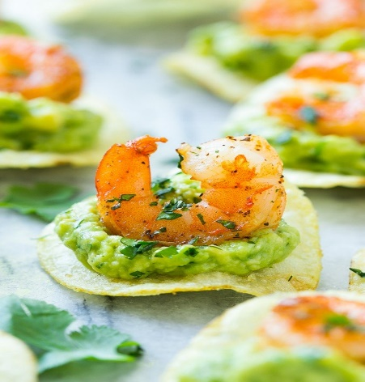
- Baked Rosemary Wedges with Garlic Aioli + Macha Tea
Ingredients
Crunchy, aromatic potato wedges immersed in a delicious 5-minute garlic aioli.The flawless taster or side to any meal
It is best served with Macha Tea derived from Japan; it's a green-colored tea that comes along with the stone-ground powder. Whenever you locate green-tea somewhere, that's definitely derived from Matcha. @ $15.59
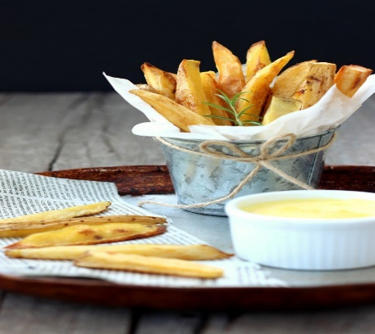

Chicken Fried Steak Fingers
Ingredients
Chicken Cooked Steak Fingers with a crunchy, Cajun sweetened coating and a Creole mustard dipping sauce.
It is best served with Oolong Tea processed from the same plants that manufacture black and green tea. Oolong is semi-oxidized, which is brown.
The reported benefits are helping to reduce the risks of being exposed to diabetes. It comes along with a variety of antioxidants. @ $32.55
