Institution Affiliated
Course Details
Professor
Date

Introduction
The rationale for investing in a new BrewPub involves considering an opportunity by the owner of an existing restaurant/tavern basing on a running case and a business simulation package. The owner considers increasing competition locally by investing more on new system (BrewPub) in brewing craft beer (draught-beer) in the house. In aligning to the rationale in pursuing the proposed venture which seeks to capitalize on both regional and national trends that helps in demonstrating the hike in interest for craft and beers.
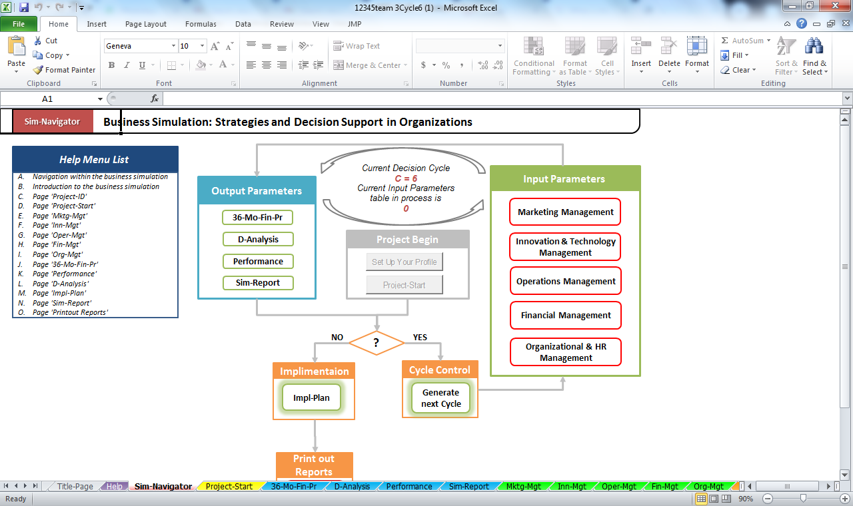
Figure 1: Business Simulation and Decision Support in Organizations

In decision making process of any company organization management is required that helps in realizing if the company is making profits or loses. If the company is making loses then through management it can be used in predicting future profits. Organizational management is a crucial element in the appreciation of a company's weaknesses as well as strengths. Companies and various organizations need to understand their weaknesses and strengths to improve and propel them further. It is crucial to realize that organizational management derives an organization's information concerning the performance and the factors that determine success. The stakeholders of an organization or company ought to participate in their formal management to gain insight into the organization's general performance. There is always room to improve even the best services regarding the customers and stakeholders within the company. Companies that plan visualize organizational management as a business opportunity that offers more than just a perspective into the company’s weaknesses and strengths. Opportunities and new business frontiers are only realized when the company improves its weaknesses and strengths as it unveils the untapped potential within a company.
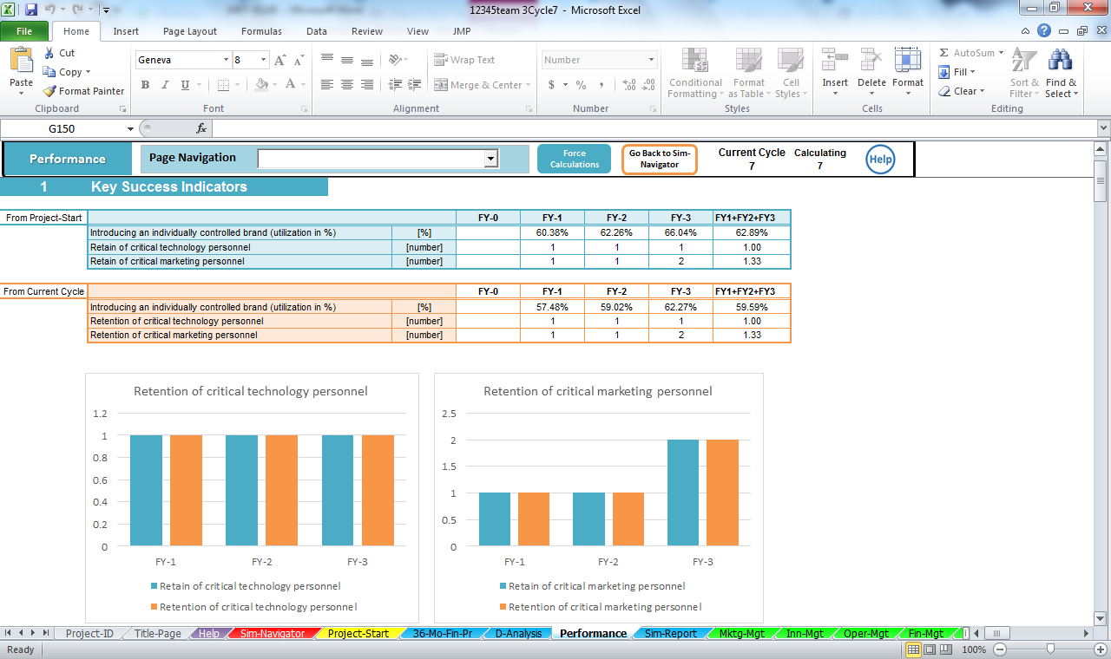
Figure 1: BrewPub Performance
Operations management
Company or operations management occurs in four different types; business operations management, culture health management, organizational/company health management, and leadership capability management within the entire organization or company. Each of these managements has its importance on the future of the said company or organization. For example, the organizational culture management indicates the interactive nature between the employees and the organizational systems put in place. This management reveals the loopholes in the said relationship and explores creative ways of improving its culture in the future. On the other hand, the business operations management is also crucial as it focuses only on its processes. The evaluation seeks to add more value to these processes by exploring their weaknesses and offering an in-depth review of how the said processes may be improved in the future. The organizational leadership management encompasses the leadership within the entire company and its effectiveness. This management analyzes how effective the organization's leadership is and identifies critical areas of improvement for its management and team leaders. The organizational health management is perhaps the most vital form of a company management that an organization can perform. The review considers all the aspects characterizing the company, including leadership, culture, business practices and business strategies. The management aims to improve the prioritization of a company's goals, business procedures, better organizational structuring, and effective allocation of the available corporate resources.
Quality Control and decisions making
Quality control is an essential element in any company that seeks the perfection of its products or services and that the quality of these services is retained. Furthermore, quality control brings value to the organization's stakeholders from the most basic level to the managerial level by creating a conducive environment where these different entities are given a chance to execute their assigned duties optimally. Quality control in an organization is achievable through thorough training of employees, product testing, and product benchmarks for quality purposes. An effective control system ought to have clearly defined control procedures to ensure minimal quality losses by specifying the standards to be followed in what products and by which employees. BrewPub Company takes quality control seriously. The company applies procedures and mechanisms that have already been tested and proven to work in different firms. The company further implements advanced technologies in the resolutions of quality control procedural challenges, meaning that it remains innovative and result-oriented. As the company has accumulated vast experience over the thirty-six years or so that it has been in existence, the quality control mechanisms that it applies while offering property management service to its customers are effective and yield results beyond the expectation. As a result, the company boasts of continually improving and exceptional results compared to other competitors in the same niche. It achieves low resident turnovers, best rental rates in the market, a high percentage of occupancy, and maximum use of the managed properties.
The structural design of an organization is a crucial element in the decision-making process within the said firm. There are two main organizational structural designs. These are organic and hierarchical structures.
- Organic organizational structure
This structure is mainly described as flat because it lacks defined leadership levels as in a typical leadership pyramid. In other words, there is no defined flow of power from the employees' level to the senior managerial levels (Leonard, 2018). In this structure, dozens of employees work in clustered groups that are horizontal instead of the in vertical clusters. An organization's culture that runs on this type of structure aims to create a harmonious employee culture via the decentralization of managerial duties (Lee & Edmondson, 2017). The employees are encouraged to organize themselves into teams that oversee the completion of specific allocated roles while fostering coordination and participation of different groups (Sollund, 2006). Here, the communication occurs between the various teams and is horizontal as compared to the vertical flow of information from lower to the upper managerial levels in the traditional hierarchical organizational structure. It is also worth noting that many organizations that adopt the organic structure are keen on implementing the open-floor office space design plan in modern times.
- Hierarchical Organizational structure
In this type of structure, the leadership roles are clearly defined, and a leadership pyramid can be drawn. The interaction between the employees and the management is different when compared to the organic structure (Lee & Edmondson, 2017). Here, the top most management and leadership levels sit at the top of the leadership pyramid and can delegate roles and duties to the employees below them in the pyramid. The leadership is centralized, and team leaders are managers (Sollund, 2006). The communication between the teams and the managers is formalized and appears in a written form. This structure is rigid and stable, especially regarding the delegation of the leadership roles between the different employee levels in the organization (Leonard, 2018). The hierarchical organizational structure is heavily driven by reports that are generated continuously at different organization levels. It is also imperative to note that the leaders in this structure must practice loyalty to the company and cultivate the same with the employees who report to them on different company or organization matters (Sollund, 2006). On the other hand, since the employees are expected to follow the guidelines and directions communicated by their leaders and managers, they ought to have explicit trust in their leaders and the decisions they are expected to follow.
The BrewPub Company is hierarchical. Different workers work under other managers. Hence, the company's decision process flows from the top management to the different levels of employees. Furthermore, the company has five different levels of employees, as illustrated by the table below.

1 | Employees
 |  |  |  |  | Salary increase
 | Position |  | Budget | Number | FY-2 | FY-3
 | Office Assistants |  | $ 6,000 | 1 | 1.11 | 1.2
 | Salesmen |  | $ 65,000 | 2 | 1.11 | 1.2
 | Executive Salaries |  | $ 12,000 | 1 | 1.11 | 1.2
 | Miscellaneous (Consultants) |  | $ 12,000 | 1 | 1.11 | 1.2
 |  |  | FY-1 | FY-2 | FY-3
 | Total |  | $95,000 | $105,450 | $126,540
2 | Utilities, Supplies and other
 |  |  | Payment | Payment increase
 |  |  | FY-1 | FY-2 | FY-3
 | Leasing of cars, computers, etc |  | $ 5,000 | 1 | 1
 | Office Supply |  | $ 2,500 | 1 | 1
 | Heat, Light, Phone |  | $ 3,500 | 1 | 1
 | Insurance |  | $ 7,500 | 1 | 1
 | Depreciation |  | $ 7,500 | 1.9 | 0.9
 |  |  | FY-1 | FY-2 | FY-3
 | Total |  | $26,000 | $32,750 | $31,325
3 | Marketing costs
 |  |  | Payment | Payment increase
 |  |  | FY-1 | FY-2 | FY-3
 | Local Advertising |  | $ 18,000 | 1.11 | 1.2
 | Trade Shows |  | $ 2,000 | 1.11 | 1.2
 | Website |  | $ 10,000 | $1.11 | $1.20
 | Total |  | $30,000 | $33,300 | $39,960
4 | Rent
 |  |  |  |  | Payment increase
 |  |  | Payment | Space (ft^2) | FY-2 | FY-3
 | Office |  | $ 220,000 | 180 | 1.1 | 1.2
 |  |  | FY-1 | FY-2 | FY-3
 | Total |  | $220,000 | $242,000 | $290,400
5 | Debt
 |  |  | FY-1 | FY-2 | FY-3
 | Loan |  | Amount | Interest rate | length (months) | payments/year
 | Bank of America |  | $450,000 | 10.0% | 36 | 12
 | Total Debt |  | $450,000
 | Payment |  | $173,152 | $173,152 | $173,152
 | Private Investment |  | $150,000
Add item

6 | Taxes
 | Taxes type |  | Percentage
 | Profit |  | 6.25%
7 | Financial Market Indicators
 |  |  |  | Percentage
 | Expected Return on Investment |  |  | 5.0%
 | Risk-Free Interest rate |  |  | 1.0%

Table. 1: Different Employee levels at BrewPub Company
Innovation & Technology Management
According to BrewPub Management is continually exploring new rising opportunities that can be offered to their clients. The company has a clear focus on technology, which is a clear indicator of its dynamic approach to arising challenges and opportunities. Apart from dealing majorly in property management, the company diversified into affordable housing that would help acquires new properties by their targeted customers and later offer more management work for these newly acquired properties. Furthermore, the company also employs strategic partnerships that are essential in its market acquisition.
Organization and HR Management
An organization or corporate culture is a critical element that dictates the management and employees' behavior in their transactions with the outside business. It is essential to note that the company culture is dynamic and implied rather than explicit. Company culture develops over a long time, derived from the employees' work and ethical characteristics that the company hires. The BrewPub company atmosphere is described using several adjectives. Firstly, the atmosphere is customer-focused and cost-conscious. The company makes striking alliances with money lending organizations and other housing bodied to ensure that the customer can access housing and cheaper and quality housing. These efforts clearly illustrate that the company operates with the customer needs at its core by ensuring that the customers get the most affordable housing options possible. The company is also innovative as it is always researching the best techniques that could be applied to bettering the company's service delivery to the customers. This aspect is also emphasized because it diversified its services to suit a changing business environment and a vast customer base by introducing new services that meet its customers' needs holistically.
Core Competency Management
Competency management refers to the thorough process of matching the professional and individual characteristics of an employee or an applicant to the business goals and plans. Most organizations today perform competency-based managements on their employees and their recruiting process to ensure that they get the right person to complete the company's required tasks (Lasse, 2020). Competency management is an essential tool in quantifying the professional and skill gaps in an individual. The review weighs how (individual behavior) the individual executes what (task). After the measurements are taken, the individual's proficiency is determined and matched against the expected ability to evaluate any possible task and skill gaps.
Capability
An organization's core competencies refer to those abilities, skills, or experience that set the organization apart from the competitors, thereby creating a competitive advantage for the company. If an organization has a core competency, the capability is translated to the organization's strategic strength or bargaining power in the market space. Core competencies are essential in the creation of new business products and strategies to outdo the competition. Some measures may be applied in the testing and determination of organizational core competency as described below;
- A core competency must pave the way for the development of new business products with an assurance of opening even more expansive market space for the product.
- In addition to the above point, the core competency must be a critical contributor to realizing success for the newly created business product or service.
- The core competency must have no loose ends in that it should be an uphill task for any competitor to copy or reproduce. If the competition copies and replicates the skill or ability, then the competitive advantage that the initial company enjoyed through the skill or experience is lost.
The organizational core competencies are identified and developed over a long period so that they are deeply mastered. The mastered core competencies then become an essential part of the creations and sustainability of the organization's competitive advantage over time (Lasse, 2020). The organization's skill set and abilities, experiences, knowledge, and technologies and techniques used in the company are vital factors in identifying its core competencies. It is critical to note that the firms continue to identify new competencies and apply them in their business processes. These companies' objective is to offer their products and services at a whole new, dynamic, and innovative level. Such organizations continue to perfect their competencies while markets' competencies market trends to develop the futures markets' competencies. The companies look to the future with confidence as they already understood the markets' wants and needs long before getting there.
The BrewPub Company has a core competency in beer brewing. As earlier illustrated in this text, the company follows a well-defined set of procedures to achieve the best results in both beers brewing and selling.

References
Lasse, C. (2020). What is a Competency Management? Association for Talent Development. Retrieved from https://www.td.org/insights/what-is-a-competency-management
Lee, M. Y., & Edmondson, A. C. (2017). Self-managing organizations: Exploring the limits of less-hierarchical organizing. Research in organizational behavior, 37, 35-58.
Leonard, K. (2018). Organic Structure of Organizational Design. Chron. Retrieved from https://smallbusiness.chron.com/organic-structure-organizational-design-58657.html#:~:text=The%20organizational%20design%20of%20a,structure%20is%20a%20centralized%20approach.
Sollund, R. (2006). Mechanistic versus organic organizations' impact on immigrant women's work satisfaction and occupational mobility. Scandinavian Journal of Hospitality and Tourism, 6(4), 287-307.

