Human resource contracting agency
Name
Instructor
Course
Date

Competitive Strategy

Competitive Forces
Strongest  Force | BOI Example | Force-Strength | BOI Response
Bargain power of suppliers and customers, government regulations threat, new entrants’ threat, and competitive rivalry are viewed as competitive forces that affect the competitions within the staffing industry(Bailey, Mankin, Kelliher, &Garavan, 2018). The staffing industry is a highly competitive industry where employees and employers meet to match demand and supply. The industry is dominated by low entry barriers and few major players shattered many small businesses. The strongest force in the staffing industry is Rivalry and a high level of competition. | Human Resource Contracting Agency | The low barriers to entry have made it possible for human resource contracting agencies to begin businesses which have increased the level of competitions and pushed down prices. Competitions among the existing human resource contracting agencies make many various forms in an attempt to acquire competitive edge that include warranty, improvements of services, the launch of new of products, advertising campaigns and prices discounting (Brewster, Chung, & Sparrow, 2016). The exit barriers within the recruiting industry are high therefore increasing the levels of rivalry within the industry. The level of competitions among the players in the recruiting is also because the market growth size is low. Not surprisingly, the LinkedIn Recruiter launch has sent shockwaves in the entire recruiting industry. LinkedIn Recruiter has caused real competition industry as it has a database which provides hiring companies to access more than 300 million job seekers and candidates bundled with analytics platforms and system of talent management. This site is appearing to minimize the cost/time barriers for in-house human resource managers' entry who can now utilize this subscription services rather than using outside human resource contracting agencies or outside recruiting firms. One might initially reach into a conclusion based on the model of Porters that the LinkedIn Recruiter Launch resulted in the strengthening of various forces within the recruiting industry that includes substitution threat, entry or enhanced other players' participation in the industry, and increased the negotiation power of the customers. | The existing competitive situations in the staffing industry is something our human resource contracting agency pays most attention to as it is of great significance for the profitability of the agency. Our human resource contracting agency strives to safeguard the structure of the industry and competitive stability. Our Human Resource Contracting Agency tends to utilize strategies like cost leadership and differentiation to respond to the stiff competition.

Competitive Strategy Identified
Our Human Resource Contracting Agency utilizes a cost leadership strategy and differentiation strategy. The agency aims to become the lowest cost producer in the recruiting industry. Our agency is large enough to compete with other agencies on the price and earn higher unit profits. Reduction of cost offers the focus of the strategy of agency (Noe, Hollenbeck, Gerhart, & Wright, 2006). The agency targets a large market and the competitive edge shall be accomplished by pulling down costs. The agency intends to be the cost to the leader and to remain unchallenged in this position. This strategy shall be so beneficial since in the recruiting industry, the customer's price sensitive.
In a differentiation strategy, our agency would develop services that provide unique features which are valued with customers and therefore make the clients to perceive our products or services to better and different than that of our competitors(Bailey, Mankin, Kelliher, &Garavan, 2018). The value added by the products’ uniqueness will allow us to charge prices for them. The differentiation shall be based on additional features, after-sales, and product image. It will be achieved through strong marketing, flair, and research capability.
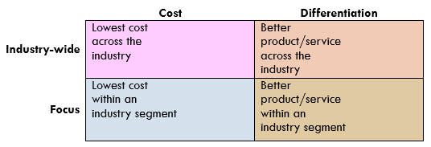



IS for Competitive Advantage
In the digital era of today, our agency needs to have dynamic boundaries view among suppliers, other agencies, and customers with both collaboration and competitions taking place with the industry set members(Noe, Hollenbeck, Gerhart, & Wright, 2006). The revolution of information is sweeping through every industry and no firm can escape the effects of Information Systems. Dramatic cost reductions in how we obtain, process, and transmit information are transforming the manner in which we conduct our business. The revolution of information is creating a competitive advantage by giving our agency new ways of outperforming our competitors. Usually, from within the existing operations of the company, information system spawns whole new businesses (Brewster, Chung, & Sparrow, 2016). Information technologies are transforming the way the agency operates. It is changing the whole process by which the agency designs its products and services. Moreover, it reshapes the product itself. Open information systems emphasize the efforts of the firm to engage and collaborate with its partners and external sources in its process of innovation. The internet technologies and telecommunications networks have made open innovations more appealing to the agency. Information system plays a critical role in the success of the competitive strategies of the organization. Nevertheless, the magic cannot be created by the competitive strategies alone. The transparency in the formulating and implementing of projects of information systems should be visible to agency managers(Bailey, Mankin, Kelliher, &Garavan, 2018). The projects of information systems accountability need to be utilized in both business parts and information systems in the firm.
Business Processes
The business processes are formal and touch various functions of the firm such as customer service satisfaction, information technology, and employee development. The human resource contracting agency involves a platform where the interim human resource staff hires highly qualified professionals with experience in particular areas on a contract basis (Brewster, Chung, & Sparrow, 2016). Our agency assists the organizations and corporations in recruiting capable and skilled candidates on a contract basis. Our agency matches the company’s precise requirement, efficient performance and extensive performance to fill the temporary needs of an organization. Our potential candidates can take up a range of staffing and leadership positions include using consultants, generalists, interim HR management and executive positions, recruiters, Human resource specialists and general staff.
Our agency has a recruiting software functionality that involves job descriptions, approval workflow, social media/job board posting and requisitioning. We carry out candidate search for the organizations and corporations that best suit their job description(Bailey, Mankin, Kelliher, &Garavan, 2018). This enables the companies and firms to hire qualified and highly talented staff that can enable them to create a pool of diverse workforce to gain a competitive edge in the dynamic business environment.

Process Title
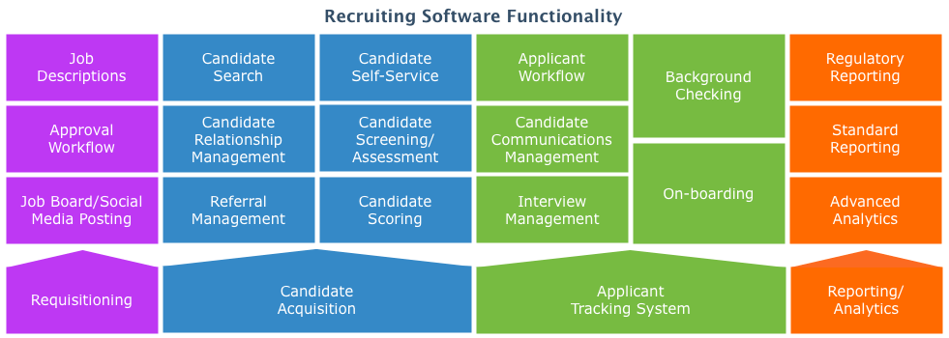

Opportunity for Process Improvement
The demand to improve our business continues to increase as competition grows, expectations change, and new technologies emerge(Noe, Hollenbeck, Gerhart, & Wright, 2006). As we conduct continual improvements of business processes as an effective technique to determine continuous improvement within our Human Resource Contracting Agency, we realized the firm has to embrace and implement a digital applicant tracking system and enhanced social media system to acquire talented employees to offer to the organizations and corporations. The opportunity for process improvements involve the information system and therefore, the experts in the department of IT should design an approach to integrate digital applicant tracking system and enhanced social media systems in the business processes of the agency(Bailey, Mankin, Kelliher, &Garavan, 2018). In this digital era, the use of social media platforms cannot be assumed as it one approach when correctly and properly embraced and executed will enable our agency to gain competitive by acquiring first-hand information about the recruitment industry and take advantage of the rising opportunities in the market. The agency should come up with more effective and quality software and hardware to improve on the work quality. The human resource contracting agency is likely to merge with each other’s to form one big organization since most of these agencies share the same visions and missions. This type of collaboration improves risk management, increased preferences of funds sources, increased space capacity, ability to share resources, ability to learn new skills and experiences and technological advancement.However, there are various risks and challenges involved in the collaboration, such as financial abuse, illegal hiring, discriminatory practices, unsafe candidates, and increased disagreements due to many people in leadership protocols. It even becomes difficult to make fast decisions(Brewster, Chung, & Sparrow, 2016). Also, there is a possibility of attracting a bad reputation from the community and the release of very personal and confidential information.
Open Source
Open-source software is software of the computers distributed with their source codes available for changes. The open-source software often has programmers license to modify the software in any manner they decide. Our agency uses the data system that can adapt the software to suit the needs of the firm, fix bugs, and improve functions. The data system helps in the establishment of the much of the internet(Brewster, Chung, & Sparrow, 2016). Moreover, the company utilizes the Apple’s Operating System X and Android Operating Systems that are based on the Unix/BSD and kernel open-source technologies respectively. The projects of Database System are cooperation opportunities which build connections and improve skills in the company. Our developers are proficient with the open-source development standard tools. Mozilla's Firefox web browser and the social media networks such as Facebook, wikis, forums, real-time messaging, and email help the agency to find bounce ideas off one another and find solutions.

Opportunities to Use Open Source
Thousands of projects of open-source are proprietary software alternatives for our agency(Noe, Hollenbeck, Gerhart, & Wright, 2006). The firm should work on a project of open-source software as a pathway to developing software development career. Additionally, the LinkedIn, Facebook, and Google release software as Open Source that our agency can use to contribute to functional and stable services, share knowledge and skills and innovate solutions. The use of social media platforms cannot be underrated because it enabled some organization to gain a competitive advantage (Bailey, Mankin, Kelliher, &Garavan, 2018). In this digital era, the use of social media platforms cannot be assumed as it one approach when correctly and properly embraced and executed will enable our agency to gain competitive by acquiring first-hand information about the recruitment industry and take advantage of the rising opportunities in the market.
IS Component
Hardware | Software | Data | Procedures | People
- Computers | - BambooHR  - ZohoRecruit  - I-sight | - Compliance data  - Records management data  - Workforce data | - Meet regularly with customers to get updated with current and future HR plans.  - Collect necessary information form the customer.  - Use that information to in meeting the HR plans and objectives.  - Obtain the required signatures of the customers for a complete action.  - Track the actions of their recruiters.  - Identify arising issues and provides solutions. | - Potential candidates  - Companies and organizations  - Government

References
Bailey, C., Mankin, D., Kelliher, C., &Garavan, T. (2018). Strategic human resource management. Oxford University Press.
Brewster, C., Chung, C., & Sparrow, P. (2016). Globalizing human resource management. Routledge.
Noe, R. A., Hollenbeck, J. R., Gerhart, B., & Wright, P. M. (2006). Human resource management.China People's University Press.

