Assignment #2
Due: 1 pm, Friday, October 4th

Open the file credit.xlxs in the data files folder. The file contains information about a sample of 400 credit card customers at a bank. The file does not contain a data dictionary so you may want to attach the following explanations to your file.

Income | Annual income of customer at time the card was issued
Limit | The current credit limit on the card
Rating | The customer credit rating on a scale of 0 to 1000. It is not clear where the rating comes from (e.g., TransUnion or Equifax or some other agency). The higher the rating the lower the risk is that the customer will default.
Cards | The number of credit cards held by the customer
Age | Current customer age
Education | The number of years of education from grade 1 onwards (12 =high school completion, 16=bachelor degree,…)
Gender | Male/Female
Student | Yes/No
Married | Yes/No
Employment | PT/FT/Unemployed
Balance | The current outstanding balance on the card

- Create a new variable called CreditGrp that classifies customers as high, medium and low risk, based upon a credit score of high = 0-299, medium = 300-499 and low = 500 and above. Print a screen shot of your spreadsheet and lookup table and write out the formula you used to calculate CreditGrp.
Solution
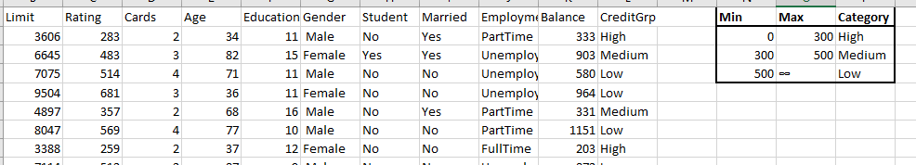
- Construct a frequency distribution and histogram for the balance owing. Make your first group be just those with a balance of zero and make the remaining groups be in increments of $100 (1-100, 101-200, …). Do not have any gaps between columns in your histogram. Print a copy of your frequency distribution and histogram.
 | Balance |  |  |  |  |  | cumulative
lower |  | upper | midpoint | width | frequency | percent | frequency | percent
-100 | < | -0 | -50 | 100 | 0 | 0.0 | 0 | 0.0
0 | < | 100 | 50 | 100 | 108 | 27.0 | 108 | 27.0
100 | < | 200 | 150 | 100 | 30 | 7.5 | 138 | 34.5
200 | < | 300 | 250 | 100 | 22 | 5.5 | 160 | 40.0
300 | < | 400 | 350 | 100 | 23 | 5.8 | 183 | 45.8
400 | < | 500 | 450 | 100 | 26 | 6.5 | 209 | 52.3
500 | < | 600 | 550 | 100 | 27 | 6.8 | 236 | 59.0
600 | < | 700 | 650 | 100 | 25 | 6.3 | 261 | 65.3
700 | < | 800 | 750 | 100 | 22 | 5.5 | 283 | 70.8
800 | < | 900 | 850 | 100 | 24 | 6.0 | 307 | 76.8
900 | < | 1,000 | 950 | 100 | 24 | 6.0 | 331 | 82.8
1,000 | < | 1,100 | 1,050 | 100 | 22 | 5.5 | 353 | 88.3
1,100 | < | 1,200 | 1,150 | 100 | 10 | 2.5 | 363 | 90.8
1,200 | < | 1,300 | 1,250 | 100 | 11 | 2.8 | 374 | 93.5
1,300 | < | 1,400 | 1,350 | 100 | 10 | 2.5 | 384 | 96.0
1,400 | < | 1,500 | 1,450 | 100 | 7 | 1.8 | 391 | 97.8
1,500 | < | 1,600 | 1,550 | 100 | 4 | 1.0 | 395 | 98.8
1,600 | < | 1,700 | 1,650 | 100 | 2 | 0.5 | 397 | 99.3
1,700 | < | 1,800 | 1,750 | 100 | 1 | 0.3 | 398 | 99.5
1,800 | < | 1,900 | 1,850 | 100 | 1 | 0.3 | 399 | 99.8
1,900 | < | 2,000 | 1,950 | 100 | 1 | 0.3 | 400 | 100.0
 |  |  |  |  | 400 | 100.0

- Using the descriptive statistics in Excel,
Balance
Mean | 520.015
Standard Error | 22.98794387
Median | 459.5
Mode | 0
Standard Deviation | 459.7588774
Sample Variance | 211378.2253
Kurtosis | -0.527857967
Skewness | 0.584595096
Range | 1999
Minimum | 0
Maximum | 1999
Sum | 208006
Count | 400

  - What is the mean balance owing?
520.015
  - What is the median balance? Why is the median so much lower than the mean?
Median is 459.5, its lower than the mean because the data is positively skewed.
  - What is the standard deviation of the balance?
459.759
  - By the Empirical Rule, approximately 2/3 of balances should be within 1 standard deviation of the mean. What range of balances would be within one standard deviation? Looking at your frequency distribution, approximately what percentage of balances are in this range? Do you think the Empirical Rule is appropriate for this data? Explain.
Solution
Range = 520.015 +/- 459.759
= 60.256,979.774
From frequency distribution the percentage is 60%. Empirical rule is not appropriate for this data because it is not normally distributed.
- You will note than many customers do not have a balance. Let us focus our attention on those with a balance owing. Filter out those with a balance greater than zero and copy your spreadsheet into a new page (tab). Create a new frequency distribution and histogram. It should look almost the same as what you had before.
Balance
Mean | 670.9871
Standard Error | 23.50817
Median | 637.5
Mode | 133
Standard Deviation | 413.904
Sample Variance | 171316.5
Kurtosis | -0.3658
Skewness | 0.467081
Range | 1994
Minimum | 5
Maximum | 1999
Sum | 208006
Count | 310

  - Using the descriptive statistics in Excel, find the mean balance and the median balance.
Mean = 670.9871
Median = 637.5
  - What is the standard deviation of the balance owing?
Standard deviation = 413.904
  - By the Empirical Rule, within what range should you find 2/3 of balances?
Range = 670.9871 +/- 413.904
= 257.0831, 1084.8911
  - Looking at your answers to the questions above, do you think the Empirical Rule is working better?
No, it is not working better because that data is negatively skewed.
- Let us compare the pattern of balances among those considered high, medium and low risk. Filter on those with a balance greater than zero and high risk. Copy this column to a new sheet and give it a heading of High. Repeat these steps to obtain those with a balance greater than zero and Medium risk. Copy these balances to a new column to the right of the High risk customers and label the column Medium. Repeat these steps to create a column of balances of Low risk customers. The new sheet should look something like the one below with many more rows.
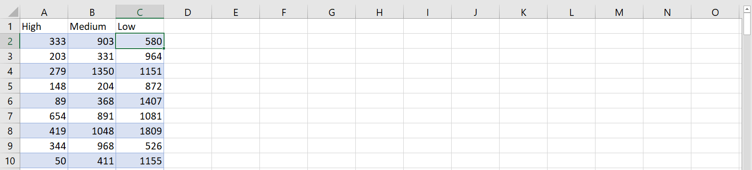

  - Construct histograms for each risk group.

  - Use descriptive statistics to find the mean, median and standard deviation for each risk group. You can do all three groups at once by making the input range all three columns, or you can do each variable separately.
 | High | medium | Low
Mean | 119.9444 | 673.0575 | 1116.609
Standard Error | 14.21227 | 24.72191 | 44.23724
Median | 0 | 655.5 | 1123.5
Mode | 0 | 531 | 1050
Standard Deviation | 180.8927 | 326.1044 | 353.8979
Sample Variance | 32722.15 | 106344.1 | 125243.7
Kurtosis | 3.06124 | -0.2816 | -0.02744
Skewness | 1.747434 | 0.13561 | 0.007392
Range | 868 | 1549 | 1749
Minimum | 0 | 0 | 250
Maximum | 868 | 1549 | 1999
Sum | 19431 | 117112 | 71463
Count | 162 | 174 | 64

  - Comment on any patterns that you have observed.
Solution
The distribution for high risk is positively skewed while that of medium and low is relatively normally distributed.
  - You should have observed that those with better risk (higher credit score) have larger balances. This may seem counter intuitive. Would not those with more debt have a lower credit rating? Can you offer any explanation? There are no points for getting this right or wrong. This is the first pattern we have seen and I want you to start thinking of why it has happened.
Solution
This is because those with better risks have huge loans hence high balances are still unpaid. Also, risk rating is based on probability of defaulting not the balances remaining.

