Assignment #3
Due: 1 pm, Friday, October 25th

Open the file credit.xlxs in the data files folder. The file contains information about a sample of 400 credit card customers at a bank. The variables in the file are as follows:

Income | Annual income of customer at time the card was issued
Limit | The current credit limit on the card
Rating | The customer credit rating on a scale of 0 to 1000. It is not clear where the rating comes from (e.g., TransUnion or Equifax or some other agency). The higher the rating the lower the risk is that the customer will default.
Cards | The number of credit cards held by the customer
Age | Current customer age
Education | The number of years of education from grade 1 onwards (12 =high school completion, 16=bachelor degree,…)
Gender | Male/Female
Student | Yes/No
Married | Yes/No
Employment | PT/FT/Unemployed
Balance | The current outstanding balance on the card

If you did not do assignment 2, please revisit it and group customers into the three credit groups, High Risk, Medium Risk, and Low Risk, as explained in question 1 of that assignment.

Create a new variable called Owe. Use the formula =IF([@Balance]=0,”No”,”Yes”) to populate this variable. Alternatively, if you have Balance in column L and put Owe in column M of your sheet, then in cell M2 enter the formula =IF(L2=0,”No”,”Yes”).

- Create a Pivot Table for the data set (including the CreditGrp variable from assignment 1).
  - Find the average Balance for Low, Medium and High Risk customers. The results will NOT be the same as you found in assignment 2, question 5. In Assignment 2, q5, you had filtered out those customers with a balance = 0. If you drag Owe to the Filter box, then above the Pivot Table select the down arrow beside Owe and select “Yes”, then your averages will match what you did in Assignment 2. Although you can explore this filter, do not do any filtering at this time.
Row Labels | Average of Balance
High | 514.377
Low | 572.938
Medium | 505.799
Grand Total | 520.015

  - Find the average Limit for Low, Medium and High Risk customers.
Row Labels | Average of Limit
High | 4619.241
Low | 5013.375
Medium | 4741.764
Grand Total | 4735.6

  - Find the average Income for Low, Medium and High Risk customers.
Row Labels | Average of Income
High | 43.219
Low | 47.330
Medium | 46.304
Grand Total | 45.218885

  - Create a Pivot Chart that shows Income by CreditGrp. Note that if you right click on High, Medium or Low, you can select Move to move a group up or down in the list so you can sequence the groups from high to low risk (or low to high).
Row Labels | Sum of Income
High | 7001.527
Low | 3029.132
Medium | 8056.895
Grand Total | 18087.554

  - In assignment 2 you observed the pattern of balances that you see in part a – low risk customers have more debt (larger balances) than high risk customers. How do your answers to parts b and c assist in explaining this pattern?
Solution
The result show that most people had a low risk.
- It is likely that credit ratings depend upon Income. To determine if it depends upon other factors, we may wish to see if average incomes vary by credit group as well as another variable.
  - Construct a Pivot Table for average Income by CreditGrp (rows) and Gender (col). Print this table.
  - Construct a Pivot Table for average Income by CreditGrp (rows) and Married (col). Print this table.
  - Construct a Pivot Table for average Income by CreditGrp (rows) and Employment (col). Print this table.
  - Construct a Pivot Table for average Income by CreditGrp (rows) and Student (col). Print this table.
  - Are there differences by gender, married, employment or student? Would you expect these results?
- Let us look at a breakdown of demographics of the various groups in this sample. Does it look like a reasonable cross-section of the population?
  - Do a frequency count by gender (rows) versus married (columns). You can count on any of the variables since we have 400 observations on every variable. Convert your table to show the percentage of males that are married (or single) and the percentage of females that are married (or single). Print your table. Assuming that most males are married to females and the population is approximately 50:50 male female, does the sample look reasonable?
Count of Married | Column Labels
Row Labels | No | Yes | Grand Total
Male | 19.00% | 29.25% | 48.25%
Female | 19.75% | 32.00% | 51.75%
Grand Total | 38.75% | 61.25% | 100.00%

  - Find the percentages that are employed full time, part time, or unemployed (columns) by gender (rows). Print your table.
Count of Employment | Column Labels
Row Labels | FullTime | PartTime | Unemployed | Grand Total
Male | 12.25% | 24.25% | 11.75% | 48.25%
Female | 12.50% | 25.50% | 13.75% | 51.75%
Grand Total | 24.75% | 49.75% | 25.50% | 100.00%

  - Find the percentages that are students (columns) by employment (rows). Print your table.
Count of Student | Column Labels
Row Labels | No | Yes | Grand Total
FullTime | 22.25% | 2.50% | 24.75%
PartTime | 45.50% | 4.25% | 49.75%
Unemployed | 22.25% | 3.25% | 25.50%
Grand Total | 90.00% | 10.00% | 100.00%

  - Are there any patterns that you feel are unexpected?
Yes, because most students are part time employees.
- In assignment 2 you looked at histograms of credit balances for low, medium and high risk customers. We can do this by building a Pivot Chart.
  - Build a Pivot Table and Pivot Chart for Balances, showing counts for each possible Balance (rows). Group Balances with increments of $100. Print the frequency table and chart.
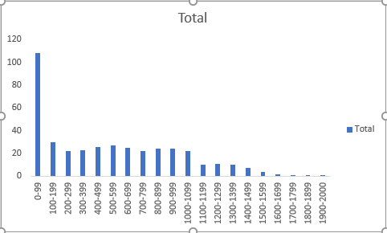

Row Labels | Count of Balance
0-99 | 108
100-199 | 30
200-299 | 22
300-399 | 23
400-499 | 26
500-599 | 27
600-699 | 25
700-799 | 22
800-899 | 24
900-999 | 24
1000-1099 | 22
1100-1199 | 10
1200-1299 | 11
1300-1399 | 10
1400-1499 | 7
1500-1599 | 4
1600-1699 | 2
1700-1799 | 1
1800-1899 | 1
1900-2000 | 1
Grand Total | 400

  - Filter out those with a Balance of zero and then show frequency distributions by CreditGrp(columns). Print the frequency table and chart.
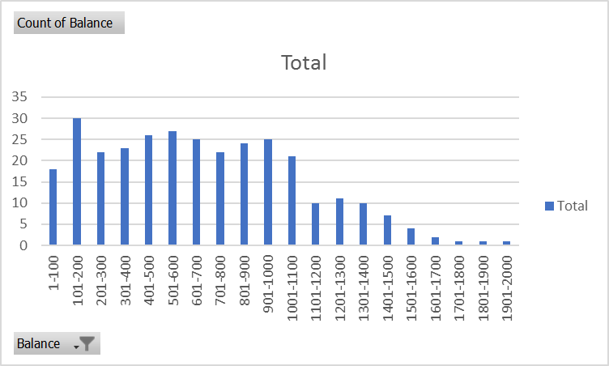

Row Labels | Count of Balance
1-100 | 18
101-200 | 30
201-300 | 22
301-400 | 23
401-500 | 26
501-600 | 27
601-700 | 25
701-800 | 22
801-900 | 24
901-1000 | 25
1001-1100 | 21
1101-1200 | 10
1201-1300 | 11
1301-1400 | 10
1401-1500 | 7
1501-1600 | 4
1601-1700 | 2
1701-1800 | 1
1801-1900 | 1
1901-2000 | 1
Grand Total | 310

  - Scale the graphs such that it is the percentage of accounts in each $100 group instead of the frequencies in each group. Print the frequency table and chart.
Row Labels | Count of Balance
1-100 | 5.81%
101-200 | 9.68%
201-300 | 7.10%
301-400 | 7.42%
401-500 | 8.39%
501-600 | 8.71%
601-700 | 8.06%
701-800 | 7.10%
801-900 | 7.74%
901-1000 | 8.06%
1001-1100 | 6.77%
1101-1200 | 3.23%
1201-1300 | 3.55%
1301-1400 | 3.23%
1401-1500 | 2.26%
1501-1600 | 1.29%
1601-1700 | 0.65%
1701-1800 | 0.32%
1801-1900 | 0.32%
1901-2000 | 0.32%
Grand Total | 100.00%

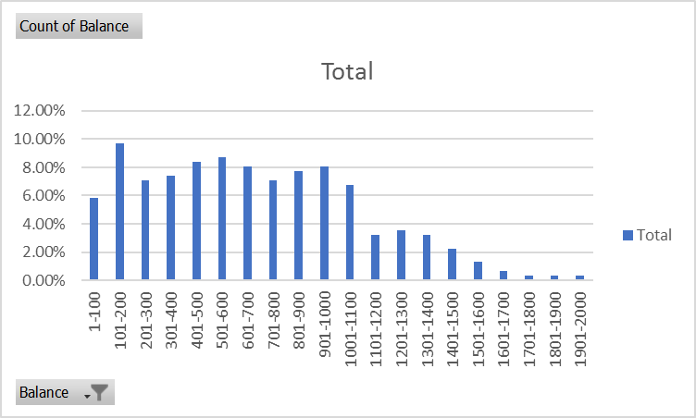
  - Create a Box and Whisker chart of Balances. Print the chart.
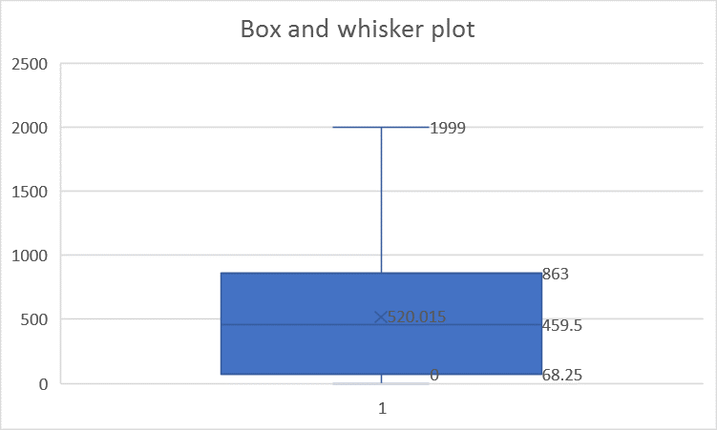
  - Create a chart showing Box and Whiskers by Credit group. Print the chart.
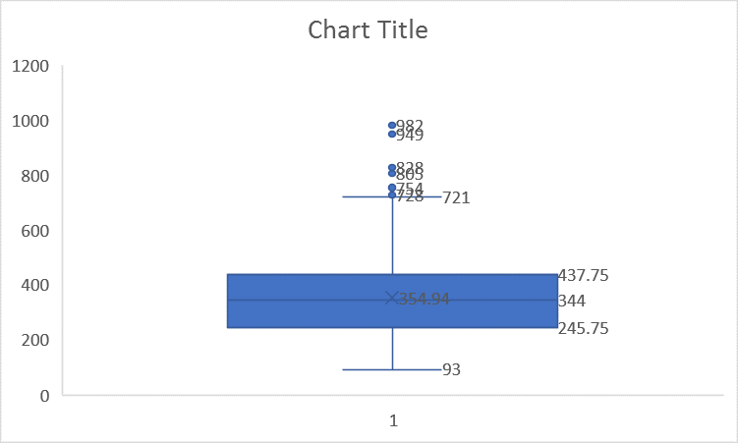
- Create a Scatter diagram of Balance versus Rating, with Rating on the horizontal axis.
Solution

