Assignment #4
Due: 1 pm, Friday, November 1st

Open the file HousingBubble.xlxs. It contains data with respect to house features, assessments and selling prices, before the 2008 housing bubble and afterwards. In 2008, there was a collapse of the housing industry in the USA that triggered a financial crisis that spread around the world. People could no longer pay their mortgages. As a result, there was a surplus of housing that was for sale and prices became depressed. I do not know the exact source of this dataset. It was provided by a US publisher. I believe that the data is authentic.
For each house we are given data with respect to the size of the home, the number of bedrooms, bathrooms and other rooms, and the size of the deck or garage, if there is one. We are given the age of the home as well as an indicator of whether the house is in particularly good or poor condition. Each property has an assessment of the value of the land and of the building. An assessment is determined by the local town as the basis for assessing property taxes. It reflects the estimate of what the property should sell for if offered for sale. We are also given the selling price. The selling price is what the property actually sold for, whereas the assessment is what the town thought it was worth.
It is interesting that we have assessments for both the property and the building, separately. In Nova Scotia, they only assess the combined value since you cannot sell one without the other. In the US, states collect most of their taxes from property taxes and not income taxes. In Canada, provinces collect income taxes and only towns/cities can collect property taxes (and not income taxes). Both countries have their issues with respect to how local governments can fund their services, but taxes drives what services can be offered and no one wants to be taxed. Regardless, assessment of property values is beyond the scope of this assignment but it is one that is a perfect example of Value Estimation.
How does the town assess property? This is a value estimation problem. The town knows what properties have sold for. It also knows the size of the land and the size of the building and the size of any garage. They may also have records on how previous owners have used a home in terms of the number of rooms, bedrooms, and bathrooms. However, the current owners may have made modifications. Although homeowners often need a building permit from the town to make changes, this does not always happen and the information may not be given to the assessment office.
To make assessments of all properties in a town, every year would be impossible if you had individuals go and look at each property. They would likely use a model. If the model gives an assessment that the property owner thinks is too high, this person will complain – a high assessment will mean high taxes. So, the model needs to be reasonably accurate.
When a property is offered for sale, the owner usually uses an agent who gives an estimate of the selling price. The agent does a physical examination of the property, so would have more information than is used in an assessment. The agent also has the town’s assessment.
The questions that follow look at how we might build models for determining assessments and for estimating selling prices. We will also look at how the 2008 housing crisis affected the models.

Excel requires that variables selected for Correlation or X variables used in Regression must be adjacent (beside) one another. For the questions below, in many cases you will be selecting a set of variables that are not clustered together. I strongly recommend that for each question, you select the variables that you will need and then copy them to a new sheet. Have a separate sheet for each question. You can rename sheets 1, 2, 3a,… so that you can keep track of which sheet is for which question.
- The only variable we have that describes the land the house is built on is the size of the lot (acres). Using the pre-2008 data, make a scatterplot of the Land Value (vertical axis) versus the size of the lot (acres) (horizontal axis). Comment on the scatter plot. Do you think you could make accurate predictions of Land Values? Would accuracy be similar for different sized lots?

The scatter plot shows that there is positive linear relationship between the two variables. I don’t think it can make accurate prediction because most points are lying far away from regression line. Accuracy for different sized lots would not be similar since land value is affected by other factors. A land is semi urban area will cost different from a land in urban area.
- As noted above, property assessments should reflect the value of a home (land and buildings). The best measure of “value” is the selling price.
  - Make a scatterplot of selling price versus total assessment. To get Price on the vertical axis it is easiest if you move the price column to the right of total assessment.

  - Find the coefficient of correlation between total assessment and price.
Correlation Matrix
 | Price$ | total assess
Price$ | 1.000
total assess | .945 | 1.000
The correlation coefficient = 0.945
  - Construct a simple linear regression model to predict price based upon the total assessment. Write out the estimated regression equation.
Solution

Regression Analysis
 | r² | 0.892
 | r | 0.945
 | Std. Error | 17467.095
 | n | 1977
 | k | 1
 | Dep. Var. | Price$
ANOVA table
Source | SS | df | MS | F | p-value
Regression | 4,996,583,885,891.5000 | 1 | 4,996,583,885,891.5000 | 16376.90 | 0.00E+00
Residual | 602,571,339,365.9280 | 1975 | 305,099,412.3372
Total | 5,599,155,225,257.4300 | 1976
Regression output |  |  |  |  | confidence interval
variables | coefficients | std. error | t (df=1975) | p-value | 95% lower | 95% upper
Intercept | 8,174.8983 | 931.1169 | 8.780 | 3.48E-18 | 6,348.8237 | 10,000.9729
total assess | 0.9395 | 0.0073 | 127.972 | 0.0000 | 0.9251 | 0.9539
Regression equation: -
Price = 8174.8983 + 0.9395x
  - Explain what the intercept represents in this equation.
Solution
The intercept for the equation is 8174.8983, which the price when total assess is 0.
  - Explain what the slope represents in this equation.
Solution
The slope of the equation is 0.9395, this means that a unit increase in assessment will lead to 0.9395 increase in price.
  - Based upon your answers to d and e, do you think that, on average, the assessments over estimate value or under estimate value or do they sometimes are under and sometimes over?
Solution

From the answers the estimate can overstate or understate price since there are some points that lie below the regression line.
  - What should the intercept and slope be if on average the assessments are neither too high nor too low. Note that due to randomness, there will be differences between prices for homes with the same assessment. The line reflects the average.
Solution
The intercept is 4.1371 and the slope is 0.0005. The equation will be: -
Price = 4.1371 + 0.0005x
  - The standard error reflects the standard deviation of the differences between actual and predicted price (the error in model predictions). By the Empirical Rule, how large a difference should we expect to see 68% of the time?
Solution
The expected difference is 15362.
- The total assessment is likely based upon the acres, above space, basement, deck, car and age (those variables that the town may have accurate data on).
  - Find the correlations among these variables. Excel requires that variables be in adjacent columns, so it is recommended that you copy these variables to a new sheet and then find the correlations.
Solution
Correlation Matrix
 | Acres | AboveSpace | Basement | Deck | Age | Car | total assess
Acres | 1.000
AboveSpace | .264 | 1.000
Basement | .161 | .104 | 1.000
Deck | .180 | .158 | .169 | 1.000
Age | -.151 | -.079 | -.343 | -.250 | 1.000
Car | .201 | .375 | .238 | .157 | -.469 | 1.000
total assess | .362 | .736 | .380 | .289 | -.449 | .541 | 1.000

  - Make a scatterplot of assessment with the variable that has the highest correlation with assessment. Would you have confidence in making predictions based only on this variable?
Solution

  - Individually, the correlations may not be very high, but taken together, they may be useful in predicting total assessment. Build a regression model that uses all of these variables. What is the equation of the model?
Solution
Regression Analysis
 | R² | 0.753
 | Adjusted R² | 0.752
 | R | 0.868
 | Std. Error | 26640.866
 | n | 1977
 | k | 6
 | Dep. Var. | total assess
ANOVA table
Source | SS | df | MS | F | p-value
Regression | 4,262,169,855,164.7400 | 6 | 710,361,642,527.4570 | 1000.88 | 0.00E+00
Residual | 1,398,179,396,560.1000 | 1970 | 709,735,734.2945
Total | 5,660,349,251,724.8400 | 1976
Regression output |  |  |  |  | confidence interval
variables | coefficients | std. error | t (df=1970) | p-value | 95% lower | 95% upper | std. coeff.
Intercept | 37,423.8983 | 2,529.6131 | 14.794 | 4.84E-47 | 32,462.8998 | 42,384.8968 | 0.000
Acres | 38,568.7173 | 4,697.1806 | 8.211 | 3.92E-16 | 29,356.7527 | 47,780.6818 | 0.097
AboveSpace | 77.5230 | 1.5738 | 49.258 | 0.00E+00 | 74.4365 | 80.6095 | 0.618
Basement | 39.4257 | 2.7417 | 14.380 | 1.16E-44 | 34.0488 | 44.8027 | 0.174
Deck | 26.3917 | 5.0675 | 5.208 | 2.11E-07 | 16.4535 | 36.3300 | 0.061
Age | -497.1093 | 26.4333 | -18.806 | 1.07E-72 | -548.9495 | -445.2692 | -0.254
Car | 37.0466 | 4.2550 | 8.707 | 6.49E-18 | 28.7019 | 45.3913 | 0.120
The regression equation: -
Total assesses = 37,423.90 + 38,568.72(Acres) + 77.52(Above Space) + 39.43 (Basement) + 26.39(Deck) – 497.11 (Age) + 37.05 (Car)
  - The coefficient for Age is negative. What does its value tell you?
Solution
The coefficient implies a unit increase in age decreases total assess by 497.1093 while all other variables are held constant.
  - If a homeowner was considering adding a 300 square foot deck to their home, how much would you expect the assessment to increase? This summer I built a cottage. The view is amazing so I asked the contractor to add a 600 square foot deck, for which he charged me $11,000. If this model was appropriate, was this a good financial investment? The view was worth it so I don’t care.
Solution
If 300 square foot is added basement increase is: -
= 26.39× 300
= 7917
When 600 square foot deck is added, according to the model a total of $ 15,834 will be charged. This is an over charge of from the actual charge of $110000, hence using this model will lead to over charge by the model.
  - How much might you expect your estimate of the assessment to be off from the actual 68% of the time?
Solution
The estimated difference between from 68% of the actual time is 1250.
- Suppose you are a real estate agent and you wished to build a model to predict the selling price.
  - Construct a regression model that used only acres, above space, basement, deck, car and age to predict price (that is, the same as was used for assessment). What is the equation of the model?
Solution
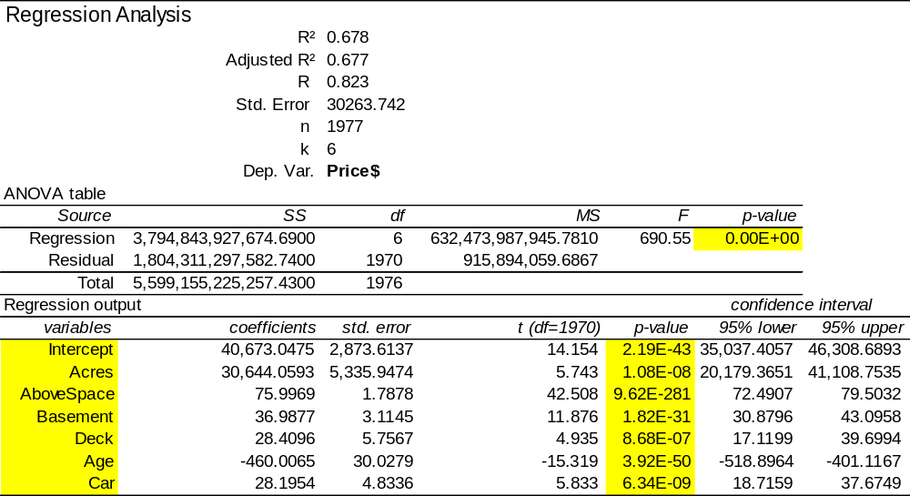
Price = 40673.05 + 30644.06(acres) + 75.998(abovespace)+36.99(basement)+ 28.41(deck)- 460.001(age)+ 28.195(car)
  - Do these variables predict selling price as well as they predicted assessment? Explain.
Solution
The variables predict price well since they are all statistically significant. Their p-values are less than 0.05. The value of r-squared also shows that there is strong relationship between the independent and dependent variables.
  - The agent will have access to information about how space is used (bathrooms, bedrooms, …). Add these variables to your model but do not include the indicator variables (AC and condition) and recalculate the regression equation. Is the model significantly better? Comment on R-Square and standard error.
Solution
The regression model is: -
Price = -73991.48 – 4062.79(Acres) + 4.31 (abovespace) + 1.04(basement) -0.59(deck)-1464.28(baths)+235.87(toilets)+1303.24(fireplaces)+743.09(beds)-108.31(rooms)
The value of r-squared is 97.80% implying that the overall fit of the model is good.
  - The data set includes data on several indicator variables (air conditioned Y/N, good condition Y/N and poor condition Y/N). Although these are nominal variables, when coded 0/1 as they are in this data set, we can add them to the model. Do this and recalculate. What is the penalty of having a home in “bad condition”? What is the benefit of being in “good condition”? Note that some homes were classed as neith good nor bad condition.
Solution
When a home is in bad condition, its price will reduce by $50.25 but when it’s in good condition its price will increase by $50.25.
  - As measured by standard error, what has been the improvement (reduction in error) in c and d compared with the initial model in a?
Solution
In model 1 the standard error is 30263.74 which reduced to 7921.41 implying that the second model is more accurate compared to the first 1.
  - Your model still has not predicted price as well as was done just using the assessment in question 2. But can we improve upon the assessment prediction by including all of the variables we used in d? Recalculate the model using everything. What is the standard error?
The standard error is 0.0000
  - The model in f has many redundant variables. Almost all of the features of the property are reflected in the assessment. If you look at the P-values in the regression output, you will find that many are greater than 0.10 suggesting that these variables contribute no information. Particular exceptions are the indicators of good and poor condition. Recalculate the model with just the assessment, poor and good condition as predictors of price. What is the equation of the model?
Solution
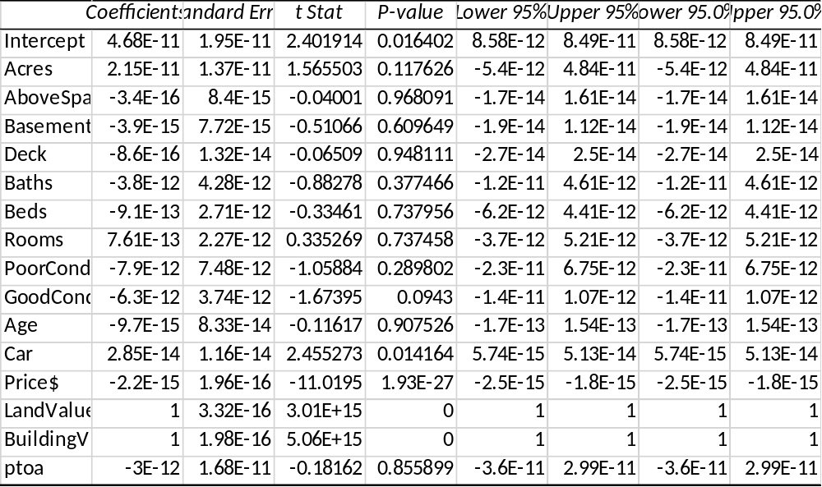
  - How does this compare to your answer in f? If the results are better, then there is more information in property features than is captured in the assessment, excluding the condition of the property. Is there any new information?
Solution
The model does not fit well as that in part f.
- We have data on homes after the 2008 housing crisis. The crisis may not have affected assessments (yet) but it has affected prices. Look at the model that you used in 4d that used property features, including condition, to predict selling price.
  - Find the equation of the regression line for the post-crisis properties.
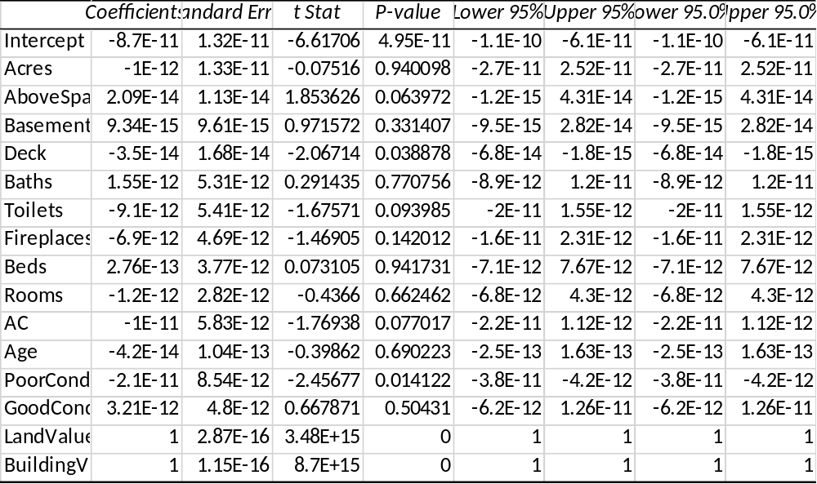
  - Is your new model as good, better or worse than the one we had pre-crisis?
The model is better since its standard error is low. The value of r-squared is high implying that the overall it of the model is good.
  - The intercept reflects the base price, regardless of the property qualities. A decrease in the intercept means that all properties post-crisis have experienced an average decrease in value of this amount. What has been the average impact of the crisis?
Solution
The model shows that when the base price is high assessment will be high too.
  - One might expect that the crisis decreased values not by a fixed amount, but by a percentage. In this case, we should have seen decreases in most or all of the coefficients of the variables. Did this happen?
Solution
This did not happen since the current value is larger than the previous one.
  - The coefficients are only estimates since they are based upon just a sample of homes. 1,000 or 2,000 homes may seem like a lot, but we are still dealing with estimates. In the regression output table, beside the coefficients is a column labelled “standard error”. These values give us an indication of how much the estimates might change if we took another sample. Make a table of the coefficients before and after, and the standard errors before and after. Recognizing that a change that is less than either standard error could just be due to accuracy of our estimates, do any variables stand out as being affected by the crisis? Many statisticians would take exception to what I have asked you to consider, but this is the “quick and dirty” approach to seeing if there are important changes. Anything you miss with this approach is likely very subtle and will not affect important decisions. Managers must choose what issues warrant their attention and action. There are many problems, but you do not have time to deal with all of them.
Solution
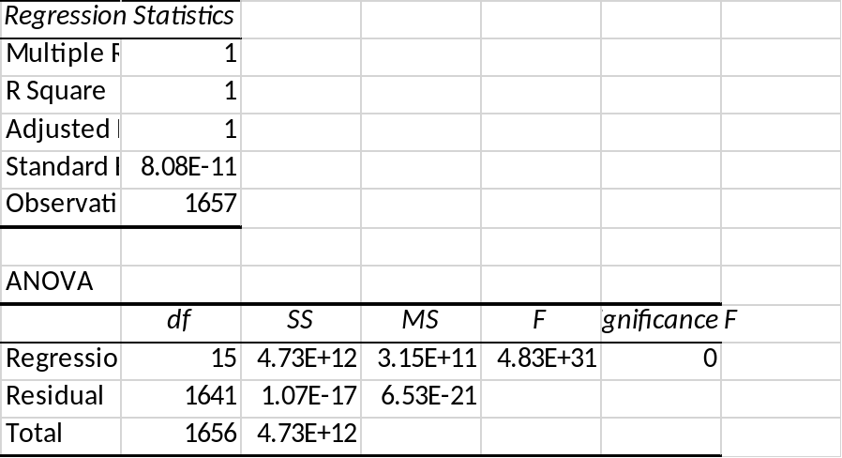
The only value affected is age of the building.

