The Project Schedule Management and Performance Report
Student’s Name
Institutional Affiliation

TABLE OF CONTENTS
Part A: The Project Schedule Management Plan 4
Project Scope Definition 4
Schedule Management Plan 4
Scheduling Process 6
Activity Sequence 7
Resource and Project Talent 9
Project Resource Allocation and Project Costs 10
Project Schedule 12
Part B: The Project Performance Report 14
Reference 19

List of Figures
Figure 1: Sequence of activities 8
Figure 2: Project Gantt chart 12
Figure 3: Project baseline 13
Figure 4: Project summary 15
Figure 5: Earned Value Report 16
Figure 6: Earned Value cost indicators 17
Figure 7: Earned Value Schedule Indicators 18

Part A: The Project Schedule Management Plan

Project Scope Definition
This project is a celebratory and transformational expedition for all Canadians. It entails a journey aimed at captivating the Canadians’ imagination and more understanding of their country, beauty and vast opportunities in the future. The project is purposed to instill a long-term sense of pride and inspire future Canadians to contribute to their country and the world at large. The project is limited to a 150-day sailing from Toronto to Victoria through the Northwest Passage that connects the Canadians from coast to coast to coast (C3). After the journey, other deliverables include documentaries and videos, books and giant floor maps describing the journey and what was learned. Also, we will create traveling multimedia exhibitions and analyze samples collected during the journey.

Schedule Management Plan
To establish a project schedule, I am planning to adopt the following five steps. The first step involves writing down the project tasks. This step seems obvious, but it is the stage where the project team may forget some activities, and once the project schedule is created, we might forget adding them until we discover they are undone.
As a project manager, I will involve other members in creating tasks. We will begin the list with we what know should be included such as all wider project management activities, then get members together to add to it. Every element of the project will be deeply planned. We will have weekly meetings to reflect on the project scope and allocate some time updating the schedule before finalizing it.
The second step is establishing the order of activities/tasks. This step means what task should be done before the other. In this project, the first task is creating the scope, then identifying partners while the last steps are creating traveling multimedia exhibitions and analyzing samples obtained during the journey.
A Gantt chart graphically represents a project schedule and illustrates the connection between activities. They are called dependencies, and often are marked using black lines. The MS project draws lines to link dependencies if the dependency information is entered; the order of tasks to be done. I intend to work with the team to plan the priority of tasks. At first, the order of tasks will be written on the paper before entering them into the MS project software.
In the third step, we will create the project milestones. Project milestones are points that mark completion of an activity or any important moment on the plan. For instance, a milestone is the end of the task “production of Canada C3 documentaries and videos” in this project. We will put milestones in their appropriate places and connect them to relevant tasks. The aim is making the milestones always appear on the schedule to identify if we are on track in completing tasks within the deadline. A milestone eases project scheduling.
Fourthly, I will calculate the timescale. Once we have tasks, their order of execution and milestones, fixed dates will be added. For instance, a MS project automatically schedules the project to start today, which is against our intentions. Thus, I will use the MS project and navigate through dates to ensure the tasks begin according to our expectations. This can be done by altering the dates manually or adding additional dates. A timescale will also allow reviewing the project duration. An MS project sets the task duration to a default value, which can be as little as one day. In this project, different durations will be allocated to each task depending on their complexity.
Finally, we will have specific people executing specific tasks. Allocating people to tasks is important because if it is unclear who works on a certain task, some project members might underwork at the expense of others. Activities in the Gantt chart will be used to allocate tasks to appropriate members. After a task is assigned, project members will receive a call informing them of the new roles. Also, I will check to ensure no one is overworked or underworked, and if this happens, the order or dates of tasks can be changed to fit periods the resources are available.

Scheduling Process
The project manager should learn how to accurately estimate the project duration. Managers who have experience in specific type of projects have knowledge how to start the project, when they can end and the amount of time required to be completed. Inexperienced project managers can use MS project to accurately estimate the cost and duration of projects. A project involves various dynamic aspects, but it is also limited to finite conditions that make accurate estimation a challenge.
Accurate cost and duration estimation in a project is challenging especially for inexperienced project managers, even if they use MS project and other project management software. This is because they are unaware of hidden or unknown variables that may emerge and are difficult to solve, which adversely affects the project duration. Also, they tend to be idealistic of their abilities. Often, project managers assume that they can achieve more than what is possible within the set timeline. At the start of a project, the team should list down a realistic project scope and not please other people by giving them information they want to hear.
One of the techniques used to increase accuracy in estimation in this project was analyzing tasks and removing unnecessary or repetitive procedures to reduce the overall duration and improve the whole process. Also, the bottom-up approach was used, which involves creating the project estimate as a whole. To analyze from the bottom –up approach, the whole project was split into larger tasks and further to smaller tasks. Then, I estimated the time required to complete each smaller task. This time estimation approach is more accurate because it considers each task incrementally. Finally, the total amount of time required to execute each larger task was added up to estimate the total amount of time needed to complete the whole project.

Activity Sequence
There are four stages of project management: initiation, planning, execution and closing. The initiation phase of this project will involve determining the project scope and identifying partners. Project scope is the first task to be done and upon completion, will be followed by identification of partners. The planning stage comprises of gathering resources and creating the budget. After identifying partners, this will be followed by resource gathering and then budget creation. Thereafter, the project will be executed by sailing coast to coast to coast and meeting coastal communities. The final stage is closing which will start by producing documentaries, then books, maps, traveling multimedia exhibitions and analyzing samples. Thus, the milestones in this project are:
- Project scope
- Identification of project partners
- Gathering of resources
- Creation of the budget
- Sailing coast to coast to coast and meeting coastal communities
- Production of Canada C3 documentaries and videos
- Canada C3 books
- Production of Canada C3 Maps
- Creation of traveling multimedia exhibitions
- Analysis of samples collected during C3 science program
Figure 1: Sequence of activities
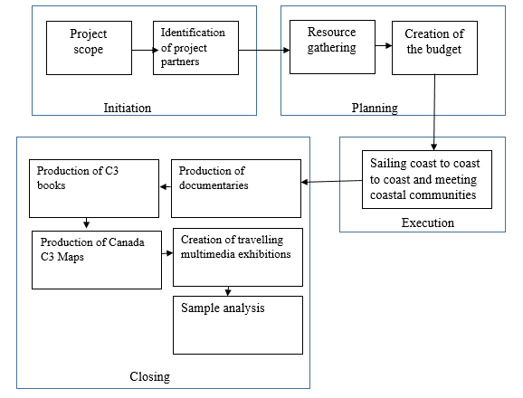

Resource and Project Talent
Project resources are people, capital, equipment, materials and tools required to successfully plan and execute a project. A project resource is what is required to get work done. They differ depending on the type of a project. For example, an IT project requires equipment, software, communications and modeling tools, while a video production project will rely on studio rentals, cameras, video cameras and designers.
Issues may arise without proper planning of project resources. Project managers should ensure they have the right resources before starting a project. They should not simply assume resources are available. Lack of resources may hinder progress of a project or extend the deadline. If we lack journalists in this project, we will be left waiting until they are available. Thus, lack of resources is unideal when the project aims to meet the deadline and stay within the budget.
Successful completion of a project depends on the availability of project resources, but there is no guarantee that they will be available at the right time and at the right amounts. However, proper planning prepares the team to handle emerging issues and proceed quickly. In this project, people identified to participate in this project were informed three months before the start of the project to confirm their availability and seek appropriate replacements. The resources required in this project include the scientists, artists, indigenous elders, historians, community leaders, youth, journalists and educators. Also, we need twenty computers and fifteen video cameras. The following are agencies needed in this project:
- Alliance of Natural History Museums of Canada
- Arctic Inspiration Prize
- Communications and Power Industries
- HoneyBar
- Vancouver Maritime Museum
- Assembly of First Nations
- Facebook
- Canadian Museum of Nature
- Samsung
- First Air and
- Higher Me

Project Resource Allocation and Project Costs
Indigenous elders and community leaders have been involved in this project to transfer knowledge and culture to Canadian coastal societies. Indigenous and community leaders are the most respected people in a society. They tell stories, arts, songs and language to the societies. Elders help communities especially those dealing with social issues such as discrimination and tribal conflicts. The coast to coast sailing will have elders and community leaders to teach communities the need to leave in harmony and appreciate cultural diversities.
Throughout the project, different arts and music will be created to enable the Canadians connect and appreciate their culture. Music is a universal performing art common in all societies, and it integrates different forms of art and cultural heritage. Illustrating music and art to different societies makes them appreciate other cultures. The Youth and artists have been included in this project to create art and music and perform it.
The role of historians, scientists and educators in this project will be providing history of Canadian coastal communities and analyzing samples collected during Canada C3 program. Also, they will create traveling multimedia exhibitions and help in the production of C3 book and maps. Lastly, the journalists will capture videos and prepare documentaries of the Canada C3 program.
The planned cost (baseline cost) of creating the project scope and identifying partners is $3,000, which includes the costs for the purchase of writing materials, venue costs where the team meets to plan the project, logistic costs and phone calls to partners. $3,000 has been allocated to gathering of resources and budget creation. We are not planning to purchase new products and $1,000 has been allocated for hiring and other logistics associated with gathering resources. The team will regularly meet to prepare the budget and consequently incur traveling costs and expenses for food and drinks. We have reduced the cost of this task to as low as $500. The most expensive task is sailing from coast to coast for 150 days. The project team comprises of 300 members. If each member spends $20 every day on food, we need ($20*300*150) = $900,000 for the entire traveling period. We have allocated 11% contingency reserve to account for phone credit cards and miscellaneous raising the baseline cost for execution phase to $1,000,000. The project closing phase is also expensive and is expected to incur as much as $458,000 baseline cost. In overall, the baseline cost for the entire project is $2,196,000, which has been inflated by sailing coast to coast to coast and closing activities (production of documentaries and videos, books, maps, creation of traveling multimedia exhibitions and analyzing samples).

Project Schedule
The project runs for 406 days. Of the four stages of project management, planning is the shortest lasting for 13 days. Six days are required to create a project scope and another 15 days to identify and contact project partners. Consequently, 21 days are needed to complete the initiation phase. Other than the 150 sailing days, the project requires 33 days to produce videos, 60 days to create books, 35 days to create maps, 50 days to create traveling multimedia exhibitions and 45 days to analyze samples collected during the journey. As a result, the closing phase requires 222 days to be complete (Figure 2).
- Figure 2: Project Gantt chart
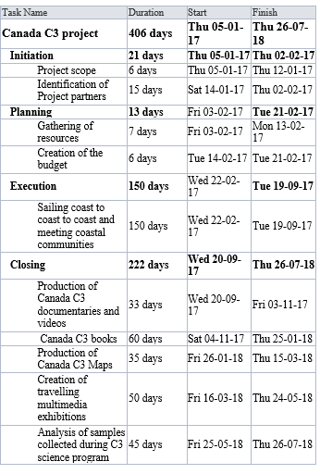

Figure 3: Project baseline
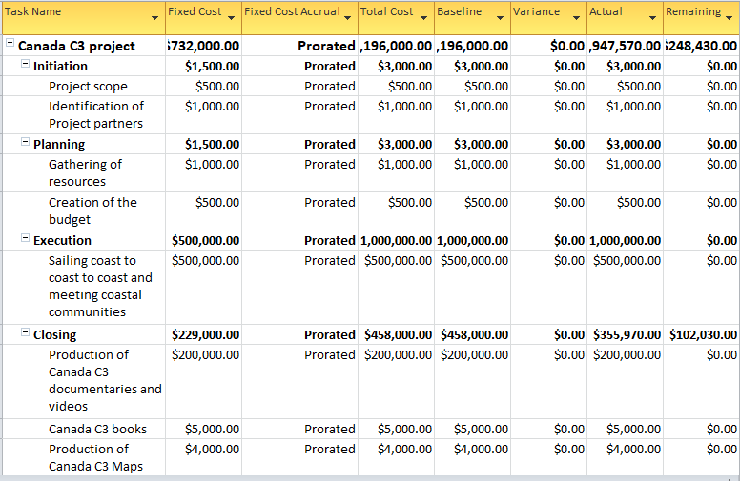

Part B: The Project Performance Report
The earned value (EV) includes a time variable in measuring progress (Larson, 2018). The EV bridges the gap by seeking to answer "looking at the way the project progresses, is the company getting value for money." Some of the equations used by EVA include cost and schedule variance, cost performance indicator, estimated cost at completion and estimated time at completion.
So far, the milestones under initiation, planning and execution are 100% complete. However, Closing is 63% complete. Under the last phase of project management closing, the tasks production of documentaries, books and maps are 100% complete. Creation of traveling multimedia exhibitions is 27% complete while analysis of samples is completely undone. As a result, we are 80% into the project as shown in Figure 4. Figure 5 shows the earned value report, while Figure 6 and Figure 7 show earned value cost indicators and earned value schedule indicators respectively.

Figure 4: Project summary
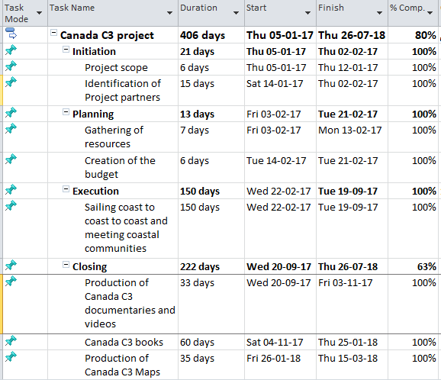

Figure 5: Earned Value Report
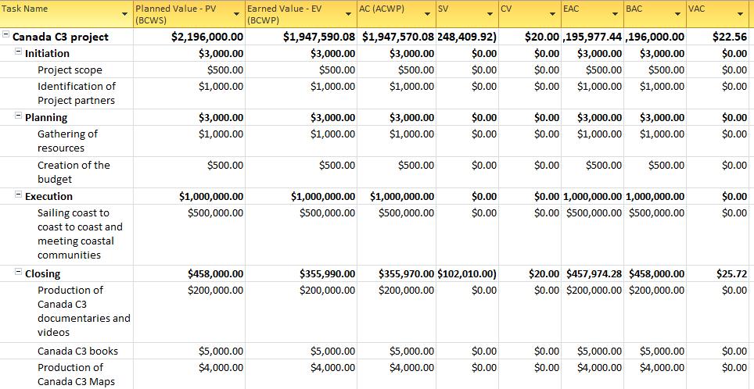

Figure 6: Earned Value cost indicators
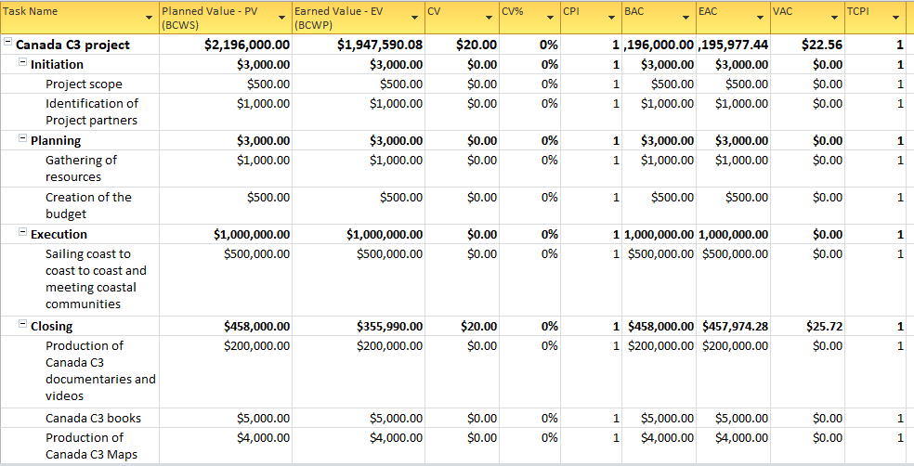

Figure 7: Earned Value Schedule Indicators
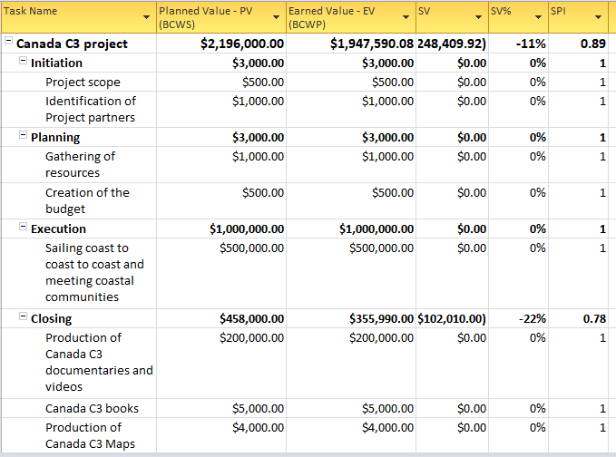

Reference
Larson, E. (2018). Project management: The managerial process, 7th edition. New York: McGraw-Hill Higher Education.

