Solution attached to any other email accounts will be rejected. Deadline: Wednesday May 27th 1:00 p.m.

1. At a summer art show a vendor sells lemonade for $2.00 per cup. The cost to rent the booth is
$120.00. Furthermore,, the vendor knows that the lemons, sugar, and cups collectively costs $0.50 per cup.
a. Consider 𝑥 to be the number of cups of lemonade sold/produced, and 𝐶(𝑥) 𝑎𝑛𝑑 𝑅(𝑥) are the total cost and revenue to the seller. Write a linear model for the cost and revenue functions;

𝐶(𝑥) =

𝑅(𝑥) =

- Find the break-even number of cups of lemonade (to the nearest whole cup).
- Find the profit if 50 cups of lemonade are produced and sold (2 decimal places)
- Find the profit if 128 cups of lemonade are produced and sold (2 decimal places)
- Sketch a NEAT and labeled graph of the cost and revenue functions: label the axes, and the breakeven point.

4. The graph of a function 𝑦 = 𝑓(𝑥) is given below
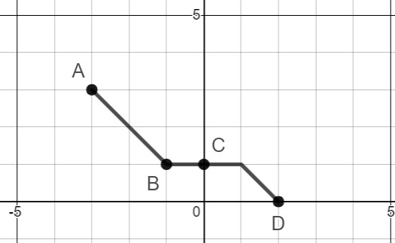
Under the following transformations, write the new ordered pairs for A, B, C, D

A

B

C

D

(
-
3
,
3)

(
-
1
,
1)

,
1)
(0

0)
(2
,

a)
𝑦
=
𝑓
(
𝑥
+
2
)

b)
𝑦
=
3
𝑓
(
𝑥
)

c)
𝑦
=
−
3
𝑓
(
𝑥
+
2
)

d)
𝑦
=
−
3
𝑓
(
𝑥
+
2
)
−
2

e) Sketch a neat graph of 𝑦 = 𝑓(−𝑥) – label the new points A, B, C, D on the graph

- A wrist-watch company has found that it’s supply and demand functions have the following linear equations
𝑆(𝑝) = 50𝑝 − 800 𝐷(𝑝) = −10𝑝 + 2950
Where 𝑝 is the price per watch in dollars.
  - What is the equilibrium price per watch and what is the equilibrium quantity demanded? Show work.

  - Depict the supply-demand function in the axes provided. Label the functions, the axes, and the equilibrium point.

- Construct graph of the following piecewise function and then answer the questions that follow:

𝑥² ; −1 ≤ 𝑥 < 0

𝑓(𝑥) = {−2 ; 0 ≤ 𝑥 < 2
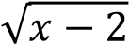 ; 𝑥 ≥ 2
Make sure to label all functions, ordered pairs, open/closed holes etc.

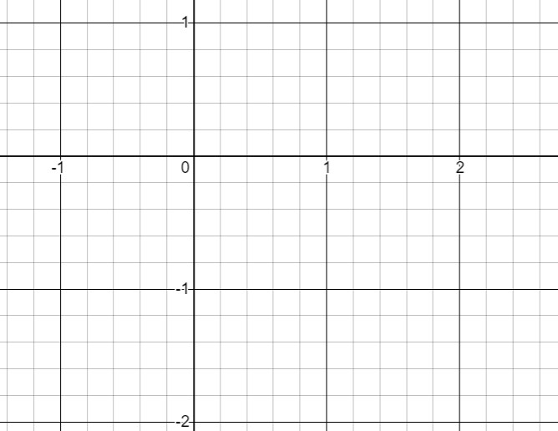

Write ordered-pairs and intervals for the questions below:
i) Write the domain of the graph above: ________________________________ ii) Write the range of the function: ________________________________

iii) Write the ordered-pairs of its extrema local min = ______________

local max = ______________

abs. min = ______________
abs. max = ______________
iv) Where is the function increasing, decreasing, remaining constant?
Inc: ____________________

Dec:

Constant:________________

THIS QUESTION 7 SCREEN SHOTS.

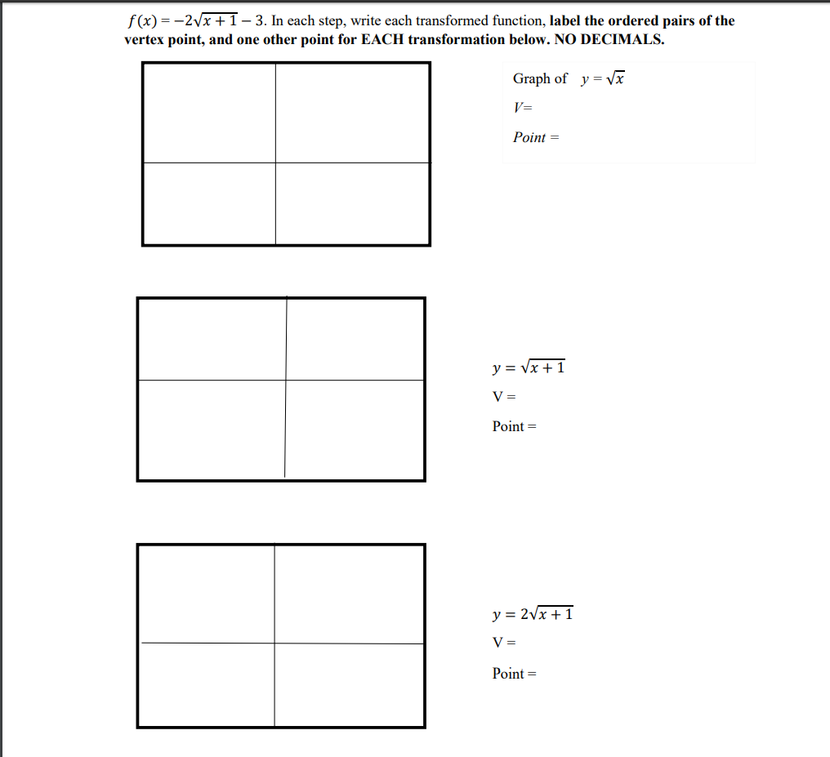

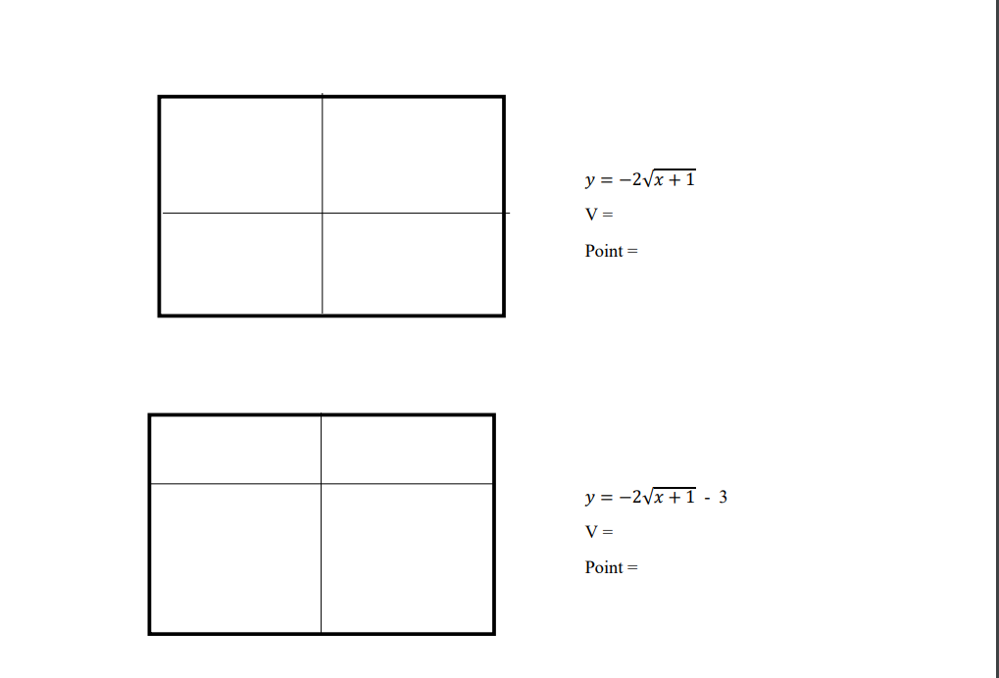

7. Starting from the an original function 𝑦 = 𝑓(𝑥) below, sketch the graph of
𝑓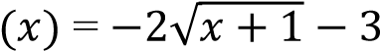. In each step, write each transformed function, label the ordered pairs of the vertex point, and one other point for EACH transformation below. NO DECIMALS.
Graph of y 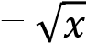
V=
Point =

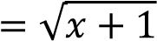

𝑦

=

√
𝑥
+
1

V=

Point =

𝑦

V =

Point =

𝑦
=

−
2
√
𝑥
+
1

𝑦

=

√
𝑥
+
1

V=

Point =

𝑦

V =

Point =

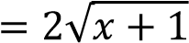

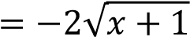

𝑦 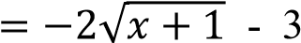 V = 𝑦 = √𝑥 + 1
V= Point = Point =

𝑦

=

√
𝑥
+
1

V=

Point =

𝑦

V =

Point =

