NUR 627 – FALL 2020
Makeup test1
Answer the following NINE questions, provide rationale for your answer and send by email

- Which of the following improves the reliability of diabetes screening tests?
- Having the same lab analyze all samples
- Taking more than one sample for each subject and averaging the results
- Insuring that the instrument is standardized before each sample is analyzed
- a and c only
- All of the above
- In 1990, there were 6,500 deaths due to lung diseases in miners aged 20 to 64 years. The expected number of deaths in this occupational group, based on age-specific death rates from lung diseases in all males aged 20 to 64 years, was 1,500 during 1990.
- What was the standardized mortality ratio (SMR) for lung diseases in miners?
SMR = 4,500/1,800 = 2.5 (it is a ratio with no units)
- Interpret the value of the SMR:
SMR= the ratio of the total number of (lung disease) deaths actually observed to the total number of (lung disease) deaths expected if the population of interest (miners) had had the mortality experience of the known population (all males).SMR = 4,500/1,800 = 2.5 (it is a ratio with no units)

- What would be the effect on age-specific incidence rates if women with hysterectomies were excluded in the denominator of calculations, assuming that there are some women in each age group who have had hysterectomies?
a. the rates would remain the same
b. the rates would tend to decrease
c. the rates would tend to increase
d. the rates would increase in older groups and decrease in younger groups
e. it cannot be determined whether the rates would increase or decrease

Question 6 is based on the following information:
A physical examination and an audiometric test were given to 500 persons with suspected hearing problems, of whom 300 were actually found to have them. The results of the examinations were as follows:

PHYSICAL EXAMINATION
HEARING PROBLEMS
Result Present Absent
Positive 260 30
Negative 40 170

AUDIOMETRIC TEST
HEARING PROBLEMS
Result Present Absent
Positive 290 10
Negative 10 190
- Compared with the physical examination, the audiometric test is:
a. Equally sensitive and specific
b. Less sensitive and less specific
c. Less sensitive and more specific
d. More sensitive and less specific
e. More sensitive and more specific

- For the figure below: describe and interpret the results in the figure.

New estimates predict top cancers for 2005-2009: African American, White and American Indian are the 3 most common cancers expected in women in 2005-2009. And in men, African American, White and American Indian are expected to be the most common this year.
- For the figure below: describe and interpret the results in the figure.

Cancer death rates continue steady decline: The cancer death rate for both men and women in the United States has been trending downward over the past two decades.

- Complete the Table 1 (Table below) by calculating the polio incidence rates, disease-specific mortality rates, and case-fatality for each of the past five years. Interpret the data and the trend over time.

Table 1:
 | # New |  | Midyear | Incidence | Mortality | Case-fatality
Year | Cases | # Deaths | Population | per 100,000 | per 100,000 | (%)
1986 | 55 | 4 | 360,000
1987 | 58 | 9 | 373,680

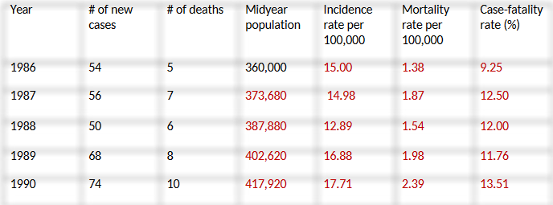
Add .038 each time on midyear population 54/360,000x100,000. 5/360,000x100,000. 5/54x100
- Providing education to a diabetic on how to use his/her insulin is an example of which level of prevention?

- Primary prevention
- Secondary prevention
- Tertiary prevention
- Community prevention

 | - The nurse researcher knows that there are two primary criteria for assessment of an instrument. What is reliability?
 | A) | Degree of consistency or accuracy with which an instrument measures an attribute
 | B) | Magnitude and direction of a relationship between two variables
 | C) | Extent to which an instrument yields the same results on repeated administrations
 | D) | Extent to which an instrument's items are measuring the same attribute

