Table of Contents
ABSTRACT 3
Introduction 4
Demand and supply analysis 5
Econometric Model 12
Scatter Plots 12
The line of Regression 14
Regression Line Equation 16
Excel Worksheet of the Regression Analysis: Apple Inc. 19
Elasticity 20
Transcript of Apple iPad Elasticity Analysis 20
Income Elasticity of Demand 20
Product Elasticity 20
Pricing Analysis 21
Hypothetical Analysis 22
Forecasting 23
Equities 23
Consented Recommendation 23
Share price forecast 24
Dividends 24
Earnings History & estimates 25
Historical Revenue & estimations 25
Marginal Analysis 26
Apple Inc., Smartwatch Economic Analysis 28
References 30

Abstract
This is an apparently Apple Company case study based on the five instruments used to solve strategic management problems. They are supply and demand, regression analyses, elasticity, forecasting, and marginal analyses. Supply and demand are a strategic management tool that looks to boost performances, establish a clientele and outcompete for competitors in the selected markets. Demand and supply may be computed using linear functions to which we use some variables as slope parameters to give statistically accurate estimates of what the demand and supply for commodities are within a specific market. In turn, this enables economists to compute the state of stability or equilibriums, increasing the efficiency of the firm. These increases in efficiencies are vital to boosting the performances of the organization that help in solving the problem of increasing sales into 2018. Regression analyses are other instruments that are the techniques used in determining how one or more explanatory variables affect the values of a regress and. The regress and is sales. In the case of this project and the explanatory variable can be income.
The regression analyses may be categorized into five components of simple regression, multiple regressions and interpreting the P, F and T values generated from the data analyses from the collected data on the regressors from the amount demanded and supplied functions. Elasticity calculations are the third component to use, which will enable economists to compute the changes in demands or supplies with declines or increases in the price of the commodities which directly relates to increasing sales. Marginal analyses are the fourth mechanism and will focus on experimenting with the selection of variables by small quantities to see if the objectives (increased sales) maybe further increased due to the fact this is a maximization problem. The ultimate tool in solving the issue of decreased sales will rely heavily on qualitative data such as an expert opinion on the movements of the market supported by the evidence provided from the previous four tools.

Introduction
One of the PC companies and driving purchaser hardware in the world is Apple. The research and development teams of Apple have been tasked with the redesign of Apple Technologies. It is no secret that every company needs an update once in a while. Apple technologies have moved far along from its' days of producing solely PC's and are now manufacturing a variety of software and IT infrastructures such as iPod and iPhone. As of March 2019, Apple Technologies has become one of the leaders in IT infrastructure. To portray this significant change to its consumers, Apple Logo has created a new logo for the company to reflect the growth, modernity, and force of Apple Technologies. Primarily, the redesigned logo focuses on using colour to market the brand and create a brand identity. By using the colours, yellow, orange, blue, and purple, Apple Technologies will appear reliable, creative, and joyful to the consumer. Previously, the old logo only showed one of those dimensions, secure, yet unmemorable. The old logo also had a negative connotation because it was what appeared when your computer froze or was slow. The research and development team of Apple Logo has created a new logo that will bring life to this powerhouse IT company.
Apple creates and personalizes computers, specifically for its consumers, to fit their needs and budget. This makes the company is unique because it shows that they value their customers. This leads to the need to redesign Apple's logo. The current logo is very bland and needs to be enhanced in a way that makes a statement and fits its unique identity. The current Apple logo does not provide consumers with a progressive and innovative impression that could be achieved with a simple change in status. The goal is to create awareness and build loyalty for the corporation. The personal logo tells the story of a company in a manner that develops excitement, commitment, and knowledge. The new logo creates a brand identity how the company wants its clients and potential clients to perceive its services, brands, and products.
The project to redesign the logo for Apple Technologies was authorized by the Executive Board of the Apple Corporation. The project was allowed because, as Apple Company has begun to focus more on IT infrastructure, it is time to reflect these changes. As the board starts to make changes internally, it needs to communicate this with its consumers and hone in on brand identity. The research and development team has conducted market research and used expertise to create a logo that will be beneficial and reflective of the new direction Apple Company is moving toward. The logo builds an excellent reputation for the company, its values, products, and services.
The customers will instantly acknowledge the logo of Dell since the new logo will be continuously displayed and use by every brand. People will recognize the brand identity of Dell based on this new logo. The logo takes contrasting visual components and brings them into complementary systems. The logo is consistent in its feel, colour, scope, use, and appearance. Well designed, good partnerships, consistent messaging, and effective marketing all promote the brand. Rather than leaving public perceptions of the brand, it is often a good practice to shape and build its brands. A logo strategy may assist Dell to take its business to another level.
To measure and evaluate the capability of Apple Company to generate revenues or profits comparative to revenues, assets of balance sheets, operating expenses, stockholders equities; the financial ratio analysis is carried out. The financial ratios enable Apple Company to determine how much returns they need to earn in a fiscal year. Over the previous year's sales, Apple would be capable of setting proportion increment or cash amounts. Besides, the companies will be to establish their particular revenue and profit objectives. Keeping the expenses track of the organization is part of accomplishing the firm profitability objectives. The business expenses may as well increase when the company puts extra energies to generate additional incomes and profits. Apple Company should design programs, methods, and initiatives to maximize revenues and reduce expenses.

Demand and supply analysis

Basic Demand Functions:
Q_{d} = f (P,M,P_{R},T,P_{E},N)

There is a general law of demand and supply in economics. Where, ceteris paribus(holding all factors constant), the price worth of a specific decent or administration increases, then the demand for such high or policy declines. On the off chance that the price diminishes then the likelydemandadditionally builds (there is an inverse relationship between the variables). In the supply side, if the price of a decent or administration makes, then companies will supply the higher volume in the market of such management. On the off chance that the price diminishes, then companies will cut their supply of the great or authority (thereare positive relationships between the variables) (Rios et al., 2013). The market then alters the price of the great or policy with a particular end objective to fulfil both the clients and the providers. This is called showcase harmony. In this paper, an examination of the supplies and demands for Apple iPhone products is the fundamental course of the discourse (Rachet, 2014).

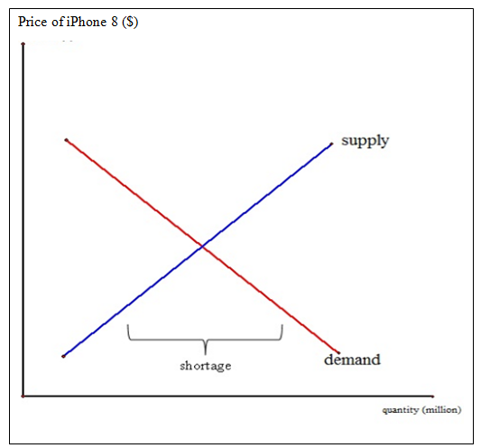
Diagram 1: iPhone 8 launch: Demand and Supply Analysis
GivenDiagram 1, the amount demanded iPhone 8surpasses the number delivered by Apple; thus, there is a lack of supplies. Apple can create more arrangements because the sum requested is depended upon to be ten million units (Rachet, 2014). If Apple made sense of how to supply ten million numbers of iPhone 8 to take mind without limits requests from purchasers, Apple could grow its advantage at the adjust point where adequacy happens.

Personally, the matters on the employees' go-sloware not a massive issue to Apple because the iPhone has transformed into an essential mobile phone in the markets, particularly in the United States market (Rachet, 2014). Why do numerous individuals pick iPhones over various cell phones? The significant features of this are item qualities, cost, and brands. iPhonesare highlighted with widescreens sort out that enable their customers to watch recordings and touch the screens rapidly. iPhones moreover continue running on iOS, which is a working system that gives a critical number of uses (Tan and Carrillo, 2016). While many Android phones make a significant part of the markets, still many telephone customers assume that the applications iOS be just excellent. Given the iPhone 8's business desire, unmistakably customers will pay a high price for the iPhone. It is a value purchasing telephone due to its high calibre.
Apparently, along these lines, Apple may set high prices for its iPhone and generate more vital general income. Also, iPhones have been a reliable brand in the overall markets. Customers purchase the iPhone as an adult toy. For instance, iPhone customers are perceived as wealthy individuals or potentially 'tech geeks' (Tan and Carrillo, 2016). Every one of these zones has isolated iPhones from their close-by substitutes, yet not a superb replacement. Lovers of iPhone fans, for example, will pay more for the iPhone. Along these lines, when their values augment, the sum requested iPhone reduces, yet it doesn't mean genuinely reduction to zero unless the cost rises by adequately inconceivable totals (Rachet, 2014). Right when buyers change to their substitutes, the request twist for iPhones shall move to the other side, however not greatly gigantic, i.e. lessen sought after. Given Diagram 2, as buyers swing to elective phones, the request bend D1 Move to D2.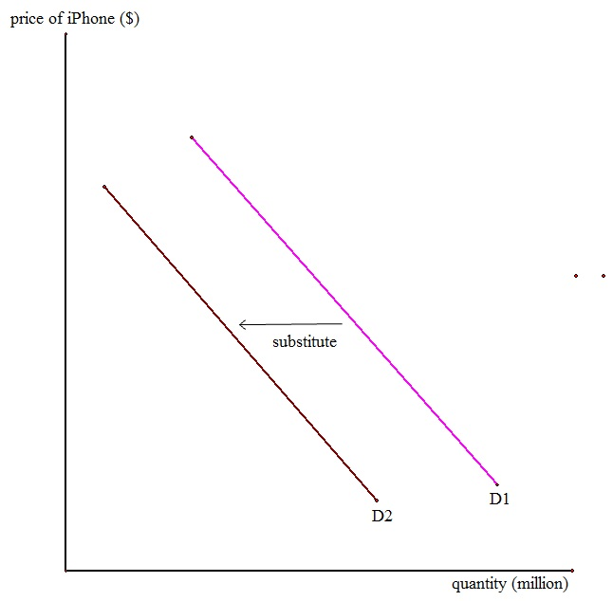
Diagram 2: the effect of Substitution
As iPhones have the commodity separations over theiropponents who continue operating on the Android system for their phones, Apple may make excellent arrangements. Since iPhones are in monopolistic contention, iPhones make short-term yields and value decisions necessarily as a controlling framework company does.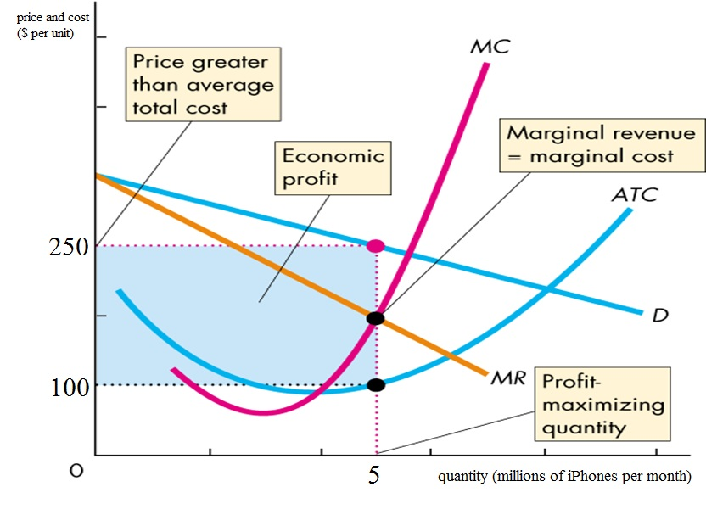
Diagram 3: Economic profits in the Short-run
Apple augments gain by delivering the quantity at which small incomes break even with negligible costs, a massive number of iPhones a month and setting the prices of two and fifty USD per unit. This number surpasses the typical aggregate costs of one-hundred USD per unit. The blue rectangles delineate the financial benefit of seven-hundred and fifty million USD every month. (Allude to Diagram 3).
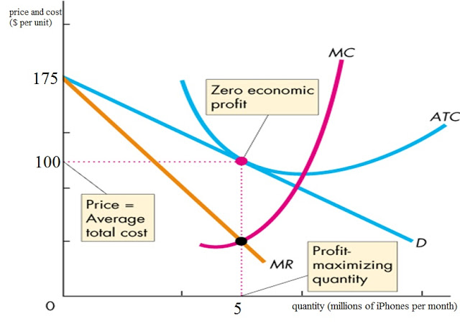
Diagram 4: Zero economic Profits in the Long-run
In any case, the iPhone is not profitable to increase monetary yield for long. Inevitably, its rivals and new companies join the cell phone advertise as iPhone creates a financial profit. Asa result, the demands for iPhones diminish as more companies enter the marketplace (Tan & Carrillo, 2016). The demand bend and peripheral income move leftward. In this manner, the profit-boosting amount and price decreases. At the benefitaugmentation, the changes in price measure the standard aggregate cost, so monetary profit is zero (Rachet, 2014). With the end goal for iPhones to recapture earnings in the short-term, Apple needs to dispatch a new telephone to begin the cycle once more.

Relatively, this infers that Apple would require outlininga new phone which far prevalent isolated so Apple may battle in the markets with more necessary arrangements amount. This circumstance may be noted when Apple propelled iPhones8 after iPhone 4-S have been in the markets for a year in light of different cell phones such as Samsung Galaxies enter the markets (Allude to Diagram 4). In conclusion, I believe that everyone realizes that iPhones have been sensational to the worldwide markets. Demands for iPhones are growing for each prototype propelled. The accomplishment of Apple iPhones in the telephone markets is taking its energy to impact the market for cell phones. Any possible dangers and adverse hypotheses appear not to upset Apple gravely. Without any doubt, Apple is the driving force for mobile phone markets (Tan & Carrillo, 2016).

Econometric Model

Scatter Diagrams and Plots
As shown by the movement, one of the initial phases in relapse is to plan your information on a disseminate plot(Kenett et al. 2014). The accompanying table records the month to month deals and publicizing consumptions for all of a year ago by an advanced hardware organization.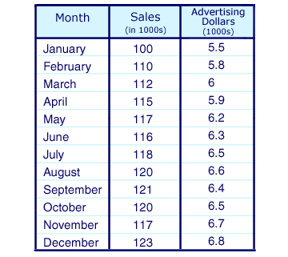
For this situation, you would plot a year ago information for a month to month deals and promoting uses as appeared on the thin plot underneath. (Information for independent and ward factors must be from a similar timeframe.)
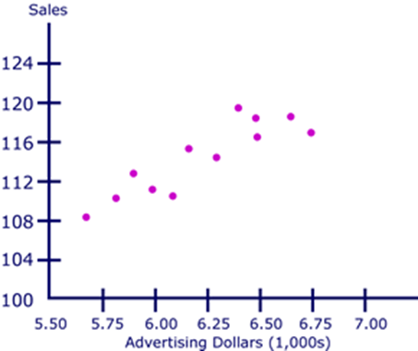
Scatter plots are viable in outwardly recognizing connections between elements. These connections can be communicated numerically regarding R^2 (coefficient of correlation), which is usually alluded to as a relationship. Associations are records of the quality of the link amid two factors. They could be in whichever incentive from between –1 and +1. (Grasa, 2013).
Consequently, once you apply relapse to forecast future estimations of the bankrupt variables, the perfect relationships among the free as well as ward variables are higher in through and through regard terms, someplace in the amid-range of 0.5 and 0.99. Seeing the thin plan over head, one could see that there appears, all in all, to be some level of the relationship among the level of advancing utilization and item care. At whatever point figured, this connection measures up to .89. This recorded data will engage you to predict the association between the two components later on before any further cost is obtained. With a particular ultimate objective to make these desires, a relapse line should be constructed from data that appear in the scatter plots (Grasa, 2013).

The lines of Regression
The diagrambeneath is similar to the scatter plot overhead, as well as the range of regression fixed to the historical figures.
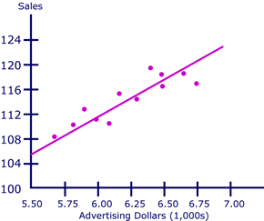
The line of regression is the one with the littlest conceivable arrangement of separations amongst itself and every information point(Grasa, 2013). As should be obvious, the regression line touches a few information focuses; however, not the rest. The separations of the information focuson the line of regression are called stochastic terms.
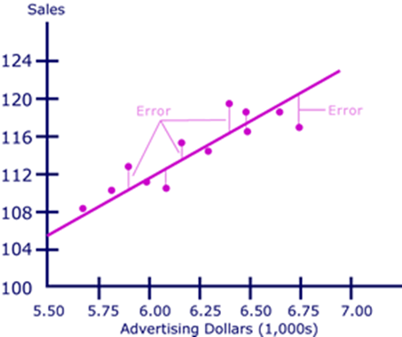
The lines of regression will dependably comprise of stochastic terms since, as a general rule, independent factors are never flawless indicators of the dependent factors. There are numerous wild figures in the commercial world(Grasa, 2013).The stochastic term is real since a regression model could not once incorporate every conceivable variable; some prescient limit will dependably be missing, especially in a first recession.
The standard process for discovering the best fit line is known as the minimum squares technique. This count is typically completed utilizing PC programming. In this count, the best fit is found by captivating the distinction amongst the line and each information point, squaring every difference, and including the qualities collectively(Grasa, 2013). The least-squares technique depends on the rule that the entirety of the adjusted errors ought to be little as possible, so the line of regression has the slightest mistake.
When the line is resolved, it may be stretched out past the chronicled information to foresee the upcoming level of produce mindfulness, with a specific level of publicizing consumption.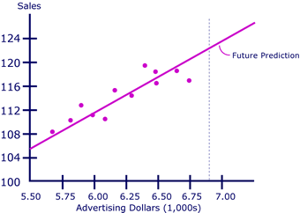
The expansion of the line of the regression needs the presumption that the primary procedure bringing about the connection between the two factors is substantial past the scope of the specimen information (Grasa, 2013). Regression is an active business apparatus because of its capacity to foresee future relationships between elements, for example, these.

Regression Line Equation
In the equation line, coefficients, variables as well as constants are represented as:
• X accounts forthe regressor
• F(x) accounts for the regressand
• the coefficient symbolizes the y-intercept-this shall be the worth of the regressandwhen the regressor is equivalent to zero
• theconstant m defines the shift in the regressand as a due to a givenchange in the regressor
In economics, straight regression is regularly applied to portray the profits of separate securities (subordinate variables) contrasted with the benefits of the markets when all is said in done (regressor) (Grasa, 2013). The condition for the significant direct regression utilized to depict safety developments is additionally straightforward lines and is communicated in a configuration that, while comparable, contains several turns.
The equations below are relapse equations for straight lines portraying the connection between the profits of securities I and the markets when all is said to be done.

• ri symbolizes the yield of securities I and is the regress and
• r_{m} symbolizes the overall return of the markets and is the regressor
• in general, b is the slopes of the regression lines, and they describe the movement levels in securities I as due to a movement unit in the markets
• a is the regression line y-intercept
• I am a stochastic phrase which defines the distances between real data points and the equivalent points on the line of regression
The diagram below gives a graphic portrayal of the regression line. The profits of the markets, all in all, are spoken to in this chart by the S & P 500benefits. 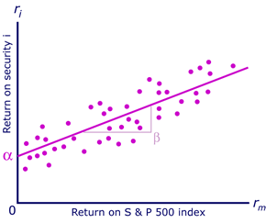
There can be conversant with talks in money related loops about the security beta, (b) being measures of the risk of the securities. The use of relapse strategies figures the hazard activity of beta. The relapse line slope, Beta, was delineated above as the levels of advancement in the benefits of a particular security for every unit of improvement in the markets when all is said in done (Grasa, 2013). Wellbeing with a higher beta is seen as dangerous and shall encounter colossal fluctuate in its benefits when it appeared differently concerning the ones of the markets. Securities with a low beta are seen as less risky and shall have given back the shifts not precisely the ones of the markets. The alpha period (an) in the relapse state of securities addresses the securities’ slant to change self-governing of the markets. The betas and alphas of securities can't be detected yet are evaluated, given the past execution of securities, via relapse examination (Grasa, 2013).

Excel Worksheet of the Regression Analysis: Apple Inc.
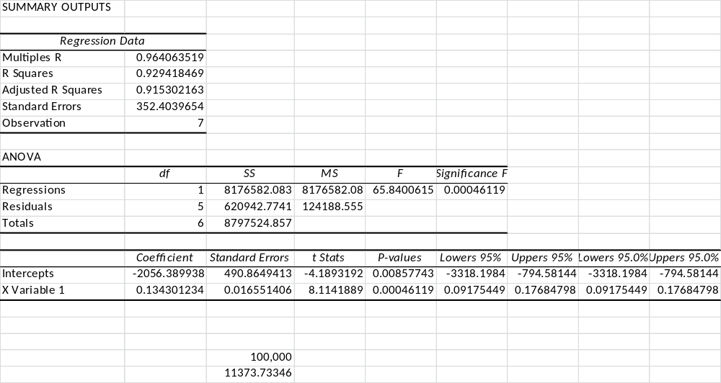

Elasticity

Transcripts of Apple iPads Elasticity Analyses
16 GB: -2.090
32 GB: -1.930
54 GB: -1.990
Price Demand Elasticity: Elasticity Analysis of Apple iPads
The percentage change of the quantity demanded would exceed the percentage change in price.
It means that (Zhang et al. 2016): In case Apple reduces the prices, the revenues are likely to increase because of higher demands.
In case Apple increases the price, the revenuewillreduce because of much lesser demand.
For instance, +1.600averages for all iPad models.
Demand Income Elasticity
1) theamount, being greater thanonemeans that the income of buyers implies significantly affects the demands for the products.
2) It is a luxurious product and is revenue elastic
3) a rise in revenuemeans that a customer is expected to purchase more amounts of the products.

Product Elasticity
The past specified financial evaluating plan is related to the Game-Theory idea that is utilized to decide an ideal approach to exceed their adversary. It is finished by embracing lows-to-highs or highs-to-lows price methodology which shall maintain their adversary speculating that is most appropriate to the markets a specific time (Song, 2015). It ought to likewise be noticed that the demands of oligopoly' bends shall rely on upon how every opponent responds to the valuing alterations by either party.
Mostly, oligopolistic endeavours shall regularly arrange the fighting value diminish which falls underneath the "going-cost" since it shall undermine their original cost as well as along these lines do their customers switch items (Song, 2015). Regardless, they will slight any cost augment that is over the "going cost" because the foes' assessing increment methodologies would now and again provoke business hardships. Since their value help that was over the client's value wants. By then, it is sensible to express that most oligopolists will demonstrate a non-deceitful value direct that is known as the pleated request twist(McConnell et al., 2009). This request bend is consistently portrayed as an incredibly flexible request when they are over the going cost, yet they are inelastic when falling underneath the going-value.

Pricing Analyses

Subsequently, kinked-demand curves have established a see assignment that modifications in the costs of the commodities shall have adverse effects on the customer acquiring needs and shall incite gain lift to enemies which do not oblige the esteeming arrangement underneath the going-costs(McConnell et al. 2009). By then, it is insightful to acknowledge that a value reduction shall manufacture the aggregate wage, yet the aggregate cost of oligopolists may have increased. Since the supplies total shall rely on upon the way request flexibility, adjust the buyer's slant at a given time of offers. Likewise, "a cost reduction in the inelastic territory cuts down the organization's aggregate wage, and the creation of a greater yield constructs its total costs" (McConnell et al., p.236, 2009). Like this, the creation of oligopolists’ cycles the cost should outperform negligible costs as well as standard total costs.
Regardless, if generation is underneath the yield where it might constrain the standard total costs, by then, they are protected from acknowledging that neither the profitable adequacy that creation should be neither equal nor least ordinary aggregate expenses(McConnell et al., 2009). Itadditionally cannot depend upon the allocative efficiency approaches, which states production should be comparable to peripheral costs.

Hypothetical Analyses
The theoretical analyses were to figure out what changes in variable and settled costs might affect the operations of the firm fetched for one unit using short-term costs of productions. With particular end objective to along the lines, the variable and settled values were computed from the preparation of outputs of the iPhone 8. The commodity was priced at six-hundred and fifty U.S dollars, including assembling costs of $ 226.86 and operational costs of $ 61.19 and after that discount markups of $ 68.91(Sherman, 2013). Then the aluminium smart-watches were just used as parts of this model, and its stainless steel marks $549 and $599 prices go with demand curves of 0.090% (=50.00 U.S dollars/549.00 U.S dollars. At those points, the evaluated fifteen million for every amount from the totals at the most astounding costs of this theory shall be familiarized with a discount of $50 with increment consciousness marks of these sorts and to prevent match passages into the markets(Sherman, 2013).

Forecasting

Equities
Price (USD):143.65
Today's Changes: -0.14 / -0.10%
Shares Transacted: 20.86m
1 Year Changes: 51.48%
Betas: 1.1642
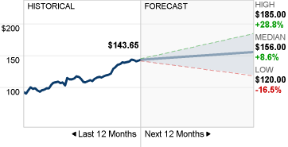

Consented Recommendation
The agreement forecasts as of 24th April 2017 among fifty-two polled investment economists studying Apple Company advised that the performance of the firm shall outdo that of the markets(Konchitchki & Patatoukas, 2016). These have been the consensus forecasts because the investment analysts’ sentiments worsenedon 17th October 2011. The prior agreement forecasts investors to buy equities in Apple Company.
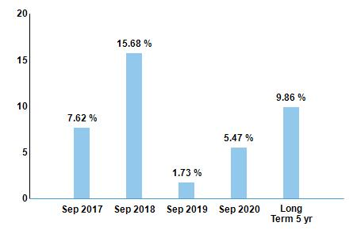

Share price forecasts
The forty-one financial analysts providing twelve-month prices focus on Apple Company have a significant consensus of with highest gauges of 180 and lowest gauges of 104 (Konchitchki&Patatoukas, 2016). The middle measures peaked at expansions of 7.9% from the previous prices of 143.66.

Dividends
In 2016, Apple Company detailed a profit of $ 2.18, which speaks to 10.1% increases over a year ago. The eighteen investigators studying the organization anticipate earnings of $ 2.320 for the up and coming financial year, a rise of 6.28% (Konchitchki&Patatoukas, 2016).
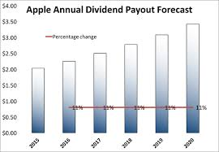

Estimates and History of Earnings
On 31st January 2017, Apple Company detailed the first quarter 2017 profit of 3.360 for each stock. These outcomes whereby the agreement of the thirty-six investigators taking after the organization and surpassed a year ago the first quarter comes about by 2.440%. The following income declaration is standard on 2ndMay 2017.

Historical Revenues& estimates
In the first quarter of 2017, Apple had incomes of $ 78.350 billion. This better than the predicted amount of $ 77.28 billion by most economists who studied the company. It was 3.270% better than the previous results of the first quarter of the year (Konchitchki & Patatoukas, 2016). For the whole of 2016, the company had a total revenue of $ 215.44billion. These were 7.730% of the results of the previous year.
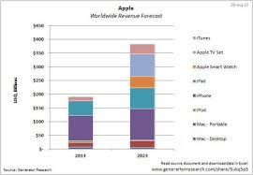

Marginal Analysis
Apple makes an extra $ 84.50 in profits on the telephone off chances that customers buy an iPhone 8 or more instead of the little iPhone as per Bloomberg that refer to collections of costs breakdown by exploration frames of HIS (Coughlin, 2016). From Teadown.com, another part of assessments realized something comparative: the battery and bigger screen of the iPhone 6 Plus.
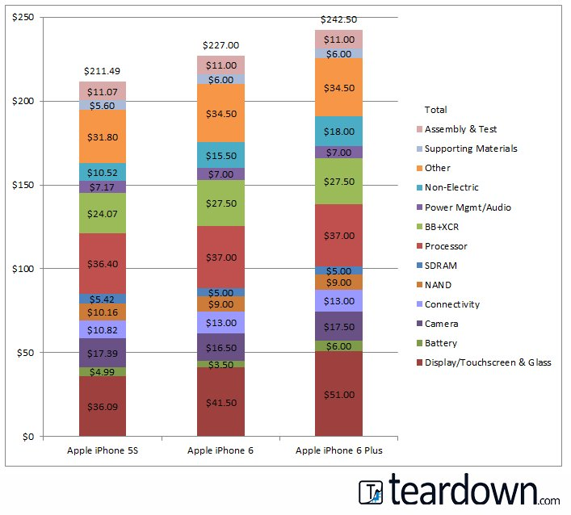
Below is the IHS breakdown charts:
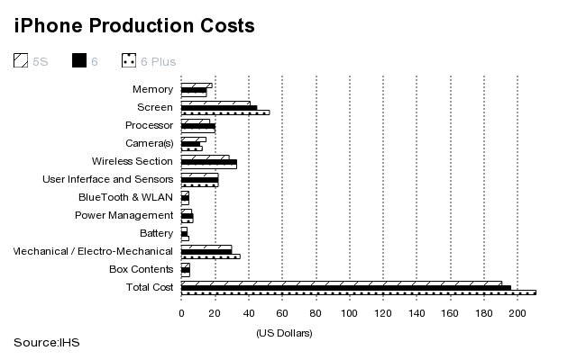
Teardown-com asserts the two elements of the iPhone 6 Plus, which increase its costs of productions are the batteries and screens. Bringing the total costs of the screen to $ 51.00, the large screen on iPhone 6 Plus costs $ 9.5 more and going at $ 6.00, the large batteries are costing $ 2.5 more (CouStronger Competitor

In many highly competitive segments of products like application and enterprise software, smart-watches, laptops, mobile payment, tablets, and smartphones, Apple competes appropriately in the industry (Dolata, 2017). In each product category, the rivalry of each product is fierce. That is the reason Apple Corporations appreciates that competitions are significant threats to their growth and profit returns. Stiff competitions confront the company in all its business areas, and the products and services of Apple are highly competitive in all the markets. The operating results and financial condition of the company can be negatively affected by the competitions. The major competitors of Apple in the smartphone segment are LG, Google, HTC, Huawei, and Samsung (Dolata, 2018). The rest of rival companies are either target different consumer categories or too small and do not pose immediate threats to the market shares of iPhones or the profit returns of Apple.
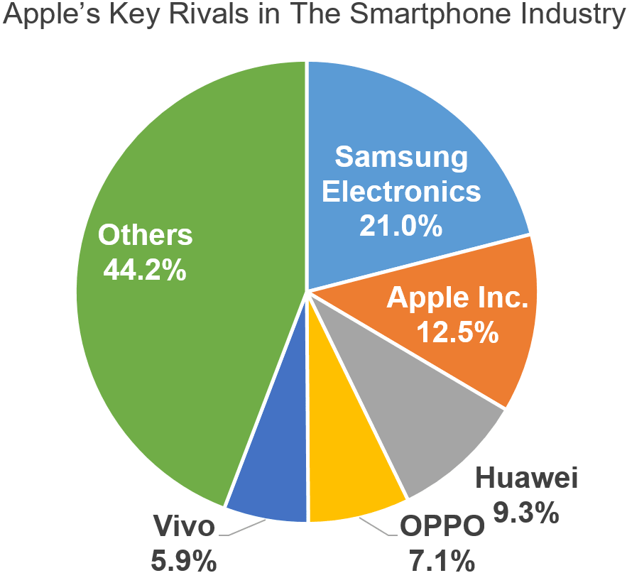[Source: IDC]
Samsung is a stronger competitor to Apple Group. Samsung dictates 21% of the market share as compared to Apple Inc., which dictates only 12.5%.
Opportunities for each firm
Apple Inc. has better prospects than Samsung (Dolata, 2018). Some of the opportunities linked to Apple Company include new environmental policies, decreasing transportation costs, new clients from online channels, differentiated pricing strategies in the new markets, the lower rate of inflations, and penetrations to emerging economies brick-and-mortar business expansion, and boost controls to reduce counterfeit sales. Penetrations to emerging economies will allow the company to create its presence in the emerging markets and therefore giving the business a definite competitive advantage in the e-commerce industry (Kaur & Abodallahian, 2014). Product analysis and processes of automated consumer reports can help reduce the number of counterfeit goods on the website. Apple Company has business models that maintain low operation costs by not providing many amenities and through an excellent fuel hedging strategy. Besides, the firm has staff members who are concentrated on a high customer service level (Dolata, 2017). These services have brought repeat clients, coupled with low costs of electronic products.
The performance of Apple Company and Samsung in the Industry
Free cash flows of Apple Company listed in the current year and prior year are $ 1,900 and $ 2,000 million, respectively (Dolata, 2017). The company shows reducing trends in cash flows but increasing trends in profitability offered by operations. If the firm wanted to depend on the investment required to build its ability to finance expansion change, then it must raise its free cash flows. Operating cash flow may be viewed as the most organic sources of cash and is earned from normal operating activities of the company. Apple Corporation may also sell assets or investments for money (Dolata, 2018). However, the investing activities are outside the primary operations of the company, and the resulting cash flows do not measure its capacity to generate continuous cash flows to support business acquisitions or capital expenditures.
Long-term and Short-term Investment
The overall brand value of Apple went up by 11%, which was approximately $ 200 billion. The consumers changed to more affordable phones and electronics of Apple during the recession (Dolata, 2017). The corporation is famous for its superior products. In the world, with a total brand value of $ 200 billion, Apple is one of the most valuable and classic brands. Posting net profits of over $ 55 million for 2018 that is a 7.7 % decrease from the previous year (2018) where net profits were over 59 million; Apple remains competitive in U.S Stock Exchange. The company has remained robust than its peers, where sales grew by 16.5%.
The overall value of the Samsung is $ 61.1 billion (Dolata, 2017). The current decreases in stock prices are likely to create substantial buying opportunities for Samsung. The stocks can significantly go up into 2019 and beyond. Samsung stocks received significant attention from the considerable movement of the price at one point during the year. The amount of the stock has gone down at the lowest of $ 44.94 and has increased to the highest at $ 55.56 (Kaur & Abodallahian, 2014). The excellent volatility level provides the financiers with the opportunity to enter into the shares and possibly purchase them at the theatrically lower prices. Samsung stock at the moment appears equitably valued according to the model of valuation. The financiers seeking for expansions in their portfolio can consider the firm potentials before purchasing the shares. More attractive investments would be excellent prospects for the growth of stocks at relatively affordable (Dolata, 2018). The future seems bright for Samsung, with profits anticipated to increase by 56.3% in the future.
Apple Competitor Matrix
Product Categories | Competitors | Weights | Ratings | Scores
Smartphones (iPhone) | Samsung | 0.630 | 4.00 | 2.520
Smartphones (iPhone) | Huawei | 0.630 | 3.00 | 1.890
Smartphones (iPhone) | OPPO | 0.630 | 2.00 | 1.260
Smartphones (iPhone) | Vivo | 0.630 | 2.00 | 1.260
Smartphones (iPhone) | LG Electronics | 0.630 | 2.00 | 1.260
Smartphones (iPhone) | Google | 0.630 | 3.00 | 1.890
Tablets (iPad) | Samsung | 0.100 | 3.00 | 0.300
Tablets (iPad) | Amazon.com | 0.100 | 4.00 | 0.400
Tablets (iPad) | Lenovo | 0.100 | 2.00 | 0.200
Tablets (iPad) | Huawei | 0.100 | 2.00 | 0.200
Personal Computers (Mac) | Lenovo | 0.110 | 4.00 | 0.440
Personal Computers (Mac) | HP | 0.110 | 3.00 | 0.330
Personal Computers (Mac) | Dell | 0.110 | 3.00 | 0.330
Personal Computers (Mac) | Asus | 0.110 | 3.00 | 0.330
Services (Internet Services, Apple Pay, Apple Care) | Google | 0.110 | 4.00 | 0.440
Services (Internet Services, Apple Pay, Apple Care) | Microsoft | 0.110 | 3.00 | 0.330
Services (Internet Services, Apple Pay, Apple Care) | Samsung | 0.110 | 2.00 | 0.220
Services (Internet Services, Apple Pay, Apple Care) | Amazon.com | 0.110 | 3.00 | 0.330
Services (Internet Services, Apple Pay, Apple Care) | Spotify | 0.110 | 1.00 | 0.110
Services (Internet Services, Apple Pay, Apple Care) | Netflix | 0.110 | 1.00 | 0.110
Other Products (Smartwatches, Apple TV, Accessories) | Samsung | 0.050 | 4.00 | 0.200
Other Products (Smartwatches, Apple TV, Accessories) | Garmin | 0.050 | 2.00 | 0.100
Other Products (Smartwatches, Apple TV, Accessories) | Lenovo | 0.050 | 2.00 | 0.100
Other Products (Smartwatches, Apple TV, Accessories) | Amazon.com | 0.050 | 1.00 | 0.050

References
Arnold, N. (2014, December 21). Apple's 7 Most Innovative Device through the Years. Retrieved from Cheatsheet: http://www.cheatsheet.com/stocks/apples-product-timeline-the-best-of-the-best.html
Coughlin, T. (2016). Apple, Inc. v. Samsung Electronics Co.: Economics of Design Patent Trolling. Cardozo Arts & Ent. LJ, 35, 209.
Cecere, G., Corrocher, N., & Battaglia, R. D. (2015). Innovation and competition in the smartphone industry: Is there a dominant design?. Telecommunications Policy, 39(3-4), 162-175.
Dolata, U. (2017). Apple, Amazon, Google, Facebook, Microsoft: Market concentration-competition-innovation strategies (No. 2017-01). Stuttgarter Beiträge Zur Organisations-und Innovationsforschung, SOI Discussion Paper.
Dolata, U. (2018). Internet companies: Market concentration, competition, and power. In Collectivity and Power on the Internet (pp. 85-108). Springer, Cham.
Fogliasso, C. E., & Williams, A. (2014). Analysis Of The Business, Societal And Governmental Relationships Of Apple Inc. Leadership & Organizational Management Journal, 2014(1).
Grant, R. M. (2016). Contemporary strategy analysis: Text and cases edition. John Wiley & Sons.
Grasa, A. A. (2013). Econometric model selection: A new approach (Vol. 16). Springer Science & Business Media.
Jaswal, R., Novo, J., Ponton, A., Smith, K., & Tan, D. (2016). Section D200 Strategic Analysis for BlackBerry Ltd.
Jobs, S., Mantia Jr, L. D., Bachman, W. M., & Robbin, J. L. (2015). U.S. Patent No. D720,773. Washington, DC: U.S. Patent and Trademark Office.
Kenett, D. Y., Huang, X., Vodenska, I., Havlin, S., & Stanley, H. E. (2015). Partial correlation analysis: Applications for financial markets. Quantitative Finance, 15(4), 569-578.

Kaur, H., & Abodallahian, M. (2014, April). Analytical study of the global mobile market: Forecasting and substitution. In 2014 11th International Conference on Information Technology: New Generations (pp. 485-489). IEEE.
Khan, U. A., Alam, M. N., &Alam, S. (2015). A Critical Analysis of Internal and External Environment of Apple Inc. International Journal of Economics, Commerce and Management, 3(6), 955-961.
Konchitchki, Y., &Patatoukas, P. N. (2016). From forecasting to nowcasting the macroeconomy: A granular-origins approach using financial accounting data. Review of Accounting Studies.
Madigan, K., (Jan 2015). Economic News Coverage on Oil Prices Turns Negative, Wall Street Journal.
McConnell, C. R., Brue, S. L., & Flynn, S. M. (2009). Economics: Principles, Problems, and policies (18th Ed.). Boston, MA: McGraw-Hill Irwin.
Olivarez-Giles, N. (2015). Battery Worries on Apple Watch. Wall Street Journal, B4.
Rachet, B. (2014). Swot Analysis of Apple Inc. Docs. School Publications.
Rios, M. C., McConnell, C. R., & Brue, S. L. (2013). Economics: Principles, problems, and policies. McGraw-Hill.
Sanchirico, C. W. (2014). As American as Apple Inc.: International tax and ownership nationality. Tax L. Rev., 68, 207.
Sherman, J. (2013). Spendy but indispensable: Breaking down the full $650 cost of the iPhone 5. Digital Trends, 1-5.
Song, M. (2015). A hybrid discrete choice model of differentiated product demand with an application to personal computers. International Economic Review, 56(1), 265-301.
Tan, Y. R. & Carrillo, J. E. (2016). Strategic analysis of the agency model for digital goods. Production and Operations Management.
Zhang, Z., Tao, Y., Drzaic, P. S., &Wurzel, J. G. (2016). U.S. Patent Application No. 14/987,129.

