Edouard Manet

Edouard Manet (born January 23, 1832, died April 30, 1883) was a French modernist painter. He was one of the first 19th century artists to paint modern life. Manet is credited with the transition from Realism to Impressionism.

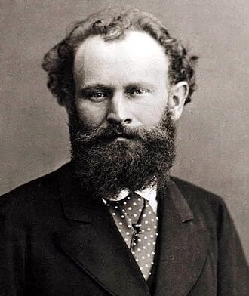

- Edouard Manet was born in Paris, to an upper-class family. As a boy Manet lived a luxurious life with his parents and two siblings. His parents were both highly regarded in their hometown. His father was a popular judge and his mother was of royal descent. He loved art from a young age and wanted to be an artist. However, he did not receive any support from his father. His father hoped he would pursue a career as a lawyer or a naval officer. Monet failed the entry examinations for the naval Academy.
- In 1845 after Manet’s failure to enter the Naval Academy, his father disappointed though he was, began to rethink his aspirations for his son. Manet was finally given the green light to study art! Manet was given the opportunity to study under Thomas Couture. Couture was a famous French history painter and teacher of the 19th century.
- To further his knowledge and skills, Manet went on a Grand Tour. During his travels around the world Manet visited places like Italy, the Netherlands, and Germany. His trip impacted his concept of various art forms and styles. He found inspiration in several artists including Titian, Caravaggio, Vermeer, Rembrandt, and Diego Velazquez.

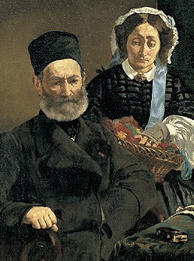
Portrait of Monsieur and Madame Manet, 1860, Oil on Canvas, 43x35 inches

- Manet’s early works during the 1850’s was inspired by Gustave Courbet. Courbet was a painter and a leader of 19th century French Realism.
- During the mid 1850’s to the early 1860’s Manet’s artwork depicted contemporary themes and everyday life.
- Two paintings where curated into the Paris Salon in 1861. Portrait of Monsieur and Madame Manet, and The Spanish Singer where both selected.
- Having paintings exhibited at the Salon was a quick way to gain success as an artist. Unfortunately, the Salon’s jury leaned towards mythological and biblical themes, which weren’t Manet’s strong suits. Manet submitted his work anyway; sometimes his subjects of contemporary urban life caught the attention of the jury and the Salon attendees.
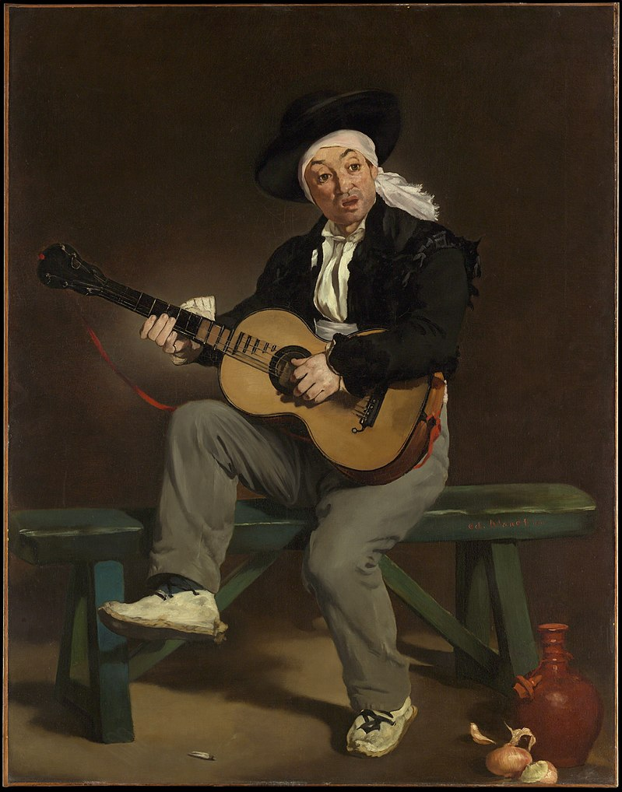
The Spanish Singer, 1860, Oil on canvas, 58x45 inches

- This painting is why Manet was curated into the Salon of 1861.
- The painting was composed in Manet’s studio, it utilized a model and props which were later used for at least one other painting. This work is both realistic and exotic in its depiction of its subject. It exhibits Manet’s interest in Spanish art, and the influence Velazquez had on Manet’s style.
- This painting received positive criticism and won an honorable mention at the Salon. It is often praised for its “very true color” and “vigorous brush” and because of the success brought on by this painting Manet became the leader of the avant-garde movement.

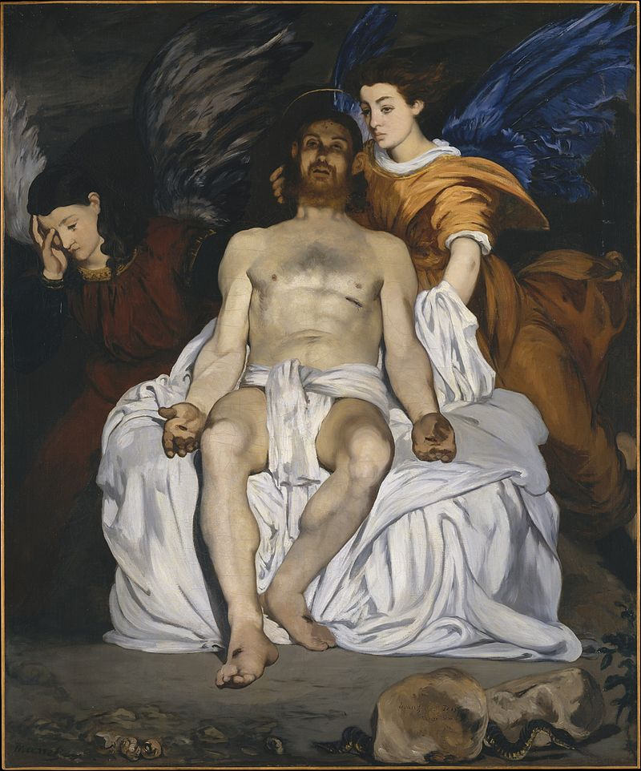
The Dead Christ with Angles, 1864, Oil on canvas, 70x59 inches

- Manet depicts the biblical story of Mary Magdalene entering the tomb of Jesus and seeing two angles with the body of the dead Jesus still visible. This is a rare example of Manet’s religious paintings.
- The picture is painted in somber tonality of funeral tints and shades, complemented by browns and blues, typical of Spanish painters like El Greco and Francisco Goya.
- Manet was fond of using light colors, his paintings often had a hint of black, which was very unusual for the time period.
- In 1864 Manet submitted this work and others to the salon. These paintings were harshly criticized by artists and critics. The Dead Christ left people unimpressed because of its lack of decorum. Manet was attached because of his depiction of Christ. He depicted him in a realistic manner, as a man, instead of ethereal and spiritual being. Manet also got the spear wound on the wrong side of Christ body (Manet didn’t realize it until he submitted it to the Salon). It is safe to say that these moves did not go over well with the public, especially the Salon.

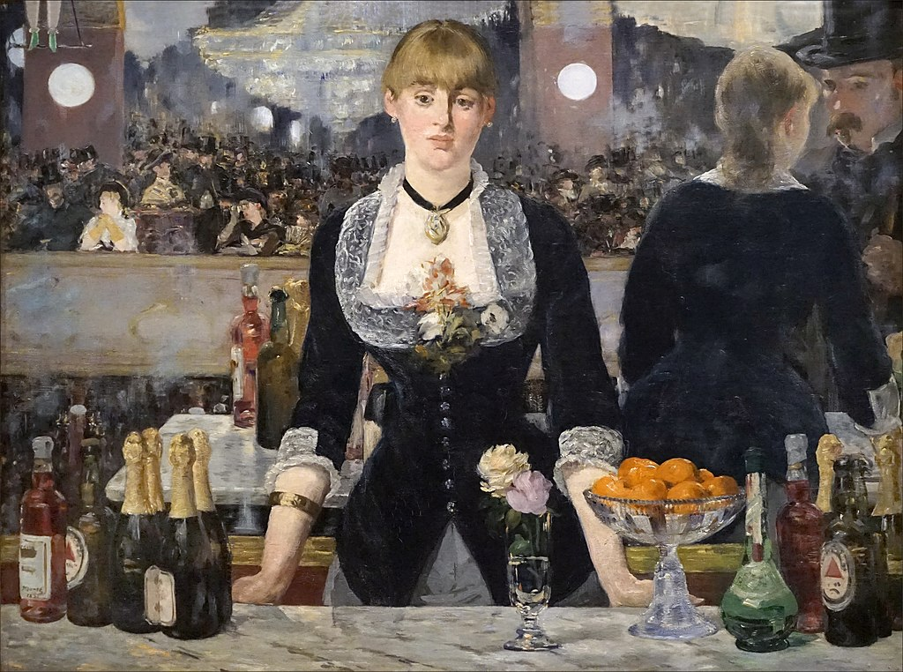
A Bar at the Folies-Bergere, 1882, Oil on canvas, 37x51 inches

- This painting is considered Manet’s last major work. Painted in 1882 and exhibited at the Salon of that year. It depicts a scene at the Folies-Bergere nightclub in Paris. This painting is a detailed representation of Realism and is a good example of Manet’s subject of contemporary life in Paris.
- The painting is rich with details that provide ques to the social structures of the time. The Folies-Bergere was one of the most elaborate variety-show venues in Paris, showcasing entrainment ranging from ballets to circus acts. Another attraction was the barmaids, who were assumed by many contemporary observers to be available as prostitutes. Something for which the Folies-Bergere was well known for. The barmaid is represented as both a salesperson and something to be purchased. Manet very purposefully introduced morally suspect, contemporary subjects into the realm of “high art” by treating the topics with deadpan seriousness and painterly brilliance.
- In addition to the social tensions evoked by Manet’s subject, his composition presents a visual puzzle. The barmaid looks directly at the viewer, while the mirror behind her reflects the large hall and patrons of the night club. Manet seems to have painted the image from the viewpoint directly opposite the barmaid. Yet this viewpoint is contradicted by the reflection of the objects on the bar and the figures of the barmaid and a patron off to the right. Given such inconsistencies, Manet seems not to have offered a single, determinate position from which to confidently make sense of the whole.
- The woman at the bar is a real person. Her name was Suzon who worked at the nightclub in the early 1880’s. For this painting Manet posed her in his studio including still life objects in the foreground.

Manet’s Influence: One of Monet’s popular painting techniques is alla prima painting. This style features laying down of colors that resembles the ones he envisions in his thoughts. This unique approach was well-accepted by the Impressionists, as it worked perfectly in capturing atmosphere and light as one paint in the outdoors. It is generally believed that Manet introduced and popularized Impressionism and avant-garde painting. In fact, he frequently met up with contemporaries such as Claude Monet to work towards initiating exhibitions around Impressionism. Manet kept himself apart from the Impressionists and always exhibited on his own at the Salon.

Manet’s roughly painted style and sense of lighting are seen as modern, specifically “early modern” partially because of the use of black in his figures, which draws attention to the surface of the picture plan and highlight the materiality of the paint.

Manet was rejected numerous times and received a bunch of criticism for his unconventional painting methods, yet he didn’t let it stop him, and his peers considered him a gift of ingenuity and artistry that ushered in a new era of painting.

Manet’s Death: In April 1883, his left foot was amputated because of gangrene, due to complications from syphilis and rheumatism. He died 11 days later on April 30th in Paris. Manet left behind 920 works of art made during his 32 yearlong public career.

