Manufacturing and service industry
Name
Institution

Manufacturing process flow chart in Camper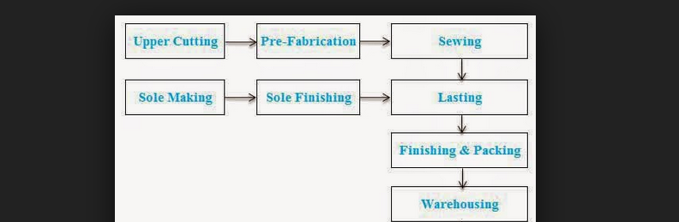
(Image courtesy of camper.com)
- Upper cutting and sole making is the first step in processing shoes. This involves sketching models and shoe lasts. Designers have the role of drawing a detailed type of shoe which is depended on the purpose of the shoe. Drawing can either be hand drawn or computer generated.
- Stage two involves sewing and marking the pieces of leather based on the lasts. This process is called stampling and plays an important role in ensuring that the shoe maker does not get confused (Borkhataria 2015). Edges are also thinned and in case the shoe is customized, any additional elements like perforation holes are made.
- The third step is to make shoe lasts which are made of wood. It involves finishing the soles and fabricating the toppings. Lasts play an important role as they ensure that the shoe is of the intended size, fits perfectly, and has the ability to last longer. These moulds resemble human feet and are an important element in shoe making process because they ensure perfection lasts
- Assembling is the most crucial stage. It involves the final finishing and packing. Fixing of the insole, ensuring that the material being used takes the shape of the last perfectly and welts the shoe. Reinforces of the shank and adds the final insole with the Brand name (Borkhataria 2015).
- The final stage in the process of shoe manufacturing at Camper is the show room. Shoes are put in warehouse. Final touches are made to the shoes in the shoe room before the shoes are distributed to different stores.
Motif Investing Inc.
Motif Investing is a service industry started in 2010, which allows investors to focus on their investments [3]. It exposes investors to the real world, presenting them with different investment opportunities depending on market trends. Investors are allowed to choose a particular theme based on their assets, needs and interests.
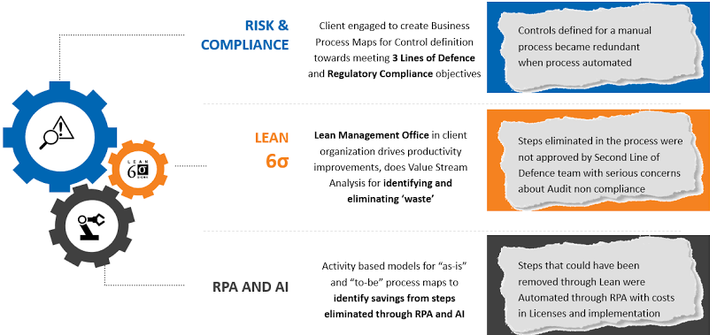
(Image courtesy of motif.com)
- Motifs are also prepackaged to serve different needs of investors, depending on whether the investment is short-term or long-term. This allows them to choose a viable plan on the basis of the company’s modern portfolio [4].

Summary
Camper and Motif Investing operate in different environments. However, there are still some similarities which exists in both. A detailed analysis of the differences and similarities will be emphasized.
Differences
At Camper, the products produced are tangible and are manufactured in different departments, while at Motif Investing the products are intangible. The environment here is that in the manufacturing company there is more physical work required to produce a tangible product as compared to service industry where the products cannot be touched. As a manufacturing company, Camper manufactures shoes while Motif Investing offers customers with financial services.
Another difference is that at Camper, there is an inventory which is required in order to help address issues of demand. In order to address this issue, Camper manufactures two different collections annually which are approximated to have 500 different types of shoes. These shoes are inventory, which are manufactured in order to forecast the level of demand. On the other hand, service industries do not keep inventory, but rather operate in an environment where services are created when a client requests. In the case of Motif Investing, the company allows an investor to choose an investment plan of their own. Thus, service industries operate in an environment where service production costs are not represented.
At Camper, shoes are manufactured without customer orders, but depends on the level of demand. On the other hand, Motif Investing operates in an environment where a customer has to request the service first before it is produced. Also, Motif Investing produces tailored services, with investment plans being developed based on customer needs while Camper manufactures its shoes based on the level of demand and not specific customer needs.
Another difference between the companies is the level of labor which is required for proper organizational output. Motif Investing operates in a labor intensive environment in the sense that services being offered cannot be automated. Professionals are required to ensure that each service is delivered in the most appropriate manner. On the other hand, Camper works in an environment where labor is divided among different people, each with different skills. At Camper, a shoe can be made by approximately 300 people before it reaches its final stage. Here, it can be argued that the process can be automated in the case of mass production.
There is also the difference in how operations are managed. In a service industry environment, managers assign workers with duties of handling customers. This allows managers to be able to oversee other sectors of the business including looking for partners, new markets, and ways to maximize on investment returns. On the other hand, manufacturing industries usually have the managers oversee operations and activities. From our cases, Camper’s operations and activities are overseen by managers while at Motif Investing workers are often scheduled to handle customers.
Similarities
Although there are many differences existing between the industries, there are some similarities which can be identified between the two companies. First, the two companies face the challenge of cost control. At Camper, the management has to look for reliable suppliers, who provide quality supplies at a lower cost. On the other hand, Motif Investing faces indirect costs as it has to keep costs at a lower level by providing customers with competitive prices. Therefore, both industries focus on minimizing costs while at the same time providing customers with quality products and services.
Both companies also conduct forecasts to determine the level of demand. This is important because it helps them stay at the competitive edge in the market. Forecasts are important as they help the companies predict the future of the business and thus, being able to take any risks and uncertainties the future may have. This, in turn, determines whether the company achieves a competitive advantage or not.
Conclusion
At Camper, there is Customer-introduced variability because each year the company produces two different collections with a total of 500 shoes. These different types of shoes are made for different customers, allowing the company to address varying customer needs. Similarly, customer-introduced variability is present because the company allows each investor to choose a motif which is best suited to serve their needs and/ or interests. Having a deep understanding of both manufacturing and service industries is essential in my future career because it would help me have the basic knowledge of the production and operations environments, understand how customization and standardization in both industries can be achieved, and enhance my understanding on how to remain competitive in the market.

References
[1]. https://www.we-heart.com/2015/07/30/life-on-foot-camper-design-museum-London/
[2]. Https://www.motifinvesting.com
[3]. Https://www.process flow a.co.UK/software-and-solutions/process-mapping/
[4]. Https://www.motifinvesting.com/products/impacts-portfolio
Borkhataria, C. (2015) ‘Life on Foot’: Discovering Spanish shoe brand Camper. Retrieved from https://www.felixonline.co.uk/articles/2015-5-15-life-on-foot-discovering-Spanish-shoe-brand-camper/

