- Explain what Goldman Sachs is, and what it does, to someone who has never heard of the company.
- What has been Goldman's core business, by historical standards? Describe the target market for that core business.
- What services accompany Goldman's Marcus brand? Who is the target market for those services?
- What factors have contributed to the fact that Goldman has lost $1.3 billion so far on its Marcus brand?
- In your estimation, did Goldman make a miscalculation or error in its assumptions when it launched a consumer bank?
- How is Marcus doing in covid era?
Article at
https://www.wsj.com/articles/goldman-sachs-tries-banking-for-the-masses-its-been-a-struggle-11569643252

https://thefinancialbrand.com/97672/marcus-goldman-sachs-branding-marketing-growth-trends-dustin-cohn-podcast-interview/

By
Liz Hoffman and
Peter Rudegeair
Sept. 28, 2019 12:00 am ET
Two dozen of Goldman Sachs Group Inc. GS +0.08% ’s most profitable traders were kicked off their desk last year to make room for the swelling ranks of the firm’s Main Street lending arm.
Harit Talwar, the newcomers’ Allbirds sneakers-wearing boss, ribbed his counterpart, a Briton named Julian Salisbury who favors crisp suits and ties knotted in a double Windsor. “Thanks for making all the money we’re spending,” he said, according to a person who heard the exchange.
With its core businesses of trading and deal-making on the wane, Goldman has pushed into savings accounts and credit cards. Yet its makeover is a money pit—and is challenging its identity as a titan of high finance.

Goldman’s new consumer bank, which operates under the brand Marcus, has lost $1.3 billion since launching in 2016. It spent heavily to buy startups and cloud-storage space, hire hundreds of techies, and build call centers in Utah and Texas. Loans have gone bad at a higher rate than that of rivals.
Marcus launched without a collections team to chase down delinquent borrowers, resulting in early loan losses, people familiar with the matter said. A credit card developed with Apple Inc. was a coup, but a costly one: Thousands of engineers across Goldman were diverted to finish it in time for an August debut, delaying other projects. Apple ads for the card carried the phrase: “Designed by Apple, not a bank”—a line that didn’t appear in a giant banner ad in Goldman’s lobby this fall.
Goldman Sachs total revenueSource: the company
.billionTradingOther revenue2010’12’14’16’180204060$80
It’s still early days, but Goldman has a lot riding on getting this right. The firm brings in less revenue than it did in 2010. Its stock trades below that of rivals with big consumer businesses, which are now in vogue with investors for their predictability and low-cost retail deposits.
Mr. Talwar’s joke to Mr. Salisbury captures the tension between Marcus and the dealmakers whose money it is burning through. Even those who buy into Chief Executive David Solomon’s vision of a more well-rounded Goldman still wince as their bonus checks shrink, as they likely will again this year. Dozens of long-tenured partners are leaving.
The tension cuts both ways. Coders wooed from Silicon Valley had their requests for MacBooks rejected by Goldman’s compliance department, employees said. Mr. Salisbury’s traders, edged into a corner of the 26th floor of the bank’s headquarters, complained the bathroom had become too crowded.
A poll commissioned by Goldman this spring asked Marcus customers whether the brand was “downmarket,” a heartburn-inducing word at a firm known for advising billionaires and big companies.
Meanwhile, the kind of loans Marcus offers are the first to go bad in a recession and aren’t backed by collateral, as home mortgages are. Goldman pulled back on consumer lending this year after losses were higher than expected, people familiar with the matter said.
Executives say Marcus has helped lure tech talent to the firm and has proven that Goldman can stand up new businesses. They also point to the success of Marcus’s savings accounts, which have gathered $50 billion in deposits, a new type of low-cost funding for the bank.
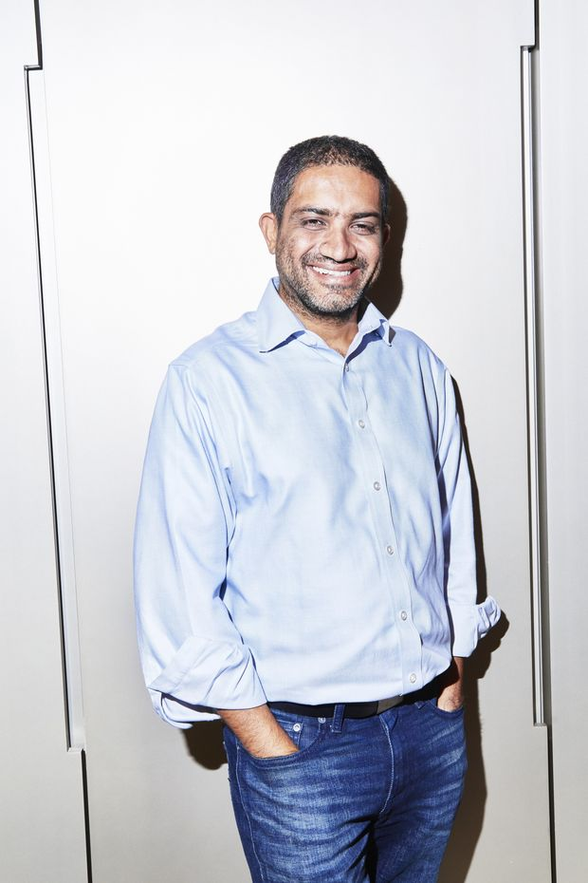
Omer Ismail, head of Goldman’s U.S. consumer business. PHOTO: AMY LOMBARD FOR THE WALL STREET JOURNAL
“We’re developing muscles we didn’t know we had,” said Omer Ismail, who runs Marcus in the U.S.
A hat bearing the letters MVP hangs on his office door, a gift from the team. At the old Goldman, it would have meant “most valuable player.” At the new Goldman, it means “minimum viable product,” tech-speak for a new offering that is ready to be launched—if just barely.

Profit engines
For most of its 150-year history, Goldman dominated the high end of finance. It virtually invented institutional stockbroking in the 1960s and the modern initial public offering in the 1980s. It brokered $1.3 trillion worth of corporate mergers last year.
Price-to-book valuationSource: FactSetNote: Calculated by dividing a company’s share price by its net assets.
.timesJPMorgan ChaseBank of AmericaMorgan StanleyGoldman SachsCitigroupJan. ’18JuneNov.April ’19Sept.0.51.01.52.0
Those profit engines have sputtered since the financial crisis. New regulations have reined in its securities traders, who earn less than half the revenue they did a decade ago. Goldman once invested billions of dollars of its own money into deals; that, too, is off-limits now.
Goldman’s stock is stuck at 2014 levels. Investors have flocked instead to rivals such as JPMorgan Chase & Co. and Bank of America Corp. , which churn out steady profits from lending and money management.
Marcus, hatched at a 2014 gathering of executives in the Hamptons, the exclusive New York enclave, was meant to get the firm growing again. With a blank canvas and a generous budget, executives believed they could pick off business from slower-moving rivals.
Marcus debuted two years later to make personal loans of a few thousand dollars. It also offered online savings accounts that customers could open with as little as $1.
Naming the startup after the bank’s 19th-century immigrant founder gave it some distance from the Goldman brand, still tainted by its role in the 2008 meltdown. Uncomfortable memories of the crisis informed other early decisions.
Executives worried that aggressive debt-collection efforts would dredge up a predatory image it had spent years trying to stamp out. So Marcus launched without a team of specialists to contact delinquent borrowers and try to recover what they owed, people familiar with the matter said. When the first borrowers fell behind, Goldman lost more money than it should have, those people said.
The bank now has dedicated collections staff that is specially trained, a spokesman said.
Marcus loan balances, quarterlySource: Goldman Sachs
.billion4Q20171Q’182Q3Q4Q1Q’192Q01234$5
It still has higher loan losses than rivals. Goldman wrote off $156 million in 2018 and another $155 million in the first six months of 2019, according to public filings. In the year ending June 30, its losses amounted to 5.5% of its loan book, higher than peer Discover Financial Services and above the 4% estimate previously given by Goldman executives.
Though the bank was wary of being heavy-handed in collecting debt, in at least one case it overstepped.
Last August, an Oklahoma woman filed for bankruptcy with debts that included a $19,894 Marcus loan. As is standard in personal bankruptcies, the court barred Goldman from attempting to collect the debt.
Goldman contacted her nine times over the next two weeks seeking repayment, even after her lawyer sent another letter notifying the bank that she had filed for bankruptcy, the woman alleged in court filings.
Goldman settled the case.

‘Not a bank’
Goldman doesn’t have a brand that consumers know or physical branches to pull them in off the street. So it is looking for other ways to get the word out, acquiring or partnering with well-known brands that can bring their own customers and cachet.
It is pitching corporate human-resource officers on “Marcus@Work,” which offers financial education to employees. It is also in talks with AARP, the retiree organization, to provide banking services to its 38 million members, people familiar with the matter said.

Mr. Talwar and Mr. Ismail at Goldman’s Marcus headquarters. PHOTO: AMY LOMBARD FOR THE WALL STREET JOURNAL
Last year it acquired Clarity Money, a personal finance app with more than 1 million users. It is one of several suitors eyeing GreenSky Inc., an online lender that is exploring a sale, according to people familiar with the matter.
AARP and Goldman declined to comment. GreenSky didn’t respond to a request for comment.
Finding customers through well-known partners spares Goldman the hassle of building a network of branches and sending out millions of pieces of direct mail, as Marcus did in its early days.
But it casts Goldman as a vendor that, in most cases, needs those partners more than they need it.
That imbalance was on display in its partnership with Apple to launch a credit card, Goldman’s first. The cost of beating out other banks was accepting a number of demands from Apple, which is famously design-obsessed and exacting in its dealings with partners, according to people familiar with the matter.
Goldman agreed not to charge late fees or sell customer data, trading away two key ways that credit-card issuers make money.

Goldman Sachs' Main Street Makeover Falters
00:00 / 12:50
SUBSCRIBE
Apple wanted control over the monthly statements sent to cardholders, pushing for jargon-free disclosures and its own signature font. Goldman’s lawyers warned that veering from standard industry language could invite regulatory problems, but the bank compromised. Apple got its font and Goldman trimmed the fine print.
Apple and Goldman declined to comment.
Apple initially wanted to charge everyone the same interest rate, regardless of their credit scores, people familiar with the matter said. On this point, Goldman pushed back. The card currently charges rates between 13% and 24%.
When Apple unveiled the credit card on stage in March in Cupertino, Calif., it did so with a zinger: “Designed by Apple, not a bank.” Mr. Solomon and other Goldman executives watched from the audience. The same line was repeated in ads that Apple ran promoting the card.
In a final snub, Marcus executives weren’t allowed into a Tribeca loft that served as Apple’s command center in the days leading up to the card’s launch in August.
Even beyond the roughly $300 million Goldman spent to build it, the Apple card was a drain on the firm’s resources. When early testing of the software this spring revealed a security vulnerability, Goldman reassigned thousands of engineers from around the firm to patch it, people familiar with the matter said.
That put other initiatives months behind schedule, these people said. A Marcus budgeting app and a digital wealth-management tool that had been planned for early next year are now expected in late 2020 at the earliest.
Executives say the costs are justified by the chance to reach hundreds of millions of iPhone users, a young, affluent bunch who might be converted into Marcus customers.
In particular, Goldman wants their deposit dollars, a cheap source of funding for the bank. Every $10 billion raised in deposits saves Goldman $100 million a year, Goldman’s chief financial officer, Stephen Scherr said in April.

Identity crisis
Three years in, Goldman hasn’t settled on an identity for Marcus. It has been cast both as a buzzy Silicon Valley startup, where coders sip kombucha from a tap at a WeWork office in San Francisco, and as a nostalgic throwback, its logo a simple M on the type of wooden sign that might swing from a small-town general store.
The Goldman poll this spring asked customers to imagine Marcus as a party guest. Is he a spunky teenager or a chill boomer? Does he drive a minivan or a hybrid? Is he standing alone by the snack table or DJ’ing? Is he playful, hardworking, cultured or cool?
Users earned Amazon gift cards for their feedback.
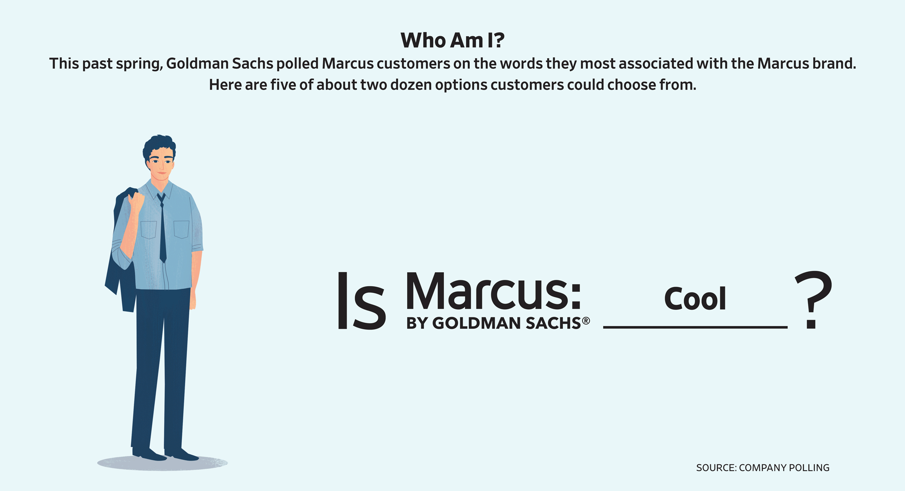
ILLUSTRATION: FEDERICA BORDONI
Even Marcus’s products don’t fit easily together. It pitches personal loans to cash-strapped consumers who need money to fund home renovations or pay off other debt. Its high-yield savings accounts are marketed to wealthier individuals with cash lying around. Marcus is courting tech-savvy consumers but doesn’t have a smartphone app.
Meshing Goldman’s buttoned-up culture with an influx of new talent has also been a challenge, executives say. Marcus has hired some 500 people from rival consumer banks and another 500 from tech companies, according to a spokesman.
Marcus acquired four tech startups including Clarity Money, a personal-finance app whose founder, Adam Dell, zipped around Goldman’s headquarters on a hoverboard until it was confiscated by legal staff after someone crashed it, people familiar with the matter said.

SHARE YOUR THOUGHTS
How have you seen investment banking companies change over time? Join the conversation below.
Marketing staffers, drawn from companies including PepsiCo and American Express Co. , churn out jingles that aired on sports radio this fall. (“I feel like a smart money guy,” chimes a middle-aged man, “now that my savings rate is high.”)
As Marcus heads toward its third birthday, turnover has spiked—some of it welcome by senior executives, who say they have learned more about what it takes to run a consumer business. Marcus has had three heads of product in three years. Its chief risk officer went to Barclays PLC. Darin Cline, the operations chief who walked the call-center floor in Utah in cowboy boots, left earlier this year.
As Marcus becomes more central to Goldman’s future, executives have discussed phasing out its name entirely, people familiar with the matter said. Goldman is already killing off other brands it has acquired in its push onto Main Street, including wealth manager United Capital and 401(k) startup Honest Dollar, whose logo’s shade of cornflower blue Goldman spent months perfecting.
Mr. Solomon, according to people familiar with the matter, favors a single brand on the firm’s consumer products: Goldman Sachs.
Write to Liz Hoffman at liz.hoffman@wsj.com and Peter Rudegeair at Peter.Rudegeair@wsj.com

