2.1 Precision, Accuracy, Tolerance

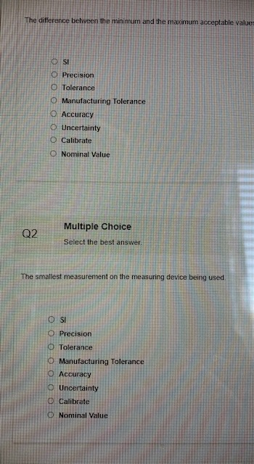
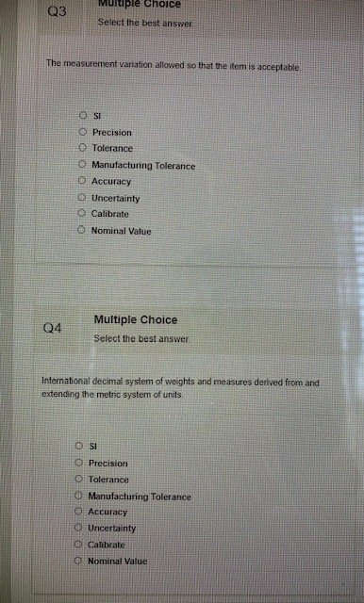
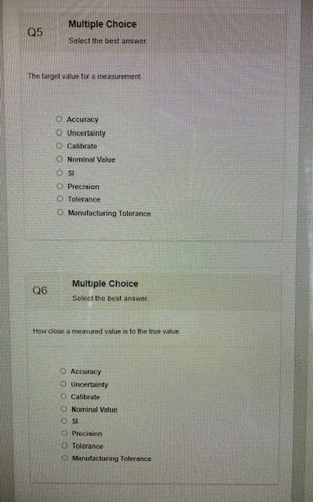
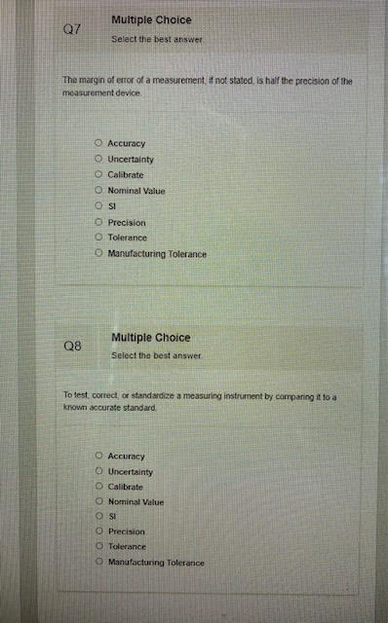
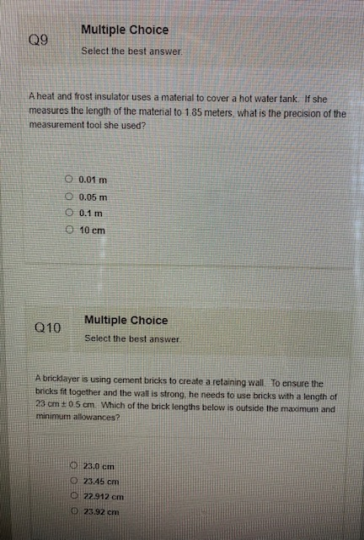
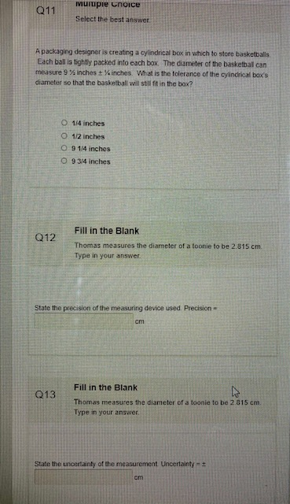
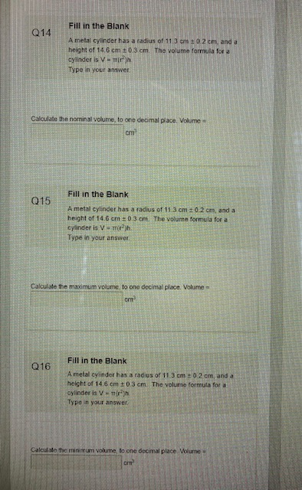
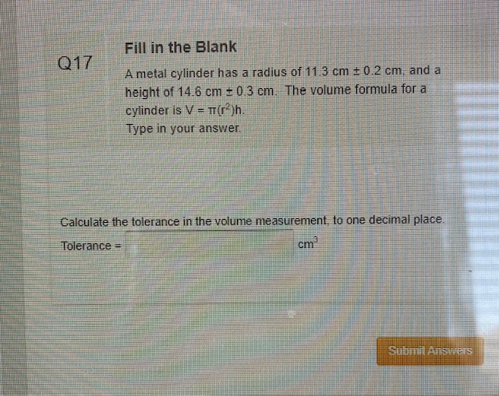
Answers:
1.Tolerance
2.Precision
3.Manufacturing Tolerance
4.SI
5.Nominal Value
6.Accuracy
7.Uncertainty
8.Calibrate
9.0.01m
10.23.92cm
11.1/2 inches
12.0.001cm
13.0.0005cm
14.5856.8
15.6190.6
16.5535.2
17.655.4

2.2 Carpentry Math
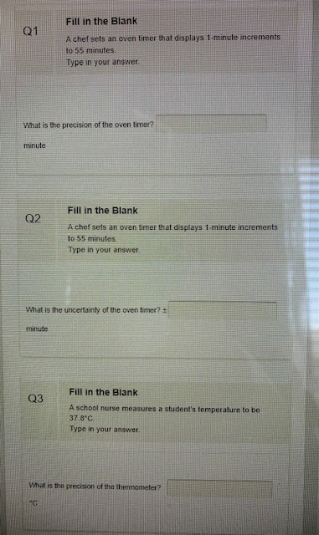

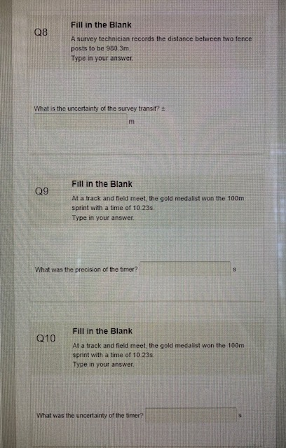
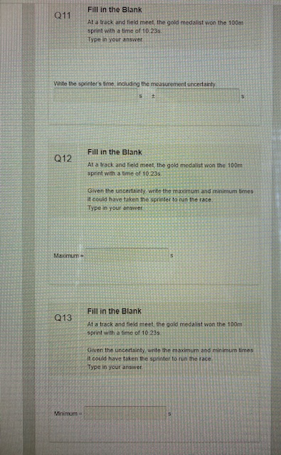
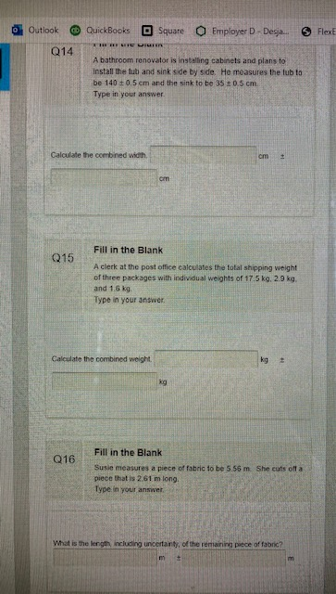
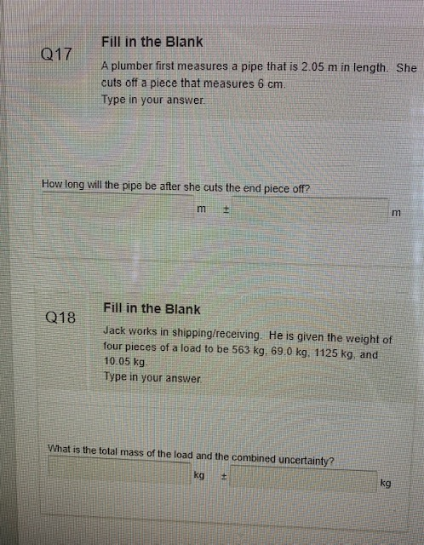

Answers:
1.1
2.0.5
3.0.1
4.0.05
5.0.001
6.0.0005
7. Leave blank-no question
8.0.05
9.0.01
10.0.005
11.10.23 ± 0.005
12.10.235
13.10.225
14.175 ± 0.1
15. 22 ± 0.15
16. 2.95 ± 0.01
17.1.99 ± 0.01
18.1767.05 ± 1.055
3.1 Measure of Central Tendacy + Percentiles
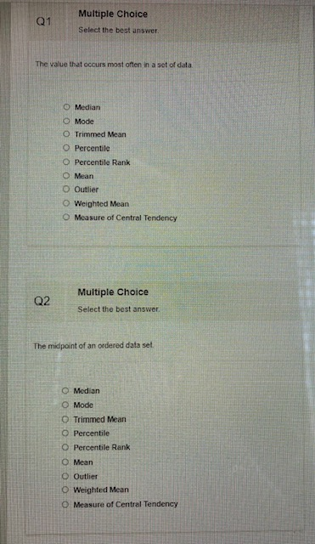
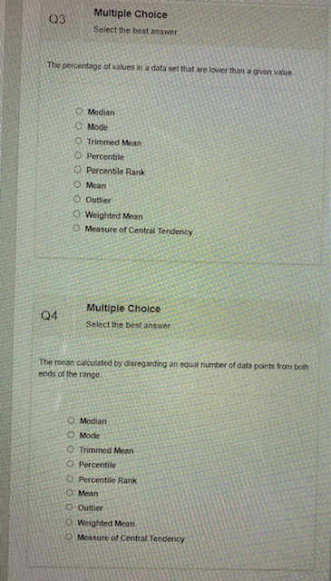
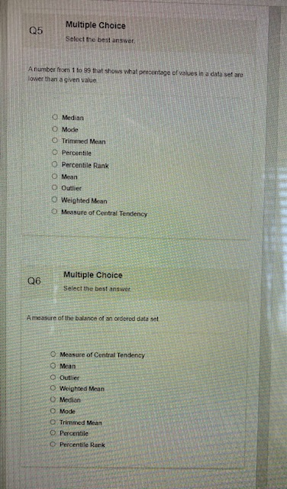
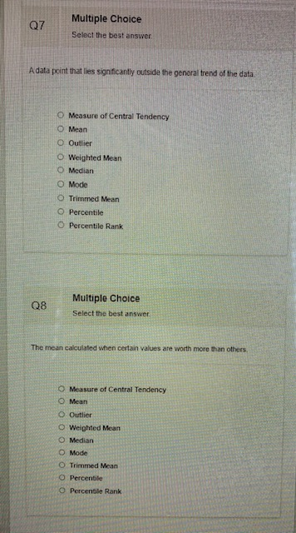
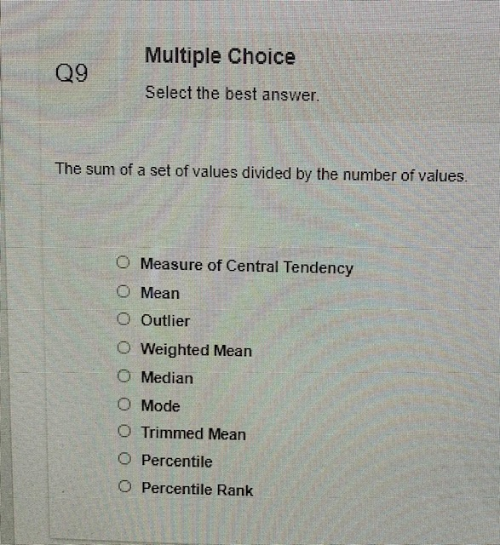
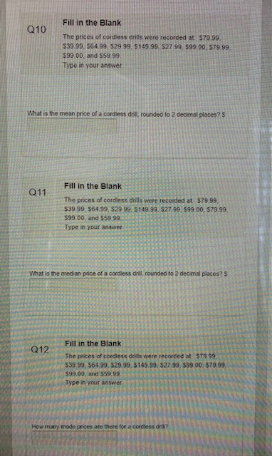
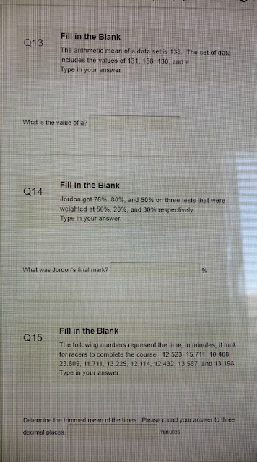
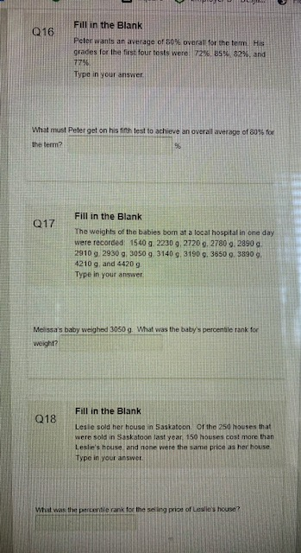
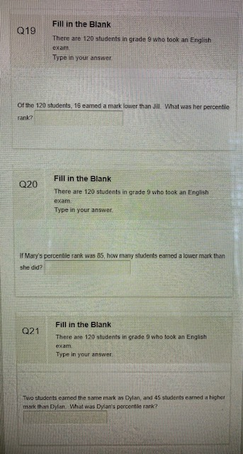
Answers:
1.Mode
2.Median
3.Percentile
4.Trimmed mean
5. Percentile Rank
6.Measure of Central Tendency
7.Outlier
8.Weighted mean
9.Mean
10.73.09
11.72.49
12.2
13.133
14.70
15.13.063
16.84
17.50
18.39.6
19.13.33
20.120
21.60.83

