Geometry Mid-Term Exam Name: ____________________ Student ID: _____________

- Locate the point on the line segment between 𝐴(3, −5) and 𝐵(13, −15) given that the point is 4/5 of the way from 𝐴 to 𝐵. Show your work.
For a point on the straight line joining (x₁, y₁) and (x₂, y₂) dividing the straight line internally in in the ratio a:b
x =$\frac{ax2 + bx1}{a + b}$
y =$\frac{ay2 + by1}{a+b}$
Explanation:
A = (3, -5)
B = (13, -15)

Let the point between A and B is C.
The distance of point and C is 4/5 of the distance of A B.
AC = $\frac{4}{5}$AB
AC =$\frac{4}{5}$ (AC + BC)
$\frac{AC}{BC}$ = $\frac{4}{5}$($\frac{AC}{AC}$ + $\frac{BC}{AC}$)
$\frac{AC}{BC}$ - $\frac{4}{5}$ $\frac{BC}{AC}$ = $\frac{4}{5}$ $×1$
$\frac{AC}{BC}$ ($1-\frac{4}{5}$) = $\frac{4}{5}$
$\frac{AC}{BC} ×\frac{1}{5}$ = $\frac{4}{5}$
$\frac{AC}{BC}$ = $\frac{4}{1}$

Hence, the point divides the line in the ratio 4:1

The coordinate of point C is determined as follows:
x$=\frac{ax2+bx1}{a+b}$
=$\frac{\left(4x13\right)+(1x3)}{4+1}=\frac{55}{5}=11$
Y=$\frac{ay2+by1}{a+b}=\frac{\left(4x-15\right)+(1x-5)}{4+1}$=$\frac{-65}{5}=-13$
Point C (11,-13)

- Solve for 𝑥 in the figure below. Show your work.
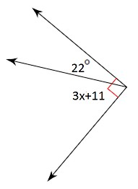 Solution
22°+3x+11°=90°
33°+3x=90°
3x=90°-33°
3x=57°
X=19°

- Find the exact area and circumference of a circle whose diameter is 8 meters. Show your work.
Area of a circle=πr² = $\frac{22}{7}×4×4=50.286m^{2}$
Circumference =Π D=$\frac{22}{7} ×8=25.143m$

- Briefly explain the Law of Detachment. Write a statement that is concluded using the Law of Detachment for the following statements.
If Jillian gets a raise, then she will buy a new car. Jillian got a raise.
In mathematical logic, Law of Detachment says that if the following two statements are true
1) If p, then q
2) p
Then we can derive a true statement q
In the above question the statement that can be concluded by using law of detachment is' She will buy a new car'.

- Solve for 𝑥 given that 𝐶𝐸 = 36. Show your work.

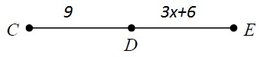
9+3x+6=36
15+3x=36
3x=36-15
3x=21
X=7

- Solve for 𝑥 in the figure below.
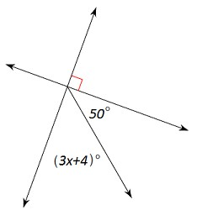

90° +(3x+4) ° +50°=180°(the sum of angles in a straight is equal to 180°)
144° +3x=180
3x=180°-144°
3x=36°
X=12°
- Are the two lines parallel, perpendicular, or neither? Explain your answer. Show work needed to answer the question.
3𝑥 + 7𝑦 = 15
7𝑥 − 3𝑦 = 6
The lines are parallel if their gradients are the same
3x+7y=15
Write in the form of y=mx+c
7y=-3x+15
Y=-$\frac{3x}{7}+\frac{15}{7}$
The gradient(M1)=$-\frac{3}{7}$
Finding the gradient for 7x-3y=6
-3y=-7x+6
3y=7x-6
Y=$\frac{7x}{3}+3$
Gradient (M2)=$\frac{7}{3}$
Therefore, the two lines are not parallel because their gradients are not equal
The lines are perpendicular sine M1xM2=-1=$-\frac{3}{7}×\frac{7}{3}=-1$

- Using the figure above, which theorem can you prove, given that m∠1 = m∠2? Explain your answer.
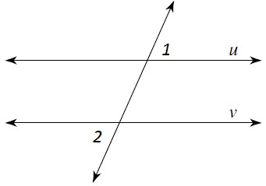
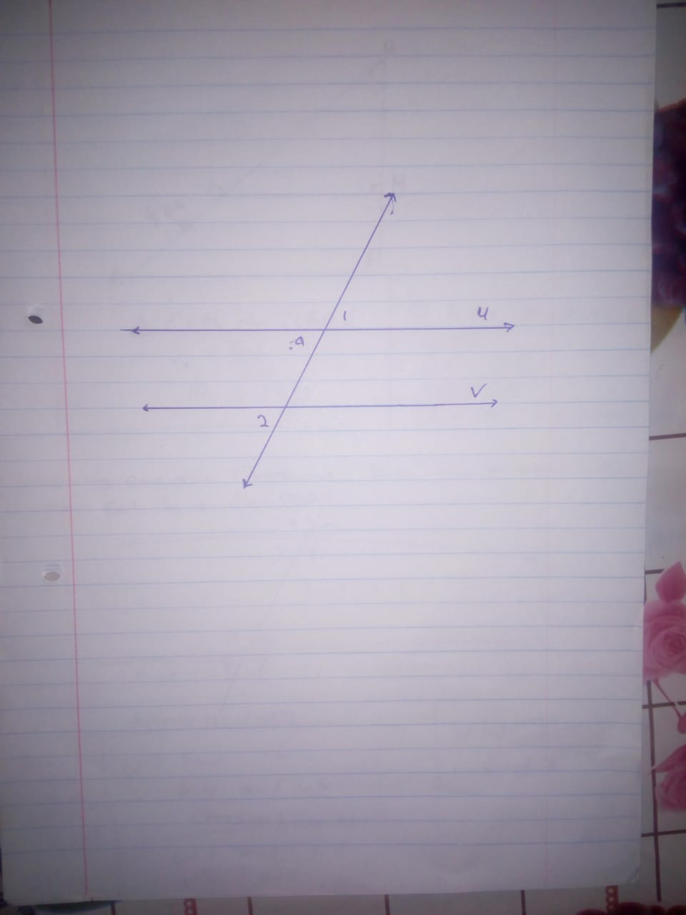
I will use the theorem that states that corresponding angles are congruent or equal since the parallel lines are cut by a transversal. m∠1= angle a (vertically opposite angles) and angle a = m∠2(corresponding angles). Hence, m∠1 = m∠2
- Find the exact distance between the line 6𝑥 − 𝑦 = −3 and the point (6,2). Show your work. Explain your answer.
The distance a point from the line=$\frac{∣ax+bx+c∣ }{\sqrt{a^{2+}} b^{2} }$
=$\frac{∣\left(6×6\right)+\left(-1×2\right)+3∣ }{\sqrt{36}+1}$=$\frac{37}{√37}$ units

- Which theorem can you prove, given that m∠1=m∠2 in the figure above? Explain your answer.
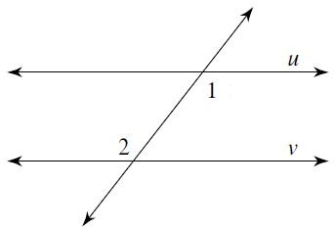
The theorem 3.2, which states that if two parallel lines are cut by a transversal, then the alternate interior angles rate equal and congruent. m∠1and m∠2 are alternate and congruent.

- Suppose ∆𝐷𝐸𝐹 ≅ ∆𝑊𝑋𝑌. Which choice below shows corresponding parts to congruent triangles that are congruent? Explain your answer.
- ∠𝐸 ≅ ∠𝑋; ̅𝐷𝐹̅̅̅ ≅ ̅𝑋𝑌̅̅̅ (not congruent because DF and XY are not congruent)
- ∠𝐷 ≅ ∠𝑌; ̅𝐸𝐹̅̅̅ ≅ ̅𝑋𝑌̅̅̅ (not congruent because angle D and angle Y are not congruent)
- ∠𝐸 ≅ ∠𝑋; ̅𝐷𝐹̅̅̅ ≅ ̅𝑊𝑌̅̅̅̅ (satisfies AASS)
- ∠𝐹 ≅ ∠𝑋; ̅𝐷𝐸̅̅̅ ≅ 𝑊𝑋̅̅̅̅̅ (Not congruent angle F and angle X are not congruent)
Therefore, the answer if option C, since AASS, is satisfied.

- Determine if the triangles in the figure are congruent. If so, write the congruency statement and the reason the triangles are congruent. Explain your answer.
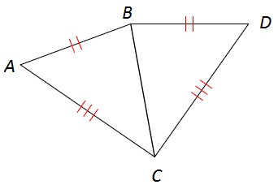
The two triangles are said to be congruent if all the corresponding sides and angles are congruent. Hence, the triangles are congruent is there is SSS, SAS, AASS
The triangles BCD and ABC because CD is congruent to AC, BD=AB, and angle BCD=angle ACB. This is because two sides and one angle (SAS) are congruent.
- Determine if the triangles in the figure are congruent. If so, write the congruency statement and the reason the triangles are congruent. Explain your answer.
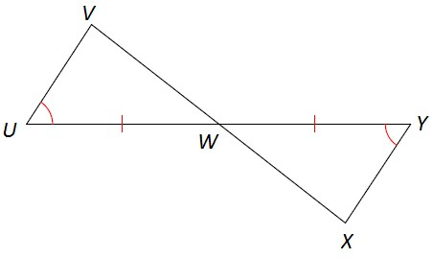
Triangle XYW and UWV are congruent because WY=UW and angle XYW= angle WUV(alternate angles)
- In the figure, ̅𝐵𝐷̅̅̅ is a median. If 𝐴𝐷 = 6𝑥 + 10 and 𝐶𝐷 = 2𝑥 + 12, find the length of 𝐴𝐶. Show your work.
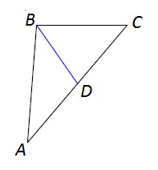
AC= AD +CD=(6x+10)+(2x+12)=8x+22
- Where is the circumcenter of a right isosceles triangle located?
The circumference is located at the midpoint of the hypotenuse as indicated the diagram below
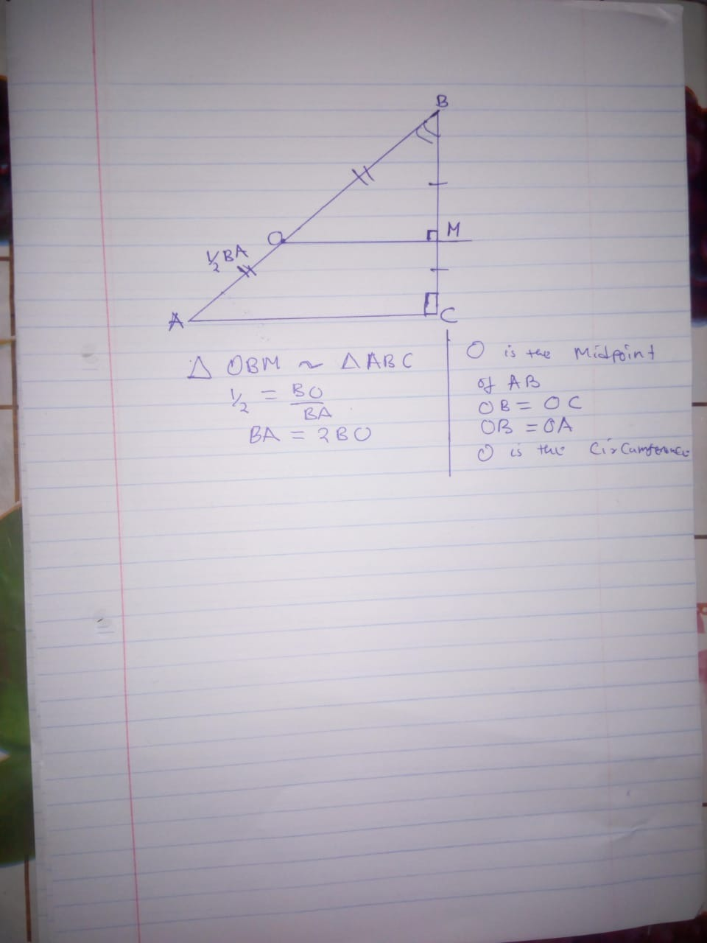

- In the figure above, ̅𝐷𝐺̅̅̅ is the angle bisector of ∠𝐹𝐷𝐸. If m∠1 = 7𝑥 + 4 and m∠2 = 9𝑥 − 4, what is the measure of angle ∠𝐺𝐷𝐸? Show your work.
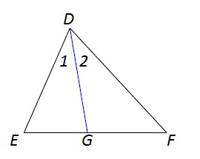
Using the angle bisector theorem
7x+4=9x-4
2x=8
X=2
∠𝐺𝐷𝐸=7x+4=(7x2) +4=14+4=18$°$

- What is the sum of the measures of the interior angles of a dodecagon? Explain your answer.
Sum of interior angles=180(n-2) °= 180(12-2)=$180×10=1800°$

- Find the measure of ∠𝑊𝑍𝑋. Show your work.
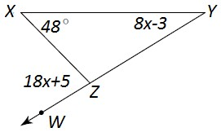
∠𝑊𝑍𝑋=180-(18x+5) =175-18x (angles at a line)
48$°$ +8x-3+175-18x=180$°$
220$°-180°=18x-8x$
40$°=10x$
X=4$°$
∠𝑊𝑍𝑋 =175-18x
=175-(18x4)=103$°$

- Quadrilateral 𝐴𝐵𝐶𝐷 is a parallelogram. What is the measure of ∠𝐷𝐴𝐵? Show your work.
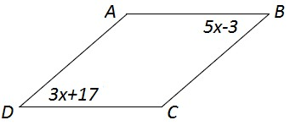

Angle ADC=Angle ABC (opposite angles are congruent)
3x+17=5x-3
2x=20
X=10$°$
Angle ADC=30+17=47$°$
Angle ADC +Angle DAB=180$°$( Adjacent angles are supplementary)
∠𝐷𝐴𝐵=180 $°$-47$°$=133$°$

- What is the exact perimeter of kite 𝑈𝑉𝑊𝑋? Show your work.
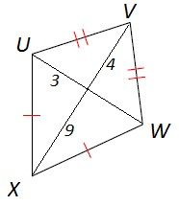

Uv=$\sqrt{9}+16=5=VW$
UX=$\sqrt{81}+9=9.487$
P=2(S1 +S2)=2(5+9.487)=14.487 units

