Unit 3: Surface Area, Volume, and Capacity

Lesson 1: Surface Area of Prisms and Pyramids

Assignment

/6 1. Mandy bought a gift for her friend. She wants to put the gift in a box with a length of 9 inches, a width of 12 inches, and a height of 4 inches.
- What is the surface area of the box?
- If Mandy bought a roll of wrapping paper that is 3 feet long and 2 feet wide, will it be enough to wrap the box?
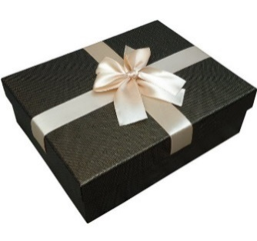
(Source: https://www.aliexpress.com/)

/5 2. Donny wants to wrap the gift below where A = 5 cm, B = 12 cm, C = 13 cm and H = 5 cm. How much paper is he going to need?

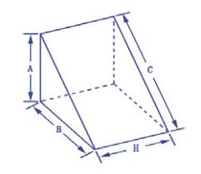
(Source: https://ybtoptics.en.alibaba.com/product/60497301976-801951318/Fused_silica_BK7_K9_60_degree_equilateral_right_angle_glass_triangular_prism_dispersion_prism_for_physic_teaching_instruments.html)

/8 3. What is the surface area of the composite figure below?

18 in
9 in
6 in
7 in
5 in

/6 4. The following aquarium can be purchased at PetSmart.
- Calculate the surface area of glass needed to construct an aquarium with a length of 50.0 cm, a width of 34.0 cm, and a height of 40.0 cm.
- If the glass costs $58.95/m², what is the cost of glass for this aquarium?
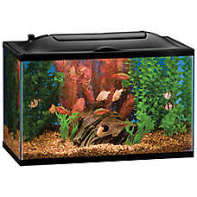
(Source: http://www.petsmart.ca/fish/supplies/aquariums-and-stands/)

/8 5. What surface area of metal would be needed to construct the trough shown below? For a trough, assume the top is open. Convert your answer to m² and round to the nearest tenth.

118 cm
65 cm
210 cm
83 cm
63 cm

/13 6. A gift box is in the shape of a regular pentagonal prism as shown.

5.9 cm
8.5 cm
5.4 cm

- Sketch a net for the box. Record all measurements on your net.
- What is the area of each rectangular side?
- What is the area of the top of the box?
- Find the total surface area of the box.
- If you wrap the box and include 8% extra paper for cuts, how much paper will you need, to the nearest square centimetre?
/8 7. The top view of a roof is shown. The top of the roofline is 10.7 m. The length of the roof is 14.3 m.

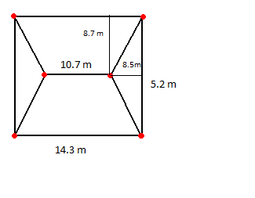
(Source: https://commons.wikimedia.org/wiki/File:Triangular_prism_graphs.png)
- Calculate the surface area of the roof.
- The roof is to be covered with shingles that cost $49.50/m². What is the cost of the shingles needed?

/3 8. An octagonal-based pyramid has a slant height of 18.7 cm and each side of the octagon measures 12.6 cm. What is the lateral surface area of the pyramid?

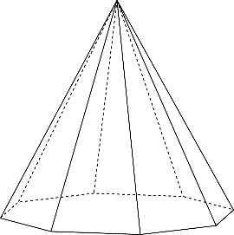
(Source: http://etc.usf.edu/clipart/43100/43186/oct5_43186.htm)

/6 9. A triangular pyramid has faces that are all equilateral triangles. Each side length is 16 cm. What is the surface area of the pyramid, to the nearest tenth?

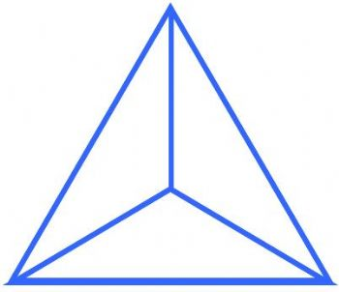
(Source: https://blender.stackexchange.com/questions/12219/how-to-model-an-equilateral-triangular-pyramid)

/1 10. For an assignment, Sandra created several 3 by 3 magic squares. A magic square is a square grid filled with distinct positive integers such that the sum of the integers in each row, column, and diagonal is equal. Which magic square below is incorrect?

2 | 7 | 6
9 | 5 | 1
4 | 3 | 8
a.

8 | 1 | 6
3 | 5 | 7
4 | 9 | 2
b.

6 | 1 | 8
7 | 5 | 3
2 | 9 | 4
c.

4 | 9 | 2
1 | 6 | 8
7 | 3 | 5
d.

Total Marks: /64

