Unit 5: Scale Representations

Lesson 1: Scale and 2-Dimensional Drawings

Assignment

/2 1. Solve the proportions.

a.) 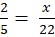
b.) 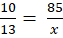

/2 2. A 7.8 m object is shown in a picture as being 1.5 cm. What is the scale factor?

/4 3. The second largest moose statue in located in Moose Jaw, Saskatchewan. It is 32 feet tall. The smallest replica you can buy at the gift store is 8 in tall.

a.) What scale factor was used to build the replica?
b.) How big would a medium replica be that is 145% larger than the smaller replica, to one decimal place?

/2 4. The image of a castle measures 18.1 cm wide by 10.6 cm tall. If the actual castle is 16.4 m wide, how tall is it, in metres? Please round your final answer to one decimal place.

/3 5. A model of the “H” from the Hollywood sign has a scale statement of 1:36. What are the dimensions of the actual sign letter?
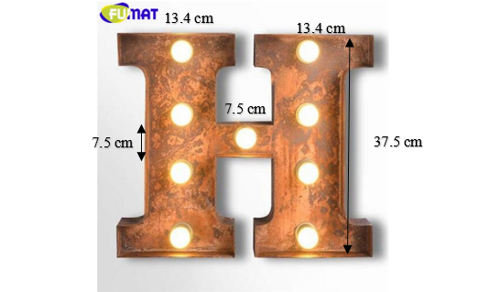
(Source: https://www.aliexpress.com/w/wholesale-h-letter-logo.html)
/20 6. You are a landscape designer and have signed on a new client. Your client wants you to draw a scale diagram of a backyard plan for her. Your plan must include:
- A shed that is 2 m wide, 3.25 m long and 2.8 m tall.
- A deck near the patio doors big enough to sit at least six people.
- A circular pond with an area of 7 m².
- Flower borders no wider than 1 m wide.
- A gravel path 1 m wide to go from the shed to the house and from the garden gate to the house.
- Cover the remaining of the backyard in grass.
Please use the garden plan sheet to draw the features listed above. Record all your calculations. Make sure to record the scale you use on the plan.
You must also calculate the cost of the material you will be installing. This includes:
- The gravel should be 8 cm deep and it costs $40 per cubic meter.
- Grass costs $3 per square meter.
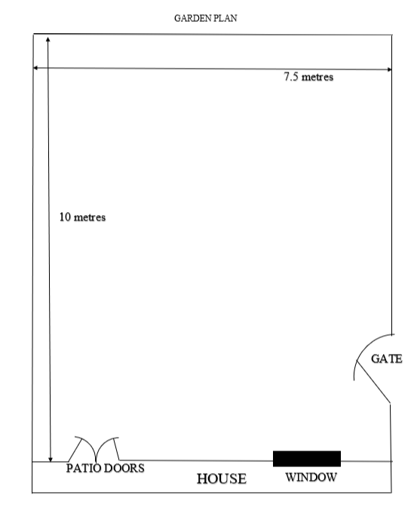

/9 7. Complete the table below.

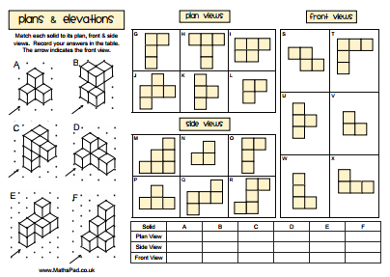

Solid | A | B | C | D | E | F
Plan View
Side View
Front View

/12 8.
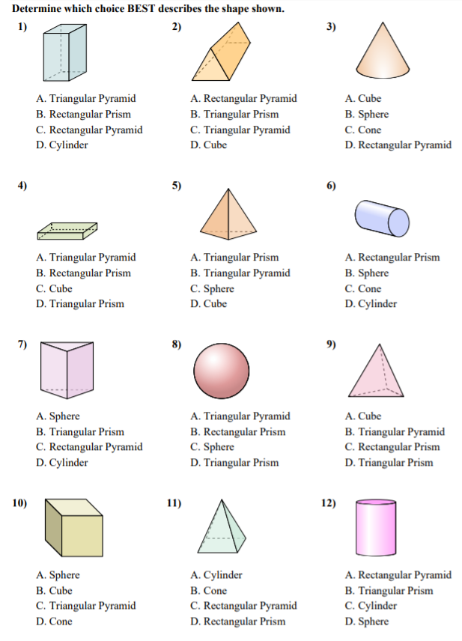

Question | Answer
1.
2.
3.
4.
5.
6.
7.
8.
9.
10.
11.
12.

/1 9.

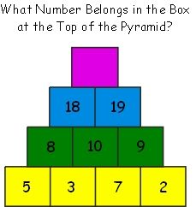

Assignment Grade: /55

