Mathematics

Name
Affiliation
Date

Mathematics
Describe how you can use a double-angle formula or a half-angle formula to derive the formula for the area of an isosceles triangle. Use a labeled sketch to illustrate your derivation. Then write two examples that show how your formula can be used.
Solution
- Let a triangle ABC
- Let the angle between the two sides be A and the length of the equal sides of the isosceles triangle be x
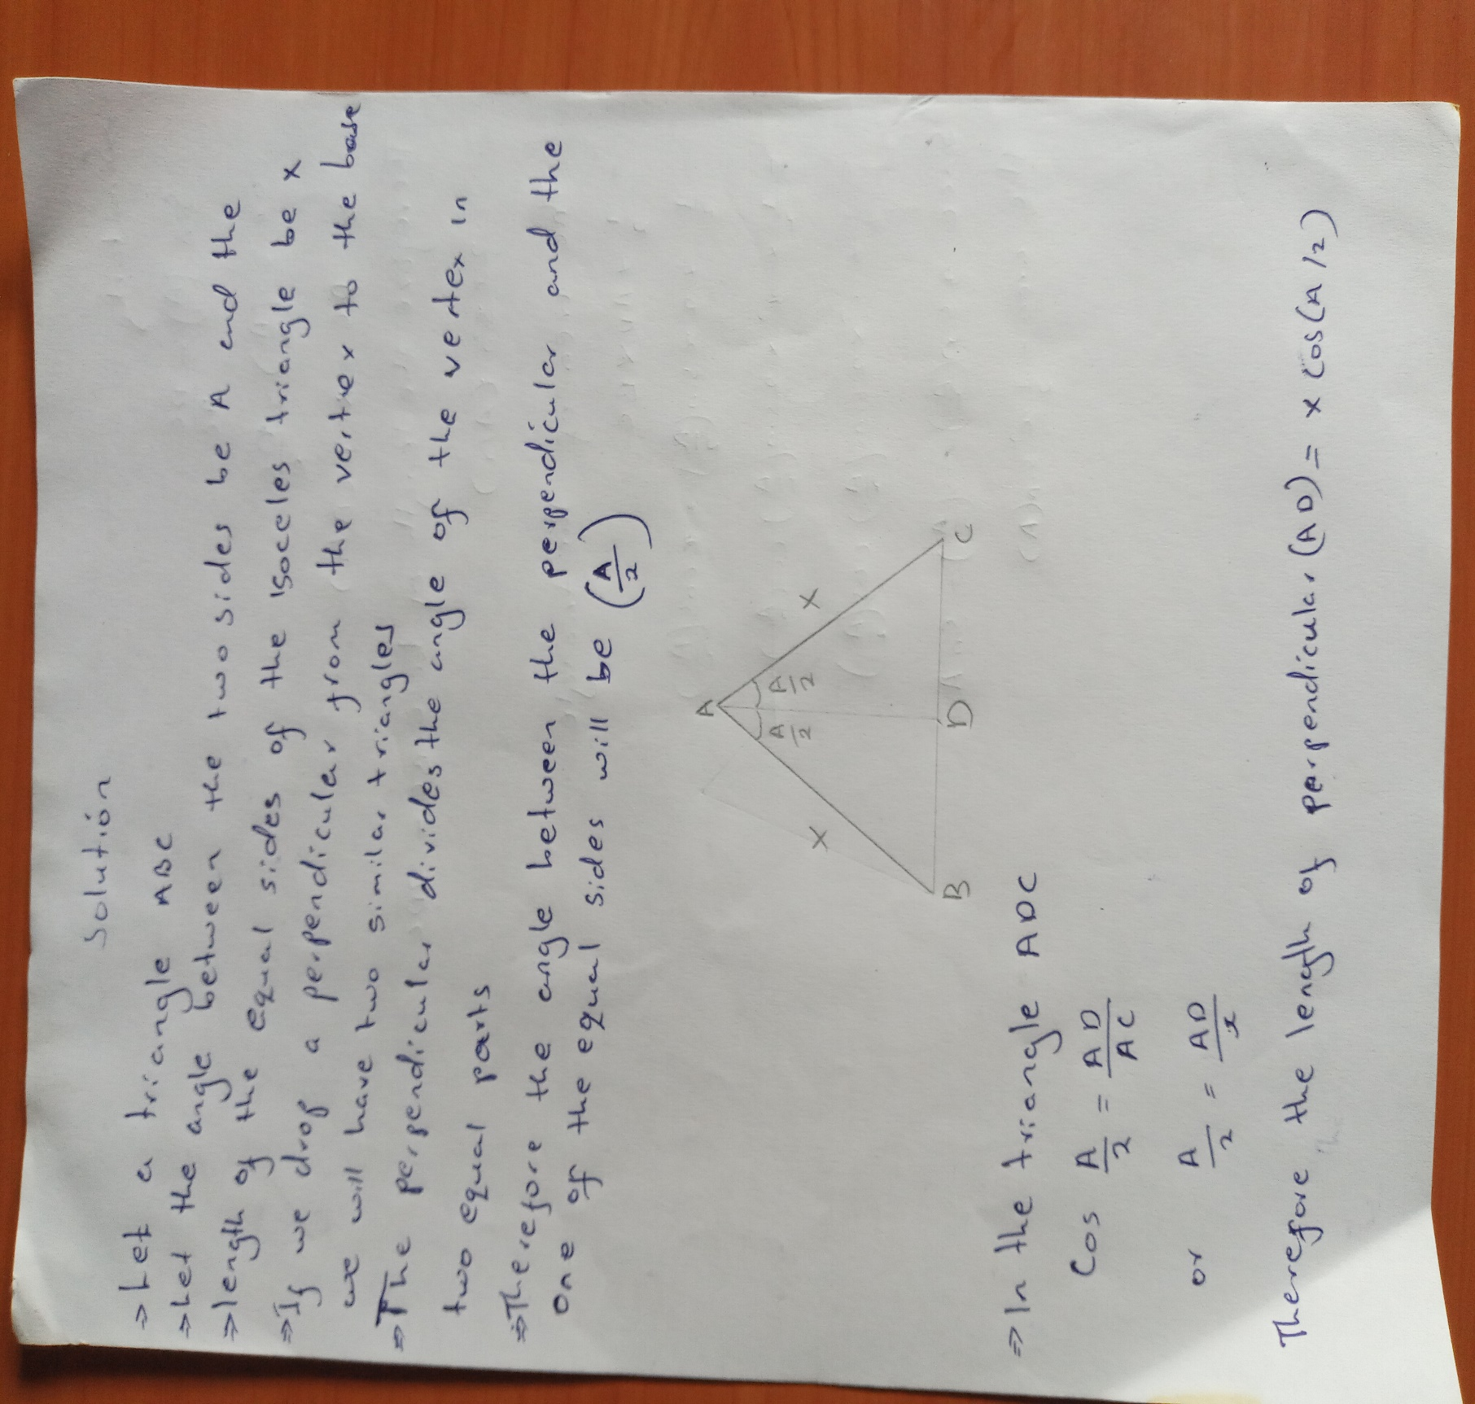
- if we drop a perpendicular from the vertex to the base, we will have two similar triangles. Thus, the perpendicular divides the angle of the vertex in to two equal parts.
- Therefore, the angle between the perpendicular and the one of the equal sides will be (A/2)
