Bloodletting and Sacrifice in the Maya Culture
Name of student
Name of tutor
The institution of affiliation
Date

While it may not have always been in the public domain why blood was fundamental to human survival in ancient times, people often worshipped blood unlike anything else. The ancient Mexican religion depicts a society where blood or human sacrifice was mainly practiced. In fact, every tribe throughout the Mesoamerican history practiced blood or human sacrifice. Even though every tribe in Mesoamerican history had their own beliefs and rituals, blood was an integral part of ceremonies. Also, the extent to which blood was used differed among tribes. While some tribes sacrificed animals, some only sacrificed humans, and others did not make sacrifices at all. Blood sacrifices happened for different reasons: coming of age, crowning a new king, and building new temples, among other reasons. In this study, we will discuss the different forms of human sacrifices that the Mayans carried out and the rationale behind such acts. The Mayan Spirituality was an integral part of people’s daily traditions such as bloodletting in order to appease the gods and secure a prosperous life for members of the community.
Who Performed Bloodletting Sacrifices?
Mayans conducted blood sacrifices, which was an integral part of their religious belief. They were an advanced civilization during their time. The Mayans were not that inclined to human sacrifices, but they often had blood rituals. The tribe conducted many religious festivals and rituals throughout their calendar year. The festivals that were not reflected on the calendar had few animal sacrifices but all had some sort of bloodletting ceremony. The bloodletting rituals were performed by practically anyone in the community (Walton 2020, 1-33). Both men and women practiced bloodletting sacrifices. Also, the practices involved the highest nobles who would mainly pierce their own body parts including their tongues, lips, and genitals. Ritual bloodletting, along with fasting, tobacco smoking, and ritual enemas, was pursued by the royal Maya in order to provoke a trance-like state and thereby achieve supernatural visions and communicate with dynastic ancestors or the underworld gods. The sacrifices were meant to petition their ancestors and gods of rain, good harvests, and success in warfare, among other needs and desires.
Bloodletting Occasions and Locations
There were dates on the calendar year where bloodletting services could be performed. The rituals were often performed on significant dates on the calendar year. Also, the rituals could be3 performed at scheduled state events reflected on the Maya ritual calendar. The events were held mainly at the beginning or end of a calendar cycle, that is, when a King would be crowned to exercise power and at building dedications. Also, other stages in the life of kings and queens including births, deaths, and marriage would be accompanied by bloodletting. Furthermore, blood sacrifices were performed at the end of wars. The rituals often would be practiced in private places. These places included private temple rooms on the top of pyramids. However, public functions celebrating the bloodletting rituals were organized during such events.
A palace scene and blood-drawing ceremony. Rollout of the design on a Maya vase from southern Carnpeche or northern Peten. Courtesy: The Center for Pre-Columbian Studies, Dumbarton Oaks.

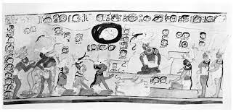
Masses of people were therefore allowed to attend them, crowding into the plaza at the base of the main pyramid of the Maya towns. The display of the rituals in public was one way in which rulers would demonstrate to people their ability to appease gods in order to seek advice on how to balance the world of the living and to ensure the natural cycles of the seasons and stars. Through her statistical study, a United States archeologist by the name Jessica Munson found that most references to bloodletting on Maya monuments and in other contexts are from a number of sites along the Usumacinta River in Guatemala and in the Southeastern Maya lowlands. Most of the known sites are from inscriptions that refer to antagonistic statement about warfare and conflict.
Bloodletting Tools
The Maya people pierced their body parts during the bloodletting rituals. The piercing of the body was done using sharp objects. The sharp objects used to pierce the body included: obsidian blades, stingray spines, carved bones, perforators, and knotted ropes. Some equipment used included bark paper which was used to collect blood and copal incense to burn the stained paper and provoke smoke and pungent odors. Also, blood was collected in receptacles made out of ceramic pottery or basketry (Haines 2008, 83-98). Cloth bundles are reflected on some of the murals which archeologists think were used to carry around all the equipment.
This is a Stone Seat with Polychrome Reliefs Depicting self-sacrifice (Zacatapalloli), House of Eagles, Templo Mayor, Mexico City, ca. 1500. De Agostini/ G. Dagli Orti.
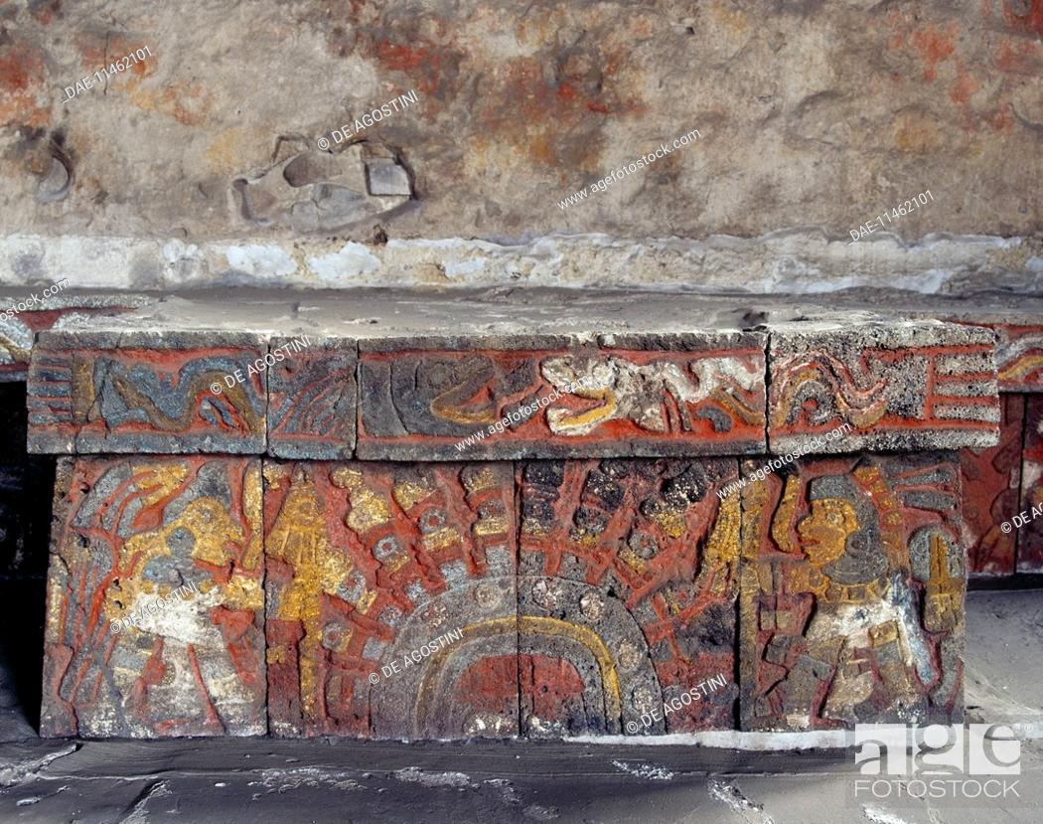
Stringray spines were the major tool used for body piercing during bloodletting rituals. This is despite the danger it posed during its usage. Dirty stingray spines contain venom and therefore their usage in body piercing would have caused a lot of pain to victims. Also, they had grave effects ranging from secondary infection to necrosis and death. As archeologists Haines and colleagues observed, the Maya people could regularly fish for stingray spines and therefore would have known the dangers associated with their use. The archeologists observe that the Mayans either used stingray spines that had been carefully cleaned and dried or the reserved them for special acts of piety or in rituals where reference to the necessity of risking death was a fundamental factor.
Stingray Spines
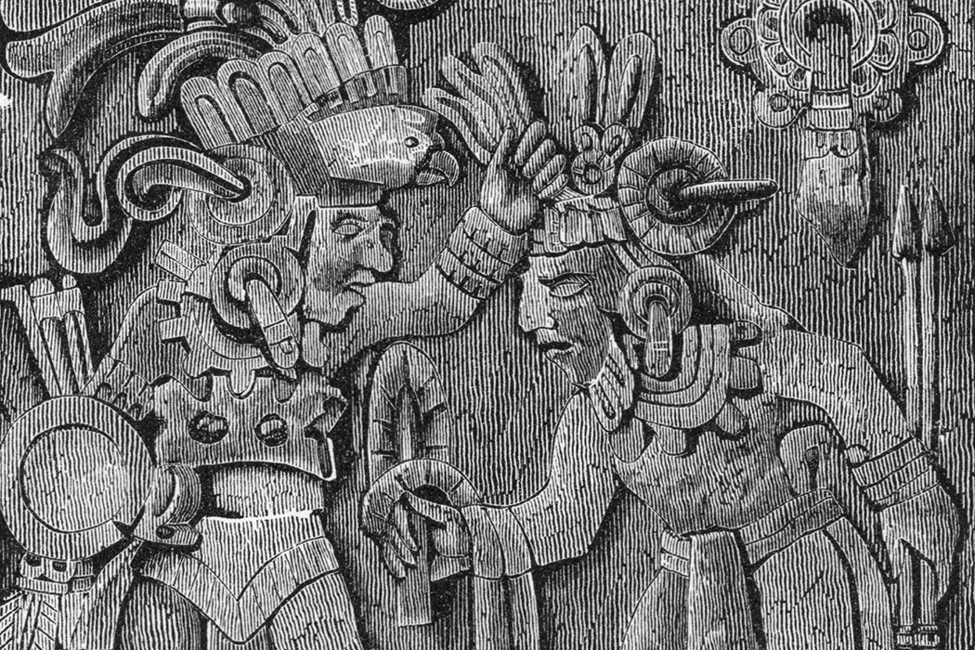
Why Bloodletting was practiced by the Mayans
Bloodletting rituals were practiced by the Mayans for a number of reasons. The Mayans believed they could traverse cosmic boundaries in bloodletting rituals and therefore Maya leaders could talk to deities and ancestors. The bloodletting could be performed by sticking a barbed rod through the tongue, ear, or foreskin and blood would be collected on a piece of parchment and then burned for the gods. The foreskin of the penis and vagina were the most preferred places where blood would be drawn. This is because blood from these regions was considered to be fertile and therefore would be used in ceremonies concerned with the plant life and the growing crops.
And they believed that as the smoke comes through the air during the ritual, the Maya gods or ancestors will appear to the Maya people and communicate with them important information they needed to be successful in many aspects of life. The gods would often appear in the form of a medium known as the “vision serpent.” Therefore, they performed these rituals to see the Vision Serpent. The serpent was the most acknowledged social and religious symbol for the Mayans and the Vision Serpent was the most important of all serpents. The importance of the ritual therefore was to contact and communicate a deceased relative and or a god. During a successful bloodletting, the participants would see the Vision Serpent and out of its mouth would form the head of the god or the ancestor they are communicating with. Therefore, the Vision Serpent linked people in the physical world with those in the spiritual world.
Another importance of these sacrifices was to sanctify important rituals like crowning a new king, designation of a new heir to the throne, or the dedication of a new building. The rituals were meant to welcome new leadership and also show how important and successful a current king was. The Mayans only used human sacrifice as a way of proving that the new king was worth exercising leadership in the city (Joralemon 1974, 59-75). Kings were important figures in Maya tribe and therefore the rituals were a great deal of proving how important they were to the Mayans. They could perform the rituals after a king successfully leads people into war. This was a way of thanking the gods for victory in war. Mayan people also chose to sacrifice animals in order to appease the gods to help them construct buildings like a great pyramid.
Archeological evidence also proves that the drawing of blood from the penis of a man was meant to magically maintain the health and productivity of the natural world. The blood drawn from the penis was considered to be pure. And therefore, the kingship of the Mayans recognized it to be of essence to the tribe. The drawing of blood form the penis symbolized the King’s role in ensuring the fertility of the natural world and therefore guaranteeing improved productivity in the agricultural sector. The image below shows the archeological evidence shows how blood was drawn from the penis in order to improve productivity in society.
Ceremonial blood-letting from the penis. Rollout of a scene painted on a Maya vase from Huehuetenango. After Gordon and Mason 1925-28: Plate XXVII
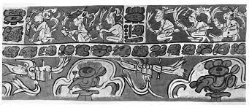
In conclusion, blood played an essential role in every civilization and tribe throughout Mesoamerican history. Therefore, blood ceremonies were a part of every culture including the Maya people in Mesoamerica. Sacrifice and bloodletting were important ritual events among the Mayans. These events served various ideological and cultural functions with their culture. Human sacrifice often involved the taking of captives during warfare in order to sacrifice them of bloodletting. Bloodletting involved the ritual autosacrifice of puncturing of a part of the body. The parts of the body pierced included the tongue or cheek for women and the penis for men. The blood was collected on paper and then burned as an offering to the gods.
The piercing was done with sharp objects like the stingray spines or obsidian blades. Also, there are representations in Maya art of a rope with thorns being pulled through the tongue or earlobes. Essentially, bloodletting and sacrifice played an important role in society. These rituals helped to maintain balance within the supernatural world. It was a medium through which Mayans communicated with spirits in the spiritual world and seek advice. It was also meant to maintain the sociopolitical structure of Mayans. It helped to legitimize rulership and elite positions of power. Therefore, whether it was for cultural, religious or political purposes, bloodletting and sacrifice remained an integral part of in the lives of the Mayans.

Bibliography
Haines, Helen R., Philip W. Willink, and David Maxwell. "Stingray spine use and Maya bloodletting rituals: A cautionary tale." Latin American Antiquity (2008): 83-98.
Joralemon, David. "Ritual blood-sacrifice among the Ancient Maya: Part I." Primera Mesa Redonda de Palenque. Pebble Beach, CA: Robert Louis Stevenson School (1974): 59-75.
Stemp, W. James. "Twist and shout: Experiments in ancient Maya blood-letting by piercing with obsidian blades and splinters." Journal of Archaeological Science: Reports 9 (2016): 134-142.
Walton, David P. "Bloodletting in Ancient Central Mexico: Using Lithic Analyses to Detect Changes in Ritual Practices and Local Ontologies." Journal of Archaeological Method and Theory (2020): 1-33.

