McDonald’s U.K.

Name

Course
Professor
Institution
Date

Table of Contents
- Introduction 3
- Environmental analysis 3
2.1 Political factors 3
2.2 Sociocultural factors 4
2.3 Technological factors 4
2.4 Competitive rivalry 5
2.5 Threat of substitution………………………………………………………………………… 5
3.0 Situational analysis………………………………………………………………………….5
3.1 SWOT analysis……………………………………………………………………………….6
4.0 Most appropriate growth opportunities……………………………………………………7
4.1 Expanding deliveries………………………………………………………………………….7
4.2 Drive-through restaurants…………………………………………………………………….8
5.0 Segmentation and positioning……………………………………………………………...11
6.0 Recommendations…………………………………………………………………………..12
6.1 Media channels recommendations…………………………………………………………...12
6.2 Distribution channels recommendations……………………………………………………. 13
7.0 References………………………………………………………………………………….. 14
8.0 Appendices…………………………………………………………………………………..19

1.0 Introduction
McDonald's started in 1940 in California in the United States as McDonald Brothers. From 1953, the company began expanding its territories via franchise agreements. The company set up its first branch in 1974 in Britain at Woolwich in London (Ismael et al., 2019). The location was chosen to serve American tourists who already knew the brand and its products. Currently, it has around 1 2900 outlets in Britain, with a turnover of about £1.6 billion (Theodore et al., 2021). The paper seeks to highlight substantial changes in the United Kingdom's marketing environment to pinpoint relevant growth opportunities for McDonald's U.K. The report will conclude by recommending the most appropriate promotional and distributional channels that the company can use to stay relevant in the market.
2.0 Environmental Analysis
This section looks at the macro and microenvironment of McDonald's operations in the United Kingdom. It aims at determining external factors that present threats and opportunities to the company (Perera, 2017). The findings can help the management to strengthen their capabilities and also address areas that it falls short including fighting the fierce rivalry stemming from competitive firms like Starbucks, Burger King, and Wendy's Subway
2.1 Political factors—This first part of the PESTLE analysis concerns the effects of government directives, policies, and actions that impact the fast-food industry and the economy as a whole (Jian et al., 2021). The most notable external political factors that touch on the veins of Macdonald’s include strict hygiene and health regulations in the United Kingdom that the restaurant must follow to avoid closure and legal penalties. Breaching the rules attracts both financial loss and tainting of the brand's image. In 2018, McDonald’s was fined £200,000 for safety and health breaches when an employee sustained a fractured knee in its Lakeside Retail Park outlet (Boyar and Davis-Friday, 2019). This prompted the management to roll out training programs on safety. McDonald's enjoys the stable political atmosphere that the U.K. offers, focusing on its businesses without political interruptions.
2.2 Sociocultural factors— This element considers the social and cultural conditions that limit or support McDonald's operations. The factors determine consumer behaviors that affect revenue (Miksch et al., 2018). The most relevant factors for McDonald's include rising disposable income amongst the U.K. population, which is an opportunity due to an increase in purchasing power of citizens (See Figure 2). Another opportunity is the busy lifestyle in the urban settings of the United Kingdom that makes most consumers buy fast food compared to cooking at home. The increasing cultural diversity in the U.K. is a threat and an opportunity (Nguyen et al., 2018). Sociocultural factors produce a diverse set of customer preferences as dictated by local and other regional markets, which must be accounted for by the restaurant. It is an opportunity when newcomers have a taste for the company's products. However, it is a threat when the company makes product modifications to suit other exceptional tastes. Preference for a healthy lifestyle is a threat and also an opportunity for McDonald's company. When its products were criticized for containing much sodium and sugar, it reduced the sugar content to 9% compared to its U.S. specific content of 13% (Robinson et al., 2018; Martins and Cro, 2021). Its products have adverse health effects (for instance, diabetes and hypertension) (Kee et al., 2019; Zhang et al., 2020). It has an open opportunity to design healthier products on its menu.
2.3 Technological factors— The company's success rests in utilizing technical resources and trends such as automation. Automation of its operations can increase its productivity and also sales (Togan, 2021). Also, the company can improve its sales via digital platforms such as mobile devices to reach a larger audience and customer base (Rajawat et al., 2020). It can increase efficiency and effectiveness via R & D (Research and Development) innovations (Kee et al., 2021). The company has a strong presence on social media platforms. It also offers online food services for delivery.
2.4 Competitive rivalry—The fast-food industry in the United Kingdom is saturated. The company faces fierce competition from other big players, for instance, Burger King and Starbucks. Many other restaurants pose a threat to McDonald's. They include KFC, Subway, and Nando's. They are much aggressive in marketing their products (Ceil, 2017). The company's customers can easily switch to other restaurants that offer the same products as McDonald's (See figure 1under appendix). The company teamed up with Echelon corporation to improve its kitchen equipment that consumes less energy (Chia et al., 2020). It has also attained data efficiency via the use of the Echelon Internet. The company has improved its customer loyalty via its interactive kiosks that enable customers to order food based on their preferences.
2.5 Threat of substitution— The U.K. market has many substitutes that pose a threat to the well-being of McDonald's. The replacements include local cafes, bakeries, and home food. Also, the low switching costs imply that customers have many alternatives to choose from. The company is countered by introducing table service and ordering kiosks (Jamil, 2020). It is also contemplating expanding its home deliveries and remote drive-through services.
3.0 Situation Analysis
There exist various elements that impact McDonald's company in the United Kingdom. The following summarizes the main strength, weaknesses, opportunities, and threats of McDonald's company identified from the PESTEL and PORTER'S five forces.

3.1 SWOT Analysis
Strengths  - The company has a firm brand name beyond the United Kingdom, for it has been in the industry since 1954 (Ismael et al., 2019).  - A strong presence on social media platforms  - Effective promotion and quality food products have earned it brand loyalty  - Extensive range of products for customers to choose from (desserts, smoothies, burgers, drinks, shakes, fries, etc.)  - Economic strength because of its diversified services in over 120 countries.  - An effective pricing strategy that considers a broader audience in the market, including price-sensitive buyers like students | Weaknesses  - Food faces health concerns capable of causing lifestyle-related diseases like diabetes and obesity. The products have high levels of salt, carbs, fat, and sugar.  - Limited product range for vegans and vegetarians.  - The U.K. market is saturated with many players and product alternatives  - Long queues during peak
Opportunities  - An increase in online sales and food deliveries  - Drive-through restaurants  - The busy lifestyle of the U.K. population  - High levels of disposable income amongst the U.K. population (Pavlovskaya and Katkova, 2019)  - Automation of its operations  - The extensive use of R & D in research and development  - Introduce a wider range of food products that fit in the vegetarian market, for instance, the Vegan burger  - Introduce a broader range of coffee-related products, for instance, decaffeinated drinks (Soegoto, 2021).  - The company has opportunities to expand in other U.K. territories and developing nations  - Can rely on selling products that have a healthier proposition to consumers  - Can indulge in a joint venture with U.K. supermarkets to sell the franchise in their location | Threats  - Stiff competition from other players like Burger King, KFC, and Subway  - Changing consumer preferences as a result of government campaigns for a healthier life  - Strict hygiene and safety policies  - Varied consumer preferences due to cultural diversity

McDonald's can address the problem of long queues by embracing a robust food delivery system (Yazdanpanah, n.d; Tu et al., 20200). It should diversify more of its products to meet the varied customer preferences. Besides, it should opt for healthier products and adhere to government regulations to avoid closure and legal penalties.
4.0 Most appropriate growth opportunities
The company can rely on expanding home deliveries and remote drive-through services. The strategy will enable the company to shorten the long queues experienced during peak hours (Puleka et al., 2018). It will also allow the company to reach out to more customers in the comfort of their homes, workplaces, and even cars. (Limb, 2020) The other strategy is venturing into drive-through restaurants to expand into other untapped geographical locations and challenge existing competitors.

4.1 Expanding deliveries —Deliveries, in this case, entail availing products to the doorstep of the consumers. It will be beneficial if the company grows its services of delivering food products like fries and burgers straight to the door of its customers. It is fortunate that about 72 percent of consumers in the top ten markets of Mcdonald's live less than four miles from the company's chain (Lin and Karimi, 2018). Such a landscape is a more significant opportunity for the company to reach out to more customers. Technology has changed the way customers pay and order goods and services. Reliance on check-in customers is fading away as many people switch to the utilization of online deliveries. The United Kingdom's food delivery market is a lucrative venture that reached £11. 5 billion in 2020 (Dsouza and Shama, 2020). The high figures were attributed to COVID-19 pandemic restrictions that kept people indoors. Even if the deliveries declined by 7% when restaurants opened, the food delivery market would continue to thrive (Kumar, 2020). One of the reasons behind the expectation is that more people adopted the new culture of ordering their favorite food online, allowing them to continue with their activities.
They save time that they could have used to travel to the restaurant. More people in the United Kingdom prefer restaurant food rather than cooking their food (Warde et al., 2019). The primary reasons behind such a trend are due to busy schedules and lack of cutlery skills. Most people cannot prepare quality food that meets the taste of restaurant-prepared food. Another critical reason is that the U.K. population has witnessed an increase in disposable income which seems to inject laziness in people to shy from preparing foods and driving to crowded restaurants. In 2020, 4.4 million United Kingdom adults ordered food (Almandoz et al., 2020). Bonnie Whist (the head of Lumina Intelligence) predicted that food service delivery in the United Kingdom would be worth 12. 8 billion in 2025 (Young et al., 2019). The trend is expected to be constant and also robust from 2022 onwards. Typical fast-food- brands and independent restaurants are expected to lead the pack. Starbucks and KFC have rolled out vital delivery programs using vans, motorbikes, and even bicycles (Armour et al., 2020). McDonald's company has the necessary resources, for instance, online ordering apps and delivery vessels. Its more muscular financial strength allows it to purchase more vessels and hire drivers to make deliveries successful (Wu, 2020). Another plausible alternative is the adoption of driver-less cars to make deliveries.
The initial investment in driverless cars is expensive. The best side of such a move is that it has long-term benefits, including lowering operational costs. Also, drones can serve well in making deliveries considering that about 70% of the company's customers are geographically located within a radius of five miles. The United Kingdom Civil Aviation Authority (CAA) approved the use of drones to make food deliveries in what is termed as BVLOS (Beyond Visual Line of Sight) from next year (Smith, 2020). The drones will be required to fly under 150 feet and will initially need an observer to communicate with the remote pilot. The company uses Echelon Internet and Technologies, which will enable it to implement such innovation with ease.
4.2 Drive-through restaurants—Also referred to as a drive-through, a drive-through restaurant is where customers can order and pick their favorite food from the comfort of their cars. They consume the ordered food while in their vehicles (Ho, 2020). They mainly consist of a building with a driveway where drivers approach a microphone box or a first window to make an order. A google search by Pentagon Motor Group revealed that 11.5 million searches were carried out by individuals trying to pinpoint drive-thru restaurants in 2020 (Mathayomchan et al., 2020). Drive-through restaurants used to be part of the American culture.
However, the restaurants have become popular in the United Kingdom due to the popular Briton culture of having a bite at least every four hours. Studies reveal that market demand for drive-through restaurants has escalated by 26%. Restaurant chains are keen on opening over 200 sites each year to take advantage of the new opportunity (Cummins et al., 2020). The trend gained momentum due to COVID-19 restrictions of distance keeping in restaurants that limited the number of customers in such settings. However, the culture has stuck amongst the populations because it is a new form of enjoying fizzy drinks, burgers, and coffee. It is good news that McDonald's restaurant was the most searched company beating other companies like Subway, KFC, Gig Macs, and McNuggets. McDonald's registered "twice as many searches as next in line, caffeine fixer Costa" (Cummins et al., 2020, p. 3). The company needs to bolster efforts to expand more and structure other-through restaurants to maximize its potential. Other companies have realized the potential benefits of such restaurants compared to the traditional ones. McDonald's company needs to look back over its shoulder to see how other rivals are catching up. Currently, Starbucks, Tim Hortons, Burger King, and Costa are catching up quickly. Others include Subway, Greggs. Most youths, especially between sixteen and thirty, prefer fast food (Prasetyo et al., 2021). The restaurants thrive on ways leading to sports arenas and colleges. They are also favorites for shift workers who have limited time to return home and prepare their food.
Most people prefer drive-through restaurants because they don't have to sit in a crowded and noisy restaurant where people hover over them from left to right. Eating from the car gives them a squeezed opportunity to have a greater time and relax before embarking on their journey or other activities. Financial statistics also cushion the feasibility of drive-through restaurants. Customers in the U.K. place large volumes of orders at a drive-through compared to walk-in restaurants. On average, they spend £ 6. 19 per person compared to £5. 81 in walk-ins (Prasetyo et al., 2021). Expanding the number of drive-through sites is in line with the company's objective to be part of the community and provide a safe and fun environment in which customers can relax and enjoy quality food made with exceptional ingredients at affordable prices (Northfield, 2021). The company will reap more because affordable meals are among the key reasons people flock to drive-through restaurants. It is also an opportunity to serve varied populations based on their local tastes and experiment with newer products. Such cites can act as piloting points.
5.0 Segmentation and Positioning
McDonald's company should consider setting up a drive-through restaurant along the busy M25 route around Emergency tires. M25 is the second-longest route bypass in the U.K. at 118 miles. It is among the most active ways to connect with other major roads, such as M40, M 1, and M4 (Rubio, 2018). Most of the restaurants are at the intersection between M25 and South Mimms road. They include Carls Burgers and The Old Guinea. Other sin-in restaurants are situated in towns away from the M25 highway. They include Macaroni Restaurant and Soulakia Cypriot Cuisine (Gregson, 2018). The location will attract motorists who ply between London and Watford and the population in the neighborhood. The route is characterized by many travelers who use The Ridgeway and Cattlegate Road to attend football games in London and Watford. Most of them are working-class youths with extra coins to spend on leisure activities.
The route is used by tourists traveling to various attractions sites. They include The Dare Skywalk, Paradise Wildlife Park, Cork Oak, and National Morven Park. Another characteristic that favors drive-through business is traffic congestion (Gregson, 2018). The route experiences traffic jams, especially at noon and in the evening. Such an occurrence obstructs travelers from having a meal in significant towns. This prompts them to visit the nearest drive-through restaurant to buy some meals as they wait for the traffic to open up. The route is also a favorite for trailers with little chance of parking in city restaurants for the drivers to have a meal (Gregon, 2020). Locating a drive-through restaurant along the M25 route will enable truck drivers to eat out of town as they head to other locations. It will also be a stop-over for relaxation and engine cooling.
The company needs to extend its food delivery to Notting Hill and White City. The geographic locations are urban, with 69% of the population aged between 16 and 60 (Schofield, 2019). The place also has an elderly population of about 10.3%, forming a significant segment of homeowners. Such older adults fancy ordering food to avoid maneuvering through the busy streets to eat out in check-in restaurants. Residents in White City and Notting Hill lead an active lifestyle for they work in the local businesses, while 30% of the population work in London (Wang and He, 2021). The total population in the two locations is 16 369. 61% of the residents are Christians, hence likely to have the same food preferences on the company's menu. White City and Notting Hill prefer eating in local restaurants compared to cooking their meals at home. The culture is attributed to their high disposable income and partly due to their busy schedules as business people and workers in local businesses and factories (Keeble et al., 2021). Another reason is the relatively affordable prices that have instilled laziness in the population to avoid cooking struggles at home. They instead prefer ordering food to their locations.
6.0 Recommendations
6.1 Media channels recommendations
Social media—Social media marketing will offer McDonald's company an opportunity to engage with the existing customers and fetch new ones. The company can use YouTube to show videos about what they offer and the recent locations. Other channels include Facebook, WhatsApp, and Instagram (Figure 3). The channels are the most used platforms by people between 16 and 45 years in the U.K.
Search Engine Optimization (SEO)—Search Engine Optimization can serve the company well by acquiring the needed customer optimization. In the United Kingdom, search engines are the fundamental source of discovery for new businesses and products. On average, people do 4500 searches in the U.K. per second by looking for specific terms, such as restaurants near me and petrol stations near me (Khan and Mahmood, 2018). The company can include its new locations and services on its Google Map or its podcast.
6.2 Distribution channels recommendations
Direct sales are the most cost-effective and appropriate way to sell their products to their consumers. Most of their loyal customers like quick service, which intermediaries can compromise (Aversa et al., 2017). The company can also rely on intensive distribution channels by selling via many other outlets as much as possible.

7.0 References
Almandoz, J.P., Xie, L., Schellinger, J.N., Mathew, M.S., Gazda, C., Ofori, A., Kukreja, S. and Messiah, S.E., 2020. Impact of COVID‐19 stay‐at‐home orders on weight‐related behaviours among patients with obesity. Clinical obesity, 10(5), p.e12386.
Armour, C., McGlinchey, E., Butter, S., McAloney-Kocaman, K. and McPherson, K.E., 2020. Understanding the longitudinal psychosocial impact of the COVID-19 pandemic in the United Kingdom; a methodological overview of The COVID-19 Psychological Wellbeing Study.
Aversa, P., Haefliger, S. and Reza, D.G., 2017. Building a winning business model portfolio. MIT Sloan Management Review, 58(4), pp.49-54.
Boyar, L.B. and Davis-Friday, P., 2019. Assessing a golden opportunity: CEO performance at McDonald's. The CASE Journal.
Ceil, C., 2017. Service Quality and Branding Strategies at McDonalds. Available at SSRN 2984100.
Chia, X.R., Kee, D.M.H., Khor, S.T., Chin, K.Y., Lok, T.X., Almutairi, H.A., Quttainah, M.A., Balakrishnan, H. and Kulkarni, S., 2020. Contributing Factors to Organizational Success: A Case Study of McDonald's. International journal of Tourism and hospitality in Asia Pasific (IJTHAP), 3(2), pp.38-47.
Cummins, S., Berger, N., Cornelsen, L., Eling, J., Er, V., Greener, R., Kalbus, A., Karapici, A., Law, C., Ndlovu, D. and Yau, A., 2020. COVID-19: impact on the urban food retail system and dietary inequalities in the U.K. Cities & Health, pp.1-4.
Dsouza, D. and Sharma, D., 2020. Online food delivery portals during COVID-19 times: an analysis of changing consumer behavior and expectations. International Journal of Innovation Science.
Gregson, N., 2018. Mobilities, mobile work and habitation: truck drivers and the crisis in occupational auto-mobility in the U.K. Mobilities, 13(3), pp.291-307.
Gregson, N., 2020. Logistics at Work: Trucks, Containers and the Friction of Circulation in the U.K. Mobilities, 12(3), pp.343-364.
Ismail, A.F., Abdul Halil, M.A.A., Mohamed Faruk, A.M.F., Ahmad Hasbie, S.I. and Sudin, A.A., 2019. Fundamentals of Entrepreneurship (ENT300): McDonald's.
JAMIL, J.B., AFIZ, N.I.B.A., JALIL, P.N.R.B.A. and SUMAR, M.B., 2020. CUSTOMER ACCEPTANCE TOWARDS SELF-SERVICE TECHNOLOGY AT MCDONALD'S.
Jian, O.Z., Utama, A.G.S., Musa, W.N.A.B.W., Hasly, W.B., Al-Rifae, R.F.B., Hussa, N.S.A.B.M. and Andriawan, N., 2021. Effective Marketing Strategies of McDonald's in United Kingdom and Indonesia. International Journal of Applied Business and International Management (IJABIM), 6(2), pp.33-46.
Kee, D.M.H., Ho, S.L., Ho, Y.S., Lee, T.W., Ma, H. and Yin, Y., 2021. Critical Success Factors in the Fast food Industry: A Case of McDonald's. International journal of Tourism and hospitality in Asia Pasific (IJTHAP), 4(2), pp.124-143.
Kee, D.M.H., Ho, S.L., Ho, Y.S., Lee, T.W., Ma, H. and Yin, Y., 2021. Critical Success Factors in the Fast food Industry: A Case of McDonald's. International journal of Tourism and hospitality in Asia Pasific (IJTHAP), 4(2), pp.124-143.
Kee, D.M.H., Sivanesswaren, A., Pandiyan, L.T.P., Jeyvendranathan, A., Yuganathan, L. and Alrashed, Y.T., 2019. Health Threats by McDonald's. Journal of the Community Development in Asia (JCDA), 2(3), pp.45-51.
Khan, M.N.A. and Mahmood, A., 2018. A distinctive approach to obtain higher page rank through search engine optimization. sādhanā, 43(3), pp.1-12.
Kumar, A., 2020. A STUDY ON THE IMPACT OF COVID-19 ON HOME DELIVERY OF FOOD ITEMS THROUGH FOOD DELIVERY PLATFORMS. PalArch's Journal of Archaeology of Egypt/Egyptology, 17(12), pp.1593-1599.
Limb, M., 2020. Covid-19: Food and drink companies are exploiting pandemic to further their brands, analysis finds.
Lin, G. and Karimi, K., 2018, April. Spatial patterns in mass consumption: The fast food chain network and its street patterns, clusters and impact on street safety. In 24th ISUF International Conference. Book of Papers (pp. 1401-1012). Editorial Universitat Politècnica de València
Martins, A.M. and Cro, S., 2021. Stock markets' reaction to COVID-19, U.S. lockdown and waves: the case of fast food and food delivery industry. Current Issues in Tourism.
Mathayomchan, B. and Taecharungroj, V., 2020. "How was your meal?" Examining customer experience using Google maps reviews. International Journal of Hospitality Management, 90, p.102641.
Miksch, L., Nguyen, A. and Schulz, C., 2018. McDonald's Brand Revitalization Strategy–Big Brands Will Never Die. LBMG Corporate Brand Management and Reputation-Masters Case Series.
Nguyen, Q., Nisar, T.M., Knox, D. and Prabhakar, G.P., 2018. Understanding customer satisfaction in the U.K. quick service restaurant industry: The influence of the tangible attributes of perceived service quality. British Food Journal.
Northfield, R., 2021. The future of fast food. Engineering & Technology, 16(2), pp.42-46.
Pavlovskaya, N.A. and Katkova, N.M., 2019. Gathering Feedback At Mcdonald's: Tips And Recommendations On Service Quality Improvement. In Фундаментальные И Прикладные Исследования В Области Управления, Экономики И Торговли (pp. 551-555).
Perera, R., 2017. The PESTLE analysis. Nerdynaut.
Prasetyo, Y.T., Castillo, A.M., Salonga, L.J., Sia, J.A., Chuenyindee, T., Young, M.N., Persada, S.F., Miraja, B.A. and Redi, A.A.N.P., 2021. Factors Influencing Repurchase Intention in Drive-Through Fast Food: A Structural Equation Modeling Approach. Foods, 10(6), p.1205.
Puleka, D., Kakade, D. and Pulekar, N., 2018. Comparative analysis of training and development practices in fast food segment–McDonalds and KFC. International Journal of Advance and Innovative Research, 5(3), pp.174-191.
Rajawat, A., Kee, D.M.H., Malik, M.Z.B.A., Yassin, M.A.Q.B.M., Shaffie, M.S.I.B.A., Fuaat, M.H.B., AlDosari, N. and Santoso, M.E.J., 2020. Factors: responsible for McDonald's performance. Journal of the Community Development in Asia (JCDA), 3(2), pp.11-17.
Robinson, E., Jones, A., Whitelock, V., Mead, B.R. and Haynes, A., 2018. (Over) eating out at major UK restaurant chains: observational study of energy content of main meals. bmj, 363.
Rubio, F.J., 2018. Maintaining and widening the M25 motorway, U.K.: a private finance case study. Proceedings of the Institution of Civil Engineers-Management, Procurement and Law, 171(5), pp.197-206.
Schofield, C. and Jones, B., 2019. "Whatever community is, this is not it": Notting Hill and the Reconstruction of "Race" in Britain After 1958. Journal of British Studies, 58(1), pp.142-173.
Smith, A., 2020. Using Small Unmanned Aircraft (SUA) in HMA. The Journal of Conventional Weapons Destruction, 23, pp.46-48.
Soegoto, F.A., 2021. Product Development using SWOT Analysis. International Journal of Entrepreneurship & Technopreneur (INJETECH), 1(1), pp.1-10.
Theodore, J., Theodore, J. and Syrrakos, D., 2021. The E.U., Taxation and the Multinationals. In The European Union and the Eurozone under Stress (pp. 191-202). Palgrave Macmillan, Cham.
Togan, I.O., 2021. 13 McDonalds. Business Management Case Studies: Pran-RFL, Netflix, Mc Donalds, Google, Tesco, Apple, COCA COLA, PSA Group, Mercedes, Tesla, Toyota, Beximco, KFC, LBC Lao Brewery Company, p.205.
Tu, R., Feng, W., Lin, C. and Tu, P., 2020. Read into the lines: the positive effects of queues. Journal of Service Theory and Practice.
Wang, Z. and He, S.Y., 2021. Impacts of food accessibility and built environment on on-demand food delivery usage. Transportation Research Part D: Transport and Environment, 100, p.103017.
Warde, A., Whillans, J. and Paddock, J., 2019. The allure of variety: Eating out in three English cities, 2015. Poetics, 72, pp.17-31.
Wu, F., 2020. An Analysis of McDonald's Business Model Based on Business Ecosystem Theory. In RSU International Research Conference (No. 1, pp. 1756-1763).
Yazdanpanah, J., Change management in McDonald's.
Young, M., Coppinger, T. and Reeves, S., 2019. The Nutritional Value of Children's Menus in Chain Restaurants in the United Kingdom and Ireland. Journal of nutrition education and behavior, 51(7), pp.817-825.
Zhang, R., Wu, C., Yin, J., Liu, L., Cheng, L. and Xin, X., 2020. Corporate Social Responsibility (CSR) Survey—KFC, McDonald's. Academic Journal of Business & Management, 2(8).

8.0 Appendices
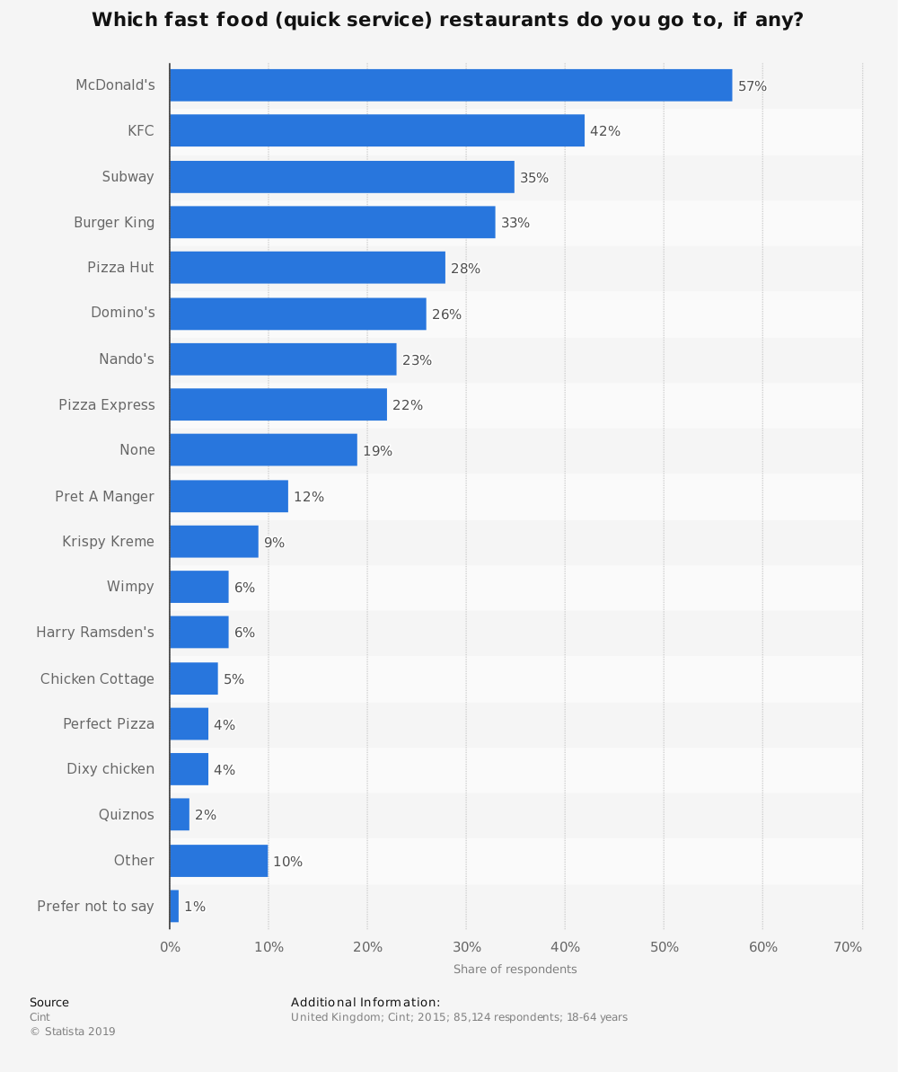
Figure 1. Fast Food Restaurants in U.K. (Statistica, 219)
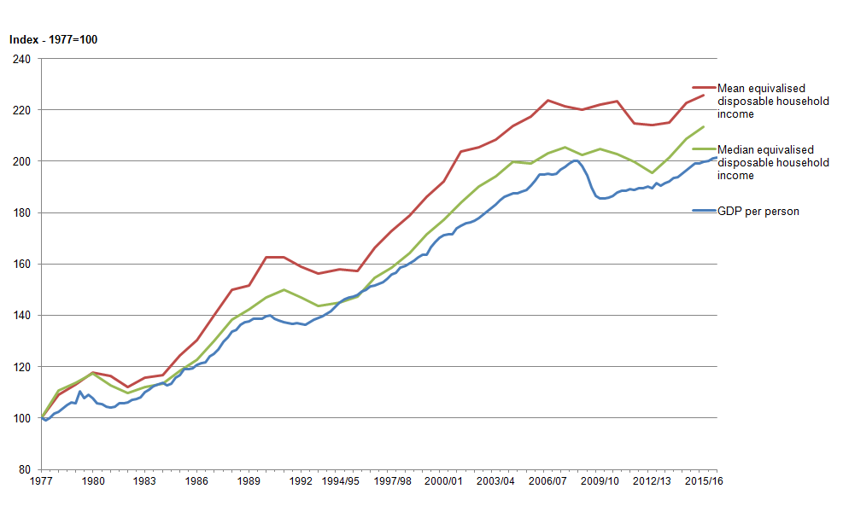
Figure 2. Rising disposable income. Office of National Statistics

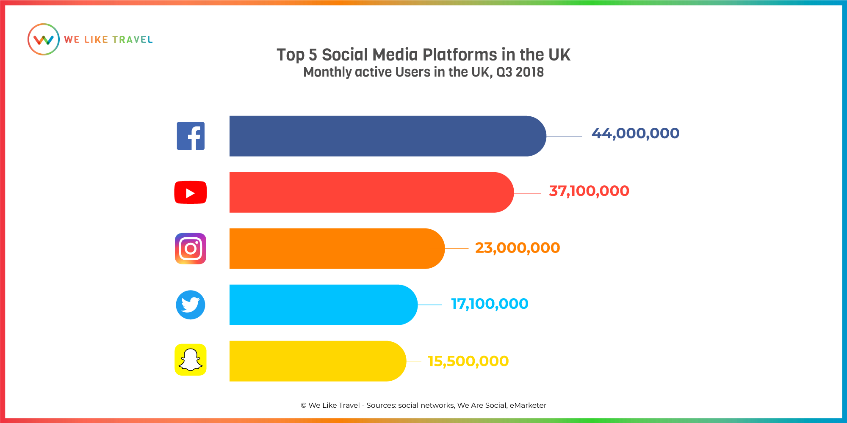
Figure 3. Social media platforms in U.K.

