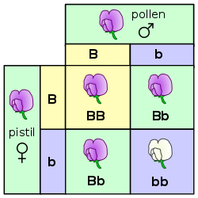 “Punnett Square”

Mendel Assignment
Directions: Read Module Reading first. Submit this worksheet with your answers in the assignment. There are 4 Parts to this lab. This lab is worth 30 points.
Part I. (no points given in Part I)
Refer to 12.3 Laws of Inheritance
Terms: phenotype, genotype, dominant & recessive alleles, homozygous, heterozygous
Part II. Follow the steps instructions. (no points given in Part II)
Steps:
1. Go to Meiosis & Genetics Interactive
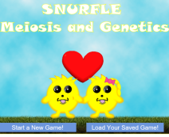
2. On the Meiosis & Genetics page, click Start a New Game.

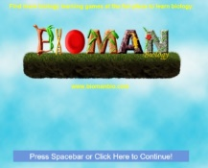
3. From the Bioman logo page, Press spacebar or click to continue.
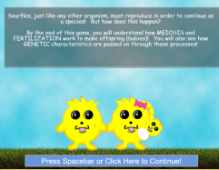

4. From this page, Press spacebar or click to continue.

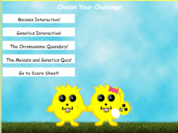
5. Once you get to Choose Your Challenge page, choose
Genetics Interactive.

6. Continue responding to the prompts on the Interactive pages. For our scientific purposes, in the animation, replace “The Snurfles fall in love,” with “The male and female Snurfles reproduce.”
Part III. Use your textbook and the Animation to answer the following questions worth 2 points each for a total of 10 points. (If you cannot access the animation, you can still answer the questions.)
1. What does a Punnett square show us? It shows the different phenotype in a plant

2. What is the dominant Phenotype (genotype “G”) of the Snurfles in this animation? (Hint: see Punnett square image below from animation.) GG
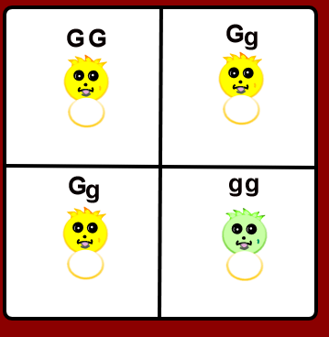
3. What is the recessive Phenotype (genotype “g”) of the Snurfles?
(Hint: see Punnett square image above from animation.) gg

4. Fill in the Punnett square below (as shown in the animation) to show the possible genotypes of the baby Snurfles.
 | G | g
G | GG | Gg
g | gG | gg

5. Using the Punnett square you filled in for #4, what is the probability of the male & female yellow-furred Snurfles having a green-furred baby?
Answer __Gg__ in 4
Part IV. Examples of Inheritance
(Questions worth 2 points each for a total of 12 points)
1. In this Punnett Square (below), “B” is the allele for Brown eyes. “b” is the recessive allele for blue eyes. The biological father (genotype - Bb) and mother (genotype -Bb) have each inherited a recessive blue-eyed allele from one of their parents. They each have a phenotype of brown eyes, however, since the brown-eyed allele they inherited from their other parent is dominant. In the Punnet Square, we see that each still carry the recessive allele for blue eyes. Hint: in order to have blue eyes (phenotype), you must carry two recessive alleles (genotype - bb).
a. Fill in the Punnett Square using Bb and Bb (set up for you).
 | B | b
B | BB | Bb
b | bB | bb

b. Their baby has a genotype in 4 chance of having blue eyes.
2. In this Punnett Square (below), “F” is the dominant allele for no freckles. “f” is the recessive allele for the phenotype freckles. The biological father (genotype - FF) has no freckles (phenotype), and the biological mother (genotype - ff) has freckles (phenotype). Hint: in order to have freckles (phenotype), you must carry two recessive alleles (genotype - ff).
a. Fill in the Punnett square using FF and ff (set up for you).
 | F | F
f | fF | fF
f | fF | fF

b. Their baby has a _Phenotype in 4 chance of having freckles.
3. In the following Punnett square for blood type, “A” is the allele for type A blood. “B” is the allele for type B blood. “o” is the recessive allele for type “O” blood.
The biological father (genotype - Bo) and mother (genotype -Ao) have each inherited a recessive blood type “O” allele from one of their parents. The father has a phenotype of type B blood; and the mother has a phenotype of type A blood. In the Punnet Square, we see that each carry the recessive allele for type O blood.
Hint: in order to have type O blood (phenotype), you must carry two recessive alleles (genotype - oo). Review Characteristics and Traits

a. Fill in the Punnett Square using Bo and Ao (set up for you).
 | B | o
A | AB | Ao
o | oB | oo

b. Complete the definition: Homozygous means having two (identical or different?) ____identical alleles for a given gene on the homologous chromosome.

c. Which genotype combination(s) in the Punnett square are Homozygous? (hint: there is 1) oo

d. Complete the definition: Heterozygous means having two (identical or different?) ___different_alleles for a given gene on the homologous chromosome.

e. Which genotype combination(s) in the Punnett square are Heterozygous? (hint: there are 3) AB and oB

Part V. Mendel’s Laws of Inheritance
Refer to Mendel’s Laws of Inheritance in your reading.
Review the Module Reading Video on Mendel Genetics.
1. Mendel’s law of _dominance___________
(fill in the blank with 1-2 words).
“This law states that paired unit factors (genes) must [separate] equally into gametes such that offspring have an equal likelihood of inheriting either factor.”
2.
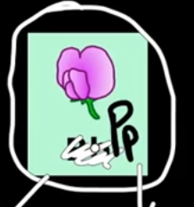In the video, the teacher gives an example of a flower, Pp, having 50% chance (1 in 2) when the gene for color separates, of the seed getting either of the alleles. “P” is the dominant allele for purple. “p” is the recessive allele for white.
This is an example of Mendel’s law of Segregation (fill in the blank with 1-2 words).

3. Mendel’s law of _ Independent Assortment (fill in the blank with 1-2 words)
states that “genes do not influence each other with regard to the sorting of alleles into gametes, and every possible combination of alleles for every gene is equally likely to occur.”
4. In the video, the teacher gives an example of a Round (dominant) or wrinkled (recessive) seed that is Yellow (dominant) or green (recessive). He uses more than one Punnett Square to show EACH is as an example of Mendel’s law of ___ dominance__________ .
Hint: See your answers to 1-3 above. Fill in the blank with 1-2 words.
The round or wrinkled seed AND whether it is green or yellow, in his example, is also an example of Mendel’s law of _____ Independent Assortment
Hint: See your answers to 1-3 above. Fill in the blank with 1-2 words.

Attribution:
This lesson was compiled for BIOL 160, Pierce College at JBLM. It is licensed under a Creative Commons Attribution 4.0 license and contains content from:

12.3 Laws of Inheritance by Biology by OpenStax College is licensed under a Creative Commons License 4.0 International
Links and images to Genetics by BiomanBiology used for educational purposes.
Image Attributions:
“Mendel Punnett Square” by Wikipedia is licensed under CC-BY-SA 3.0

