Path of the Sun

We can recognize solstices and equinoxes by Sun’s path across sky:

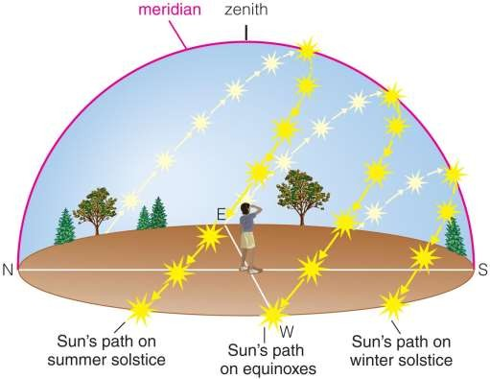Summer (June) solstice: highest path; rise and set at most extreme north of due east
Winter (December) solstice: lowest path; rise and set at most extreme south of due east
Equinoxes: Sun rises precisely due east and sets precisely due west.

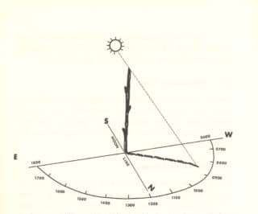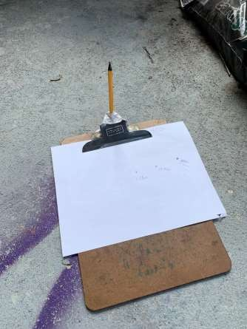
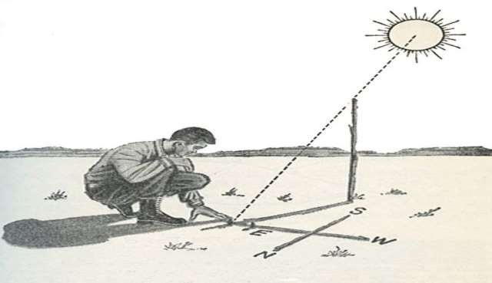
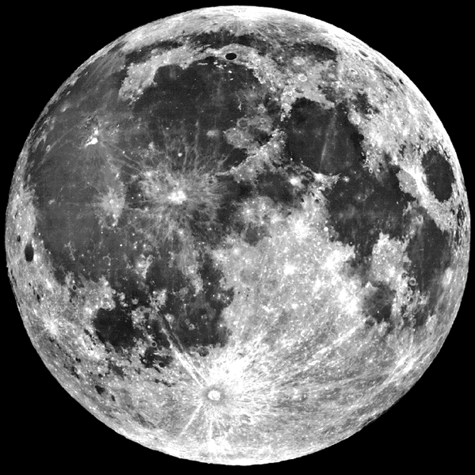
The Moon

Phases of the Moon

The Moon produces no visible light of its own • It shines only by reflected sunlight
• Surface is very dark, only ~7% reflective Each month we see a cycle of Phases:
• The sunward hemisphere is fully lit. • The opposite hemisphere is dark.
• The Phase of the Moon is the fraction of the sunlit hemisphere visible to us.

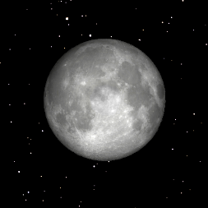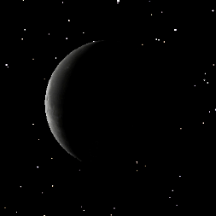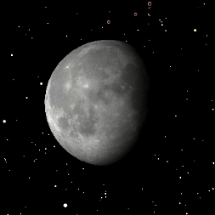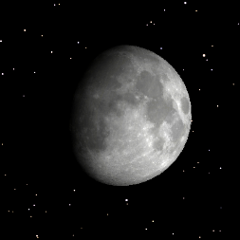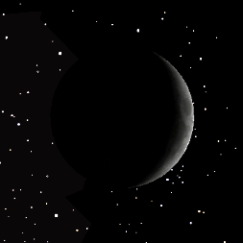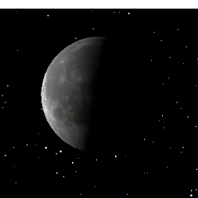Last Quarter

Waning Crescent Waning Gibbous

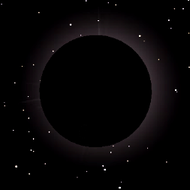SUN

New Moon

Waxing Crescent
Full Moon

Waxing Gibbous

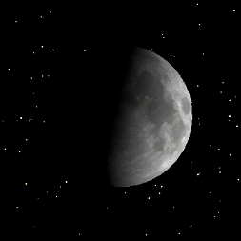
First Quarter

Moonrise, Moonset...

You don’t see all Moon phases at all times

• Never see a crescent Moon at midnight. • Never see Last Quarter Moon at sunset. • Never see a full Moon during the day.

Times of rising and setting depend on the Earth-Sun-Moon configuration as viewed from the surface of the rotating Earth.

Moonrise & Moonset at New Moon

Sunrise Moonrise


Noon Midnight

Sunset Moonset

Moonrise & Moonset at 1st Quarter

Sunrise
S t

Noon Midnight MoonriseunseMoonset

Moonrise & Moonset at Last Quarter

Sunrise
t
Moonset

Noon Midnight SunseMoonrise

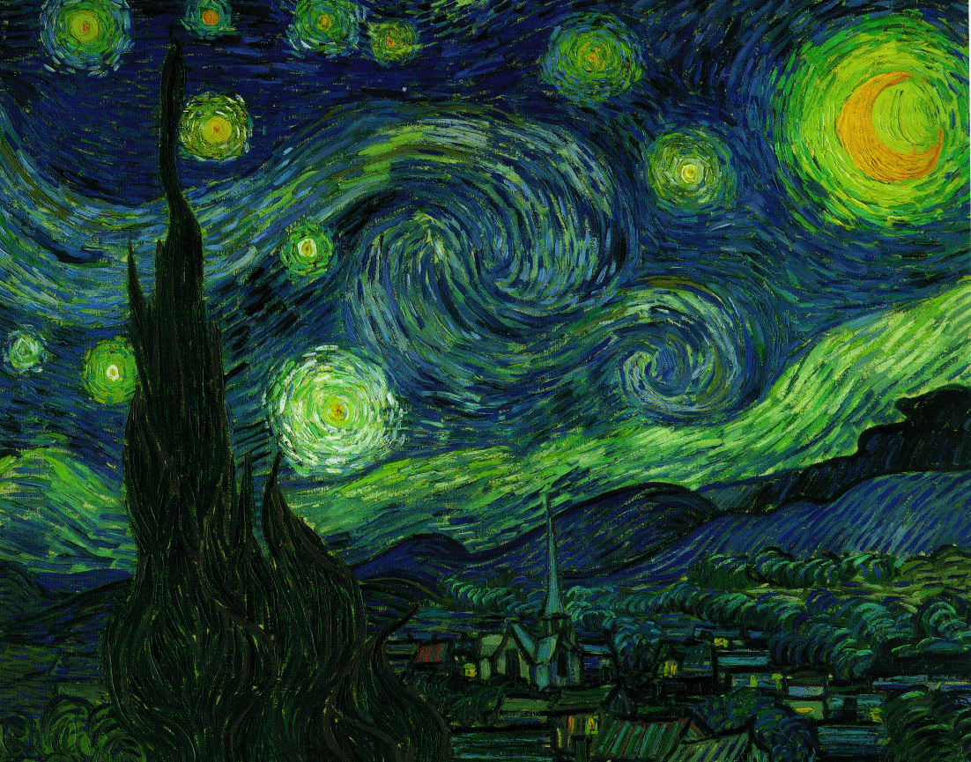The Starry Night

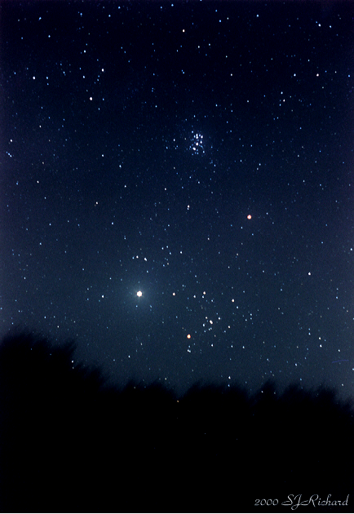
The Starry Night

About 6000 stars are visible to the naked eye on moonless nights over the course of a year.

Nearly 200 Billion stars make up our Milky Way Galaxy.

Constellations

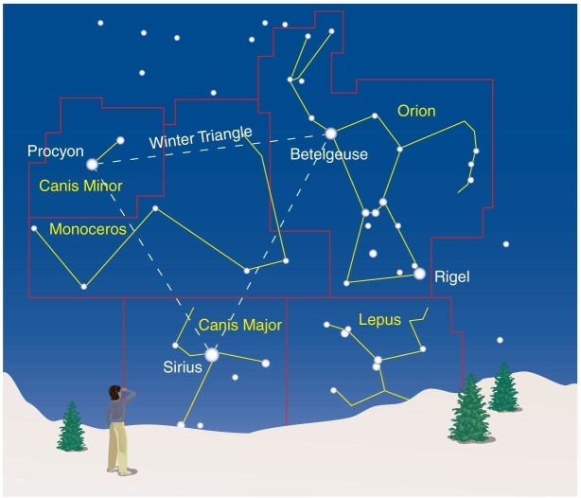
A constellation is a region of the sky.

Eighty-eight constellations fill the entire sky.

Thought Question

The brightest stars in a constellation

A. all belong to the same star cluster.

B. all lie at about the same distance from Earth.

C. may actually be quite far away from each other.

The brightest stars in a constellation

A. all belong to the same star cluster.

B. all lie at about the same distance from Earth.

C. may actually be quite far away from each other.

The Celestial Sphere

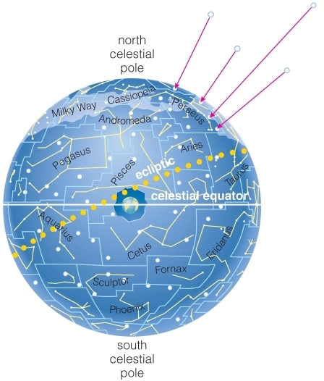
Stars at different distances all appear to lie on the celestial sphere.

The 88 official constellations cover the celestial sphere.

The Appearance of the Sky

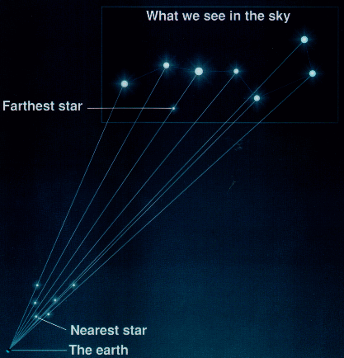Objects in the sky are so far away that we do not perceive depth.

Constellations are groups of stars that are not necessarily physically related, but appear close together from Earth.

The Appearance of the Sky

Objects in the sky are so far away that we do not perceive depth.

Constellations are groups of stars that are not necessarily physically related, but appear close together from Earth.

Constellations

From time immemorial, people have seen patterns and drawn figures in the sky by connecting the bright stars.

These starry figures are the Constellations

All peoples have populated the night sky with constellations.

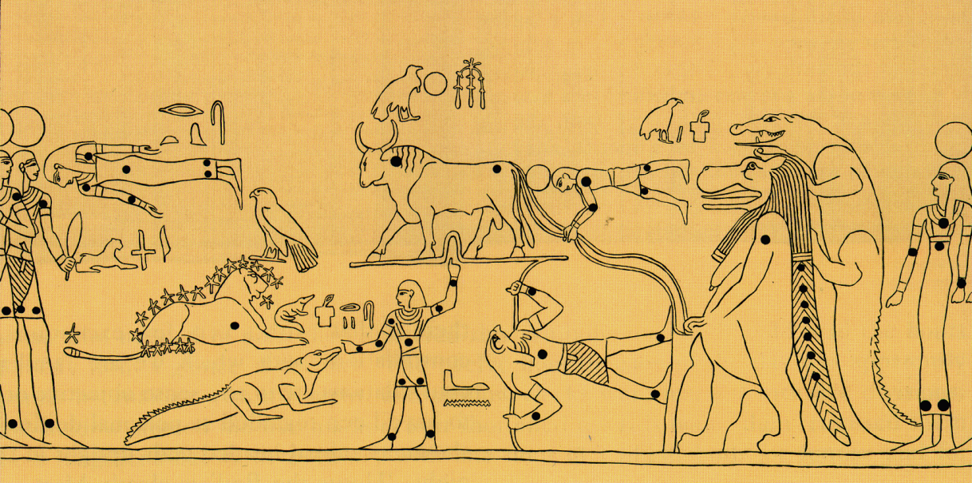

Egyptian c. 1275BC (Tomb of Seti I)

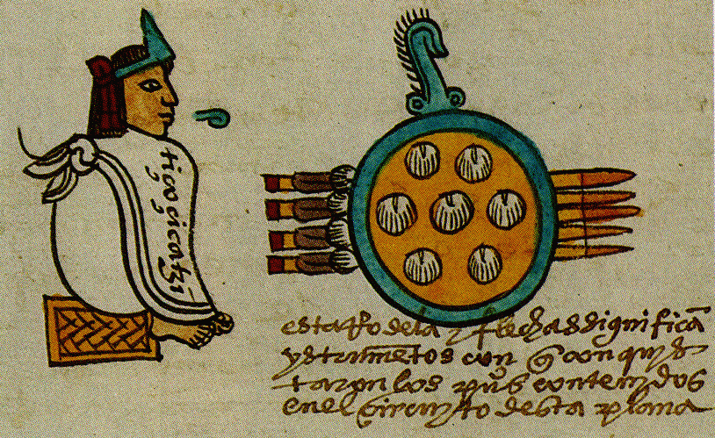
Imperial Chinese (940 AD)

Tianquinztli: Aztec Pleiades (c. 1300 AD)

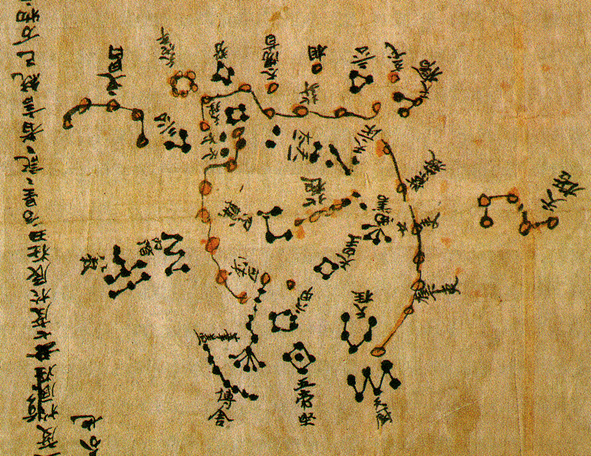
Imperial Chinese (940 AD)

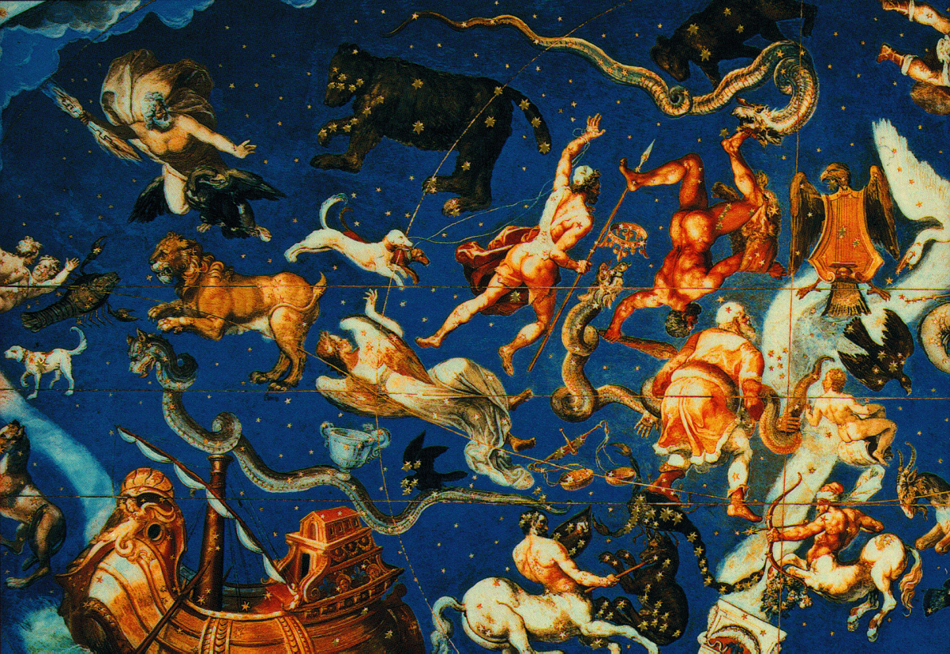

Caprarola Fresco (Anonymous 1575, Villa Farnese)

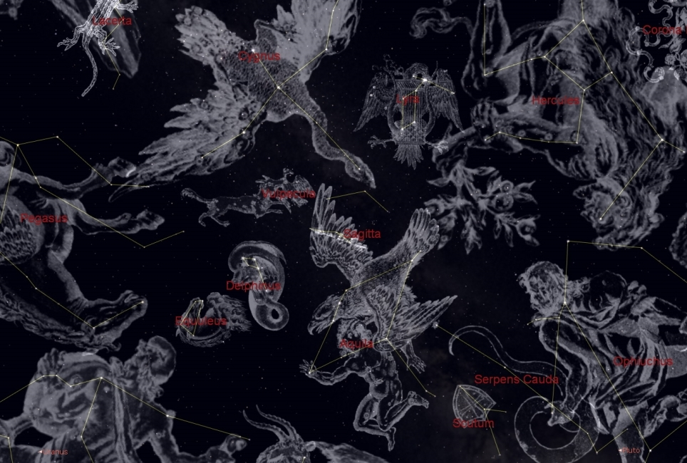

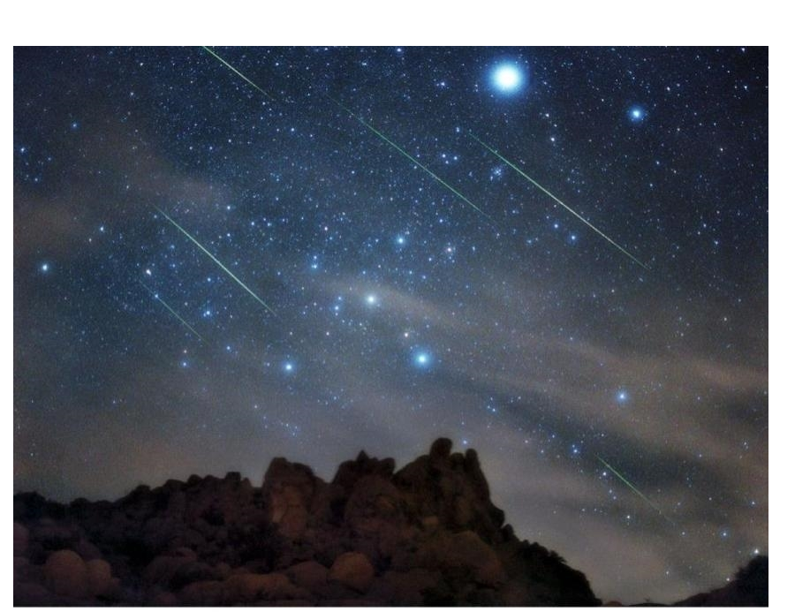
The Night Sky

As the World Turns: Motions due to the Earth’s rotation

Concept: I spin to my left, you move to my right

Application: Earth spins toward the East,

the sky moves toward the West

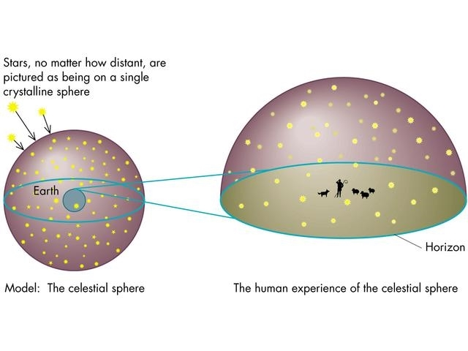
The Celestial Sphere: a useful fiction

The Celestial Sphere
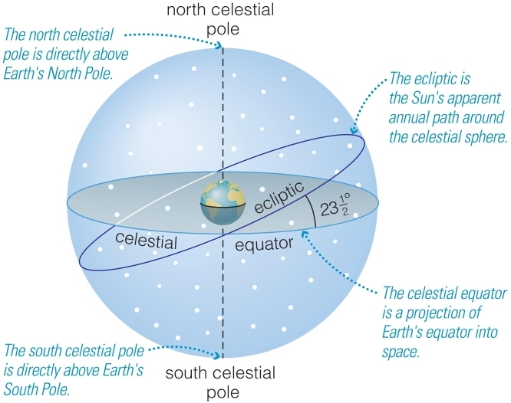
North celestial pole is directly above Earth’s North Pole.

South celestial pole is directly above Earth’s South Pole.

Celestial equator is a projection of Earth’s equator onto sky.

The Celestial Sphere

Ecliptic is the Sun’s apparent path through the celestial sphere.

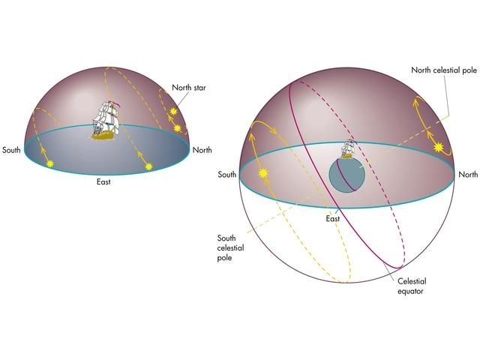
The Celestial Sphere: a useful fiction

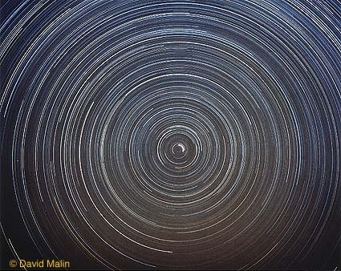
North Circumpolar Stars in a Time Exposure Image Centered on Polaris

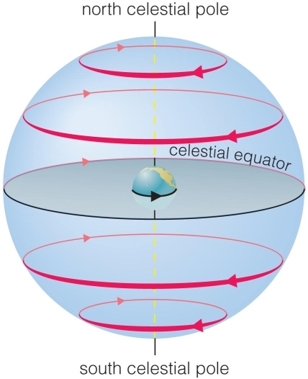
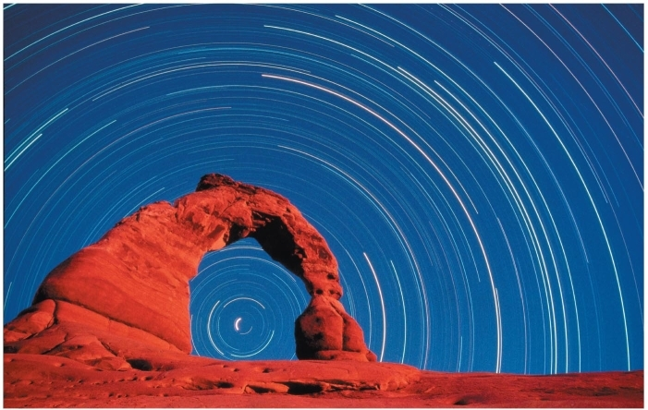
Why do stars rise and set?

Earth rotates from west to east, so stars appear to circle from east to west.

The Local Sky

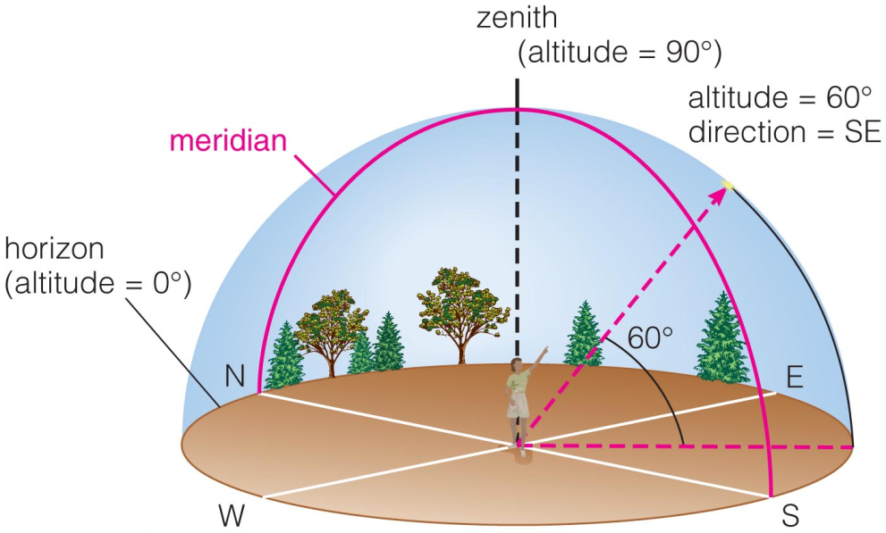
An object’saltitude (above horizon) and direction (along horizon) specify its location in your local sky.

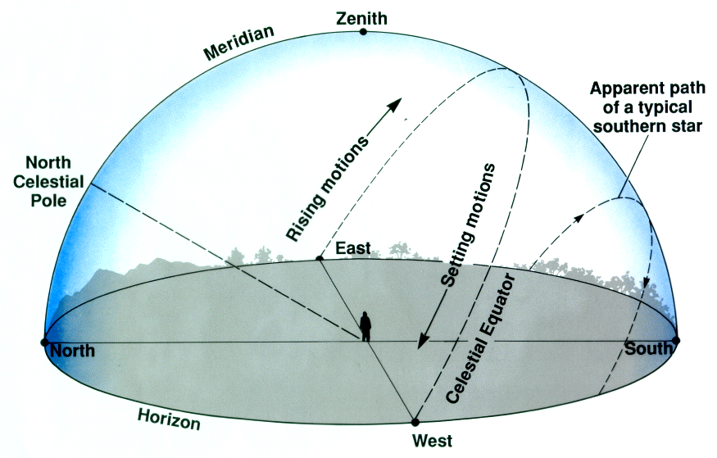

Projection of equator on to sky is the celestial equator.

Meridian

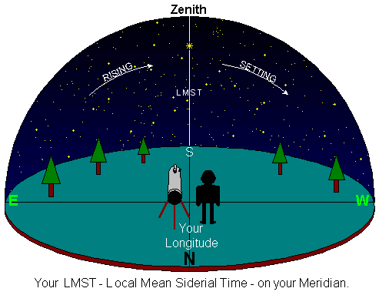
Stars that rise and set will reach their highest altitude as they cross the meridian

am and pm in clock time refer to the Sun’s position in the sky:
am antemeridian (before) pm post meridian (after)

Extra Slides

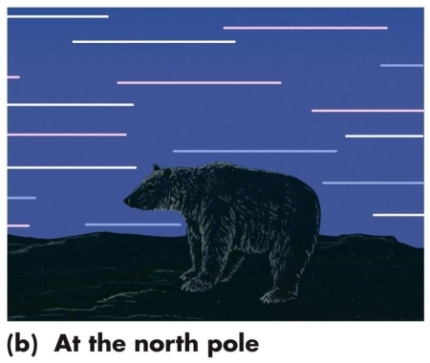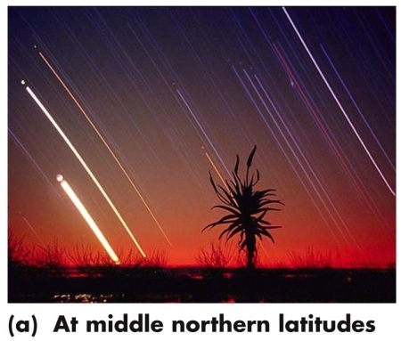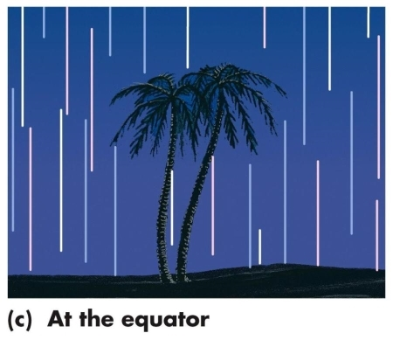Paths of stars viewed from different latitudes

Our view from Earth:

•Stars near the north celestial pole are circumpolar and never set.

•We cannot see stars near the south celestial pole.
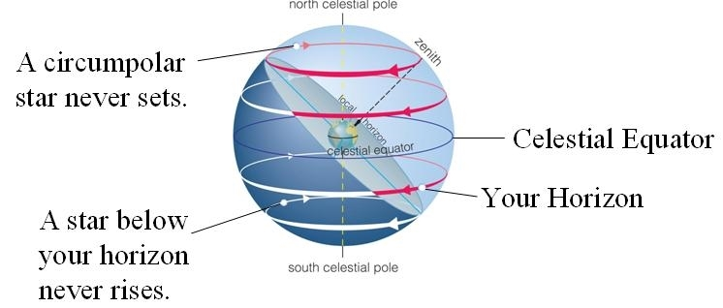
•All other stars (and Sun, Moon, planets) rise in east and set in west.
Astronomy Activity - Gravity and Acceleration - part 2

Gravitation Acceleration
$F_{g}=\frac{GM_{1}M_{2}}{D^{2}}$ $a=\frac{F}{M}$
Note: “G” is the gravitational constant , 6.67x10⁻¹¹ m³/(kg s²), which affects all masses the same. We will be focusing on concepts rather than calculations, so G won't be explicitly needed here.

Gravity, Mass, and Acceleration
Below are four pairs of masses, with each pair having the same distance between their centers (e.g. let D=1 for all the pairs). Consider each pair individually as an isolated system and then perform the following ranking tasks.

A m=1 m=1

B m=3 m=1

C m=3 m=4

D m=2 m=2

1:Rank from most to least: gravitational force on the rock on the right side of the pair

2:Rank from most to least: acceleration of the rock on right side of the pair

3: How will the previous answers change if you looked at the rock on the left side instead?
ANSWERS BELOW. TRY FOR YOURSELF FIRST!
########

ANSWERS BELOW. TRY FOR YOURSELF FIRST!
########

ANSWERS BELOW. TRY FOR YOURSELF FIRST!
########

ANSWERS BELOW. TRY FOR YOURSELF FIRST!
########

1 Most C (12) D (4) B (3) A (1) Least
2 Most B & C tie (3) D (2) A (1) Least
3 a. Stays the same since the force of gravity will be the same on both rocks.
Most C (12) D (4) B (3) A (1) Least
b. Changes if the mass being accelerated is different.
Most C (4) D (2) A & B tie (1) Least
5 Gravity and Orbits

Goals: This lab will have several small parts that will help you understand the nature of gravity, how it produces orbits, and how those orbits can be changed.
- Gravity, mass, and acceleration
- Gravity and distance
- Gravity, velocity, and orbits
- Gravity, three body interactions, and changing orbits
Resources
My Solar System http://phet.colorado.edu/en/simulation/my-solar-system

Background knowledge: Newton's version of the Law of Universal Gravitation was published in “Philosophiae Naturalis Principia Mathematica” in 1687. It states that gravity is a mutually attractive force that acts between all pairs of masses in the Universe. The strength of the gravitational force will be larger as the masses increase, but it will get smaller if the objects are farther apart. Specifically, the strength of the force will increase as the product of the masses, and decrease as divided by the square of the distance. The change in motion, or acceleration, that an object will experience due to a force will be larger as the strength of the force increases, but it will be harder to accelerate larger masses. Below are the mathematical relationships for the Law of Gravitation and Newton's 2nd Law of motion, regarding acceleration.

Gravitation Acceleration
$F_{g}=\frac{GM_{1}M_{2}}{D^{2}}$ $a=\frac{F}{M}$

Note: “G” is the gravitational constant , 6.67x10⁻¹¹ m³/(kg s²), which affects all masses the same. We will be focusing on concepts rather than calculations, so G won't be explicitly needed in this lab.

Part 1: Gravity, Mass, and Acceleration
Below are four pairs of masses, with each pair having the same distance between their centers. Consider each pair individually and then perform the following ranking tasks.

A m=1 m=1

B m=2 m=1

C m=2 m=3

D m=4 m=1

Rank from most to least: gravitational force on the rock on the right side of the pair

Rank from most to least: acceleration of rock on left side of the pair
Part 2: Gravity and distance
Consider the four pairs of masses below, now including the distances between them, and then perform the following ranking tasks. It may be possible for more than one object to have the same rank.

A m=1 D=1 m=1

B m=4 D=2 m=1

C m=2 D=2 m=2

D m=9 D=3 m=1

Rank from most to least: the gravitational force on the rock on right side of the pair

Rank from most to least: the acceleration of the rock on left side

Part 3: Gravity, velocity, and orbits

Use My Solar System simulation http://phet.colorado.edu/en/simulation/my-solar-system to explore how gravity produces orbits.

Choose the “Sun and planet” preset from the drop-down menu in the upper right. Hit start and watch an orbit. (Note: the star and planet are both moving since objects are actually orbiting around their common center of mass. In our real solar system, the Sun is so much more massive than anything else, that the common center of mass is roughly the center of the Sun.)
Reset the simulation and change the Y velocity on Body 2 before starting another one. Change the Y velocity on Body 2 from 0 – 200 in steps of 10. Find a range of values that produce a collision, a range that produces orbits, and a range where the objects escape from each other. Report the values for each range and describe in your own words how gravity produces an orbit for the right range of velocities.

Part 4: Continue using “My Solar System” to explore how orbits can change.

1)Look at the “Slingshot” preset in the drop-down menu in the upper right. How is it possible for the blue object to have its orbit changed so that it flies off away from the central star? Describe what is happening in terms of gravitational forces and accelerations.

Think about it: Why does the blue object have its motion change a lot, while the pink object has almost no change in its motion?

2)Look at the “Sun. planet, comet” preset. What happens differently to send the blue object crashing into the Star?

3)Look at the “double slingshot” preset and describe how gravity changes the orbit of the green object.

To conclude, examine the figure below which shows the trajectory of the Voyager probes that were launched in 1977. Describe in your own words what is physically happening to the Voyager 2 probe as it encounters the planets in our outer solar system and why its trajectory looks like it does. Remember to refer to the gravitational forces between the objects and the accelerations they produce in your response.

(Note: the planetary alignment making such a trip possible only occurs once every 175 years. At the time of the launch, NASA joked that “Thomas Jefferson was president the last time a chance for this happened, and he blew it.” )

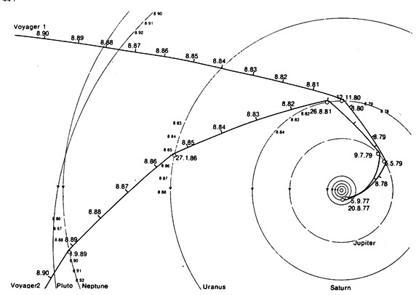

Lab Report Requirements:
Your report should include a discussion for each of the four parts. For parts 1 and 2, make sure to include your rankings for each part and a discussion of why that is the correct order. For part 3, describe the outcomes for the three ranges of motions and describe how gravity produces an orbit. For part 4, provide a response to the three questions involving the preset orbits on My Solar System and your description of Voyager 2 trajectory. Make sure your responses discus how the force of gravity acts between the objects and the accelerations it produces that play a role in sending the craft outside of the solar system.
4. Seasons

Goals
- Examine 3 competing hypotheses about how the seasons work.
- Make specific testable predictions based on the hypotheses.
- Test the predictions by using planetarium software and global temperature data.
- Evaluate each hypothesis by comparing predictions to data that will either support or refute each of the hypotheses.

Resources

Astronomical values Stellarium http://www.stellarium.org
Annual global temps Weatherbase http://www.weatherbase.com

Hypotheses

Hypothesis 1: Seasons are due to the orbit of the Earth around the Sun being in the shape of an ellipse. When the Earth is closer to the Sun it's summer and when it is farther away it's winter.

Hypothesis 2: Seasons are due to the tilt of the Earth's axis primarily because of how it affects the length of daylight. The longer the Sun is above the horizon, the more time there is for the ground to heat up. Thus, locations where the days are longer will be hotter than locations where days are shorter.

Hypothesis 3: Seasons are due to the tilt of the Earth's axis because of how it affects the angle that the sunlight hits the ground. The closer the Sun gets to directly overhead at your location, the more energy will be delivered to that area of Earth. A location on Earth has hotter temperatures in the summer when the daily path of the Sun goes higher than average in the sky and colder temperatures in winter when the Sun's path is lower in the sky.

Think about it
For each hypothesis consider locations at several different latitudes on Earth, a few north of the equator and a few south of the equator. Think about what seasonal variations would occur at those locations based on each hypothesis. Determine what observational data you would need to test those predictions.
Note: you can use Stellarium software to find things like distance to Sun, length of day, and height of Sun. You can also use www.weatherbase.com to get monthly average temp data over a year for almost anywhere on Earth.
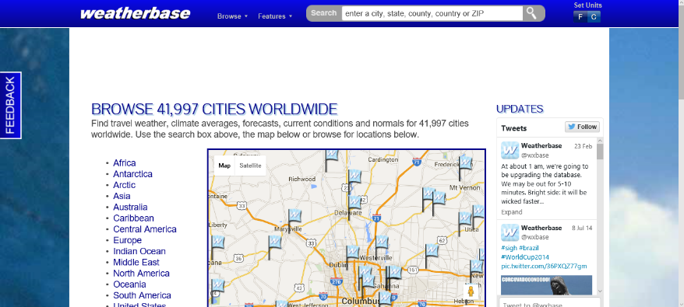

Weatherbase website (left) and sample from Sydney, Australia. (below)

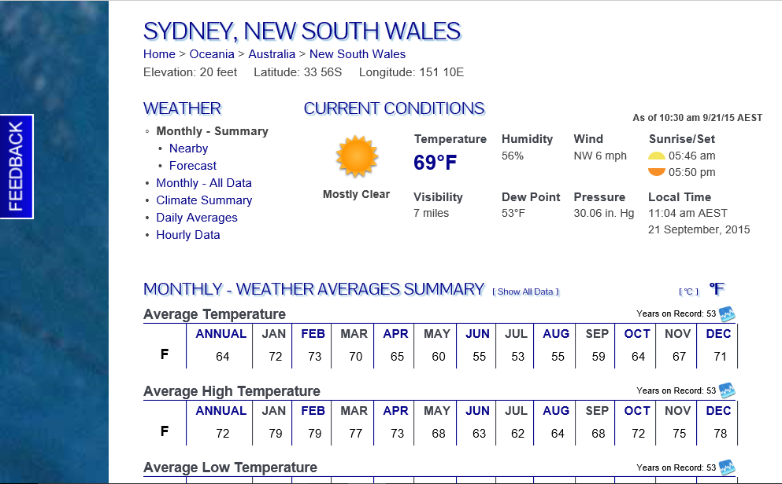
Work on it
Determine specific predictions for each hypothesis and an experimental design to test each one. Be sure to include what physical variables you will look at and what the hypothesis predicts for them. Once you have figured out your experiments, tell them to your instructor to get approval to continue on or advice on how to refine them. Once you have approval, then perform the experiments and produce a table of relevant data for each one.

Lab Report Requirements

Intro: Introduce seasons and provide a rough overview of what you will do for this lab
Part 1: Hypothesis 1:
- Clearly state the hypothesis you are going to test.
- Describe what observations you will make.
- Describe the predictions of the hypothesis.
- Report any relevant data
- Discuss if the hypothesis is ruled out or supported by the data.
Part 2: same as part 1, but use hypothesis 2
Part 3: same as part 1, but use hypothesis 3
Conclusion: Discuss which if any of the hypothesis seem to be consistent with observations, and describe how the seasons work in your own words based on what you did for this lab.
3. Daily Motions of Stars and the Celestial Sphere

Goals
In this lab exercise you will:
- Use planetarium software, like Stellarium, to examine the daily motions of stars in the sky.
- Examine the concept of the Celestial Sphere and use it to predict the motions in the sky of stars as seen from various locations on Earth.
- Observe the local sky, identify celestial objects, predict and observe their motions.

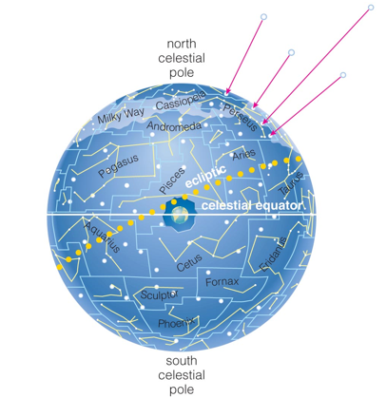
Rescources

http://www.stellarium.org

Background Knowledge
When the ancient Greeks looked at the sky, they imagined the stars were all on a sphere which would spin around the Earth to produce the motions we observe. Imagine a giant inflated beach-ball that has stars painted on it with the Earth as a small marble suspended inside the center of the ball. Then imagine spinning the ball around the stationary Earth to produce the motions of the stars in the sky. If you are unfamiliar with this concept, then find a classmate who can explain it to you, look in Chapter 2 of the Cosmic Perspectives textbook, or look online.

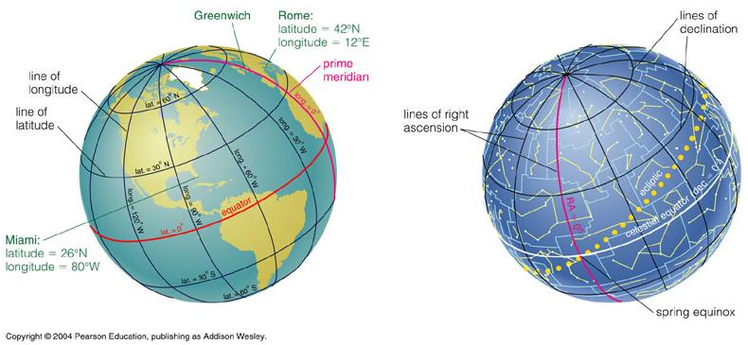

Make sure you understand what is meant by the celestial poles, the celestial equator, right ascension (RA), declination (DEC), altitude, and azimuth.

PART 1: The Celestial Sphere and the Local Night Sky

Work on it
Use Stellarium to get a view of the night sky tonight in Columbus,OH (LAT 40N, LONG 83W).
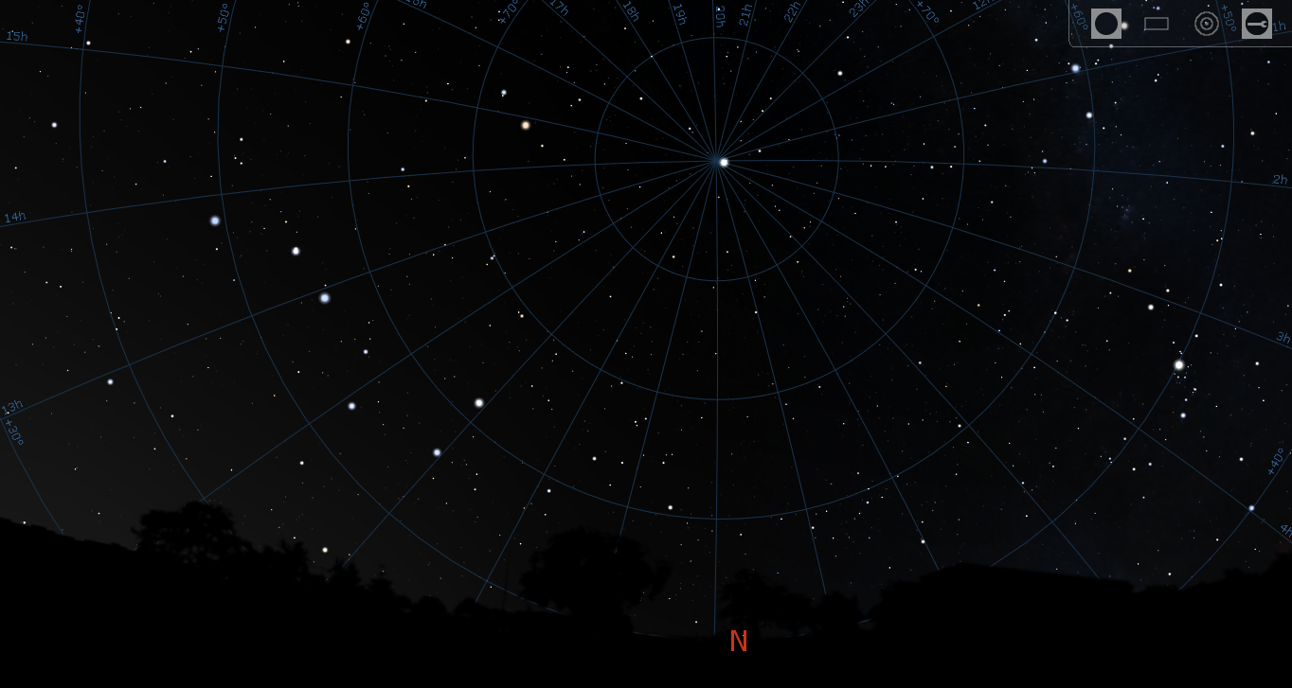
( Looking North from Columbus. At this time, the Big Dipper is on the left and Polaris is the upper center )

Find a star above the horizon of each of the cardinal points, N,S,E,W. Record the names of the stars, the RA and DEC (positions relative to the celestial sphere), and the altitude and azimuth (positions in the sky relative to your horizon on Earth). Note: you can just click on a star and the information will be displayed in the upper left of the screen

Think about it
Based on your understanding of the Celestial Sphere, predict how each of those 4 stars would move over the next several hours of the day. Explain the motions in terms of how it would look in the sky (e.g. Up and to the right, making an arc across the southern sky) and in terms of the celestial sphere (e.g. Motion relative to the celestial poles, and celestial equator.) Make sure to describe the location of the celestial poles and celestial equator when discussing motion relative to them. Also make sure to address how the RA and DEC would change and how the altitude and azimuth would change for the stars.

Work on it
Experiment to see what paths the stars actually take. Do your observations match your predictions? If not, then reevaluate your concept of the celestial sphere and repeat the process of choosing 4 new stars and making 4 new predictions. Keep doing so until you can correctly predict their motions.
Note: F5 will bring up the Date/Time interface to change the time, or you can use the arrows in the lower menu to speed up the flow of time. Use “e” to toggle on/off the RA and DEC lines of the celestial sphere, and use “a” to turn off the atmospheric effects so you can still see stars when the Sun is up.
PART 2: Views from around the world

Think about it
How would these motions change as you changed your location on Earth? What if you were on the North or South pole? What if you were on the equator? What if you were somewhere between the poles and the equator? Where would the celestial poles and celestial equator appear to an observer at these locations?

Work on it
Choose 5 locations that cover a wide range of latitudes over the entire globe: near the north pole, a mid-northern latitude, near the equator, a mid-southern latitude, and near the south pole.
Use F6 to open the location window and pick your first location to go to for a different viewpoint of the night sky. Make sure to record the latitude and longitude of the new location. Again, find a star over each cardinal point, record its relevant data, and predict the motions of each of those stars as seen from your new location. Again, make sure to describe the motion in terms of how it looks in the sky and in terms of motion relative to the celestial sphere. Make sure to describe the location of the celestial poles and celestial equator when discussing motion relative to them.
Experiment to see what paths the stars actually take and compare the results to your predictions in the same manner described above. Once you can correctly predict the motions at one location, then continue on to another one until you've gone through all your locations.
By the time you are done, you should have 5 locations with 4 stars each and a set predicted and observed motions. E.g. sample data table for stars viewed from Columbus

Location | Star | Predicted | Observed
Columbus, OH  40⁰ N lat | N Star 1 | Right and up | Right and up
Columbus, OH  40⁰ N lat | S Star 2 | Right and down | Right and down
Columbus, OH  40⁰ N lat | E Star 3 | Up and to right | Up and to right
Columbus, OH  40⁰ N lat | W Star 4 | Down and right | Down and right

PART 3 Naked eye observations of the local sky.

At least one day in the following week, go out and make direct observations of the sky. If there is a clear night, then recreate the exercise above with actual observations from your location. Find 4 celestial objects (constellations, Moon, Planets, etc..) and follow their motion for a few hours. I would recommend using the Big Dipper in the North and using it to find Polaris, the North Star. Next, find celestial objects near the East, South, and Western horizons. Predict how the big dipper will move over the next few hours and how the other stars you chose will move. Follow up by going out to observe 1-2hours later and then again 1-2hours after that. Record your observations and see how they compare to predictions.
If there are no clear nights, then at least observe the Sun over one day. Note its position at a given time, then predicting how it will move over the next few hours. Follow up by going out to observe 1-2hours later and then again 1-2hours after that, while recording your observations.

Lab Report Requirements

Intro: Describe the concept of the celestial sphere in your own words and how you intend to investigate its properties.

Method: Give an example of the method by selecting one of your locations and describing how you chose the stars to observe, how you made predictions, and how your observations compared.

Data: Show compact presentation of data for all 5 locations, e.g. data tables

Conclusion: Describe the direct sky observations you made, including the objects you chose, your predictions, and observations. Reflect on what you have learned about the celestial sphere and the local night sky based on your lab work.

PATH OF THE SUN: DAILY AND SEASONAL CHANGES

This week you will be observing the path of the sun over the course of a day. Then over the next 4 weeks, you will examine how the path of the sun changes, in particular the height of the sun in the sky at Astronomical Noon which is when the Sun crosses the Meridian in the sky and is directly above the South cardinal point.

Materials you will need:
Some kind of stick (pencil, chopstick, barbecue skewer , actual stick, etc...)
Some kind of paper/cardboard you can put beside the stick and make permanent marks on.
A ruler or tape measure
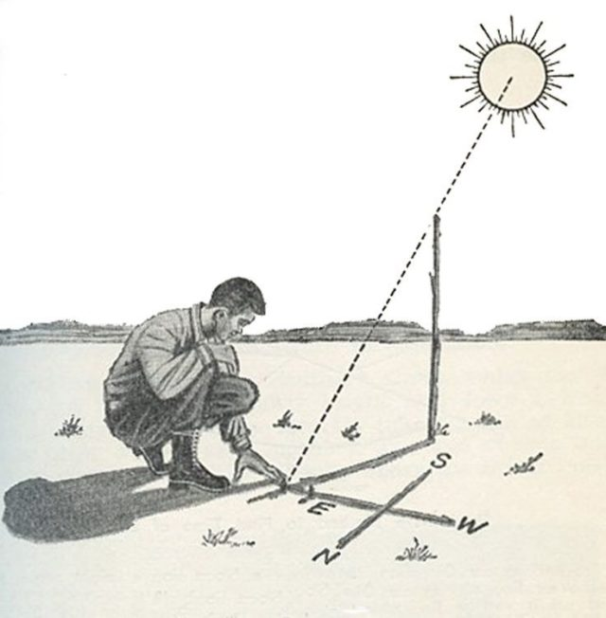

General Idea: The Sun will rise in the East and take a path that arcs to the south as it crosses the sky to set in the west. If a stick is placed in the ground, then the shadow it casts is always in line with the direction of the Sun, and the length of the shadow is determined by the height of the Sun. By placing a paper next to the stick and marking the position of the tip of the shadow throughout the day, it is possible to track the path of the Sun in the sky over the day.

Procedure: For at least one day in the upcoming week track the path of the Sun by using the stick and shadow method. Try to make observations every hour or two throughout the day. Make sure to have some well before noon and well after noon. If you are feeling adventurous you can get all the way from sunrise to sunset. You are free to use whatever materials you have, but here are a few recommendations:

1. Make sure the stick it at least about a foot long so it can be firmly placed in the ground and have plenty still sticking up.

2. Try to have a setup that you can keep in place throughout the day (e.g. garden /porch /windowsill). Otherwise have one that is mobile but can be easily setup in the same place and the same alignment over and over again (e.g. stick attached to edge of cardboard sheet)
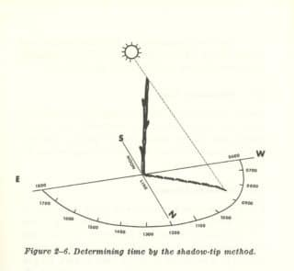
3. Make sure to note the clock time next to the marks you make on your paper during observations and put the date on the page
4. Make sure to measure the length of the stick and have its position marked on the paper so you can later use your marks to measure the length of the shadow.

Analysis:
Astronomical Noon: Once you have your marking throughout the day then imagine a smooth line connecting them and then sketch that line on your page. The position at the top of the arc will be when then Sun is due South, crossing the meridian, when local Astronomical Noon actually happens. Use your markings of the clock times along the path to estimate the clock time as the sun crosses the meridian.
Height of Sun: For this we will use a measurement of the height of the stick, h, and the length of the shadow, s, cast at Astronomical Noon. Then the angle to the Sun, α, above the horizon is given by the formula
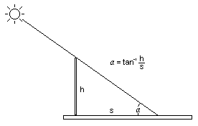
$α=\tan^{-1}\left(\frac{h}{s}\right)$

Make sure you measure the height of the stick and the length of the shadow in the same units! (e.g. both in inches or both in centimeters). Also make sure you use the inverse tangent function (sometimes called “arctan” depending on the calculator). You should get a number like 50, or 60 or 70, corresponding to the angle from the horizon up to the Sun. If you get values like 190 or .056 then you’ve entered something incorrectly.

Weekly Observations
Once you have figured out the clock time when Astronomical Noon occurs where you live, then at least once per week for the next 4 weeks, go out and observe the Sun around Astronomical Noon and mark the tip of the shadow for about an hour ( roughly 30 min before to 30 min after Astronomical Noon). Use these measurements to estimate the height of the Sun and track how its height at noon changes over a few weeks.

Report: After 4 weeks of observations, submit a brief report describing your setup, procedures, and results. For each day of observations, make sure to show data for the height of stick, length of noontime shadow, and the angle to the Sun you calculate. Be sure to estimate the clock time when Astronomical Noon actually occurs, and the angular height of the Sun at Astronomical Noon.

Sample Data
Date Astronomical Noon Height of stick Length of shadow Altitude of Sun
Week 1 12:31pm 15cm 15cm 45º
Week 2 12:35pm 15cm 13cm 49º
Week 3 12:29pm 15cm 11cm 54º
Week 4 12:40pm 15cm 9cm 59º

1. Phases of the Moon: Hypothesis, Model, and Predictions

Goals
In this lab exercise, you will:
- Evaluate a hypothesis about how phases of the moon work
- Create a model based on your hypothesis to make predictions
- Design an experiment and take data
- Interpret these data to draw conclusions about your hypothesis.
- Summarize your experiment and results in a written report

Background Knowledge

To do this lab, you will need to know how to make and record the essential information from observations of the moon. As an aid, you can use the program Stellarium, which is free planetarium software that will show how the sky looks from any location at any time. You may also want to consult your astronomy text to familiarize yourself with the names of the moon phases and what they look like.

Link to Stellarium website http://stellarium.org/

Think About It
You may have noticed that the moon is not always visible in the sky, that it is sometimes visible during the day and that it is sometimes a crescent, and sometimes is more rounded and can even appear as a disk of light in the sky. How is it that all these changes can occur? What are your thoughts on how the phases of the moon work? Take a moment to write down your ideas and/or discuss them with your nearby classmates. When you are ready, continue on to consider a specific hypothesis.

Part 1: Hypothesis

Hypothesis : The phase of the moon is determined by the amount of the lit up portion of the moon visible from Earth as it orbits around us.

Consider the Sun to be the light source to illuminate the moon. The half of the moon facing the sun will be lit up, and the half facing away will be dark. Over the course of about 4 weeks, the moon completes one orbit around the Earth, counter clockwise from a view looking down on the North Pole. As the moon orbits, the position of the Sun-Earth-Moon system changes the amount of the lit up portion which is visible on the side of the moon facing Earth.
On the picture below, color in the half of the Moon and half of the Earth that are in shadow. What portion of the lit up half of the Moon is visible from Earth? What is the phase of the Moon? Check your answers with your teacher before moving on.

Sun Earth

Part 2: Model and predictions

Use the graph paper on the last page of this lab to make a simple model of the Sun-Earth-Moon system that will let you use the current configuration to make predictions about the next three weeks. The Sun is located at the center and the Earth and Moon must be drawn in based on the current configuration. Use your resources or ask the teacher to find the following information for today.

SUN
Constellation: ________________________

MOON
Phase: ________________________

Constellation: ________________________

Rising time: ________________________

Setting time: ________________________

Think About It

How will you draw in the Earth and Moon in the correct position? When you place the Earth, make sure that the direction to the Sun matches the constellation the Sun is currently in. When you place the Moon around the Earth, make sure the direction to the Moon matches the constellation it is currently in. When you think you have them in the correct position, double check your model with the instructor.
Using your model, and knowing the phase of the moon today, figure out where you will have to look to find the moon for the next few days. Where will it be in the sky? What time will you be able to see it? What phase will it be in?

Work on it

Use the data sheet provided at the end of the lab, or one of your own making, to start recording the current information and make predictions about what you will observe over the next three weeks. Make as many predictions as you can now, focusing on phase and nearby constellation. The rising time and setting time are more difficult to predict exactly, but roughly speaking the motion of the moon causes it to rise and set about 1 hour later each day. You will have time to think of more refined predictions over the next three weeks if you can’t get them all done today.

MOON PHASE DATA and PREDICTIONS

Date | Time | Location in sky | Moon Phase  Predict | Obs. |  | Constellation  Predict | Obs. |  |  | Rise Set  Time | Time |  | Observation  Consistent?
Part 3: Observations
Think About It
Write up a description of how you intend to make your observations. Will you take pictures? Will you sketch the sky? What information will be recorded? How frequently will you take data? Where will you be when you make these observations?

Work On It
Look at the moon! Use the internet or Stellarium, if you must, to determine where and when you can find the moon. Make observations. DO THIS FOR AT LEAST THREE WEEKS.
Look at your compiled data. Do you see any patterns? Does the moon appear to change position in the sky in addition to apparent shape? Are there missing data? Why? Are there some data that you think are not really the same quality as other data? Why are they different? Were there any other issues you experienced in taking the data? Do you have enough data?
As you progress, compare your observations to your model. Do they tell the same story? Are the observations you made consistent with your model? Is there another observation (or set of observations) you could make that would confirm this explanation is the correct one? Are there any refinements to your model that you think will help make better predictions?

Lab Report Requirements

Introduction:

Introduce the goal of the lab and the experiment you planned to perform
Include a brief description of how the phases of the moon work in your own words to clarify the hypothesis that is being tested

Method:

Explain the experiment you performed
Briefly describe the model you used and how you made predictions from it
Include a discussion about the variables you observed and how you made observations

Data:

Include all relevant data you observed
Show in a clear and organized method, e.g. easy to read data tables, images, graphs, etc…

Conclusions:

Compare the observed data with the predictions of your hypothesis and model.
Do the observed data support the hypothesis or refute it?
Are there any improvements that could be made to the model or the experimental method, given what you have learned over the three weeks of observations?

Sagittarius
Dec 19 – Jan 19
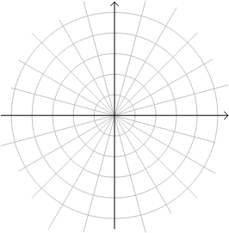
Ophiuchus
Dec 1 – Dec 18

Capricornus
Jan 20 – Feb 16
Scorpius
Nov 24 – Nov 30

Aquarius Libra
Feb 17- Mar11 Nov 1 – Nov 23

Mar 12 – Apr 18 Sept 17 – Oct 31
Pisces Virgo

Aries Leo Apr 19 – May 14 Aug 11 – Sept 16

Taurus Cancer
May 15 – Jun 21 July 21 – Aug 10

Gemini
Jun 22 – July 20

