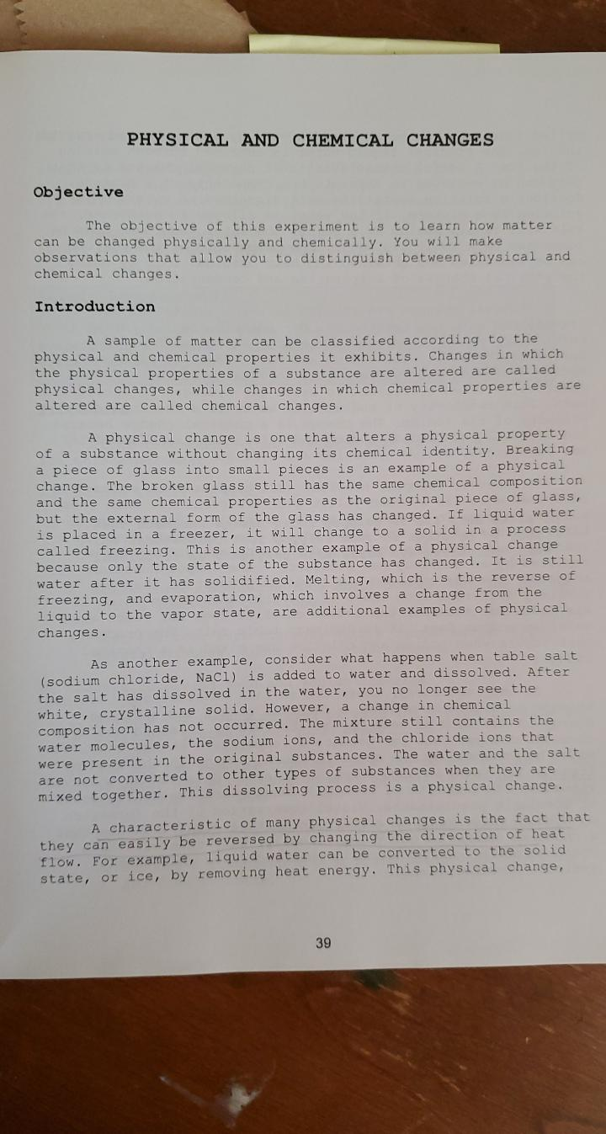

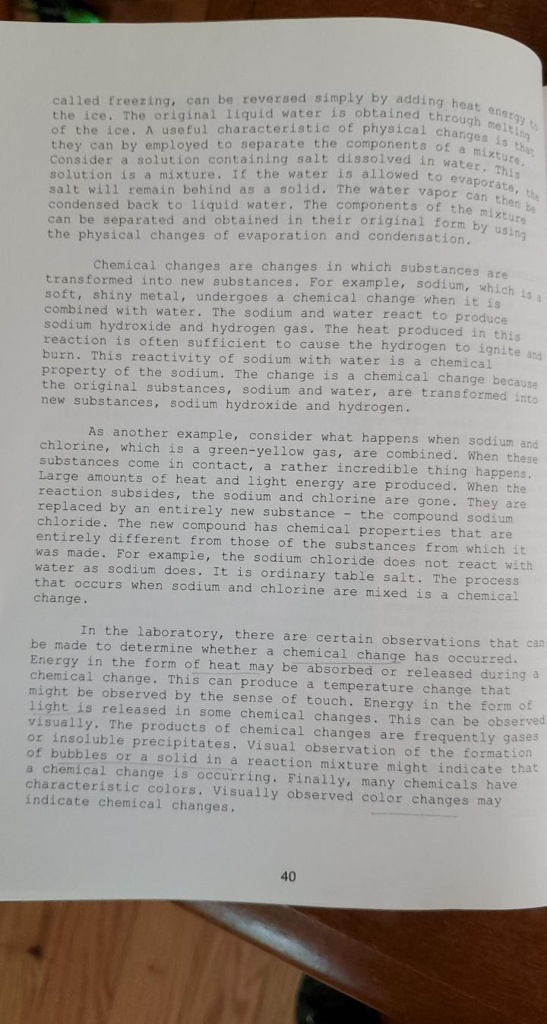

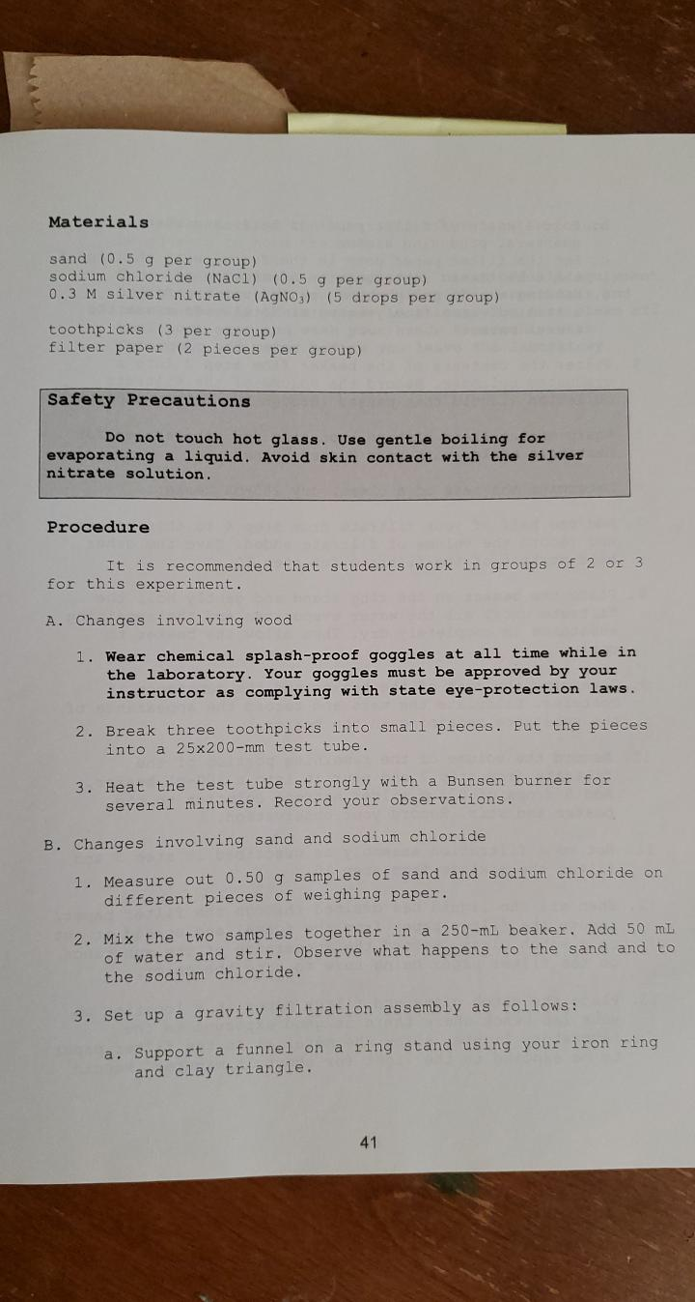

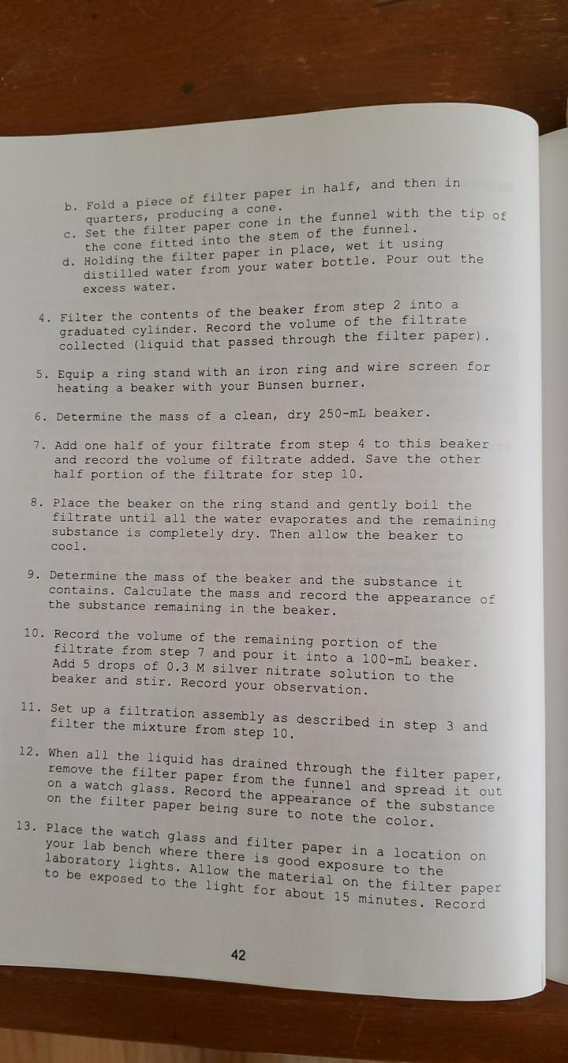

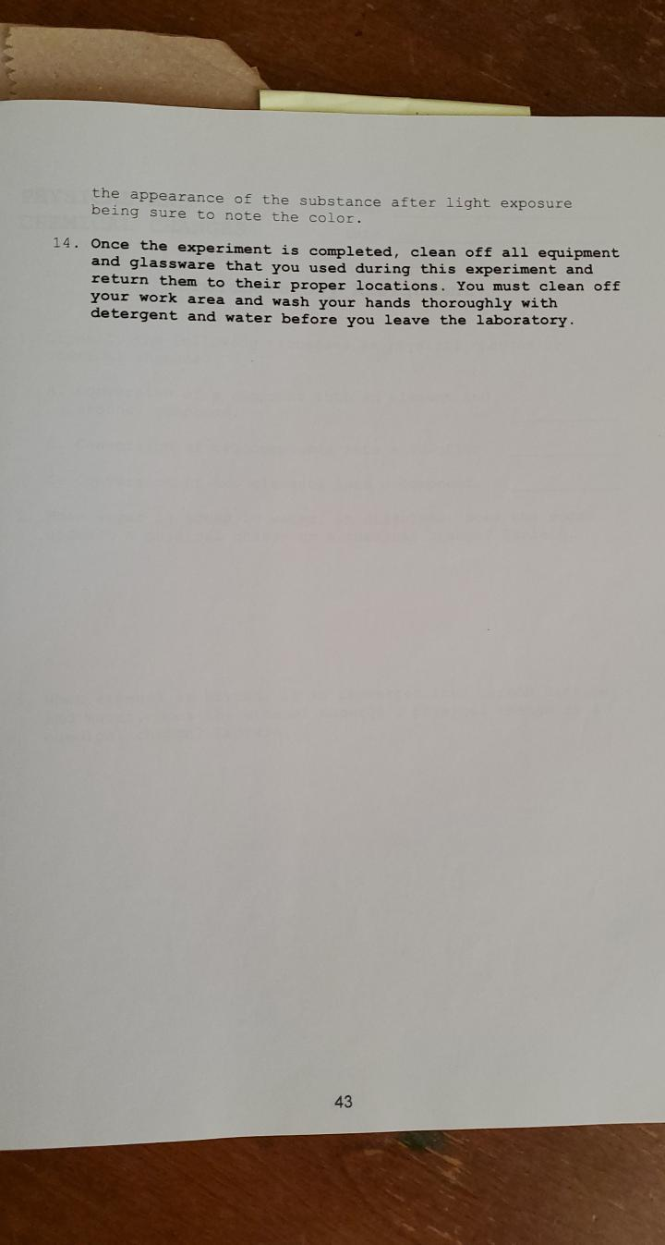

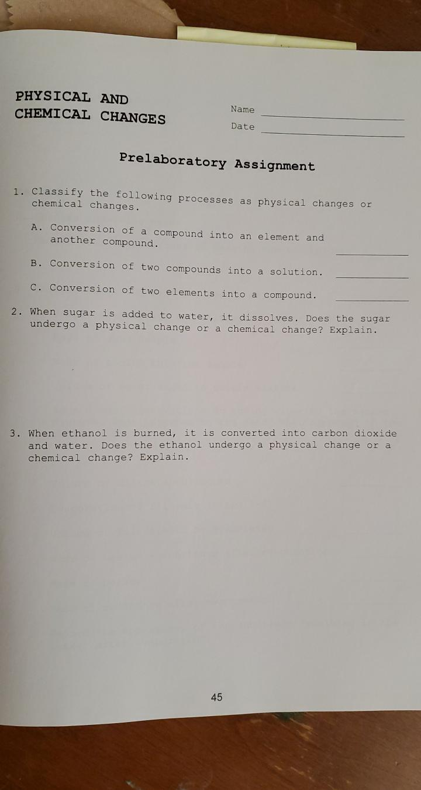

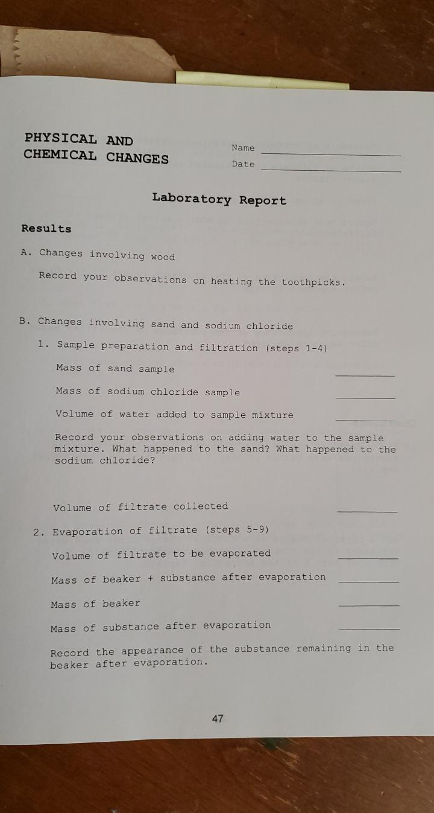

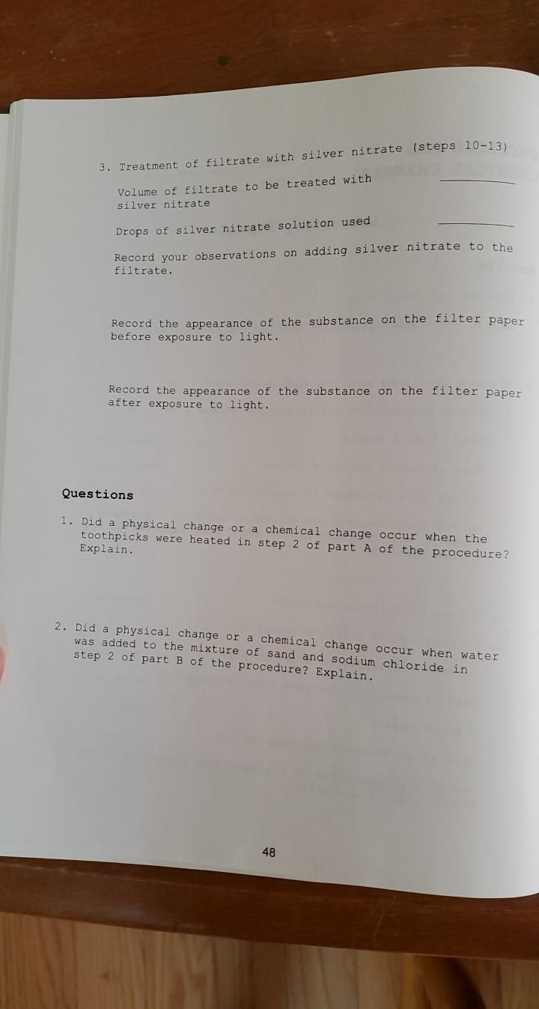

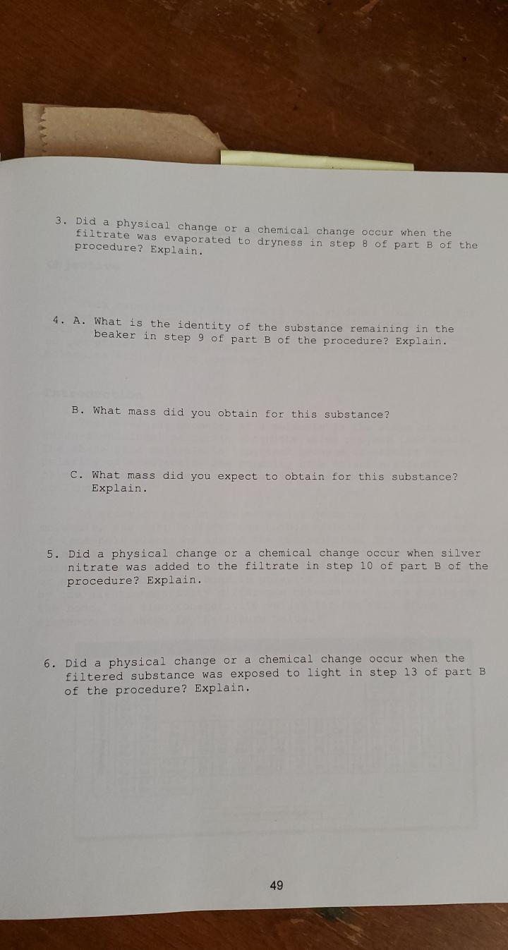
CHEMICAL BONDING I

ALL THE DATA YOU WOULD COLLECT IN THE LABORATORY TO COMPLETE THIS LABORATORY REPORT IS IN THIS DOCUMENT HIGHLIGHTED IN YELLOW

ENTER YOUR ANSWERS AND INFORMATION IN THE LIGHT BLUE FIELDS

Purpose

The purpose of this experiment is to determine molecular geometries of simple molecules, and to use molecular geometries and electronegativity data to determine whether molecules are polar or nonpolar.

Theory

The molecular geometry of a molecule is the shape or the three-dimensional manner in which the atoms project into space. The shape of a molecule is important because it affects the polarity of the molecule. The polarity of a molecule affects physical properties such as solubility, melting point, and boiling point.

In order to predict the molecular geometry of a molecule, one must consider the number of bonds and the number of nonbonding electrons around the central atom. The arrangement of bonds and nonbonding electrons, and whether the bonds are polar or nonpolar, will determine whether the molecule is polar or nonpolar. Whether a bond is polar or nonpolar is determined by the electronegativity difference between the atoms making up the bond. The electronegativity values for the elements are shown in the periodic table on the following page. Notice that electronegativity values generally increases from left to right across each period and decreases from top to bottom in the groups in the table.

Page 1
Marc Lord

Columbus State Community College

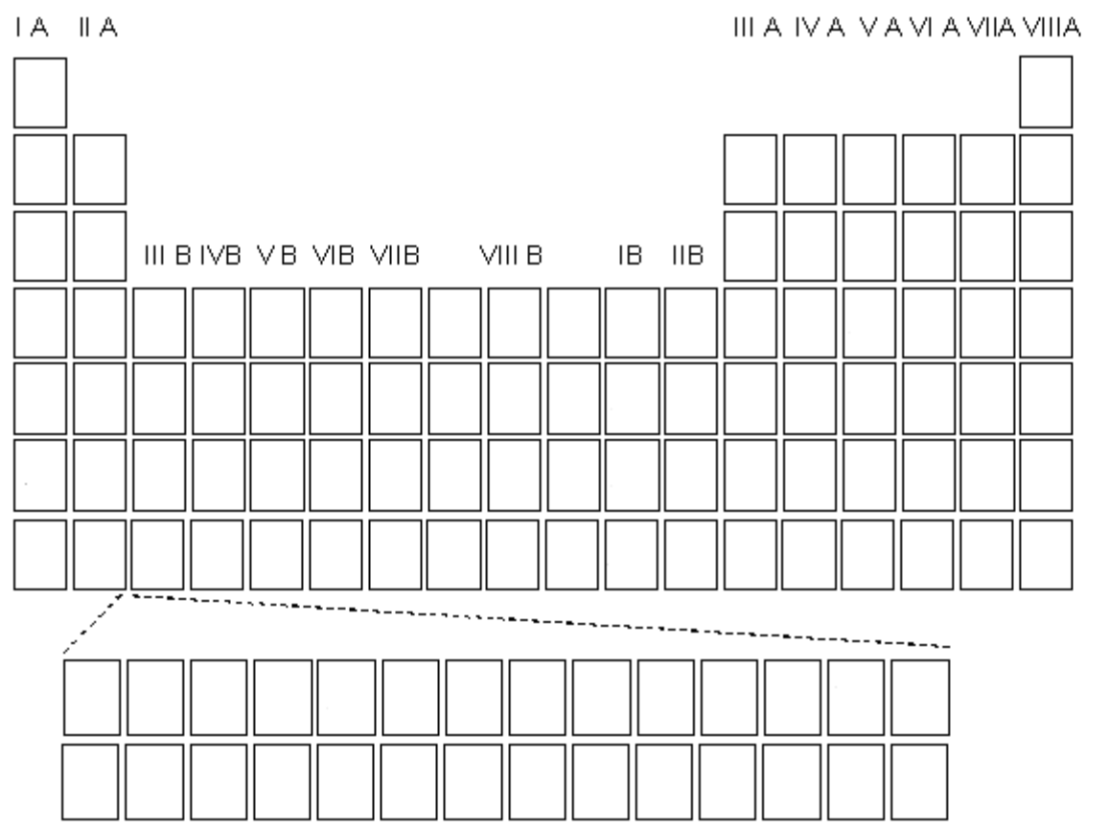

2.1
H

1.0 | 1.5 |  |  |  |  |  |  |  |  |  |  | 2.0 | 2.5 | 3.0 | 3.5 | 4.0
Li | Be |  |  |  |  |  |  |  |  |  |  | B | C | N | O | F
0.9 | 1.2 |  |  |  |  |  |  |  |  |  |  | 1.5 | 1.8 | 2.1 | 2.5 | 3.0
Na | Mg |  |  |  |  |  |  |  |  |  |  | Al | Si | P | S | Cl
0.8 | 1.0 | 1.3 | 1.5 | 1.6 | 1.6 | 1.5 | 1.8 | 1.8 | 1.8 | 1.9 | 1.6 | 1.6 | 1.8 | 2.0 | 2.4 | 2.8
K | Ca | Sc | Ti | V | Cr | Mn Fe |  | Co | Ni | Cu | Zn | Ga | Ge | As | Se | Br
0.8 | 1.0 | 1.2 | 1.4 | 1.6 | 1.8 | 1.9 | 2.2 | 2.2 | 2.2 | 1.9 | 1.7 | 1.7 | 1.8 | 1.9 | 2.1 | 2.5
Rb | Sr | Y | Zr | Nb | Mo Tc |  | Ru | Rh | Pd | Ag | Cd | In | Sn Sb |  | Te | I
0.7 | 0.9 | 1.1 | 1.3 | 1.5 1.7 |  | 1.9 | 2.2 | 2.2 | 2.2 | 2.4 | 1.9 | 1.8 | 1.9 | 1.9 | 2.0 | 2.2
Cs Ba |  | La | Hf | Ta | W | Re | Os | Ir | Pt | Au | Hg | Tl | Pb Bi |  | Po | At
0.7 | 0.9 | 1.1
Fr | Ra | Ac

The electrons in a bond are shared equally between the atoms when the atoms have the same electronegativity values. In such a situation the electronegativity difference between the atoms is zero and the bond that forms is a nonpolar covalent bond.
When the electronegativity difference between two atoms is small the bond that forms is a polar covalent bond, and if the electronegativity difference is large the resulting bond is likely to be ionic. In general an electronegativity difference between zero and two results in a polar covalent bond. An ionic bond results when the difference is larger than two.

You can predict the polarity of bonds using electronegativity data. However, it is also important to be able to predict the polarity of molecules. The terms “polar” and “nonpolar” when used to describe molecules refers to the distribution of charge in a molecule. In a polar molecule the charge is unequally distributed. In these situations the molecule has one positive end and one negative end. In a nonpolar molecule the charge is equally distributed and the molecule does not have positive and negative ends.

Page 2
Marc Lord

Columbus State Community College

First, let’s consider a hydrogen gas molecule. Both hydrogen atoms in this molecule have the same electronegativity value. As a result both atoms share the two electrons in the covalent bond equally. This results in an equal distribution of charge. As a result hydrogen gas molecules are nonpolar.
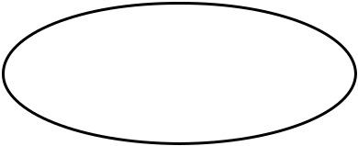

H |  | H | No positive or
H |  | H | negative charges

Now let’s consider beryllium chloride. Beryllium chloride molecules have a linear geometry with the beryllium atom in the center. The two chlorine atoms have a higher electronegativity than the beryllium atom. The electrons in the two bonds will not be shared equally because of this. The electrons will reside closer to the chlorine atoms because of the higher electronegativity of chlorine. Since the molecule is linear the overall distribution of charge is symmetrical and the molecule is nonpolar even though the bonds that make up the molecule are polar. The molecule does not have one positive end and one negative end. The negative and positive charges cancel each other out. The figure below shows the charge distribution in the molecule. The partial negative charges (designated with the symbol ⁻δ) result from the higher electronegativity of the chlorine atoms and the partial positive charge (⁺δ) results from the lower electronegativity of the beryllium atom.
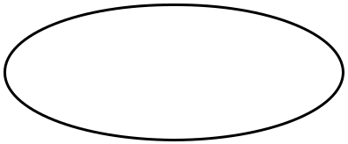

Cl Be Cl ⁻δ ⁺δ ⁻δ

Now let’s consider water molecules. Water molecules are non-linear or bent. The two hydrogen atoms have a lower electronegativity value than the oxygen atom. As a result the electrons in the two bonds will reside closer to the oxygen atom. Since the water molecule is bent the charge distribution is not symmetrical. The molecule has a negative end and a positive end. The negative end is at the top of the molecule and the positive end is at the bottom of the molecule. (See the picture below.) This unsymmetrical distribution of charge results in a polar molecule. As you can see, you must know the correct molecular geometry of a molecule before you can determine the polarity of the molecule. As in the figure shown above, the partial positive and negative charges in the molecule are caused by the difference in electronegativity of the atoms.
 | O | +_{δ} | -_{δ} | +_{δ}
H | H | +_{δ} |  | +_{δ}
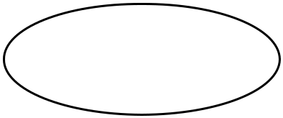

Page 3
Marc Lord

Columbus State Community College

In this experiment you will view a number of molecular models to visualize the three-dimensional shapes of some molecules. These molecules will contain single bonds, double bonds and triple bonds.

- A single bond is a covalent bond in which a single pair of electrons is shared between two atoms.

- A double bond is a covalent bond in which two pairs of electrons are shared between two atoms.

- A triple bond is a covalent bond in which three pairs of electrons are shared between two atoms.

The number and type of bonds that an atom forms depends on the number of electrons it needs to satisfy the octet rule. For example, a carbon atom has four valence electrons and therefore needs to share four more with other atoms to fulfill the octet rule when forming covalent bonds. This can be accomplished by forming:

- Four single bonds

- Two double bonds

- One double bond and two single bonds

- One triple bond and one single bond

In each case the carbon atom has eight electrons in its outer shell after bonding. The diagram below shows the four different bonding combinations that help carbon atoms obey the octet rule. The "A" refers to the atom bonded to the carbon atom, the "x"s refer to electrons on “A” and the dots refer to electrons on carbon.

- Notice that in all cases carbon has zero nonbonding electrons.

- Also notice that in all cases the carbon atom has eight valence electrons and is satisfying the octet rule.

Page 4
Marc Lord

Columbus State Community College

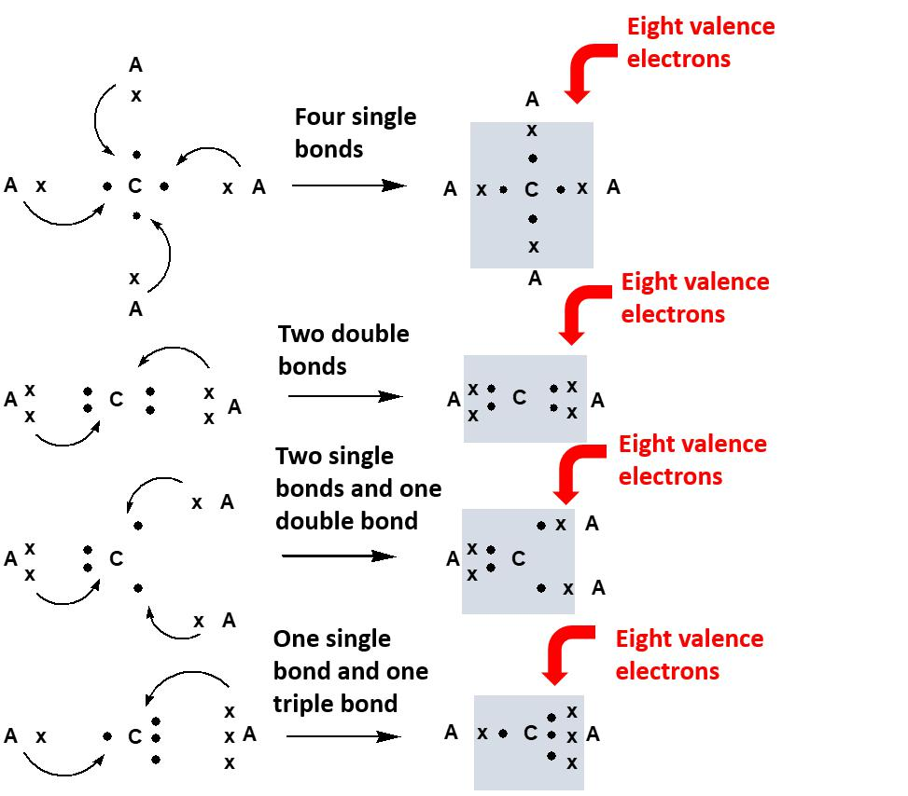

Page 5
Marc Lord

Columbus State Community College

In each case the bonds are symmetrically spaced around the carbon atom so that all bonds are as far from each other as possible. Also notice that each carbon atom is sharing eight electrons. The number of “x”s and dots around each carbon atom adds to eight.

Similar analyses can be performed with other atoms. For example, nitrogen has five valence electrons and therefore needs three more electrons to fulfill the octet rule. This can be accomplished by forming the following covalent bonds.

- Three single bonds

- One double bond and one single bond

- One triple bond

The diagram below shows the three bonding combinations for nitrogen. In the diagram the "A" refers to the atom bonded to the nitrogen atom, the "x"s refer to electrons on “A” and the dots refer to electrons on nitrogen.

- Notice that in all cases nitrogen has two nonbonding electrons.

- Also notice that in all cases the nitrogen atom has eight valence electrons and is satisfying the octet rule.
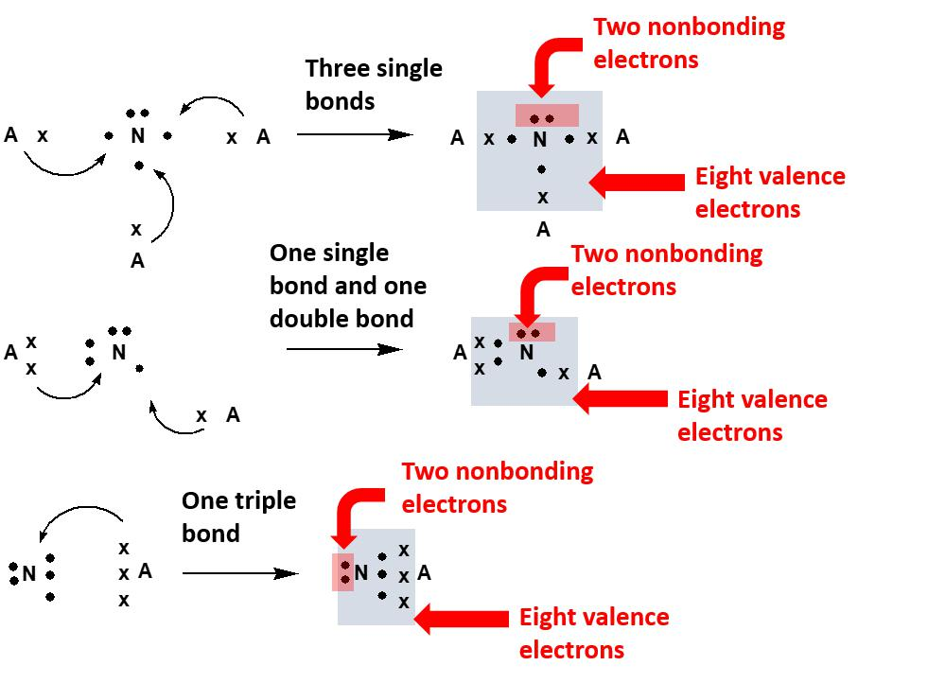

Page 6
Marc Lord

Columbus State Community College

In determining the shape of the molecule the bonding and nonbonding electrons will be as far apart from each other as possible just as they were in the molecules containing carbon atoms.

In summary, the number of valence electrons that an atom has will determine the number and type of bonds an atom needs to fulfill the octet rule. The arrangement of bonding and nonbonding electrons determines the shape or geometry of the molecule which can then be used to make judgments about the polarity of the molecule.

Page 7
Marc Lord

Columbus State Community College

Name _______________________

Date _______________________

CHEMICAL BONDING I

Prelaboratory Assignment

- Define electronegativity.

- What factors are used to determine whether a molecule will be polar or nonpolar?

- What factors are used to determine whether a bond will be polar or nonpolar?

- Carbon atoms have four valence electrons. As a result they need four more electrons to obey the octet rule. These electrons can be obtained by sharing electrons with other atoms during covalent bonding. As described the Theory section the combinations of covalent bonds that fulfill the octet rule for carbon in neutral molecules are as follows. See the figure on the following page showing these combinations.

- four single bonds

- two double bonds

- two single bonds and one double bond

- one triple bond and one single bond

Page 8
Marc Lord

Columbus State Community College

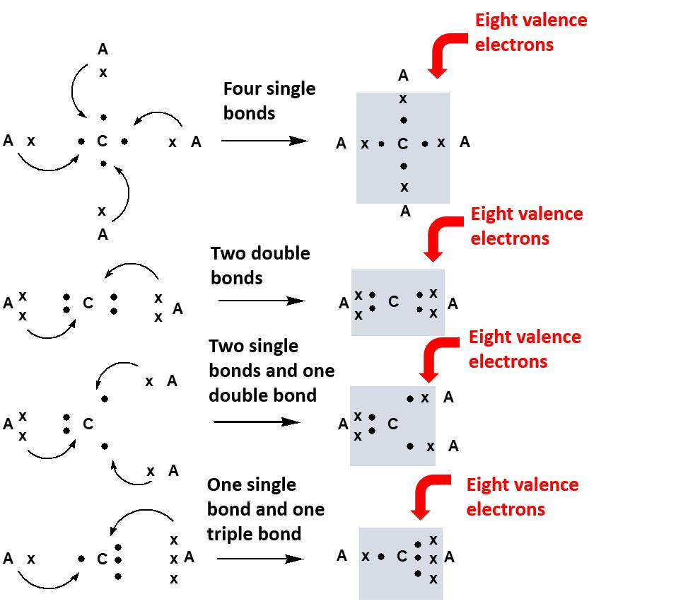

The bond combinations for nitrogen were also discussed in the Theory section.

a. Now let’s think about oxygen atoms. How many valence electrons does an oxygen atom have?

b. How many more electrons does an oxygen atom need to obey the octet rule?

Page 9
Marc Lord

Columbus State Community College

c. What are the combinations of covalent bonds that fulfill the octet rule for oxygen? Keep in mind the following.

- In all bonding combinations an oxygen atom will have four nonbonding electrons.

Indicate Correct for a correct bonding combination for oxygen. There are only two correct bonding combinations for oxygen.

• | One single bond | • | Two single | • | Three single | • | Four single
 |  |  | bonds |  | bonds |  | bonds
• | One double | • | One double | • | Two double | • | One double
 | bond |  | bond and one |  | bonds |  | bond and three
 |  |  | single bond |  |  |  | single bonds
• | One triple bond | • | One triple bond | • | One triple bond | • | Two triple bonds
 |  |  | and one single |  | and two single
 |  |  | bond |  | bonds

Page 10

Marc Lord
Columbus State Community College

- As described above atoms can form covalent bonds with other atoms to obey the octet rule and to become stable. This means that atoms will form covalent bonds to gain eight valence electrons.

One exception to this is the hydrogen atom. Hydrogen atoms will not form covalent bonds to gain eight valence electrons. Hydrogen atoms only need two valence electrons to become stable. With this in mind, answer the following questions about hydrogen atoms.

a. How many valence electrons does a hydrogen atom have?

b. How many more electrons does a hydrogen atom need to become stable?

c. What covalent bond will a hydrogen atom form to become stable? Keep in mind the following.

- In all bonding combinations a hydrogen atom will have zero nonbonding electrons.

Indicate Correct for a correct bonding combination for hydrogen. There is only one correct bonding combination for hydrogen.

• One single bond | • One double bond | • One triple bond

Page 11
Marc Lord

Columbus State Community College

Name _______________________

Date _______________________

CHEMICAL BONDING I

Procedure and Data Sheet

A. Instructions for investigating the bonding patterns and molecular geometries of molecules on the ChemSpider website.

- Go to http://www.chemspider.com/.

- Type the name of the molecule in the Search ChemSpider field. Methane is typed here.

- Hit your Return key. You should see that one result was found. Notice that the molecular formula for methane is given.

- Click on the magnifying glass to see the structure of methane.
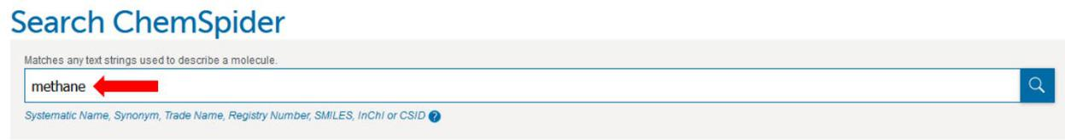
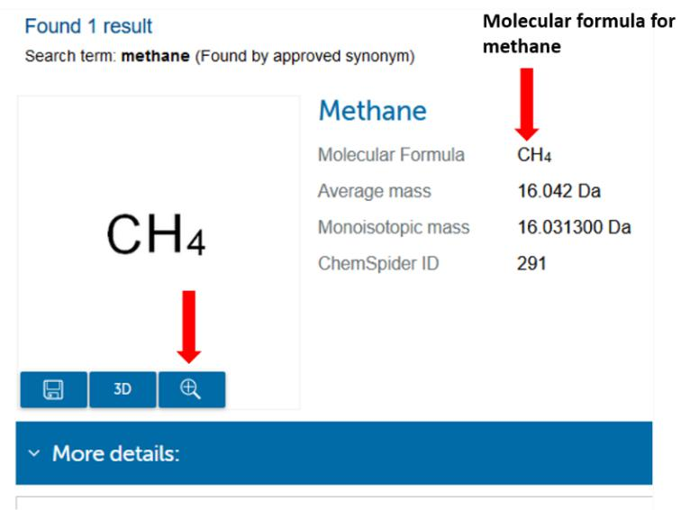

Page 12

Marc Lord
Columbus State Community College

5. A second window should appear. Click on the 3D button.
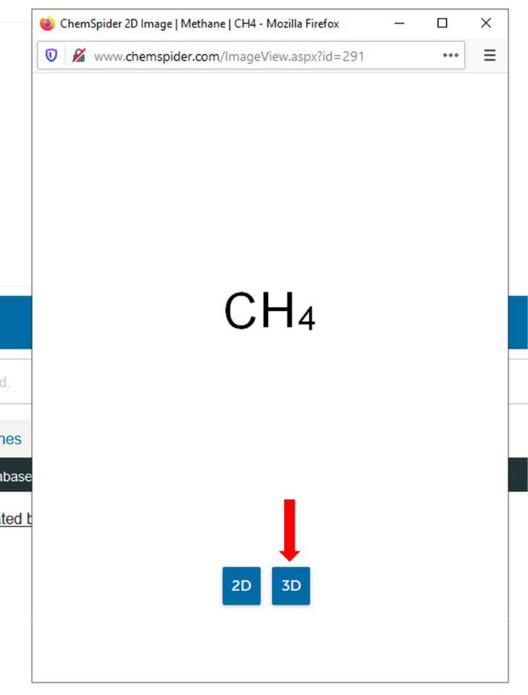

Page 13
Marc Lord

Columbus State Community College

- The three-dimensional picture of the molecule should appear. You can rotate the molecule using your cursor.
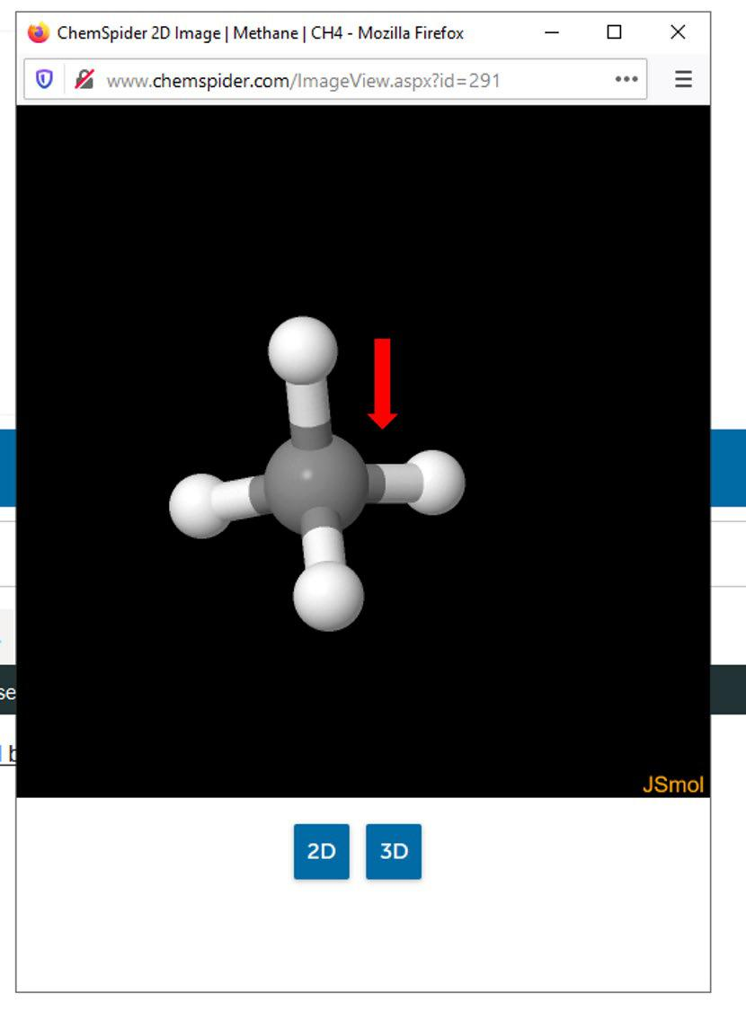

Page 14
Marc Lord

Columbus State Community College

B. Molecular formulas and molecular polarity

- Complete the tables below by observing the seven molecules listed below. Follow the instructions for using the ChemSpider website in Part A of the Procedure to view the molecules. Refer to the discussion in the Theory section about molecular polarity to determine whether the following molecules are polar or nonpolar.

Name | Molecular formula | Is the molecule polar or
 |  | nonpolar?
Methane
Ammonia
Hydrogen chloride
Dinitrogen
Chloroform
Formaldehyde
Carbon dioxide

Page 15

Marc Lord
Columbus State Community College

CHEMICAL BONDING I

Questions

- Complete the table below. Indicate whether the molecules shown below are polar or nonpolar, and indicate the atoms in these molecules that are not obeying the octet rule.

Note: All of these molecules are flat and have the geometries as indicated in the drawings. So for example SO2 and GeF2 have bent geometries and are not linear.

Remember that the geometries of all these molecules will influence the molecular polarity.

 | Indicate whether the | Are there any | Indicate which
 | molecule is polar or | atoms in the | atoms in the
Molecule | nonpolar by | molecule that are | molecule are not
 | entering POLAR or | not obeying the | obeying the octet
 | NONPOLAR. | octet rule? Enter | rule (if there are
 |  | YES or NO. | any).

S
O O

Ge

F F

H H

CC

H H

H Cl

CC

H Cl

Cl

B

Cl Cl

Page 16
Marc Lord

Columbus State Community College
Chemical Reactions Name ___________________
Date ___________________
Prelab Questions

- How is a chemical change distinguished from a physical change?

- List four kinds of observations that can lead you to conclude that a chemical reaction has occurred

- How small of a change in temperature do you think you can detect by your sense of touch? How could smaller changes in temperature be detected?

Laboratory Report Results:
The laboratory data is in red.

- Volume of sodium carbonate solution __________
- Volume of calcium chloride solution __________
- Record your observation on mixing these two solutions.

- Mass of filter paper ___0.68 g___
- Mass of dried filter paper and calcium carbonate ___0.71 g___
- Mass of calcium carbonate ___________
- Calculate the number of moles of calcium carbonate produced in your reaction.
Show your calculations.

- Write a balanced chemical equation for the chemical reaction that took place in this experiment.

Post Lab Questions:

- Balance the following chemical equations.
- __ Mg _{(s)} + __ HCL _{(aq)} __ MgCL₂ _{(aq)} + __ H₂ _{(g)}
- __ NaHCO₃ _{(s)} + __ HCL _{(aq)} __ NaCL _{(aq)} + __ H₂O_{(l)} + __ CO₂ _{(g)}
- __ NaHSO₃ _{(s)} + __ HCL _{(aq)} __ NaCL _{(aq)} + __ H₂O _{(l)} + __ SO₂ _{(g)}
- __ FeS _{(s)} + __ HCL _{(aq)} __ FeCL₂ _{(aq)} + __ H₂S _{(g)}
- __ BaCL₂ _{(aq)} + __ Na₂SO₄ _{(aq)} __ NaCL _{(aq)} + __ BaSO₄ _{(s)}
- __ Mg _{(s)} + __ O₂ _{(g)} __ MgO _{(s)}

- For each of the chemical equations in question 1, describe observations that you would have made in the laboratory to determine that the chemical reaction actually occured.

A.

B.

C.

D.

E.

F.
Acids and Bases Name ___________________
Date ___________________

Prelab Questions

- Give the definitions for the following scientific terms.

  - Acid

  - Base

  - pH

  - pOH

  - K_{w}

- What does pH measure?

- Complete the following table.

[H₃O¹⁺] | [OH¹⁻] | pH | Acid, Base, or Neutral
1 x 10⁻⁴ M
 | 1 x 10⁻⁵ M
 |  | 7
 | 1 x 10⁻¹³ M

- A solution has a pOH of 8.7
  - What is the pH of the solution? __________

  - Is the solution acidic, basic, or neutral? __________

Laboratory Report Results:

- Acid Solutions

Acid | Red Litmus | Blue Litmus | Phenolphthalein | Methyl Orange
HCl
HNO₃
H₂SO₄
HC₂H₃O₂
Vinegar

Zn (mossy) and HCl = ______________________

Na₂CO₃ and H₂SO₄ = ______________________

- Base solutions

Base | Red Litmus | Blue Litmus | Phenolphthalein | Drops of HCl
NaOH |  |  |  | 9 Drops
NH₃ (aq) |  |  |  | 9 Drops
Ca(OH)₂ |  |  |  | 6 Drops

Zn and NaOH = ______ _________________________

Post Lab Questions:

- Write a balanced chemical equation to describe the neutralization reaction that occurs when hydrochloric acid and calcium hydroxide are mixed.

- Explain why the color of the phenolphthalein changed from purple to colorless when hydrochloric acid was added to the basic solutions in step #4 of part B of the procedure.

- Write balanced chemical equations for the following reactions. Name the products in each of the reactions.

A. Zinc and hydrochloric acid.

B. Solid sodium carbonate and sulfuric acid.

Reactivities of Metals Name ___________________
Date ___________________

Prelab Questions

- How do you use the Periodic Chart to determine whether an element is a metal or a nonmetal?

- A. List some general physical and chemical properties of metals.

B. Compare these to the general properties of nonmetals.

- Give chemical symbols for the metals (below) that you will study in this experiment.

Calcium _______ Iron _______ Magnesium ________

Copper _______ Lead _______ Zinc ________

- Give chemical formulas for the test reagents that you will use in this experiment below.

Water Hydrochloric Acid Copper (II) Nitrate

______ _________ _________

Laboratory Report Results:
The laboratory data is in red.

- Reactions with Water

Metal | Initial Observation | Final Observation
Calcium | Vigorous Rxn  Heat + Bubbles | Test Tube is hot, no more bubbles, White substance
Copper | No Rxn | No Rxn
Iron | 2 small bubbles | 2 small bubbles
Lead | No Rxn | No Rxn
Magnesium | Small tiny bubbles | Lots of small bubbles  Bubbles increasing
Zinc | No Rxn | No Rxn

- Reactions with Hydrochloric Acid

Metal | Observation | Relative Rate
Copper | No Rxn | No Rxn
Iron | Small bubbles  Yellow green | Small steady pace
Lead | 1 bubble then another | Reacted very slowly
Magnesium | Lots of small rapid bubbles + very warm | Reacted quickly and  immediately
Zinc | Lots of small bubbles  Medium warm | Reacted quickly and  immediately

- Reactions with Copper (II) Nitrate

Metal | Observation on solution | Observation on metal
Copper | No change in color | Copper color black  discoloration
Iron | No change in color | Blackish silver to  copper color
Lead | No change in color | Black to light brown
Magnesium | Green color + Warm  Slowly bubbling | Silver to blackish blue  Dissolving steadily
Zinc | light green color | Silver to black dull

Post Lab Questions:

- Based on your observations, rank the metals (symbol) studied in this experiment from the most reactive to the least reactive

_______ _______ _______ ________ ________ _______
Most Least
Reactive Reactive

- Briefly explain how you used your observations to establish this ranking of the metal reactivities.

- Write balanced chemical equations for the following reactions.

Calcium + Water → ___________________

Magnesium + Hydrochloric Acid → ___________________

Zinc + Copper (II) Nitrate → ___________________

