Meteo 3, Lab 7 Due: Friday, Oct 19, 12:20pm, 109 Walker Name___________________

9.3 In the table below, you are given the average number of days that a thunderstorm occurs each month at the San Francisco International Airport.
Jan | Feb | March | April | May | June | July | Aug | Sept | Oct | Nov | Dec | Annual
0.4 | 0.5 | 0.4 | 0.2 | 0.1 | 0.0 | 0.1 | 0.1 | 0.3 | 0.2 | 0.2 | 0.3 | 2.8
- Fill in the blanks in the following statements:
  - A February thunderstorm occurs in San Francisco, on average, once every ____two__ years.

  - A July thunderstorm occurs in San Francisco, on average, once every ____ten__ years.

- In light of these data, what is the “thunderstorm season” in San Francisco, the cold season or the warm season?
Answer: Cold season

- This map (below) is a surface analysis from 00 UTC on January 5, 2008. A cold front had just moved through the Bay Area. However, thunderstorms occurred in San Francisco from 21 UTC to 23 UTC on January 5, well after the cold front passed. These maps (below) show 500-mb temperatures at 18 UTC on January 5, 2008 (left panel) and the long-term climatological average 500-mb temperatures for January 5 (right panel). Explain why thunderstorms formed later on January 5 in the context of these 500-mb charts.
Answer:
The reason thunderstorm formed later on January 5, is because the water vapor in the risen mass of air after rising its temperature kept on increasing till it reached a favorable conditions for condensation to occur. These favorable temperatures were attained later in January 5.

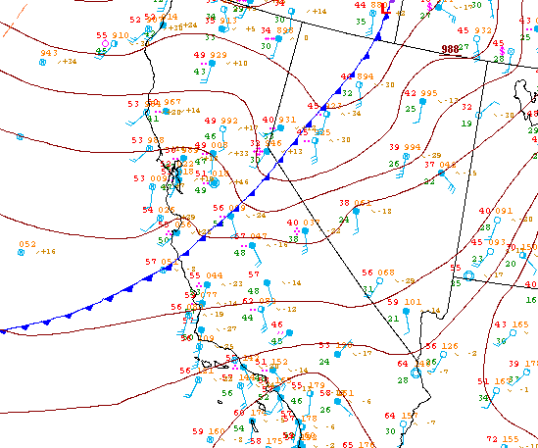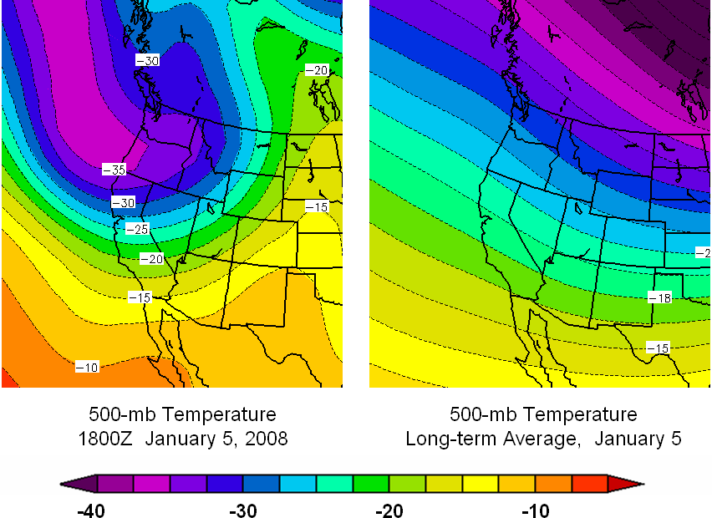
9.12 The terminal velocity of an object in flight is the maximum velocity that the object can attain as it falls. Equations to approximate the terminal velocity can be found in many standard Physics textbooks. One such empirical relationship, modified to apply to hailstones, is:
Terminal Velocity = 1750 ∗ √D
Where D is the diameter of the hailstone (in cm). The units of the constant are chosen so that the terminal velocity has units of cm/s. Calculate the terminal velocity for hailstones that are the same size as the objects below. Also convert your answers to mph.

Object | Approximate Diameter (cm)
Pea | 1
Golf ball | 4
Baseball | 7.5
Softball | 9
Large hailstone | 18

Solution:

For hailstone of pea size, Terminal velocity (T_{V}) = 1750 * square root of 1
= 1750 * 1
=1750 cm/s
But 1 mile = 161,030.6 cm and 1 hour = 3600 Sec
Therefore in mph, T_{V} = (1750/161030.6)*3600
= 39.12 mph
For hailstone of Golf ball size, T_{V} = 1750 * square root of 4
= 1750 * 2
= 3500 cm/s
In mph = (3500/161030.6) * 3600
= 78.24 mph
For hailstone of basketball size, T_{V} = 1750 * square root of 7.5
= 1750 * 2.739
= 4793.25 cm/s

In mph T_{V} = (4793.25/161030.6) * 3600
= 107.16 mph

For softball size of hailstone, T_{V} = 1750 * square root of 9
= 1750 * 3
= 5,250 cm/s

In mph, T_{V} = (5250/161030.6) * 3600
= 117.36 mph

For hailstone of size of large hailstone, T_{V} = 1750 * square root of 18
= 1750 * 4.242
= 7,423.5 cm/s
In mph T_{V} = (7423.5/161030.6) * 3600
= 166 mph

9.16 Consider this image (below), a visible satellite image from 18 UTC on a late July day. Five locations are marked with letters. Match the locations to the five descriptions below. In each case, include a sentence explaining your choice.

- Cloud development related to a high-level heat source-B
- Thunderstorm development that may be related to colliding lake breezes- C
- Relatively cool water suppressed the development of cumulus clouds-D
- Typical cumuliform cloud development related to solar heating- E
- Convection developing along a lake breeze front -A
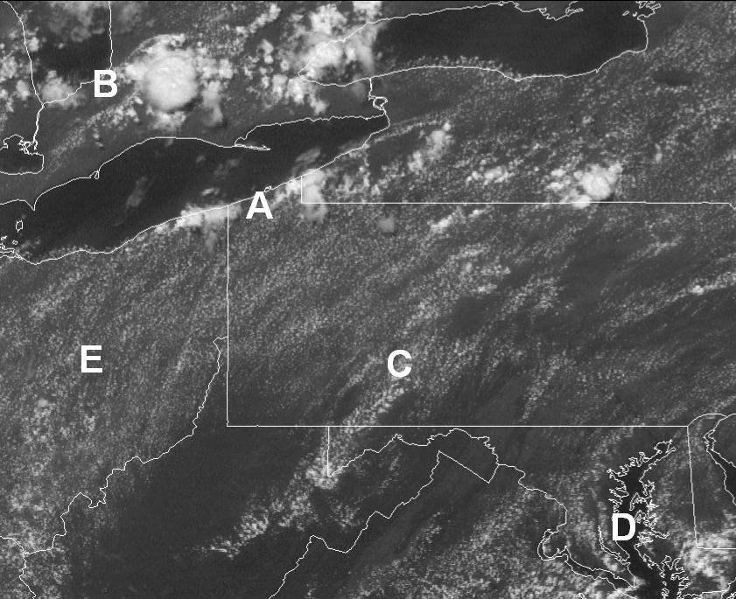
10.1 In this question, we consider hypothetical variations in the location of the ITCZ.

  - How would the seasonal meanderings of the ITCZ change if the earth’s tilt was increased from its present 23.5° to, say,30°? Briefly explain your answer.
Answer:
Increasing the earth’s tilt angle from 23.5 degrees to 30 degrees results to large surface area receiving the sunlight rays. This leads to uneven heating of the earth surface hence causing shifting of the ITCZ.
  - Assume that the earth was completely covered by water. In this case, how would the seasonal meanderings of the ITCZ change? Again, briefly explain your answer.
Answer:
When earth is completely covered by water the ITCZ will be shifting depending on the earth’s rotation. This is because rotation of earth is associated with shifting with the zone where sun rays are concentrated. This means ICTZ zone will be shifting in accordance with sun’s rays point of concentration attributed by earth’s rotation.
10.2 Consider this map of average annual liquid precipitation in Hawaii (courtesy of the University of Hawaii), and focus on the “Big Island” (the one farthest southeast). Also consider this topographic map of the Big Island.
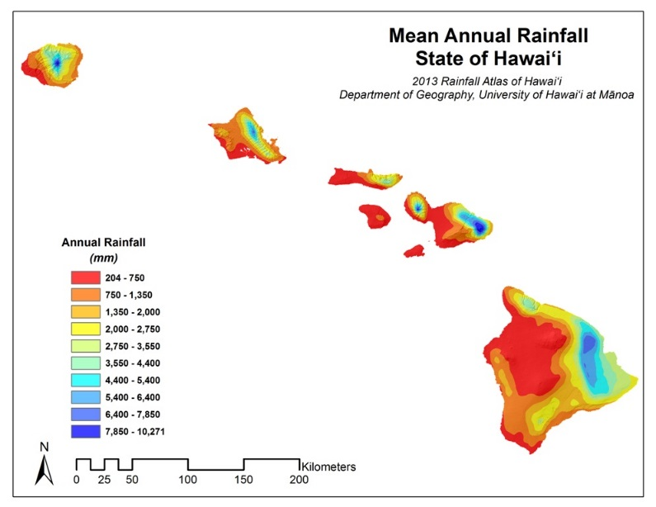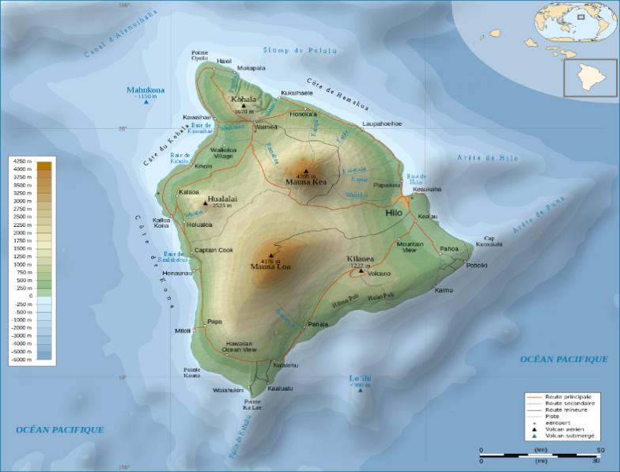
b. Using your knowledge of prevailing winds in the latitude band in which Hawaii lies, explain the patterns of average annual precipitation on the Big Island. You may assume that air arriving at Hawaii off the Pacific Ocean does not require much lifting to become saturated. Look online for bigger maps/more detail!
Answer:
The direction of prevailing low level wind is from south eastern to north western on the Big Island. These winds are referred to as southeasterly trade winds. When these winds encounter the Big Island it is forced to rise up and as it rises condensation occurs leading to high amount of rainfall which range from 7 000 mm and on the windward side of the mountain. These wind carry with them very little moisture on the leeward side of the mountain and this is reflected by the low amounts of rainfall observed which descent in amount from the mountain top to the far regions.

10.3 The color-coding in Map 1, Map 2, and Map 3 depicts the departure from average sea-surface temperature (in °C) in the tropical Pacific Ocean during three different Januarys. Areas in blue and purple are colder than average, while yellow, orange and red represents warmer than average waters. During one of these Januarys, an El Niño was in progress. During another, a La Niña was in progress. During the third, neither was occurring. Decide which is which, and explain your answer.

Answer:

- Map 1 neither represents El Niño nor La Niña
- Map 2 represents El Niño
- Map 3 represents La Niña

MAP 1
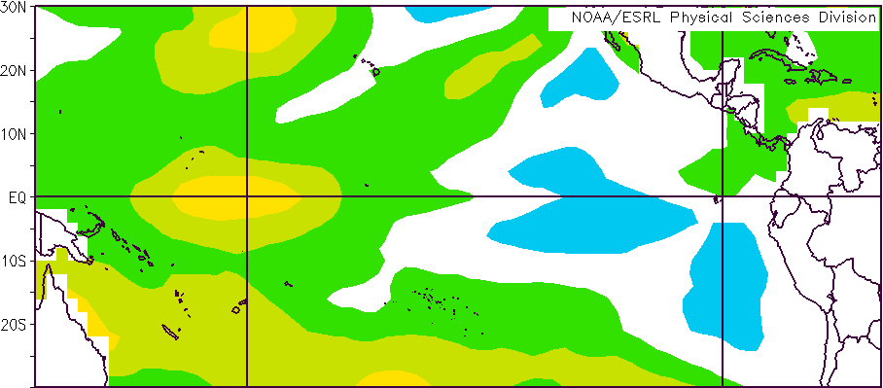
MAP 2
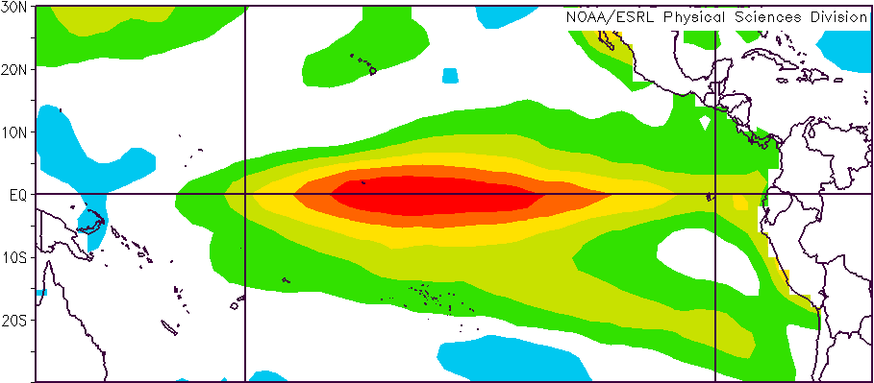
MAP 3
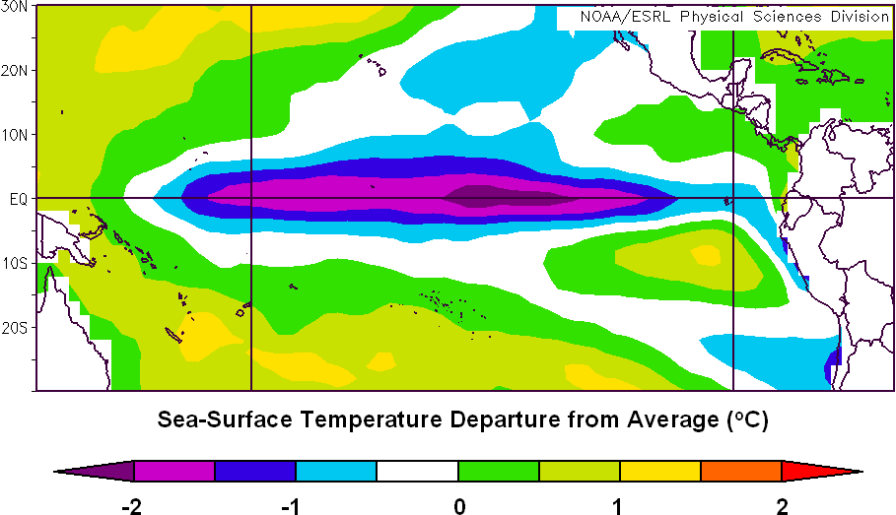
10.7 This question explores several applications of Ekman transport.

- A raft adrift on the ocean surface tends to move approximately in the same direction as the wind, but icebergs tend to drift at right angles (perpendicular) to the direction of the wind. Explain this observation. (HINT: Consider the fraction of a floating ice cube below the water and the fraction above the water).

Answer:

The draft will have force of wind acting on it since is above the water surface where force associated with wind is felt by any floating object hence tends to move in the same direction while the icebergs being below the water surface would not experience that force which means its movement will always not depend on the direction of wind.

- Meteorologists and oceanographers often deploy buoys in the oceans to gather data about weather conditions and currents. If these buoys are untethered, they can drift for hundreds and even thousands of miles.

Some buoys have drogues attached to them—a drogue is a sort of sail that extends about 15 m (50 ft) below the ocean surface. This chart shows the drift of four buoys in the northeastern Pacific Ocean released from the same point (lower left on the chart). Two of the buoys have drogues and two do not. Identify the two buoys with drogues. Explain how you made your decision. The arrow shows the average wind direction during the time while the buoys were drifting.

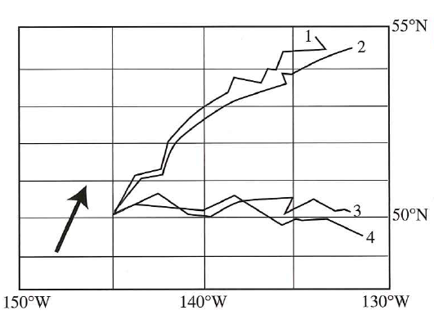

Answer:

The two buoys with drogues are 3 and 4

Reason: This is because the buoys with drogues will suffer from interference from the hanging mass below it hence it will be moving a very short distance when wind blows in a certain direction as compared to those without drogues. This means buoys with drogues will make more zigzag paths as wind keep on changing than compared to one without drogues.

11.1 In this question, we explore the differences between the circulation around Northern and Southern Hemisphere tropical cyclones.

- In what general sense (clockwise or counterclockwise) do winds blow around a tropical cyclone in the Southern Hemisphere? Write your answer immediately below. Draw isobars on the back of this page to represent a strong tropical cyclone in the Southern Indian Ocean (label the isobars with appropriate values of pressure, in mb). Then draw arrows to show the direction of the surface winds with respect to the isobars.
Answer:
The winds blow in clockwise direction around a tropical in southern hemisphere.
- Consider a tropical cyclone making landfall in the Southern Hemisphere. On which side of the eye (left or right, looking down on the storm and in its direction of movement) would you expect the larger storm surge? Explain your answer.
Answer:
- The larger storm surge is expected left. The reason for this is because the rotation is in clockwise meaning the region of lowest pressure is east of the landfall hence the surge will be from the west of the landfall to east.

- Consider Cyclone Bingiza in February 2011 which made landfall on the northern part of the island of Madagascar (see enhanced infrared loop here). At approximately what latitude did Bingiza make landfall on Madagascar? Would you expect the greatest storm surge to be to the north or the south of the eye? Explain your answer. You need to go online to view loop.
Answer:
- Cyclone Bingiza made a landfall at approximately -15 latitude
- The greatest storm surge is expected to be to the north of the eye. This is because rotation of cyclone being clockwise the region of low pressure will be north.

