Step 1: Go to https://www.cengage.com/dashboard/#/login
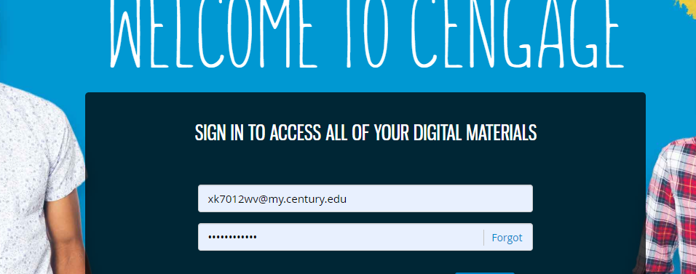
Step 2: Log in with username: xk7012wv@my.century.edu and password: Mercedees25!
Step 3: Go to Microeconomics class
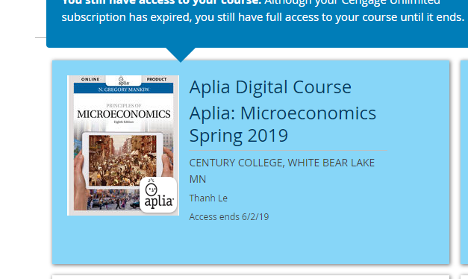
Step 4: Click ‘continue’
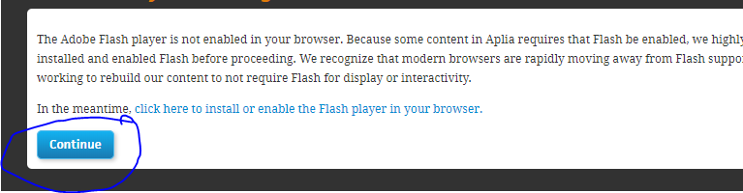
Step 5: Go to ‘Monopoly’ assignment
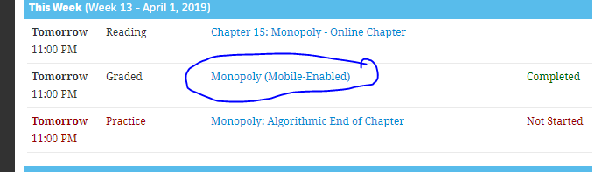
Step 6: Complete questions # 4, 5, and 7
