Global Challenge – H21
Due Wed, March 24, midnight (23:59)
5% late penalty per day from Thu, March 25 to Wed, March 31, midnight (23:59)
Not accepted Tue, March 31, midnight (23:59)
Read carefully before starting:
- Download this document in a safe place (i.e. server rather than desktop). Answer directly on this sheet below each question. When finished, submit your completed exam in BOTH Lea & Turnitin.
- Remember that Turnitin.com checks for similarity. Therefore, if your answers are identical, or even similar, to those of your classmates or to any Internet source, the system will detect it and you will get “0” for your exam as well as a letter in your Vanier file. Is it worth it? Further, if you try using my exact words from the PPts, I will notice!
* Hence, all your answers must to be IN YOUR OWN WORDS.
- All the answers must refer to the class material and to no other sources since this is not a research work but an exam on the material covered.
- Answer the questions thoroughly and in as much depth as possible within the word limit indicated for each question. Be specific, accurate, provided details and present examples if applicable.
- Your goal in answering these questions is to show me, even convince me, that you diligently covered the course material and that you understand it. Hence, integrate concepts & keywords from the course in your answers.
* Answer only ONE of the choices provided. (If you answer all of them, I will only grade the 1st one.)
** Please highlight or bold your choice for every question **
/5 | - Short answers (~70 w). CHOOSE 1 among the following.  - How does my story about Tahiti represent an example of human disconnect with nature?  - What chapter of Reading C-9 does the Grameen bank fit in? Justify your answer.  - Of the 5 “Ps” of Sustainable Dev., what do “Partnership” & “Peace” refer to?  - How can Social and Solidarity Economy play a role in creating Sustainable Cities?  - What do Al Gore’ and Neomi Klein’s messages, from the trailers of their respective movies, have in common?  Your choice? ANSWER:
/5 | - Short answers (~70 w). CHOOSE 1 among the following.  - What initiatives can be undertaken to counteract the loss of biodiversity?  - Since “no water is leaving the planet”, what are water shortage issues about?  - Why is fragmentation problematic?  - How does the case of the ozone issue represent a “success story”?  - What do coral reefs and tropical rainforest have in common?  - What is eutrophication about?  Your choice? ANSWER:
/5  /5 | - Images to words  - CHOOSE 1 among the following images. Explain what point was made in my lecture about the image. (~70 w).  a) 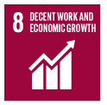 b) 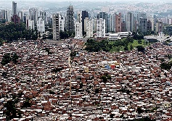 c) 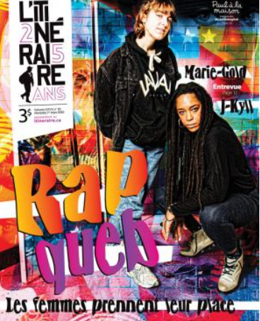 d) 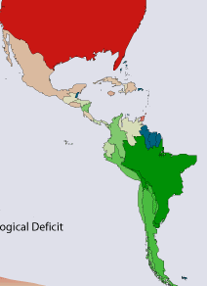  Your choice? ANSWER:  - CHOOSE 1 among the following sets of images. Explain the differences between the 2 images (~70 w).  a) 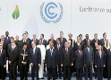  b)  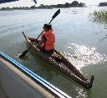 c)   Your choice? ANSWER:
/8 | - Interpreting quotes (~100w). CHOOSE 1 among the following quotes from the course material and explain it in the light of the course.  - “So-called solutions risk only serve as band-aids, hence not really resolving the issues… Root causes?”  - About worldviews, “How we see the world determines how we act” (from video Western vs Indigenous views)  - “Chemical fertilization… Is it really necessary?”  - Economic growth: “Be patient… Wait until the cake gets just a little bigger… and then we’ll start sharing it out!  Your choice? ANSWER:
/12 | - Making connections (~200w). CHOOSE 1 among the following.  - Compare and contrast linear systems as described in the Story of Stuff video with cyclical processes of some of the nature’s ecosystem services involve. Discuss the differences between them highlighting the impacts of the latter on the environment.  - Explain how the early concept of Sustainable development with only 2 realms (economy and environment) can be associated with early nature conservation efforts. Then expand on how they both fell short in addressing the 3rd realm: social dimension.  - Compare the concepts of standards of living and quality of life in terms of their meaning, applications and impacts on the planet. Refer to concrete examples provided in the course.  Your choice? ANSWER:
/8 | - Case studies (~100w). CHOOSE 1 among the following.  - In what way is the Denmark law an example of grassroots initiative?  - What is going in Cambodia and how is it related to poverty?  - What do the Grameen bank and Kiva have in common?  Your choice? ANSWER:

/48 /20

Enjoy showing off your acquired knowledge as
“knowledge is power!”
