      - Findings from Summary Function
The summary function provides statistical values including minimum, 1st quartile, median, mean, 3rd quartile and maximum. The noteworthy findings found from summary function are:
- There are noticeable differences between 3rd quartile values and maximum values for many columns.
- On average, “Other Salaries” for firefighters is about 3 times higher than that of police.
- There is a noticeable difference between “Total Salary” of firefighters and that of police
The plan from Milestone One is to see if the overtime is a factor for those who have higher salary. The output of the summary function does not change the plan as there seems no difference between previous and current analysis of the data columns. The data suggests a connection between overtime and salary but we will be able to find the truth using further statistical analysis.
      - Data Validation
The same information (min, max and average) are calculated in three different ways and places: Milestone One, the summary function and the variables. The calculations and commands confirm the findings of Milestone One. Yes this can be considered as data validation as the process is verifying the accuracy of the data. In the output of summary function, I found that there are huge difference between 3rd quartile and maximum values. This may indicate outliers and may help us in future calculations and considerations to achieve the results of our plan.

      - Data Discovery
The comparison of different numbers (min, max, average) obtained for “Salaries” and “Overtime” columns of firefighters and police datasets show that firefighters receive higher salaries and higher overtime compensations compared to those received by police.
- The minimum salary for both is 0.
- The average salary of firefighters is $26334 higher than that of police.
- The maximum salary of firefighters is $9032 higher than that of police.
- The minimum overtime for both is 0.
- The average overtime of firefighters is $15618 higher than that of police.
- The maximum overtime of firefighters is $43752 higher than that of police.
As next step, I would like the partition the data into groups based on the salary. The idea behind creating the classes/groups is to mimic the ranks. The comparison between “the persons identified with higher ranks if having higher overtime compensations” and “the persons identified with lower ranks if having lower overtime compensations” may help achieve the goal.

Appendix A: Screenshots
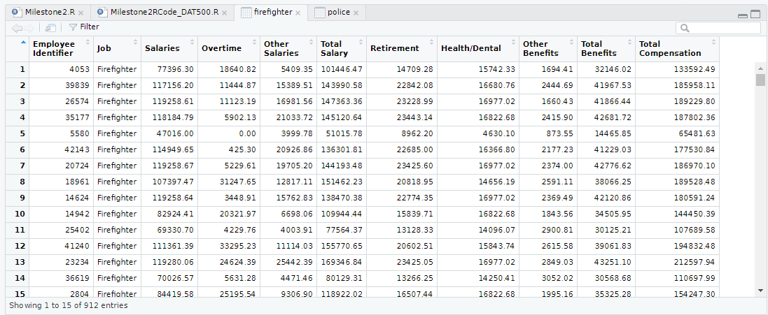
Figure 1: Firefighter data

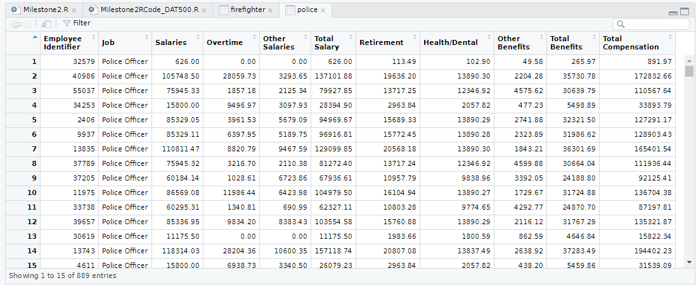
Figure 2: Police data

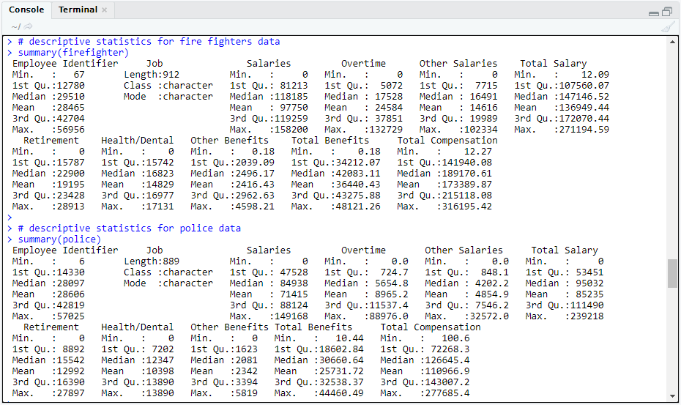
Figure 3: Summary logs

