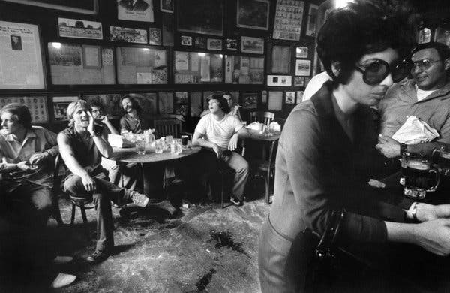
Customers at McSorley’s Old Ale House jeer at Lucy Komisar, who was among the first women to drink at the pub after the city passed a new anti-discrimination law. Prior to this, McSorley’s, which opened in 1854, had not admitted women. A waiter initially tried to bar Komisar's entry; once she was inside, some customers booed her, and another dumped a beer on her head. August 10, 1970.Credit...Barton Silverman/The New York Times
By Nina Renata Aron
- March 8, 2019
Misogyny is everywhere. Or at least “misogyny” is everywhere. The word, which conventionally means hatred of women, was once a radical accusation. But recently, it seems to have eclipsed the gentler “sexism” and “chauvinism” in popular use. It’s now unremarkable to find “misogyny” in a headline, much less a tweet.
On one end of the spectrum, the term is used to describe societal inequity, evidenced by things such as the gendered wage gap in the United States, the difficulties women have in finding adequate medical care and the career-destroying prerogatives of men like Les Moonves.
“Unfortunately, violent misogyny is nothing new in politics,” ran a 2018 CNN headline. “Women’s self-harm is being fueled by misogyny,” read a Guardian story last August. A New York Times Op-Ed from December explored “The Special Misogyny Reserved for Mothers.” Kim Schrier, a pediatrician running for Congress (now a Democratic congresswoman), flatly called Donald Trump “misogynist in chief” in a tweet last year.
A look at archival photographs, including those from The New York Times, shows how, as the term came into popular use, misogyny has also been a part of our visual landscape, from headline news to everyday experience.
But like so much of our current discourse, the word’s resonance drifts between the weighty and the meme-ified. One report indicated that a mongoose in Kenya might be a misogynist. “Chill with that misogyny,” reads a T-shirt available to buy on Etsy. And don’t forget the mug that features a whimsical-but-woke shark saying “I’m fin-ished with misogyny.”
Disdain for women, it is sometimes argued, is also the reason certain corners of pop culture are dismissed. “Has Internalized Misogyny Kept Me From Reading Romance Novels My Whole Life?” one writer asked. Hating the Kardashians has also been read as anti-woman, because in so doing we reduce the celebrity sisters to mere stereotypes. In the nesting-doll logic of the moment, disparaging any woman’s respite from misogyny — whether it’s reality TV, a self-care beauty regimen or astrology — is itself misogynist.
So, misogyny is having a moment, in more ways than one, but it also has a long history.
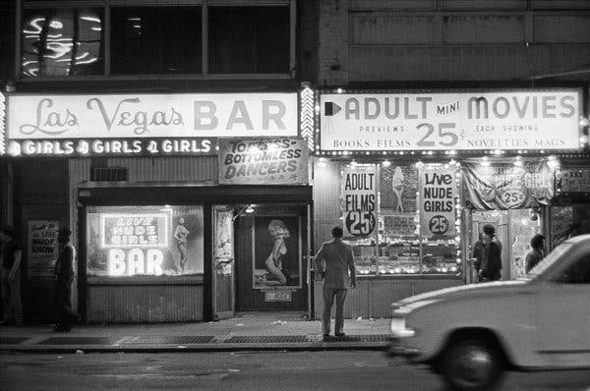
A strip club and pornography store near Times Square. May 11, 1978.Credit...Marilynn K. Yee/The New York Times
The term emerged in the 17th century, in response to an anti-woman pamphlet written by an English fencing master named Joseph Swetnam. The 1615 tract, titled in part “The arraignment of lewd, idle, froward and unconstant women” (froward meant disobedient), was published amid early modern anxiety and debate about women’s place in society. Basically a compendium of sexist jokes, the dyspeptic work was aimed at an audience of “the ordinary set of giddy-headed young men,” and it was very popular.
“Women are crooked by nature,” Swetnam wrote, sounding like a proto-incel. To him even “the fairest woman has some filthiness in her.” Going all the way back to Eve, womankind was “no sooner made but straightway her mind was set upon mischief, for by her aspiring mind and wanton will she quickly procured man’s fall, and therefore ever since they are and have been a woe unto man, and follow the line of their first leader.” They were like pumice stones because their hearts were filled with holes, he wrote, like painted ships because they looked pretty but contained only lead. Not surprisingly, the pamphlet drew several published responses from women. In one, an anonymously written feminist play called “Swetnam the Woman-Hater, Arraigned By Women,” the character standing in for Swetnam was named Misogynos.
Misogyny was little used for the next few centuries, but its popularity skyrocketed in the mid-1970s, more or less entering the lexicon of second-wave feminism with Andrea Dworkin’s 1974 critique “Woman Hating.” In the book, Dworkin argues that a deep, ingrained prejudice against women informs aspects of society from legislation to cohabitation. As she summed it up two years later, “As women we live in the midst of a society that regards us as contemptible. We are despised … We are the victims of continuous, malevolent, and sanctioned violence against us.” (An idea familiar to women like Kathrine Switzer, pictured below, who was famously harassed as she became one of the first women to run the Boston Marathon in 1967.)
In the 1980s and ’90s, reading Dworkin became for many a discomfiting and exhilarating collegiate rite of passage. Her writing is a strident and raw look at the systemic bias affecting the everyday experiences of women. Was there actual hatred lurking beneath every meeting with your boss or commanding officer, every date, sermon, novel, TV commercial? Yes, Dworkin insisted. At the time, this was a radical idea — and to many it still is.
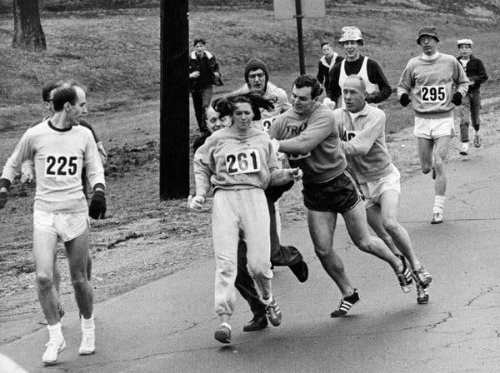
Jock Semple, a Boston Marathon official, tried to forcibly remove Kathrine Switzer from the course. Switzer completed the marathon, but it wasn't until 1972 that women were were officially allowed to participate. April 19, 1967.Credit...Paul Connell/The Boston Globe, via Getty Images
This understanding of misogyny became a commonly held idea among feminists: the issue was structural. Society was organized in a misogynistic way, even if its individual members didn’t see themselves as woman-haters. As the writer and activist Audre Lorde wrote in 1980, there is a “piece of the oppressor which is planted deep within each of us.” Susan Faludi, author of the 1991 book “Backlash: The Undeclared War Against American Women,” echoed this idea, arguing that efforts against equality “are encoded and internalized, diffuse and chameleonic.”
Much like “racist” — which was once mostly used to describe certain sheriffs, politicians or neighbors — misogynist is now as often applied to the system of institutions that creates an unequal America as it is to individuals. In this broadened meaning, happily married men, men with daughters and women themselves can be implicated. The way the word is now used, you don’t have to hate women to be a misogynist, despite what Webster’s dictionary still says today.
But can that one word do all this work? Can it describe some of the worst, most violent impulses in our world and everyday acts of gender bias? Should we use the same term to describe marital rape and the dearth of strong female leads on TV? It turns out, it already is, and we already are.
Some dictionaries have taken note. William Safire, the New York Times columnist who wrote for decades about the texture of our language, noted in 2008 that the Oxford English Dictionary had expanded its definition by 2002 to include “prejudice against women.” “Sexist and misogynist are now in some respects synonymous,” he wrote. “Because sexist has been so widely used, apparently misogynist — in the same sense of ‘prejudice’ rather than ‘hatred’ — now carries more force with those who are familiar with the word.”
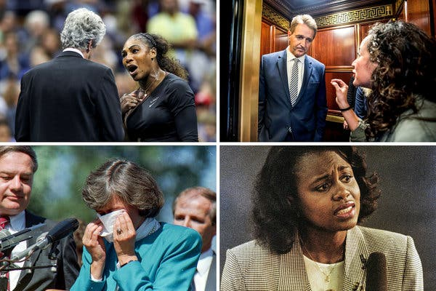
Clockwise from top left: Serena Williams at the U.S. Open, Sept. 8, 2018; Ana Maria Archila confronts Senator Jeff Flake, Sept. 28, 2018; Anita Hill at a news conference, Oct. 7, 1991; Representative Pat Schroeder announcing she would not seek the Democratic presidential nomination, Sept. 28, 1987.Credit...Clockwise from top left: Elsa/Getty Images; Jim Lo Scalzo, via EPA-EFE, via Shutterstock; Scott Andersen, via Associated Press; Aaron E. Tomlinson, via Associated Press.
The word used to be a strong, personal indictment, ugly as it hit the ears. Now, it’s less harsh to hear. But paradoxically, even as the term becomes more commonplace, it has grown more trenchant. It captures the cognitive dissonance of our moment, in which women are seemingly reviled and revered, running for president and still fighting for paid maternity leave.
This roominess feels appropriate to the time, since Dworkin’s notion of misogyny, once thought radical, has become far more widely accepted.
Consider this Dworkin quote from 1997: “Women are perceived to be appalling failures when we are sad. Women are pathetic when we are angry. Women are ridiculous when we are militant. Women are unpleasant when we are bitter, no matter what the cause. Women are deranged when women want justice. Women are man-haters when women want accountability and respect from men.”
That sounds a lot like a recent Nike ad that aired during the Oscars, to a warm reception on social media. “If we show emotions, we’re called dramatic,” the voice over by Serena Williams goes. “If we want to play against men, we’re nuts. And if we dream of equal opportunity, delusional. When we stand for something, we’re unhinged. When we’re too good, there’s something wrong with us. And if we get angry, we’re hysterical, irrational or just being crazy.”

