Part 1: Assignment Interior Design Elevator Pitch

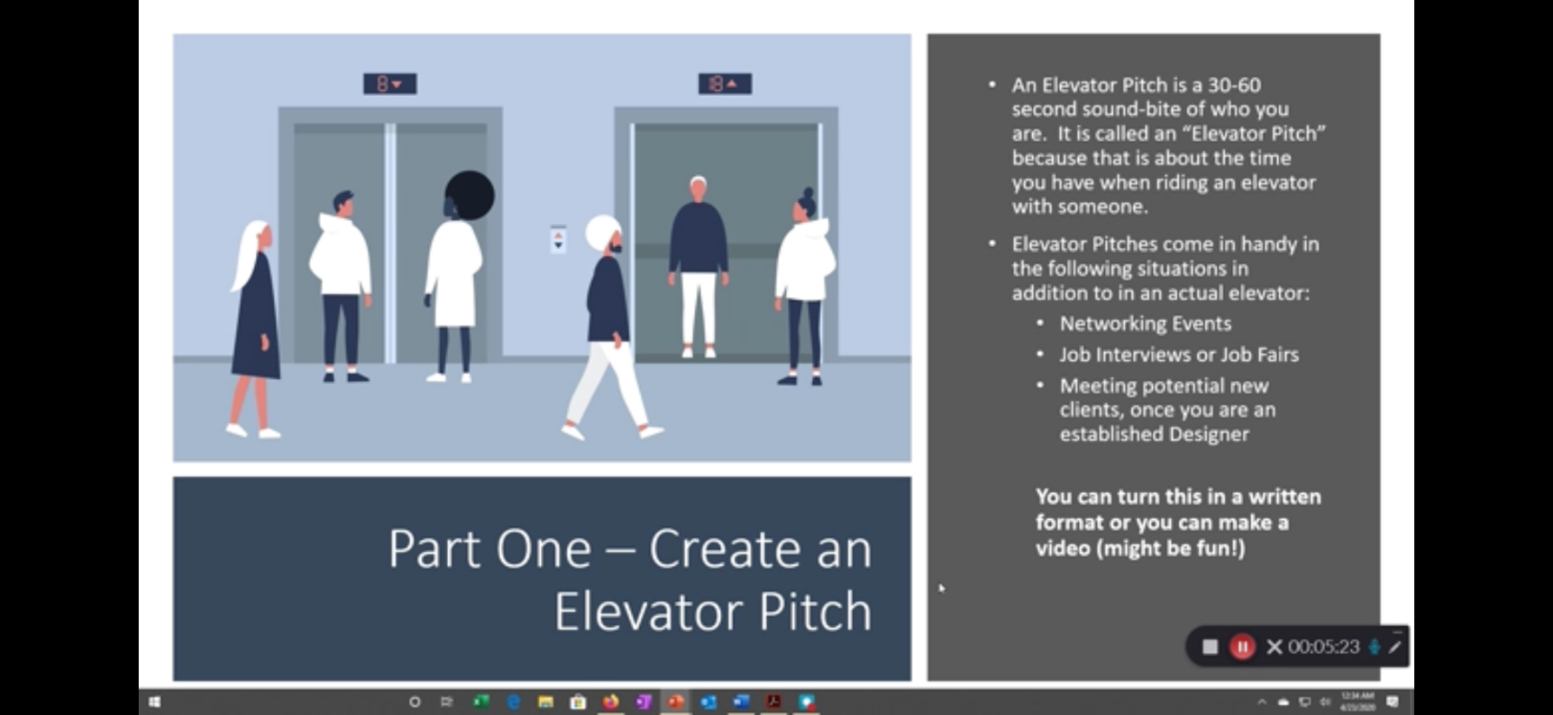

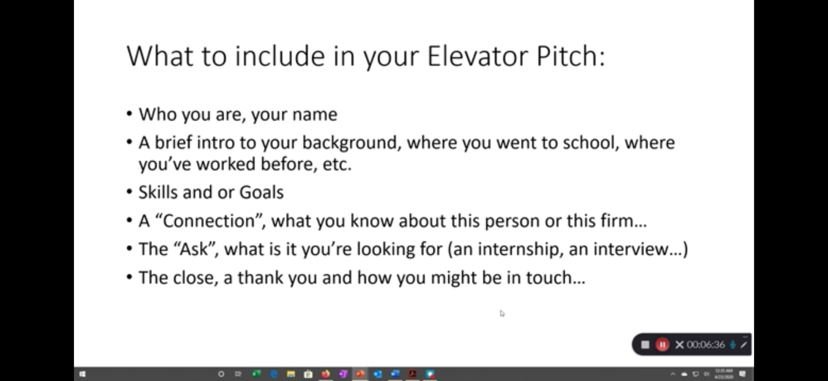

Part 2: Assignment Mailer for Your business
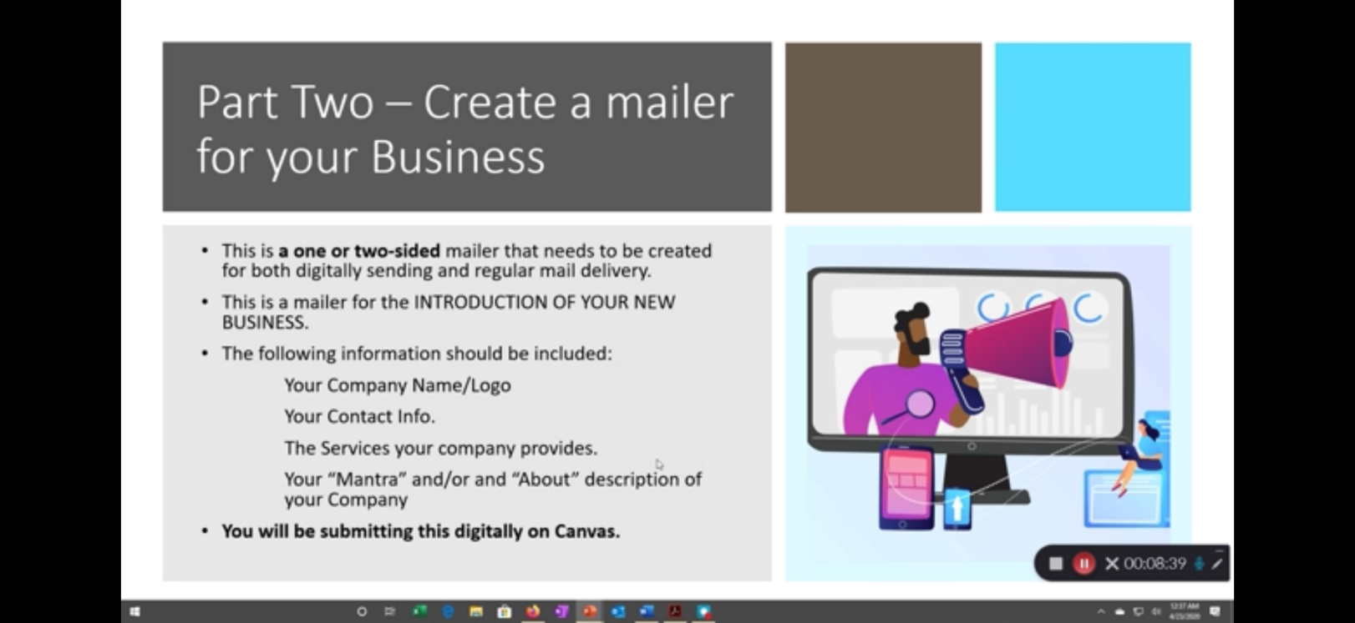

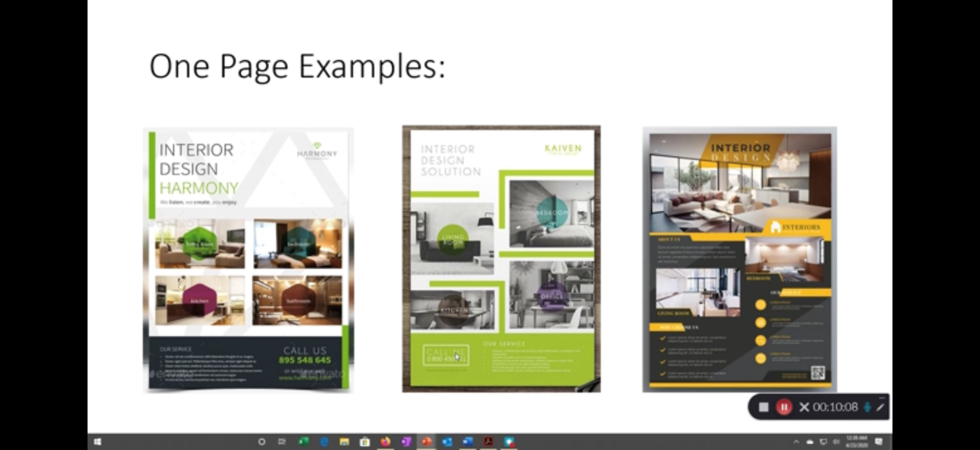
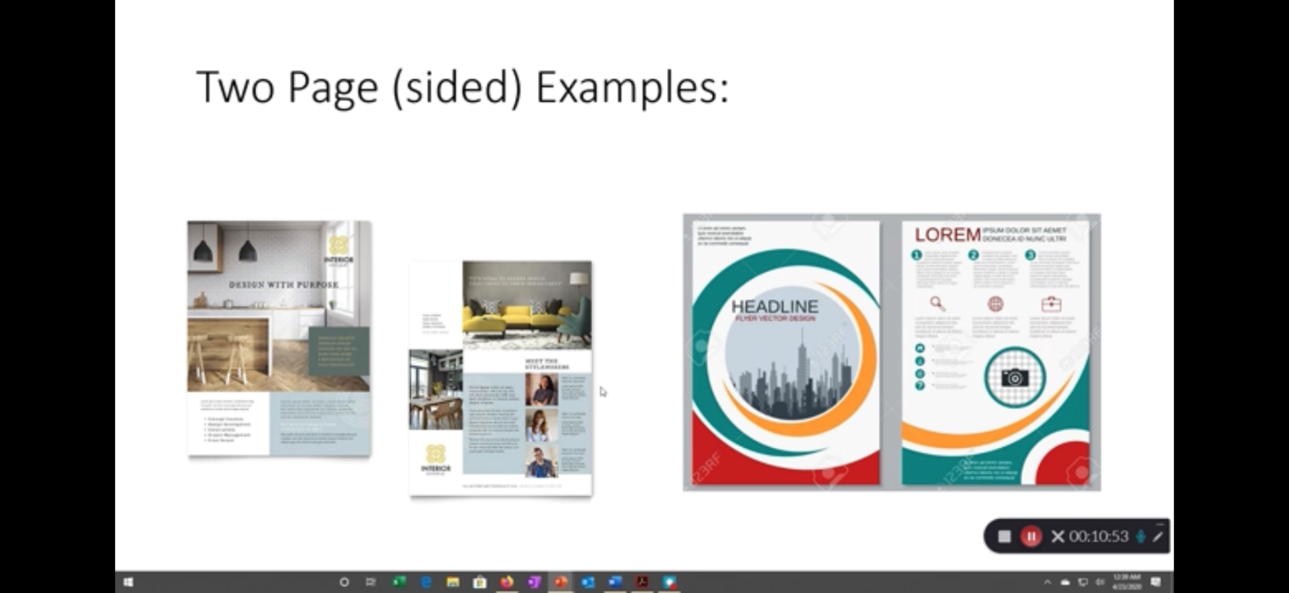

Part 3: About me page for a business website
About me, page five sentences describing what I bring to the interior design business. This is going on my web page.

