Module Two Essential Questions Assignment
  - Instructions: Answer your questions on this original document, highlight your answers for ease of grading, and submit in the module 2 assignments section.

Cardiovascular System- Blood Vessels (Ch. 21)
Complete the chart below- 2pts each
 | What stimulates its release? | Organ that secretes it | Effects on BLOOD VESSELS
Aldosterone

Antidiuretic Hormone (Vasopressin)
Atrial Natriuretic Peptide

Complete this diagram of Capillary Filtration and Reabsorption
- Choose whether there is filtration or reabsorption at the A) arterial end and B) venous end of the capillary. (worth 5 points.)

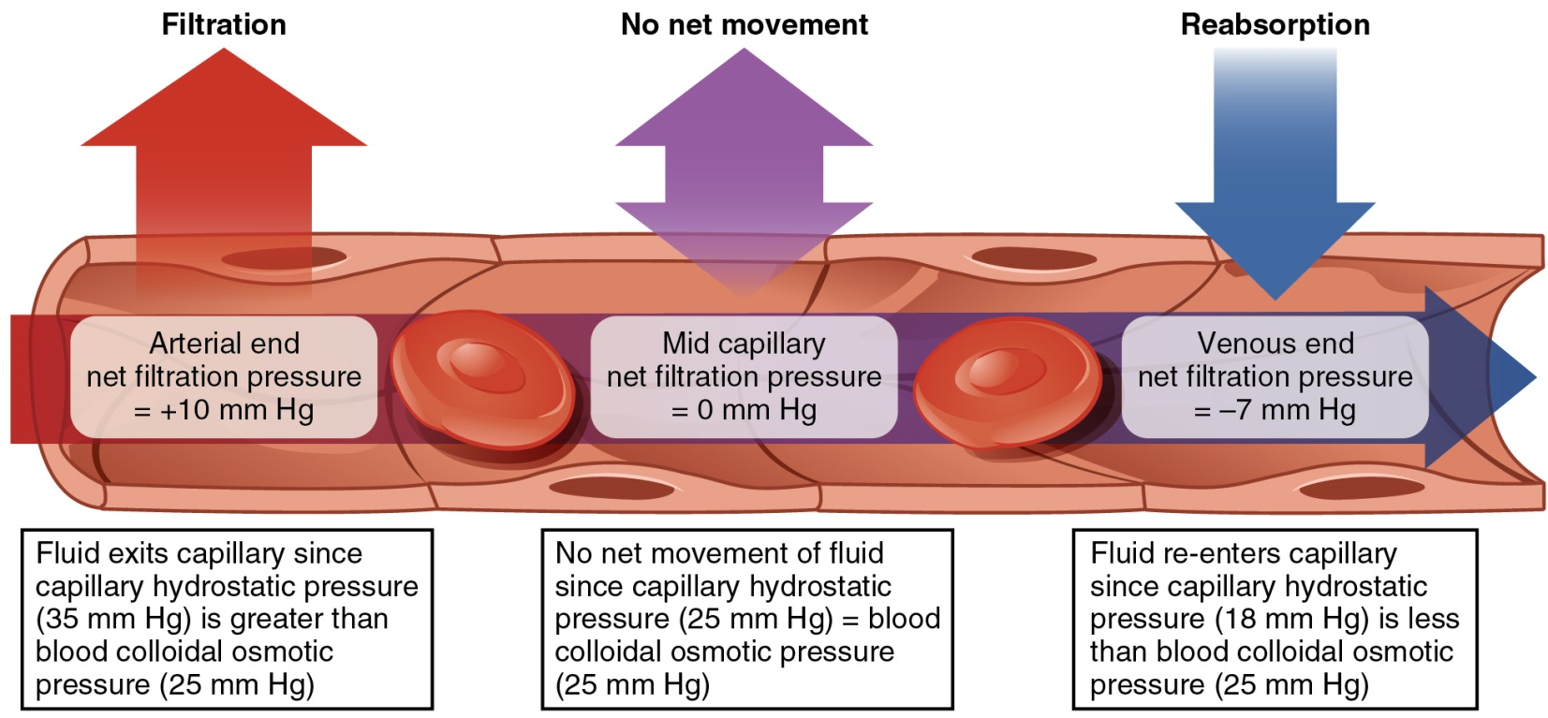
Long description: A capillary with the net filtration pressure at the arterial end (10 mm Hg), middle of the capillary (0 mm Hg), and venous end (-7 mm Hg). There is a red arrow point out of the capillary at the arterial end, a purple arrow point out and into the capillary at the middle portion of the capillary, and a blue arrow pointing into the capillary at the venous end of the capillary. Within the capillary, there is an arrow that points from right to left, it is red at the arterial end, purple in the middle portion, blue at the venous end.

- Using the above diagram as a reference, what four pressures are working in and around the capillary? What direction are they forcing the fluid? (5pts)

- Using the above diagram as a reference, which of the four pressures promote filtration and which of the four promote reabsorption? (5pts)

Lymphatic System Overview
Correctly fill in the following blanks using the terms provided below. Please keep your Answers HIGHLIGHTED for ease of grading. (Worth 2pts each)

- Helper T Cells
- Plasma cells which produce the specific antibodies for recognition of the humeral pathogen
- Adaptive
- Humeral Immunity
- Nonspecific White Blood Cells
- Cell Mediated Immunity
- Stop pathogens before it enters the body
- Cytoxic T Cells
- Complement Cascade
- Are released from virally infected cells to stimulate neighboring cells to produce antiviral proteins to prevent infection.

- The immune system is divided into 2 parts: Innate (non-specific) and ________ (specificity and memory) Immunity .
- There are 2 basic lines of define in innate immunity. The first line of defense consists of physical barriers that are used to ________.
  - Give 3 examples of physical barriers below (worth 2pts)
    - (Add your answer Here)
    - (Add your answer Here)
    - (Add your answer Here)
  - The 2nd line of defense uses nonspecific agents to protect the body from invading pathogens.
    - _______ result in the death of any invading pathogens
      - Give 3 types of these agents (Worth 2pts)
        - (Add your answer Here)
        - (Add your answer Here)
        - (Add your answer Here)
  - Chemical mediators give off chemical signals that alert the body of infection. The ________ consists of about 20 proteins that protect the body by destroying pathogens or enhancing other defenses. While Interferons _______.
- Adaptive Immunity is the 3rd line of defense. In Adaptive Immunity, antigens are processed by an APC and taken to lymphatic tissue to be presented to specific lymphocytes.
  - B cell adaptive immunity is called _______. Here B cells are activated and proliferate to produce _______ and memory B Cells which will be available if this specific humeral pathogen returns in the future.
  - T cell adaptive immunity is called _______. There are 2 types of T cells. _________ attack specific viruses and pathogens inside a cell. This type of T cell is activated and proliferates. __________ aid in the activation of effector B cells and T cells.

Respiratory System (Chapter 23) 2pts each
Section of Pharynx | Normally Carries?  (Food(liquids) and/or air) | Made of which type of tissue? | Why is this tissue type the best?
Nasopharynx
Oropharynx
Laryngopharynx

Use the following data to answer the following questions Worth 5pts each
  - Tidal Volume= 450ml
  - Inspiratory Reserve Volume= 3000ml
  - Expiratory Reserve Volume= 1100ml
  - Total Lung Capacity= 5800 Ml

- Is this person’s total lung capacity within the normal range? Yes or No? What is the normal TLC?
- Give 2 reasons why someone’s Tidal volume would not be within the 500 mL normal range?
- How is the functional residual capacity measured?
- What are 2 differences between the inspiratory reserve volume and inspiratory capacity.
- What is the difference between an obstructive vs a restrictive respiratory disorder/disease?

