Name:
Module 03 Test
Questions | Please write answers to each question in this column unless otherwise indicated.
- Ray AH bisects angle MAT. Find the measure of angle MAT.  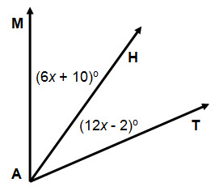 | Angle MAT = 44⁰
- Given the picture below, solve for x.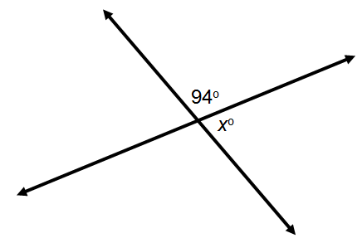 | X = 86⁰
- In the drawing below, angle TRQ is a right angle. What is the measure of angle TRS?  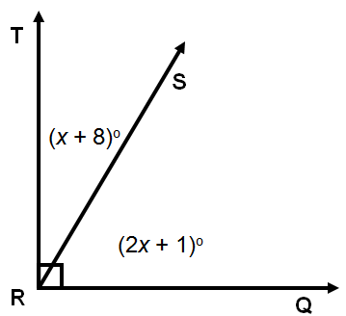 | TRQ = 35⁰
- Use the picture below to solve for x.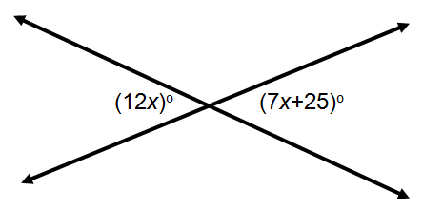 | X = 5⁰
- The measure of two supplementary angles are  $(4a + 7)°$ and $(a – 2)°$. What is the value of both angles? | The angles are 147⁰ and 33⁰
- The image below is an example of what construction?  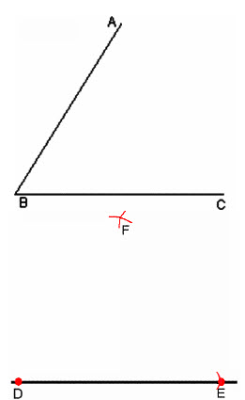 | Perpendicular bisector
- The image below is an example of what construction?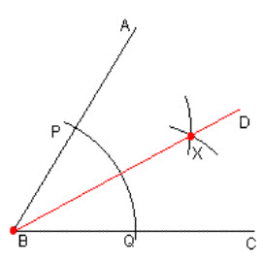 | Angle bisector
- Construct an angle congruent to angle ACB.  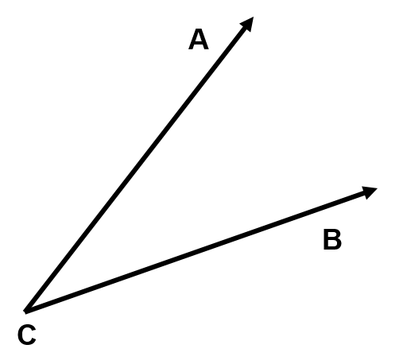 | A  B  C
- Construct the angle bisector of angle ACB.

