Name:
Module 04 Test
Questions | Please write answers to each question in this column unless otherwise indicated.
Directions: For numbers 1 – 4, match each drawing with the appropriate angle pair.

Bank:
Alternate Exterior | Alternate Interior | Corresponding | Consecutive Interior

- Determine the appropriate angle pair.  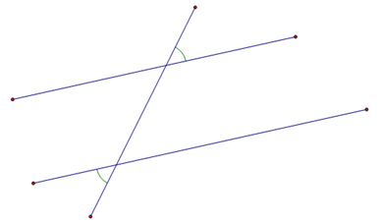 | Alternate Exterior
- Determine the appropriate angle pair.  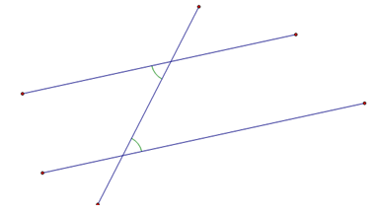 | Alternate interior
- Determine the appropriate angle pair.  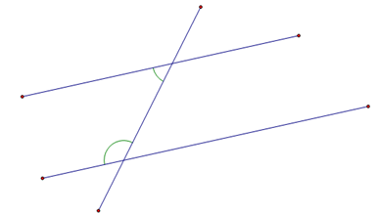 | Consecutive interior
- Determine the appropriate angle pair.  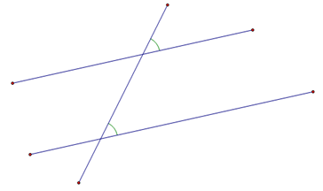 | Corresponding
- Which of the following line segments is parallel to line segment AB?  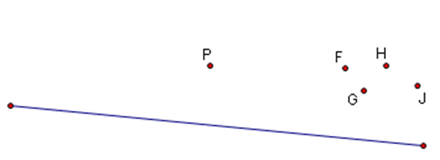 | - PF  - PG  - PH  - PJ
- What is the value of x in the drawing below if lines m and n are parallel?  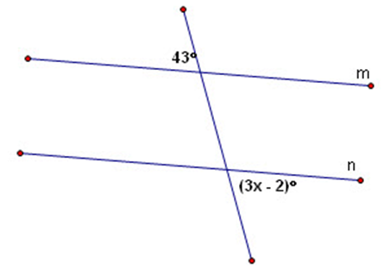 | X = 15⁰
- Line segments m and n are parallel in the drawing shown. If $m∠DBC=2x+60$ and $m∠BDE=x+12$, what is the value of x?  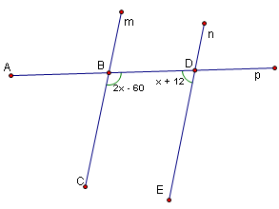 | X = 76⁰
- Which of the following would prove that line m||n?  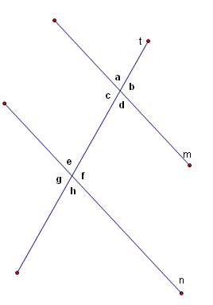 | - $m∠A+m∠B=180°$  - $m∠B=m∠C$  - $m∠E=m∠C$  - $m∠G=m∠B$
- Which lines, if any, are parallel in the drawing below?  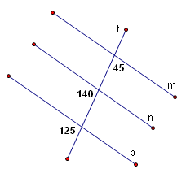 | None
- Which of the following would prove that m||n?  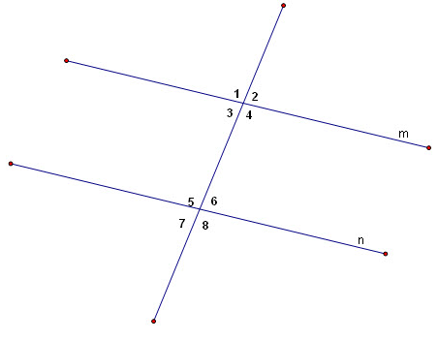 | - $m∠1+m∠2=180°$  - $m∠2=m∠3$  - $m∠5=m∠3$  - $m∠7=m∠2$
- Which lines, if any, are parallel in the drawing below?  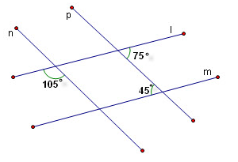 | None
- Main Street and Market Street are parallel roads that are intersected by another street, as shown in the drawing. Solve for x. 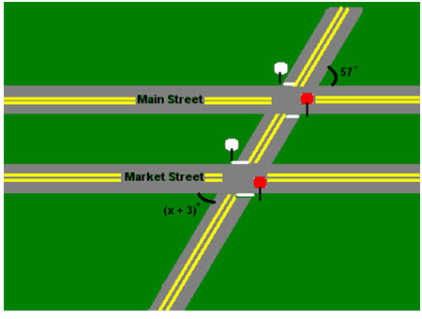 | X = 54⁰
- Given lines p and q are parallel, solve for $m∠1$, $m∠2$, and $m∠3$.  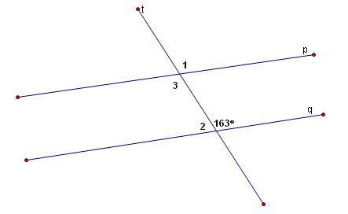 | M<1 = 163⁰  M<2 = 17⁰  M<3 = 163⁰

