Name:
Module 05 Test
Questions |  |  |  | Please write answers to each question in this column unless otherwise indicated.
- A guy wire for a pole for a tennis net makes an angle 62˚ with the ground.
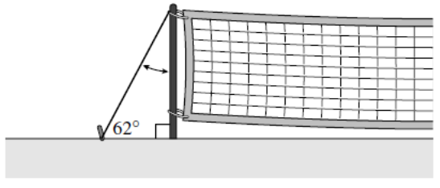
What is the measure of the angle between the wire and the pole?

- Find the value of x.
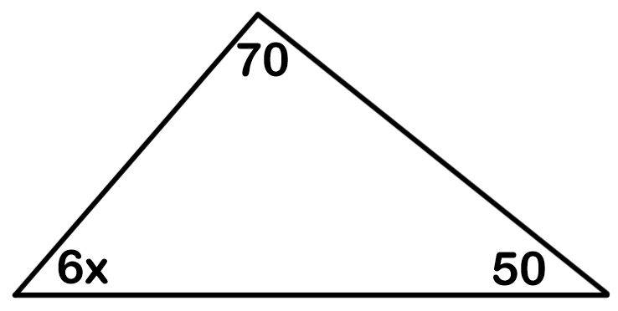

- Find the measure of angle A.
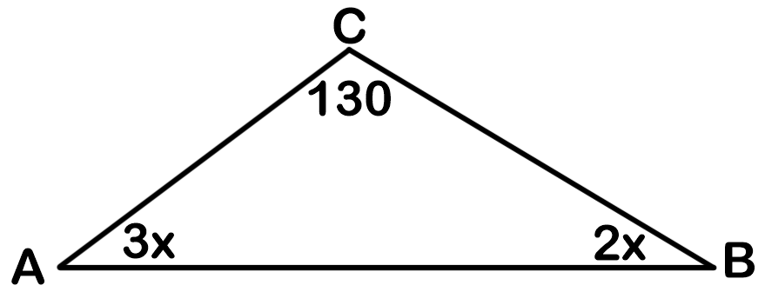
- Find the value of x.
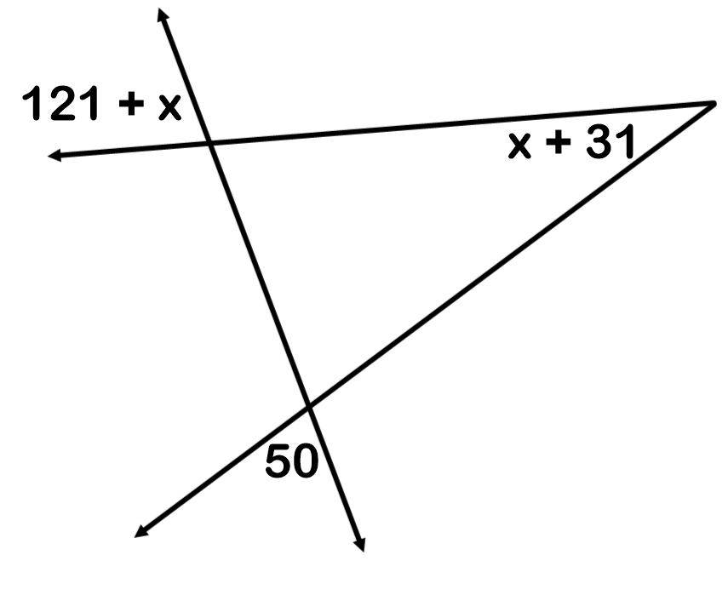
- Find the value of x and y.
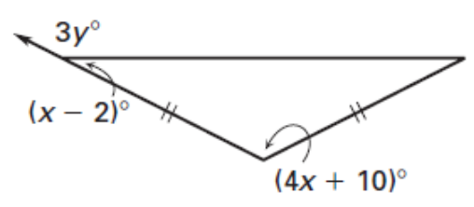

- What is the perimeter?
3x - 5
11x - 12
3x + 36
- What is the measure of angle A?
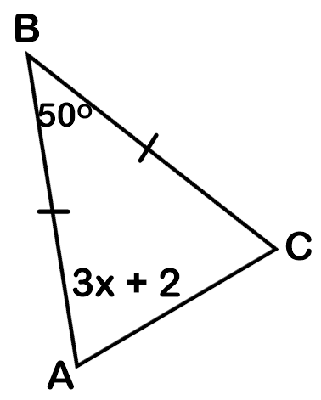
- If the perimeter is 52, what is the length of DF?
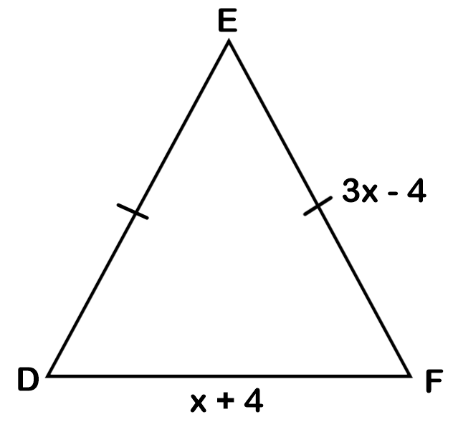
- Find the value of x.
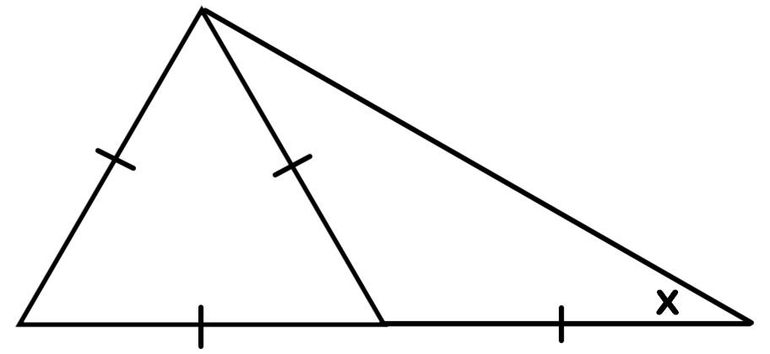

- What is the length of ST?
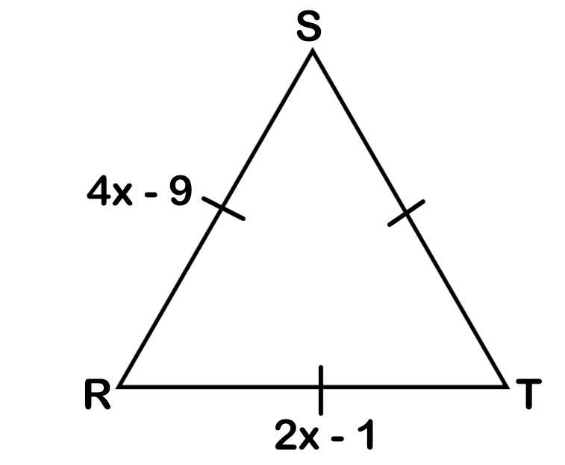
- Identify AB as a midsegment, median, altitude, angle bisector, or perpendicular bisector.
A  B | A  B  __________________ | A  B  __________________ | B  A  __________________ |  | A  B  __________________

