Name:
Module 06 Test
Questions |  |  |  | Please write answers to each question in this column unless otherwise indicated.
- Decide if each set of numbers in the left column could be the lengths of a triangle. If they can, write YES in blank. If they cannot form a triangle, write NO in the blank.
A  B | 3, 3, 5  __________________ | 9, 5, 4  __________________ | 20, 16, 1  __________________ |  | 5, 6, 10  __________________
- List the angles in order from largest to smallest.
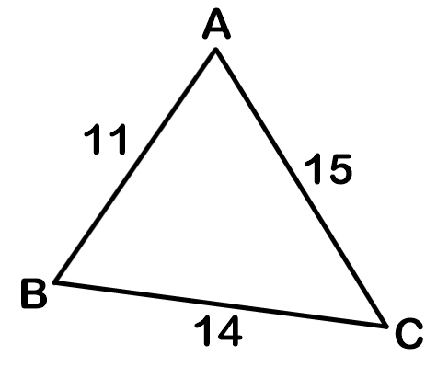
- List the sides in order from smallest to largest.
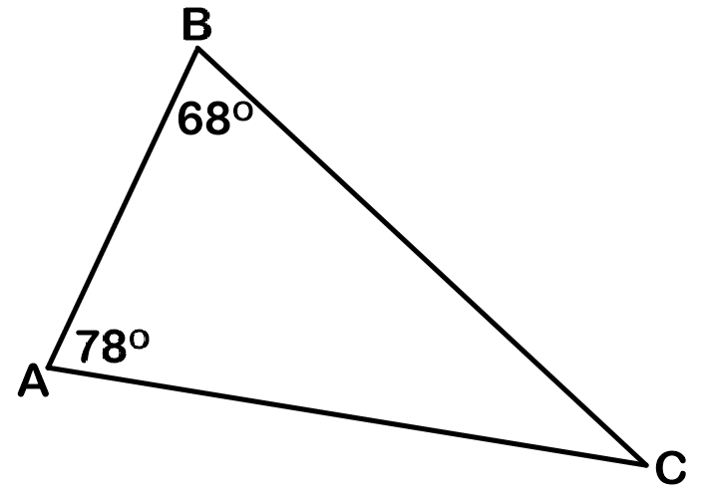
- List the sides from greatest to least.
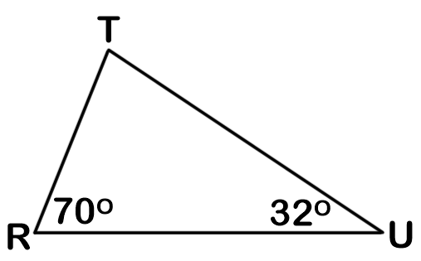
- List the angle measures from least to greatest.
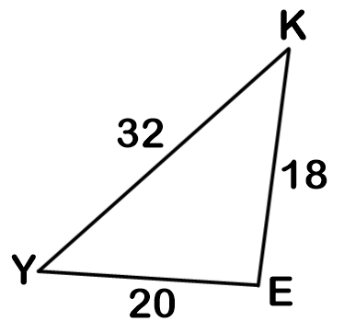
- In $∆ABC$, if $m∠C$ < $m∠B$ < $m∠A$, then |  |  |  | - AB < BC < AC  - BC < AB < AC  - AB < AC < BC  - AC < AB < BC
- Jennifer made these measurements on $∆ABC$, BC must be: 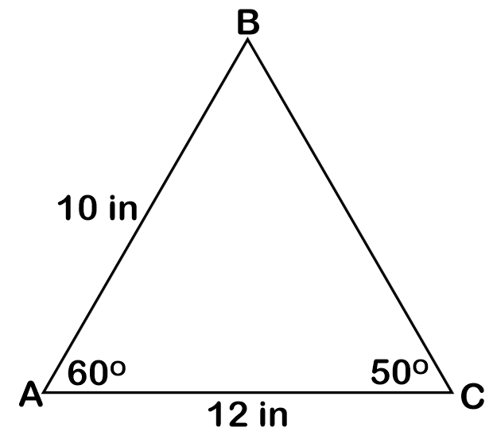 |  |  |  | - Less than 10 inches  - Between 10 and 12 inches  - Between 12 and 22 inches  - Greater than 22 inches
- An airplane traveled from Biloxi to Baton Rouge to Huntsville as shown in the map. Which was the longest distance traveled?  59˚  35˚  Baton Rouge  Biloxi  Huntsville |  |  |  | - Biloxi to Baton Rouge  - Baton Rouge to Huntsville  - Huntsville to Biloxi  - Not enough information
- Give a range of numbers that could represent the length of the third side of the triangle if the other two lengths are 12 and 5.

- Part of a marching band formed a triangle made with trumpet players on one side, clarinet players on one side, and flute players on the third side.  The angle formed by the trumpet and flute players measured 45°.  The angle formed by the flute and clarinet players measured 68°.  Which orders the sides of this triangle from least to greatest using the instrument names? |  |  |  | - Clarinet, trumpet, flute  - Clarinet, flute, trumpet  - Trumpet, flute, clarinet  - Flute, trumpet, clarinet
- Which of the following could be the third side of a triangle if the lengths of the remaining two sides are 26 and 30? |  |  |  | - 4.5  - 4  - 3.5  - 3
- Circle all possible values for the third side of a triangle with two sides whose lengths are 12 and 15.

1 3 9 12 15 18 21 27

