MOON OBSERVATION

Name___________________ Your Location: city/state _________________________
Your latitude/longitude ___________________________

Circle the closest tilt/phase below:

Date_________________
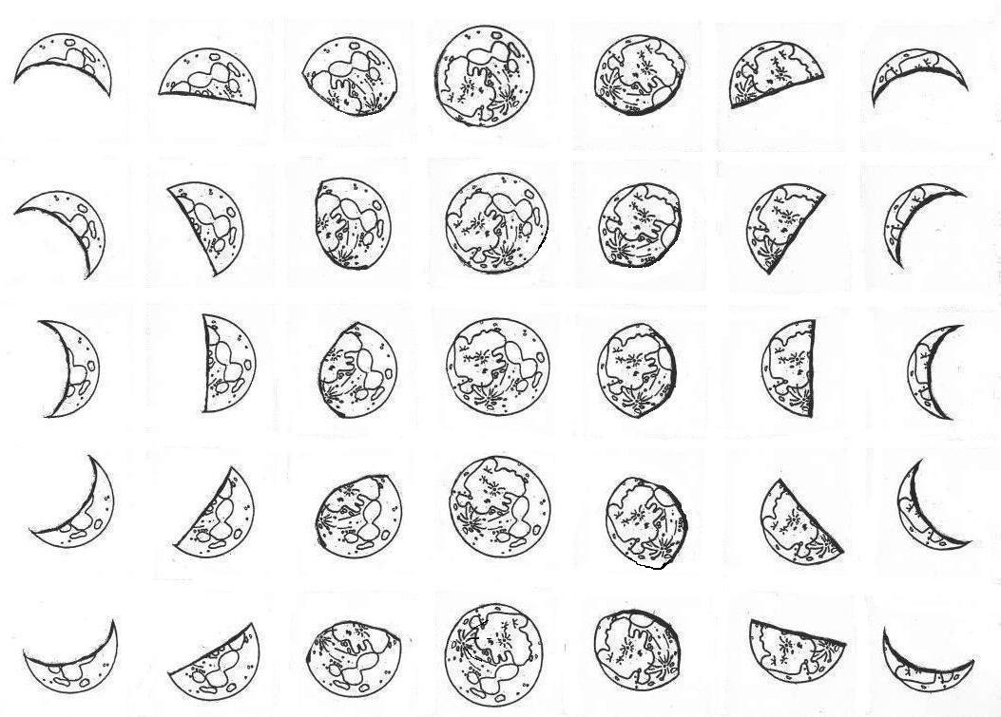

Time________________

Power_______________

Aperture ____________

Direction____________

Altitude_____________

FEATURES DRAWING

1.________________________

2.________________________

3.________________________

4.________________________

5.________________________

Website or Author, Title and Page:

___________________________

____________________________

