[Your Name]
[Instructor Name]
[Course Number]
[Date]

Below are the screens of the table developed
Employee Table:
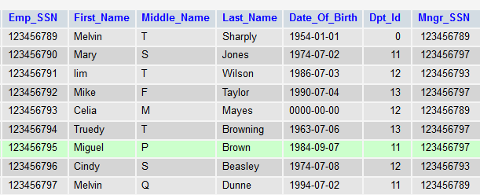
History_Benefit Table
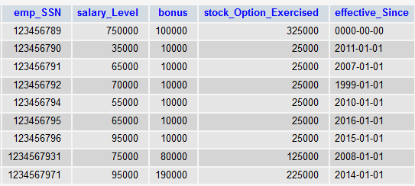
Department Table
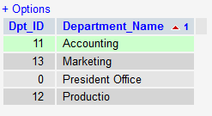

Salary_Benefit Table
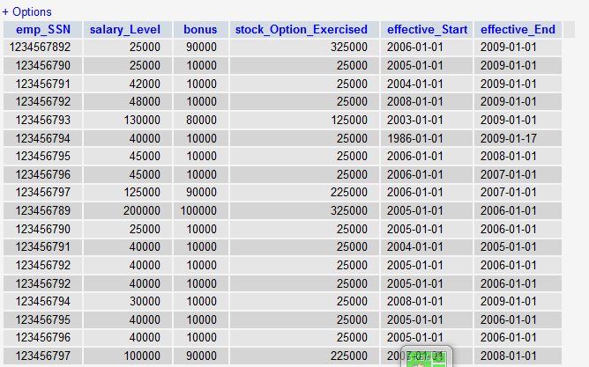

Phone_Number Table
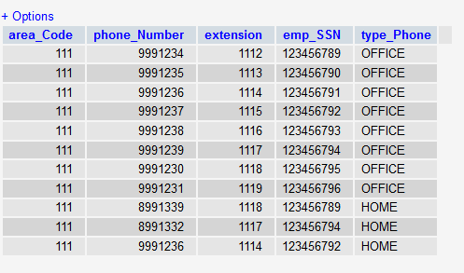

Write a query on the employees table that identify employees who have no middle name.
SELECT CONCAT ( First_Name, CONCAT(' ', Last_Name)) employee_name
FROM EMPLOYEE
ORDER by employee_name;

EMPLOYEE_NAME
————————————————————————

Identify SSN of employees who historically had salaries between $60000 and

$175000.
SELECT
FROM EMPLOYEE
WHERE HISTORY_BENEFITS BETWEEN (SELECT 60000) AND 175000

Provide a list of employee names and departments for people in accounting,
marketing or production. Order the output by department, last name and first name. Don't use "or". Use “in function”.
SELECT First_Name, Last_Name, Dpt_Id
FROM EMPLOYEE
WHERE Dpt_Id = (SELECT Dpt_Id
FROM DEPARTMENT
WHERE DEPARTMENT = ‘marketing’, ‘production’, ‘accounting);

Output
First_Name Last_Name Dpt_Id

Melvin Sharply 000

Mary Jones 011

Iim Wilson 012

Mike Taylor 013

Celia Mayer 014

Provide a query to determine if there are any employees who don't have any phone numbers. Use minus. Use SSN.
(SELECT First_Name, Last_Name, position FROM EMPLOYEE
MINUS
SELECT Phone_Number, Emp_SSN, Positions FROM PHONE_NUMBER)
(SELECT Phone_Number, Emp_SSN, Positions FROM PHONE_NUMBER
MINUS
SELECT First_Name, Last_Name, position FROM EMPLOYEE)

Provide a query to identify any employees whose name starts with BROWN. Concatenate the output lastname, firstname and mi so it would look like this, including spaces, the period and case. Use initcap.
SELECT First_Name, Last_Name INITCAP(First_Name) "First Name",
INITCAP(Last_Name) "Last Name"
FROM EMPLOYEE
WHERE First_Name LIKE ' BROWN%'
ORDER by First_Name

Output

FIRST_NAME LAST_NAME First Name Last Name
—————————— ——————————— ——————————— —————————————
Miguel Brown Brown Miguel

Provide a query to determine if there are any employees whose current salary is greater

than or equal to all historical salaries. Use a subquery with max() function.

SELECT
FROM EMPLOYEE
WHERE Emp_SSN IN
(SELECT Emp_SSN
FROM EMPLOYEE
WHERE HISTORY_BENEFITS =
(SELECT MAX(HISTORY_BENEFITS)
FROM EMPLOYEE
WHERE HISTORY_BENEFITS <
(SELECT MAX(HISTORY_BENEFITS)
FROM EMPLOYEE)));

Output

Emp_SSN MAX(SALARY)
——————————— ———————————
123456789 225000
123456793 130000
123456789 200000
123456793 100000
123456796 40000

Provide a query to determine if there are any employees whose current salary is greater than or equal to all historical salaries and whose bonus is greater than or equal to all historical bonuses.
SELECT COUNT(Emp_SSN), Dpt_Id, Salary_Level
FROM EMPLOYEE
GROUP BY Dpt_Id, Salary_Level
HAVING (COUNT(Emp_SSN) > 000
OR Salary_Level >= Historical Salaries
AND Bonus >= Historical Bonuses)
ORDER BY Dpt_Id, HISTORY_BENEFITS

Using CTAS create a copy of employee called employee_work that includes only personnel born on or after 3/7/64. Now use a merge to update the people in that table’s age by 60 days or to insert them if they’re not there.

CREATE TABLE employee_work
WITH
(
CLUSTERED COLUMNSTORE INDEX,
DISTRIBUTION = HASH(Emp_SSN),
PARTITION
(
OrderDateKey RANGE RIGHT FOR VALUES
(
2/7/74,3/7/84,4/7/90,5/7/94,7/9/84,8/7/74,2/7/94)))
AS SELECT * FROM EMPLOYEE;

Rename the Table for swapping in the new table and drop old one
RENAME OBJECT employee_work TO EMPLOYEE;
RENAME OBJECT EMPLOYEE TO employee_work;

DROP TABLE EMPLOYEE;
Provide a query to sum current salary and bonus grouped by department.
SELECT
Emp_SSN, Salary_Level, Bonus,
(Salary_Level + ((Salary_Level * Bonus) / 100)) as "Total_Salary"
FROM CURRENT_BENEFITS;

Provide a query to sum current salary and bonus grouped by department where sum of salary is greater than 500000 and sum of bonus greater than 300000.
SELECT SUM(salary))
FROM CURRENT_BENEFITS
WHERE SUM(salary) >= 500000 SUM(Bonus) >= 300000
GROUP by Dpt_Id

Provide a query to count employees grouped by department. Exclude department with less than 2 employees from the output.
SELECT COUNT(Emp_SSN), Dpt_Id

FROM EMPLOYEE
GROUP BY Dpt_Id
ORDER BY Dpt_Id;

OUTPUT

COUNT(Emp_SSN) Dpt_Id
—————————————————— —————————————
123456789 000
123456793 012
123456789 000
123456793 012
123456796 012

Provide a query to concatenate an employee's full name. Order output by last name, first

name, mi.

SELECT CASE
WHEN mid_name IS NULL OR TRIM(Midddle_Name) ='' THEN
CONCAT_WS( " ", First_Name, Last_Name )
ELSE
CONCAT_WS( " ", First_Name, Middle_Name, Last_Name )
END
FROM EMPLOYEE;

Provide a query to replace type phone with work where it says office and residence where it says home. Use the decode function.
SELECT Phone_Number, Type_Phone
FROM
PHONE_NUMBERS
ORDER BY
DECODE ('office', work, home, 'residence');

Provide a query to concatenate an employee's full name in upper case.

SELECT DISTINCT UPPER (First_Name, Last_Name) "Uppercase Employee Name"
FROM EMPLOYEE
ORDER by UPPER (First_Name, Last_Name);

Provide a query to identify employee's whose SSN does not have 7 and 9 for the seventh and eighth digit.
SELECT Emp_SSN
FROM EMPLOYEE
COUNT(Emp_SSN)
WHERE (Emp_SSN 7 AND 8) != 7,9;

Provide a query to return employee's current salary or 0 for nulls whose SSN has 5 as the
eighth digit. Use nvl() function.
SELECT AVG (NVL(salary, 0)) avg_salary
FROM EMPLOYEE;
COUNT(Emp_SSN)

AVG_SALARY
———————————————
880181.8182

Provide a query to return the employee's full name, SSN in the format 123-45-6789 (with hyphens) and dob in the format day month dd yyyy. (Friday June 3 1978). Use to_char() function
SELECT First_Name, Emp_SSN, Date_of_Birth
FROM EMPLOYEE
WHERE Date_of_Birth, Emp_SSN;
To_CHAR( sysdate, ‘FMMon ddth, YYYY’)
TO_CHAR(000-00)+1
ORDER BY Emp_SSN

Provide a query to return the name and current age of all employees.
SELECT Date_of_Birth
FROM EMPLOYEE;
WHERE DATEDIFF (YEAR, DOB, GETDATE())

Provide a query to return each employee’s concatenated full name, age, department and current salary and bonus.
SELECT Full_Name, Age, Department_Id, Salary, Bonus
FROM EMPLOYEE

WHERE ( department_Id, Salary) IN
(
select department_Id, Salary
FROM EMPLOYEE
GROUP BY department_Id, Salary
HAVING COUNT (*)> 1
)
ORDER BY Full_Name, Department_Id, Salary, Bonus;
Provide a query to return each employees concatenated full name, age, department and current salary and bonus. Ensure that every employee is included in the output.
SELECT Full_Name, Age, Department_Id, Salary, Bonus
FROM EMPLOYEE
WHERE Full_Name, Department_Id, Salary,Bomus;

Provide a query to return each employees full name and current salary and bonus if their salary is above average for employees.
SELECT Full_Name, Salary, Bonus
FROM EMPLOYEE
WHERE AVG (NVL(salary, 0)) avg_salary

Provide an update statement to increase each employees current salary and bonus by 15% if their salary is above average for employees. Commit the change.
SELECT First_Name, Last_Name, 1.15*SALARY, 1.15*BONUS;
FROM EMPLOYEE
WHERE SSN=ESSN AND PNO=PNUMBER AND PNAME= ‘CURRENT_SALARY’

Provide a command to create a complete table copy of the employee table.
CREATE TABLE EMPLOYEE_copy
AS
SELECT Emp_SSN, First_Name, Last_Name, Dpt_Id, Mngr_SSN FROM EMPLOYEE WHERE 1=0;
Provide a query to return each male employees concatenated full name if their salary is above the average current salary. Use a subquery.

SELECT First_Name, Last_Name, Dpt_Id, CURRENT_SALARY, avg(CURRENT_SALARY)
FROM EMPLOYEE
GROUP BY First_Name, Last_Name, Dpt_Id, CURRENT_SALARY
HAVING CURRENT_SALARY > (select avg(CURRENT_SALARY))

