My Leisure Activities

My Photo

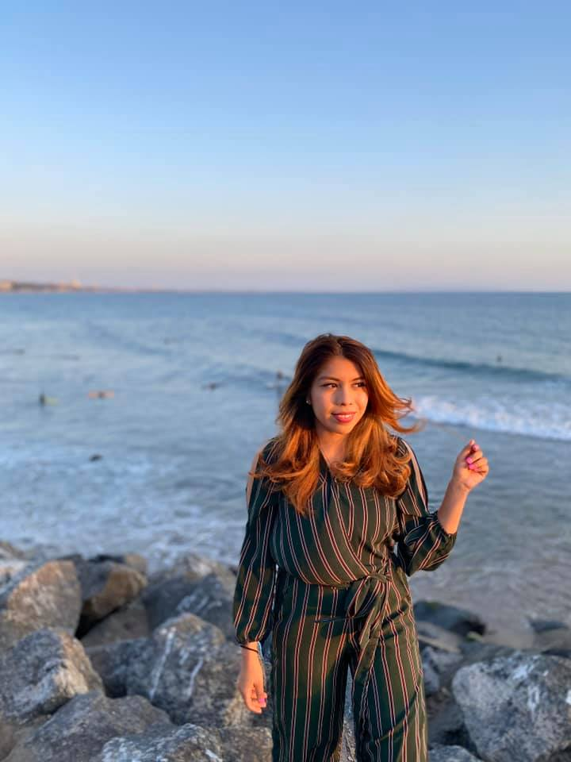
My love for outdoor adventure is intrinsic. I enjoy the thrill that comes with activities such as swimming, hiking, and bike riding. Most of the times, you would find me swimming during my leisure hours as it is my favorite recreation sport. Most of my friends are also into outdoor fun activities and we go out on hiking adventures together. We like taking photos and enjoying the weather. Sometimes I go out on a hike alone. Other times, I ride on my bike, enjoying the fresh breeze wafting past me as I race downhill.
However, since the outbreak of the Covid-19 pandemic, I have not managed to enjoy my favorite activities. Covid-19 came with lockdown and social distancing regulations that prevent me from meeting my friends for a hike or a swim. Currently I spend most of the time at home, or alone. Also, most businesses that offer recreational services such as swimming have closed down due to the pandemic. Outdoor activities have been negatively affected by the outbreak of the Coronavirus pandemic.

