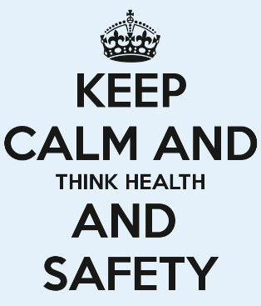



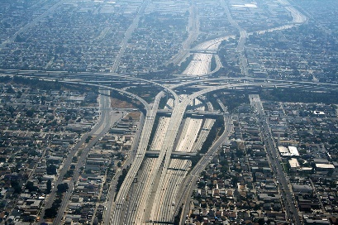
Intervention designed to address the
The car crush in Los Angeles











Background
Los Angeles is one of the busiest cities and as a result there have been an increasingly high number of car accidents which have left many injuries and death. This has prompted an immediate investigate the issue.
Eye witness-

Age 24

Methods

The data that was used comes from the inclusion criterion of car crushes collected from the National trauma data. The table below shows the comparison of the car accidents deaths and facilities among the 5 cities in California
References
De Souza, A. M., Brennand, C. A., Yokoyama, R. S., Donato, E. A., Madeira, E. R., & Villas, L. A. (2017). Traffic management systems: A classification, review, challenges, and future perspectives. International Journal of Distributed Sensor Networks, 13(4), 1550147716683612.
Fernández, M. A., García-Escudero, L. Á., & Molinero, A. (2019). Analysis of real crashes against metal roadside barriers. PloS one, 14(2), e0211674.
Goudilyan, M., Srinivasan, A., Gopishanker, M., Sridharamuniraja, K. M., &Sasikumar, K. (2018). Design and Fabrication of Shock Absorbing Bumper to Reduce Impact during Road Accident. International Research Journal of Automotive Technology, 1(2), 97-103.
Schenke, S. R., Lambe, D. M., Fabiani, S. S., &Gauvreau, D. M. (2018). Navigating the legal system after a motor vehicle collision. Psychological Injury and Law, 11(3), 265-287.

Drivers should also avoid drugs and alcohol while driving since this will prevent severe injuries. In addition, there should be the establishment of physical changes and marks that aid drivers of the dangerous parts of the road as they drive. Drivers should assume responsibility and be guided by the fact that life is too precious to be negligent when they are on the road. For that reason, being keen and ensuring that traffic rules are always followed will significantly reduce car accidents hence saving lives in Los Angeles.

CITY | Number of car crushes and injuries in 2018
Los Angeles | 82437
Orange | 21451
San Diego | 20385
San Bernardino | 41801
Riverside | 13318

It is worth noting that the car crushes in los Angeles have led to 260 deaths in 2017 which is an increase by 40%

Results
November 2016- December 2017

Use of Alcohol blow on the road
This will reduce the number of drivers on the rad who are not keen enough to stop drinking while driving

Use of safety blts on the road
In case of an accident the passagers will not move a lot and hence will reduce being injured
Passengers

Drivers 23
52.0% (128/173)
of passagersattended BOTH week 1
and week 2 for the FULL time

8&

Passagers 60%

Challenges

Attendance
  - Ignorance from the people
  - Lack of financial support
  - Time factor

Ability to Follow-Up
  - Use of alcohol blow in the road
  - Only a 50% response rate for monthly safety texts and a 20% response rate to six-month follow-ups

Injuries variation
7

8%

7%
  - Head injuries
  - Leg fracture
  - Total paralyzed due to mental injury

High staff and leadership turnover at the Recovery Center

Conclusions

In summation, it is important for drivers in Los Angeles to take note of traffic rules when they are driving. As it is shown in this discussion, the majority of car accidents are caused by the overtaking of vehicles and over speeding. Drivers should also avoid drugs and alcohol while driving since this will prevent severe injuries. In addition, there should be the establishment of physical changes and marks that aid drivers of the dangerous parts of the road as they drive. Drivers should assume responsibility and be guided by the fact that life is too precious to be negligent when they are on the road. For that reason, being keen and ensuring that traffic rules are always followed will significantly reduce car accidents hence saving lives in Los Angeles.

