Student’s Name
Professor’s Name
Course
Date
Newt
Media is the core means of bulk communication stared collectively. Media is made up of the following written press, internet, and broadcast media. Printed media majorly includes newspapers and magazines. Broadcast media is made up of radio and television, whereas the internet is an online platform that facilitates online communication. The media is of much importance as it conveys and delivers information to people at any time and place (Reinecke). Media tends to send data to a large universal community. This project is to take you through our media mainly established Newt communication platform. It also captures information concerning its written, oral, and visual genres of communication.
My project is named Newt simply because a newt is capable of reaching several places and with relation to our plan we do it better if it will be able to convey and deliver information ton several people across the globe. I chose the lighting structure as the logo for my project. The motivation behind my selection was simply because lightning travels at a very high speed, and thus my project will deliver information to masses quickly. The figure below shows my project logo and mission.
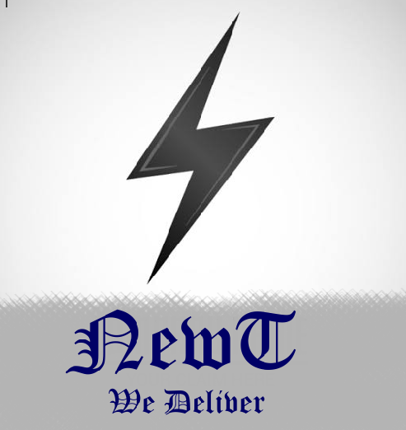
The vision of my project is becoming one among the prominent media destinations in the globe. The purpose of Newt is to provide first-hand information to people across the world mainly; it also has to equip learners with the knowledge they can apply in their daily lives to survive and handle critical situations. This media platform will always be up to date, and people can access and get information at any place, anytime so long they are connected to the internet.
Among the written modes of communication present in Newt, media platform include emails, adverts, and blog posts. Emails were explicitly for feedback. After someone goes through my media platform and has to live feedback concerning how we should provide our services or send us a mail complementing our blog posts. For any firm or media platform to be successful, it has to back up some upcoming or even well-known media platforms by posting relevant advertisements about them. Finally, blog posts are of different fields. I updated this platform with several blog posts concerning health, education, crime, religion, and love issues. Any media platform has high chances of being visited by several individuals, including students, doctors, teachers, preachers, and because of such, they should be able to access information concerning their desired fields. Written modes of communication have the following advantages (Cheng, 30). There is no requisite for personal interaction; it saves money by minimizing long distance calls, and finally it full of evidence, in case of any differences or disagreements.
Among the modes of oral communication present on the Newt, platform include Skype and video conferencing. The platform has support staff working tirelessly to ensure information is conveyed 24 hours a day. Should any individual be going through Newt and encounter some difficulties, he/she can Skype with our customer care support team to get assistance. Newt is not only an online media platform but also an educational and research destination (Zhao, 6191). This creates the need of having video conferencing mode of communication to accommodate bulk client requests and also discuss and educate them about someone or two trending issues in health, education, and even love affairs.
High technology levels have been employed to prevent damages to the Newt systems and also provide the very best media platform services in the globe. The Newt team carrying out social bonds during interviews have the following social contract traits, moral integrity, respect, and fear. Such qualities pull people closer to Newt interview services, thus marketing its name to masses in the globe. During interviews, the majority of the information is recorded in written sources. This is to mainly do away with disputes when they arise simply because there is full time evidence (Aulia). For written modes of communication, the leading equipment Newt requires are pens, books among many other things. For oral communication, the following might be needed HD cameras, high-performance laptops, microphones, secure internet connections, and headphones.
Among the purposes of Newt platform include marketing as a result of its continuous development, educating people simply because Newt blog posts are made up of scholarly articles that are of benefit to students and many other participants of my platform. It also delivers information concerning trending affairs as posted on its blog or send to a reliant Newt individual (Anderson). The Newt funs, support teams and interviews are of many benefits simply because they make online procedures attractive. With regards to platforms like YouTube, Newt has plans for expansion and providing cheaper services that each individual will be able to get regardless of their position or place in the globe. With the current marketing benefits, Newt's capital graph seems to be on the rise despite one or two things that pull it back.
The ideas behind this project mainly came as a result of my passion for computing. I checked for purposes that people could be missing and included them in my Newt media platform project. Some of these ideas were present but at a higher cost, thus not catering for every individual in the community. I came up with the same ideas but a minimal cost to equate each individual in society. Knowledge gained throughout my course study also enabled me to fill up the project strategy, compose a blueprint before starting to work on the main project. Class materials corrected every wrong step I took during working out my project blueprints (Zhu, 702). Among the trending media concepts inclusive in Newt include forms that are inborn to computers and mainly rely on computers. Machines are the best links towards reaching masses in the communication sector.
I conclude that Newt is an efficient media project that is well supported; it can overtake several media platform beasts. It reaches out to several people providing them with necessary information as it overlooks different sectors.

Interview of 5 individuals
Interviewee 1
- What do you find interesting about Newt?
Answer: What I find interesting about newt is its logo which is characterized by lightning symbol to symbolize its speed.
- Where did you learn about?
Answer: Newt will be able to relay firsthand information at any part of the world as long as they are connected to the internet.
- Are the modifications being done to Project Newt of any benefits to people?
Answer: Yes, the modifications are important to Newt as the will help deliver information faster and ineffective way.

Interviewee 2
- What do you think should be done to enhance the media platforms of Newt?
Answer: There should be continuous feedback from the customers to ascertain levels of satisfaction
- Are the qualities of Newt staff effective for media communication
Answer: Yes, Newt staff portrays good qualities that are essential for communication. They have great understanding of the English Language
- Should Newt staff employ more support staff? Why?
Answer: In my opinion, I do not think the new staff is necessary at the moment.

Interviewee 3
- With the much effort being employed, where do you see Newt in the coming years
Answer: To be sincere, in the coming years, Newt will be the leading media outlet globally
- Which mode of communication should receive high concentration from Newt
Answer: I believe social media is the future of communication. Therefore, Skype should receive more attention
- What are the benefits of employing highly qualified Newt staff members
Answer: They will help steer the organization to success. They will help outwit competitors in the market.

Interviewee 4
- What are your personal opinions concerning Newt
Answer: It is the future of relying on information in the future. Its future looks promising
- What are the benefits of being a Newt investor and benefactor
Answer: An investor with Newt will enjoy high traffic as information will reach many people at the same time
- With close reference from media platforms lime Vimeo, what do you think are the challenges likely to affect project Newt
Answer: It will not be easy for people to adopt the technology. Much effort will be needed to create awareness and make people aware.

Interviewee 5
- What are things Newt should establish to improve delivering of information in the globe
Answer: Newt needs to invest in technology. The technology should be the latest available in the industry. Also, internet is key.
- Should Newt major in a blog posting all articles or they should just concentrate on one main theme
Answer: No: newt blog should be diverse and should be broad enough to attract as many readers in all the sectors.
- What is your personal opinion about Newt
Answer: Newt should be adopted and supported as it could be the much-needed tool to deliver information.

Works Cited
Anderson, Monica, and Jingjing Jiang. "Teens, social media & technology 2018." Pew Research Center 31 (2018): 2018.
Aulia, Mia, Suwatno Suwatno, and Budi Santoso. "Improving Learners’ Oral Communication Skills through Storytelling Learning Method and Learning Facilities." 1st International Conference on Economics, Business, Entrepreneurship, and Finance (ICEBEF 2018). Atlantis Press, 2019.
Cheng, Xusen, Shixuan Fu, and Gert-Jan de Vreede. "Understanding trust influencing factors in social media communication: A qualitative study." International Journal of Information Management 37.2 (2017): 25-35.
Reinecke, Leonard, Allison Eden, and Nicole Krämer. "Media use and well-being: New perspectives on the risks and benefits of media exposure." (2016).
Zhao, Yunhe, et al. "Mode converter based on the long-period fiber gratings written in the two-mode fiber." Optics Express 24.6 (2016): 6186-6195.
Zhu, Kiwi, and Rose Mary. "Hierarchical Research on Pragmatic Failures of Apology in Public Events Under the Vision of New Media." Journal of Literature and Art Studies 9.7 (2019): 702-706.

